Image 1: Bird’s Eye View
This image provides context to premises orientation and information about nearby premises and risk areas such as bodies of water, poultry premises, feed mills, etc. Include three parcels out from your premises, identify major cross roads, topography of the area, relevant premises or potential risk areas.

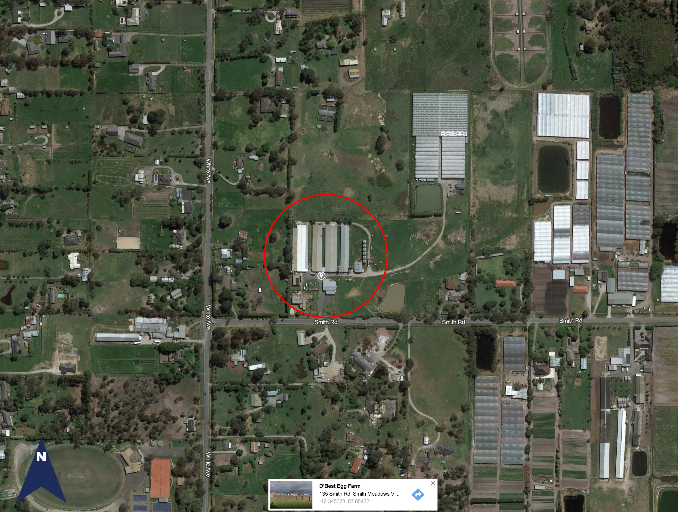

Image 2: Premises Structures
This image allows identification all of the structures on the premises.






















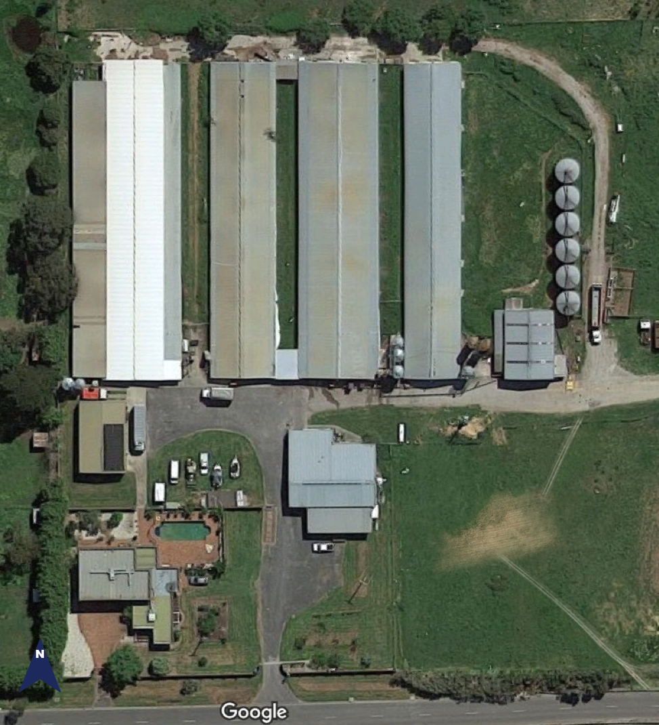

1 | [Example: Hen House #1] | 11 | [xxxxx]
2 | [Example: Hen House #2] | 12 | [xxxxx]
3 | [Example: Hen House #3] | 13 | [xxxxx]
4 | [Example: Hen House #4] | 14 | [xxxxx]
5 | [Example: Egg Storage & Cooler] | 15 | [xxxxx]
6 | [Example: Employee Changing Room] | 16 | [xxxxx]
7 | [Example: Egg Store] | 17 | [xxxxx]
8 | [Example: Repair Shop] | 18 | [xxxxx]
9 | [Example: Residence] | 19 | [xxxxx]
10 | [Example: Feed Silos] | 20 | [xxxxx]

Image 3: SFS Biosecurity Measures
This image illustrates the layout of premises and detailed information about the biosecurity measures. Please include items listed in the legend to identify activity on your premises.

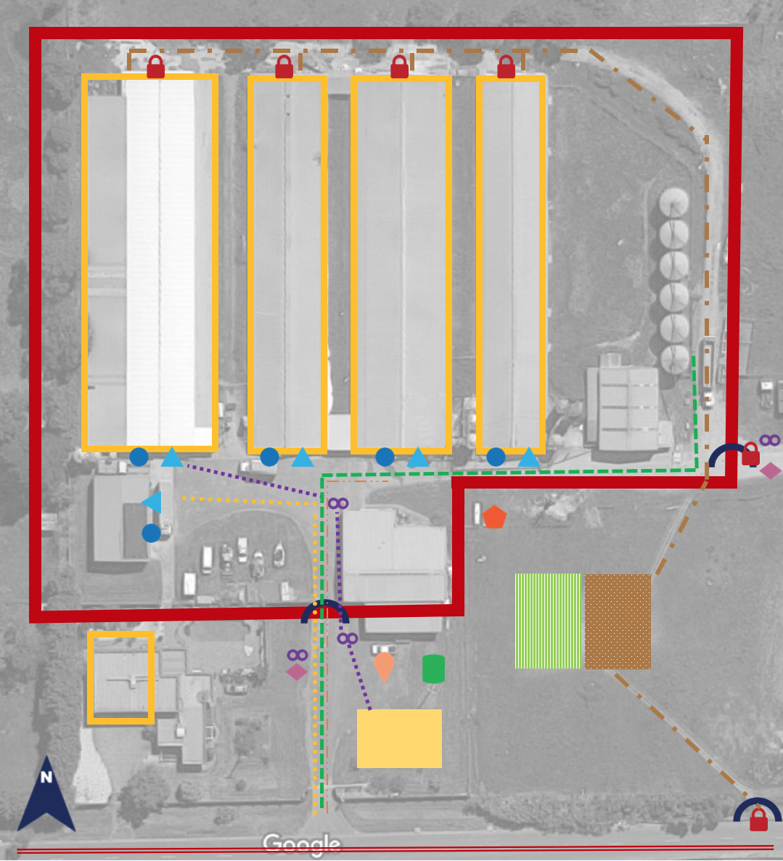

 | Premises Perimeter |  | Non-essential Pick-ups/Deliveries
 | Perimeter Access Points |  | Employee/Visitor Parking
 | Internal Line of Separation |  | Propane Tank
 | Locked Gates or Doors |  | Manure Pile
 | Vehicle C&D stations |  | Compass
 | Full PPE Stations |  | Public Road
 | Hand Sanitizing |  | Egg Delivery Traffic
 | Foot Bath Stations |  | Manure Hauler Traffic
 | Rendering Barrel |  | Feed Delivery Traffic
 | Incinerator |  | Foot Traffic
 | Compost Pile |  | Rendering Traffic
 | Garbage Barrel or Dumpster |  | Live Bird Movement Traffic

Note: Use the icons that indicate your biosecurity and managements practices. Some icons may not apply to your operation.

