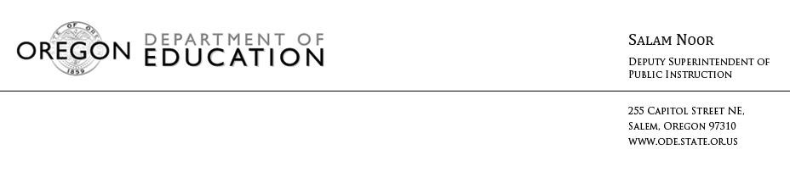 MEDIA ADVISORY

USDA Representative to Attend Willamina Kid Chef Breakfast Contest

Ronna Bach, Special Nutrition Programs Director for the USDA's Food and Nutrition Service Western Region, will attend the Willamina School District’s Iron Chef Breakfast Contest on Wednesday, March 9. Four teams of students will cook breakfast items from different nutritious recipes during an all-school assembly. The event will follow a nutrition trivia game and other activities designed to educate students about healthy eating in a fun and engaging way.

What: Willamina Kid Chef Breakfast Contest
When: Wednesday, March 9, 2016 at 1pm
Where: Willamina School, 1100 Oaken Hills Drive, Willamina, OR
The competition is in celebration of National School Breakfast week March 7- 11. Members of the media are invited to attend. Please check in at the office by 12:45 and say you are there the assembly.

Contact Number: Lynne Shore, Nutrition Service Director, (503) 876-2702

# # #

