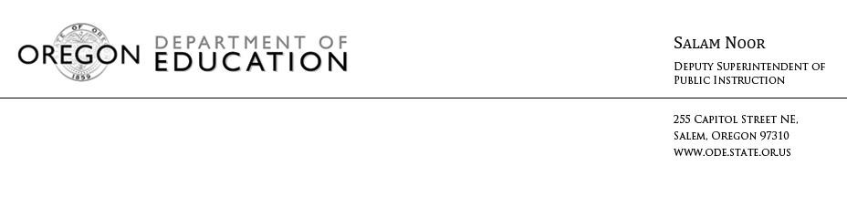
NEWS RELEASE
September 8, 2016
Media Contact: Tricia Yates, tricia.yates@state.or.us

2016 Statewide Test Results Show Across-the-Board Student Progress
Scores provide information on students’ college and career readiness

(Salem, Ore) –Oregon’s Deputy Superintendent of Public Instruction Salam Noor announced the results of the state’s end-of-year tests today, administered to more than 290,000 students last spring. Results for the 2016 tests showed statewide progress in both English Language Arts and Math. When broken down, the data show students statewide improved in most tested grades, and by as much as three percentage points. These gains include students with disabilities, students living in poverty, English Learners, and historically underserved student groups.

“What is most exciting about this year’s results is the progress made by students across the board, including those from groups that have historically performed at lower levels than their peers,” Deputy Superintendent Noor said. “This progress reflects the dedication and hard work by our students and educators to meet higher standards as we aim to ensure all students in Oregon are successfully prepared for their next steps.”

This year marks the second year students in Oregon took the online tests, aligned to Oregon’s more rigorous academic standards. The tests provide teachers and parents with a snapshot of the progress students are making to develop the critical thinking and problem-solving skills needed in English Language Arts and Math to succeed from grade to grade and in life beyond high school.

“All Oregon students should have access to a relevant, rigorous, well-rounded education,” Noor said. “We’ve raised expectations for our students so they are better prepared for postsecondary options, career, and civic life. The test results reflect just one measure of students’ achievement that -- when combined with teacher feedback and other measures -- works to provide a more complete picture of student progress.”

Nearly 160,400 (55 percent) of students earned a 3 or 4 and are considered on track to be college- and career-ready in English Language Arts, and almost 119,500 (42 percent ) earned a 3 or 4 in Math.

“I am proud of the hard work being done in classrooms across the state as teachers work to prepare students with the skills and knowledge they need for successful futures. This year’s results show that we must continue to work together to ensure each of our students are prepared for a bright future,” Noor added.

Results by grade, student group, school, and district can be found here.

For more information, view an FAQ and an additional resource.

# # #

