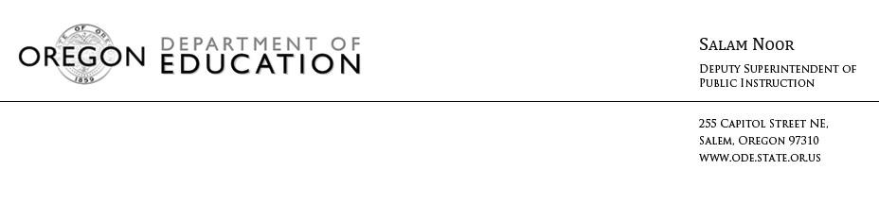

NEWS RELEASE
September 14, 2016
Media Contact: Tricia Yates, tricia.yates@state.or.us

Assessment work group calls for investment in student tests to support improved teaching and learning

(Salem, Ore.) – A legislatively required work group charged with evaluating the state’s Smarter Balanced end-of-year assessment released a report with recommendations for consideration by the State Board of Education. The report, required under 2015 House Bill 2680, highlights the need for Oregon’s school districts to have access to more than one single tool to measure students’ progress. It calls on the state to invest in a comprehensive suite of tools to ensure students, educators, and families receive a more holistic picture of their child’s academic knowledge and skills. These would include formative assessments like quizzes and class activities and interim assessments such as midterms and benchmark exams which are also aligned with Oregon’s Common Core State Standards.

“I am pleased to read the recommendations from this diverse group of education experts. The report underscores a shared vision for our assessment system,” Deputy Superintendent Salam Noor said. “We will use the work group’s findings to continue to improve our efforts to ensure our students are on the right track.”

The report -- approved by 33 education leaders from school districts and other organizations dedicated to improving education in Oregon -- also recommends that the Oregon Department of Education reach out to parents and communities to better explain the purpose of statewide summative assessments, as well as the need for comprehensive, balanced assessment systems.

“Through this comprehensive process, we confirmed that the end-of-year test is aligned with our standards,” Tigard-Tualatin School Board Chair Maureen Wolf said. “But we also found there is a need for more than just one assessment near the end of the year. We hope our state policymakers will use this report to invest in the tools districts need to ensure every student is on track to graduate.”

“This is the first time I have seen a report that not only shows the current Oregon student assessment situation but where we as a state need to go,” said Portland Public Schools Literacy Coach Lisa Kane. “Having all House Bill 2680 Work Group members come to agreement on this really gives me a lot of hope for what we can do to measure and support student achievement.”

The work group report echoes a Secretary of State audit of the first year of the Smarter Balanced assessment which was also required by lawmakers under House Bill 2713. The audit noted the benefits of using a comprehensive system to ensure teachers have a way to assess student learning throughout the year. The Oregon Department of Education is requesting a state investment for the 2017-19 biennium to fund the formative and interim assessments for all districts and to use the information the tests provide.

For more information on House Bill 2680, work group membership and the report, click here.

# # #

