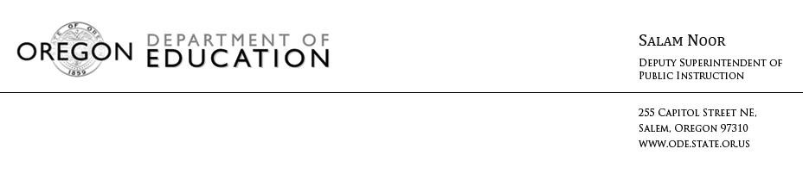NEWS RELEASE
January 28, 2016
Media Contact: Crystal Greene, crystal.greene@state.or.us, (503) 947-5650

State Graduation Rate Rises Two Percent
More Oregon students earn diploma, graduate ready for next steps

(Salem, Ore) – New numbers released today show a two percent increase in the state’s graduation rate, with 74 percent of students in the class of 2015 graduating in four years. State leaders are encouraged by the increase and recognize that there is significant work to be done to ensure each student graduates high school with a plan for the future.

“This increase moves us closer to our goal of having every Oregon student complete high school with a plan," Governor Brown said. “We have work to do as a state to reach that goal, and I am committed to making sure our education system delivers better outcomes.”

Improving graduation rates – and ensuring graduates leave school with the skills needed to succeed in their next steps – is a key priority for our state.

“While our graduation rate is far from where we want and need it to be, this increase means we are headed in the right direction and is truly something to celebrate,” said Deputy Superintendent Salam Noor. “I want to recognize our teachers, administrators, students, families, and communities for the incredible focus, dedication, and hard work they have put into helping more of our students graduate on time and with the skills needed to succeed in college and the workplace.”

Over the past five years, the state has made gains in boosting graduation numbers. A methodology change in 2013-14 brought Oregon’s rate into greater alignment with the rest of the country and resulted in a three percent increase in graduation rates last year. This year’s increase is particularly notable because there was no change to methodology or reporting.

Spotlighting Promising Practices
While the state as a whole saw a two percent increase in graduation rates, many schools and districts reported much more sizeable gains and made progress in reducing the graduation gap that too often exists for students of color, students navigating poverty, students with disabilities, or those learning English.

A graduation brief, released by ODE along with the data, highlights promising practices from schools across the state that are making significant gains in boosting graduation rates and closing gaps for historically underserved student groups. These promising practices include:
- Creating a college-going culture school-wide
- A shared commitment to success for every student
- Building strong relationships between students and staff
- Individualized attention and early interventions for students falling behind
- Summer and after-school programs to provide extra learning time for students

Read more about what schools from Newport to Neah-Kah-Nie are doing to increase graduation rates in their communities.

One school district that saw a significant increase in graduation rates last year was Medford. While graduation rates for large districts tend to change slowly, Medford saw a ten percent one-year increase, going from a 4-year graduation rate of 65 percent in 2013-14 (well-below the statewide average) to 75 percent in 2014-15 (slightly above the state average). In addition, the district, saw an almost 15 percent increase in their Latino graduation rate, hugely outpacing the statewide gain of two percent. The district attributes this improvement to an increased focus on data-driven decision making, establishing a college-going culture across the district, creating small learning communities and educational pathways to better engage students, and transforming their approach to English Language Development including receiving a state grant to provide extensive professional development on better supporting English learners.

“We met as an English Learner team and developed a three-year plan which targeted professional development, student achievement, equity, and the graduation rate,” said Terri Dahl, Medford Supervisor of Federal Programs and School Improvement. “We're very excited that our department goals and strategic plans have impacted student learning.”

Keeping the Focus on Graduation for Every Student
Oregon has adopted rigorous instructional standards and graduation requirements designed to prepare each student for success after high school – whether that student choses to go on to college, workforce training, the military, or directly into the workplace. State efforts underway to boost graduation requirements include: sharing and replicating promising school and district practices like those highlighted in this year’s brief; investing in applied, hands-on learning such as Career and Technical Education (CTE) and Science, Technology, Engineering, Arts, and Math (STEAM) programs which have been shown to keep students engaged and increase graduation rates; better supporting students through key education transition points; and promoting strategies to reduce achievement and opportunity gaps early through an emphasis on strong early learning programs.

“As we work to improve outcomes for all of our students, we must keep our focus on reducing opportunity and achievement gaps across our state,” Deputy Superintendent Noor said. “While I am very pleased with the overall increase in graduation rates this year, our state has much it can learn from Medford and others who are making significant gains in boosting graduation rates for historically underserved students. We must ensure that the promise of a bright future is afforded to all of our students regardless of zip code, race, income, language, or disability status. We have a lot of work ahead, but I am truly inspired by what schools across the state are doing to tackle this important issue. It gives me great optimism and hope for what we can accomplish together in the years to come.”

Paving a Path Forward
As part of the state’s intentional focus on improving graduation rates, ODE has established a Graduation Advisory Committee made up of key external partners to advise on the development of the state’s graduation plan. This advisory group - which includes representation from school districts, key education organizations, the business community, higher education, leaders representing communities of color, parent groups, and policy leaders – met earlier this month to review Oregon and national graduation data, discuss current barriers to improving the graduation rate, explore promising practices, and share recommendations and strategies for moving the work forward. This advisory group will continue to work closely with ODE leadership on developing a graduation plan that builds on this year’s growth and improves outcomes for high school students across the state.

In addition to graduation data, the state also released dropout data which is available online here. Unlike the graduation rate, which is based on a four-year cohort, the dropout rate is a one-year snapshot and is therefore not comparable to the graduation rate.

To access statewide graduation numbers, click here.
To access school and district graduation numbers, click here.
For the graduation brief, click here.
For an FAQ on the graduation rate, click here.

# # #

