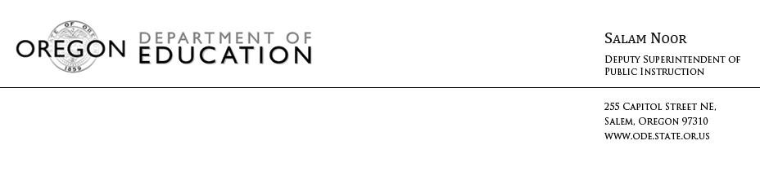NEWS RELEASE
August 17, 2016
Media Contact: Tricia Yates, tricia.yates@state.or.us

State Board of Education Adopts Rules on Lead Testing
Health and Safety of Oregon Students a Top Priority for Education Leaders

(Salem, Ore) – Today the State Board of Education adopted new rules related to testing for lead in schools. This action represents a swift response by state education leaders to ensure the health and safety of all Oregon students.

“Every child has a right to learn in an environment that is safe and any threat to the health and safety of a child in any school or classroom is unacceptable,” Governor Brown said.

The rules require school districts and public charter schools to report to the public every year the findings of lead testing, including results and ongoing monitoring. The rules also require the development and submission of a Health and Safe Schools Plan to the Oregon Department of Education.

“As we work to improve outcomes for all students, we must ensure our school facilities are welcoming and safe,” Deputy Superintendent Salam Noor said. “I am pleased that the rules reflect input from essential stakeholders like parents, educators and other community members, and that they were developed collaboratively with the Oregon Health Authority and the Oregon Department of Environmental Quality.”

You can read more about the rules and the required components of the Health and Safe Schools Plan here.

# # #

