BEFORE THE OREGON DEPARTMENT OF EDUCATION

RULE HEARING: OAR 581-018-0005 to 581-018-0020 Network for Quality Teaching and Learning - Guiding Principles

HEARING OFFICER’S REPORT

The Department held a public hearing on November 22, 2013, to receive public comment on the proposed rule amendments. Notice of hearing was published in a timely manner in the Secretary of State’s bulletin and was sent to interested parties and persons who requested notice pursuant to ORS 183.335 (7). The hearing was held at the Department’s offices in Salem, Oregon before Cindy Hunt, Hearing Officer.

There was no testimony.

Respectfully submitted this 22nd day of November, 2013

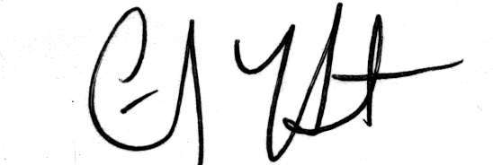

Cindy Hunt
Hearing Officer

