To: Members of the Oregon Board of Education,

My public comment for the March 6-7 Board meeting:

Please adopt the following rule as Oregon Administrative Rule 581-023-0250: High School Study Abroad:

"For the purpose of calculating Average Daily Membership (ADM) used in the distribution of State School Funds, a school district may count high school students studying abroad on programs approved and paid for by the school district."

I have submitted a "Pilot high school study abroad program" proposal to Portland Public School for inclusion in their 2014-15 operating budget. They have it under consideration and would like to know if they would be able count the high school students they fund for high school years abroad in their ADM calculation for the distribution of State School Funds. It is not clear from the current laws and rules whether they could or not. Adopting the proposed rule above would make it clear that they could.

Broader rationale:

Oregon’s best economic future is to sell more goods and services abroad, especially to the growing markets in Asia and around the Pacific Rim. Consider the chart below: “Shares of Global Middle-Class Consumprtion, 2000-2050” from the National Intelligence Council’s report Global Trends 2030: Alternative Worlds (here). Note the diminishing share of the United States. Note the growing shares of China, India, and Other-Asia.

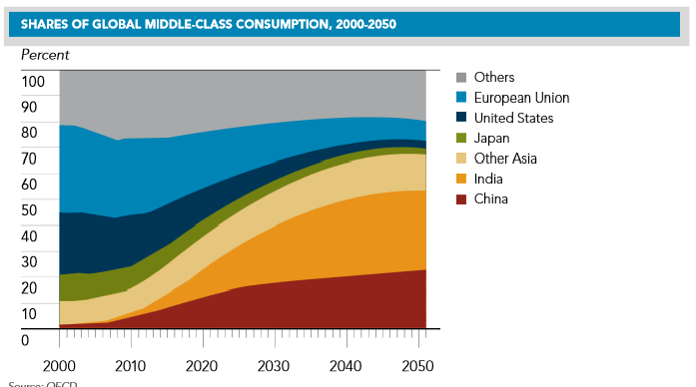
Oregon’s challenge is to adapt to this developing economic reality and to become more of an internationally oriented state. Key to this adaption is to develop a more multilingual workforce with experiences in the important growing markets abroad. And key to developing such a multilingual workforce with experiences in the important growing markets abroad is to develop high school study abroad programs in key international markets.

For individual students, studying abroad can be transformative. There are many educational benefits to studying abroad: (1) They become global citizen with a better appreciation for other cultures. By immersing themselves in unfamiliar practices and customs, students become better equipped to identify and interact with people from other cultures—whether it be in school, on the job, or in their personal lives. (2) They become flexible, independent thinkers, able to handle all kinds of experiences. Students who study abroad are better prepared to make transitions, take control of new situations, and appreciate challenging situations for what they are: opportunities to learn and grow. (3) They become more marketable to colleges. There’s a reason admissions officers like seeing international study experience on a résumé—it’s one of the greatest ways for students to acquire the kinds of life skills that can’t be learned in a classroom. Studying abroad shows initiative, maturity, and independence. (4) They become more aware of their academic and professional passions. Studying abroad helps students gain perspective for their next big step. By allowing them to explore their interests and develop new ones, studying abroad can give students a better sense of what they want to study in college or even pursue as a career. And (5) they become more adept at processing and learning from experiences. Studying abroad in high school provides students with an opportunity to reach new heights. The ability to recognize those achievements—while making and learning from their mistakes—and to grow academically and personally is integral to the study abroad experience.

Currently, most Oregon students who spend a high school year abroad come from relatively affluent families. Public programs provided by local school districts would give students from low income and minority families more opportunities to study abroad.

There are existing high school study abroad organizations that provide valuable learning experiences. School districts do not now need to develop their own programs.

Pilot high school study abroad proposal submitted to Portland Public Schools:

Here are some of the specifics from the PPS proposal.

Portland Public Schools will send six PPS high school students to study abroad for the 2015-16 school year. Three will go to Mexico and three will go to China. PPS will pay study abroad fees and airfares. Total estimated cost for six students is $49,090, or $8,182 per student. PPS will use the study abroad organization ASSE in this pilot program.

This is a pilot program to permit PPS: (1) to develop the administrative and financial systems to run a high school study abroad program, (2) to access the level of student and parent interest in a high school study abroad program, and (3) to assess the student/parent satisfaction with and student learning outcomes from such a program.

Costs:
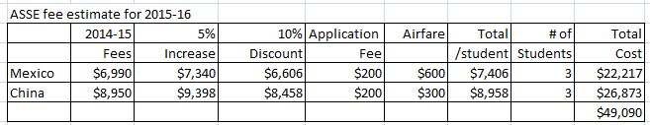

Note: ASSE study abroad fees are now known only for 2014-15. In the chart above, a 5% increase in fees is estimated for 2015-16. Also Note: ASSE gives a 10% discount for fees paid by January 15 for students leaving for abroad in August/September.

Revenues:
The goal is to get the State School Fund to pay PPS its per pupil distribution for a high school student studying abroad (when paid for by PPS) the same as if the student were attending one of PPS’s in-district high schools (that a studying abroad student counts in determining ADM).

ASSE:
ASSE was selected as the study abroad organization to use because of its low costs and large size.
ASSE was established in 1976 as the American Scandinavian Student Exchange by the Swedish Government to organize student exchange programs between Sweden and the United States. Soon Denmark, Norway and Finland elected to participate. At present, ASSE works closely with the Canadian provincial education ministries and is approved by the Ministry of Education in New Zealand. ASSE maintains 38 offices in 31 countries and accommodates more than 30,000 high school age students and host families annually in its programs in the moré than 30 participating countries.

ASSE fees cover:
ASSE arranges for tuition free high school placement.
ASSE covers the round trip international airfare from Los Angeles to Asia/Pacific. Year programs to Mexico exclude airfare.

Fees also include comprehensive health, accidental death and travel insurance, host family recruitment and screening, non-English speaking country language training, and orientation.
Timelines:
2014, May: Program and budget approved by PPS Board
2014, August through October: Notice of opportunities promoted
2014, November: Applications from PPS students due
2014, November through December, Selection of students made
2015, by January 15th, payments made to ASSE for 10% discount
2015, August: Students leave to spend 2015-16 year abroad

Administrative structure:
Some current administrator needs to be given responsibility for this high school study abroad program. It should take very little administrative time and only slightly more clerical time.

Students eligible:
Student must have attended a PPS school full time for all of the 2013-14 school year and be enrolled full time for 2014-15 as of application.
Student must have a passport or be able to obtain one prior to international travel.
Student must have a 3.0 high school grade average at application

Student selection process:
Students will be selected from those eligible according to the following priority. Students with equal priority will be selected by lottery.
First priority: Students with six years (K-5th) or more of dual language immersion in the relevant language or attending Jefferson – Middle College for Advanced Studies for the 2014-15 school year
Second priority: Students with four or five years of dual language immersion in the relevant language.
Third priority: Students with one to three years of dual language immersion or one or more years of middle or high schools courses in the relevant language.
Fourth priority: All others

Credit for high school year abroad:
The intent of this program is that students would receive a full year credit towards graduation for a full year spent studying abroad. For some students, this may require flexibility and creativity in granting credits for courses taken abroad.
Liability:
There is always the risk that something bad will happen to a student while studying abroad and that the students and/or parents will sue PPS. PPS has liability limits set by state law but PPS should take whatever steps legal counsel would recommend to reduce its risk. ASSE should bear most of the risk.

Authority of school districts to provide high school study abroad programs:

There is no law prohibiting school districts from paying for study abroad experiences for its students. School districts are explicitly authorized to provide “Extended educational experiences” in ORS 336.175, which reads:

In addition to regular courses of study, any district school board may make available to its students extended educational experiences through public and private community agencies when such experiences can be provided by the agencies more appropriately or at a lesser cost than by the school district. Programs under this section may include but are not limited to work experience programs conducted on a contractual basis with individual employers or employer groups.
Authority of the Board of Education to adopt the proposed rule:
327.125 Superintendent to administer statutes related to state financing of education; board rules. The Superintendent of Public Instruction shall administer the provisions of ORS 327.006 to 327.133, 327.348 and 327.731 and sections 1 to 3, chapter 735, Oregon Laws 2013. The State Board of Education shall adopt all necessary rules not inconsistent with ORS 327.006 to 327.133, 327.348 and 327.731 and sections 1 to 3, chapter 735, Oregon Laws 2013, to carry into effect the provisions of those statutes.
The proposed rule above is "not inconsistent" with the listed laws and is necessary if Oregon is going to have the needed multilingual workforce with experiences in important growing markets abroad.
Thank you.
Sincerely,
Dave Porter
1113 SE Cora St.
Portland, OR 97202

2/17/2014

