Using the Course to Endorsement Catalogue
The Course to Endorsement Catalogue lists all National Center for Education Statistics (NCES) course codes that have been adopted by the Oregon Department of Education. It is recommended that districts find the course that appropriately describes the content being taught and scroll right to see which endorsements are allowed to teach that course. The Course to Endorsement Catalogue uses the current TSPC endorsements.

Filtering by Endorsement:
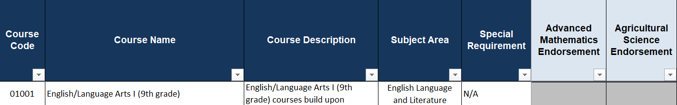
- Select the dropdown filter button in the Endorsement column.
- Uncheck the box marked “Select All”.
- Select “Eligible” to view courses that CAN be taught by the endorsement at the top of the column.
- Select “Atypical” to view courses that can be taught by any endorsement (please see restrictions in footer).
- Select “Not Eligible” to see which courses the endorsement is NOT eligible to teach.
- To clear the filter, click the dropdown arrow again and check the “Select All” and Click “OK”.

Filtering by Course Name:
- Select the dropdown filter button in the “Course Name” column.
- Uncheck the box marked “Select All”.
- Scroll down the list to find the course name or enter the course name in the “Search” field.
- Excel will show the course you entered.
- To view the endorsements eligible to teach that course, scroll to the right and find the endorsements indicated by “Eligible” or “Atypical”. A grey box means the endorsement is not eligible to teach the course.
- To clear the filter, click the dropdown filter button again and select “Clear Filter from…” and click “OK”.
Read the course description when selecting the course code to ensure it matches what is taught in the course.

Filtering by Special Requirement:
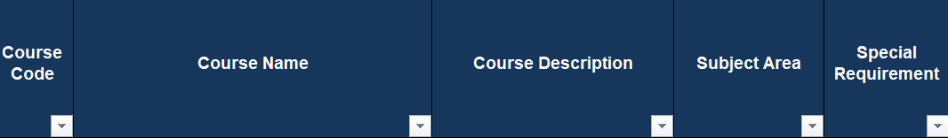
- Select the dropdown filter button in the Special Requirement column.
- Uncheck the box marked “Select All”.
- Select any Special Requirement to view courses that have special requirements. Note: Courses that do not have a Special Requirement are marked “N/A”.
Courses with Special Requirements are also color-coded for your reference. Please see the table below:
Color | Special Requirement
Blue | The College Board must have an approved syllabus on file for this course.
Orange | Course may only be taught in IB approved school and teacher IB trained.
Green | Teacher must be trained by Project Lead the Way using Project Lead the Way Curriculum
Purple | Only taught in Title 1 funded schools.
Yellow | Course can only be taught by someone with a Special Education endorsement.
No color | There is no Special Requirement (N/A).

On a valid and active unrestricted non-provisional Oregon teaching license which includes: Preliminary Teaching, Professional Teaching, Teacher Leader, Reciprocal Teaching and Legacy licenses. Licenses that do not meet this definition include: Emergency, Restricted, Preliminary CTE, Professional CTE, American Indian Language and International Visiting licenses.

