Module 1: Activity Sheet 2
How do you currently support language learning in your classroom?

Review the Theory of Action for the Dynamic Language Learning Progression. How do you think the Theory of Action might/could connect to how you plan for and support your students’ language learning?

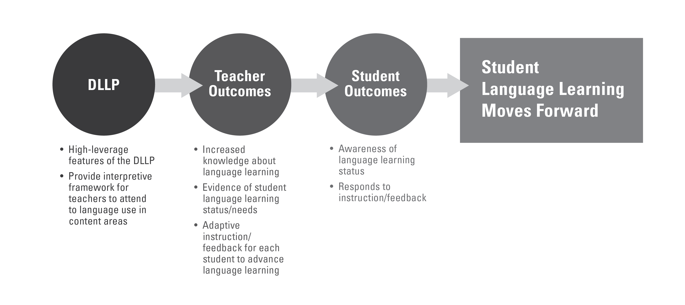
There are eight high-leverage features of the DLLP for the dimensions, word, sentence and discourse: 1) Sophistication of topic vocabulary; 2) Sophistication of verb forms; 3) Expansion of word groups; 4) Sophistication of sentence structure; 5) Establishment of advanced relationships between ideas; 6) Perspective-taking (K-3); 7) Coherence/cohesion; 8) Stamina.
[You will learn about these in detail in module 2].

