Eight DLLP Language Features
Sophistication of Topic Vocabulary:
The Sophistication of Topic Vocabulary DLLP comprises four sub-feature components: Essential topic vocabulary: the relatively small, core set of topic vocabulary words most speakers or writers are likely to rely on in order for the listener or reader to understand the topic being explained; Related topic vocabulary: words that could be used to explain a topic in further detail; Technical topic vocabulary: words not likely to be encountered outside a discipline or sub-discipline context; and Vivid vocabulary: words that evoke imagery.
- By tracing the progression for Sophistication of Topic Vocabulary teachers can monitor how students are increasing the breadth and depth of their word knowledge in different academic content areas.
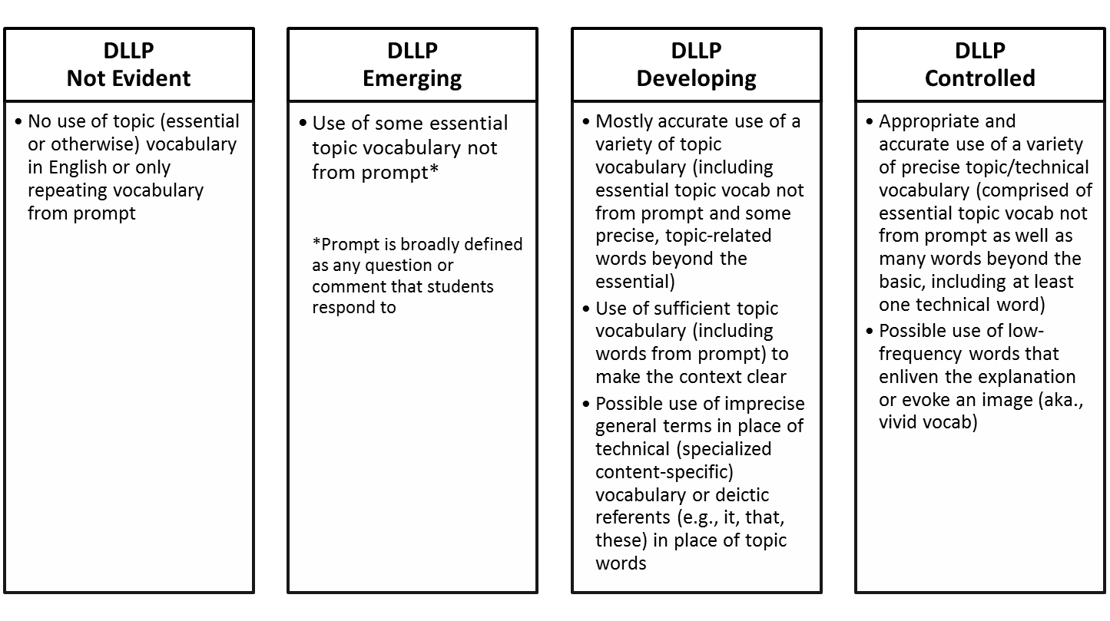
Glossary of terms: Deictic referents are words whose use depends on context such as who is speaking/writing and what point of view they have relative to the referent, for example the demonstrative pronouns “that” and “this” are used as deictic references in the following examples “that cube (over there)” but “this cube (here next to me)”.

Sophistication of Verb Forms:
The Sophistication of Verb Forms DLLP focus on the variety of simple and complex verb forms in sentences.
- Tracing the progression of the Sophistication of Verb Forms provides teachers with information about how students shift from using fragments of verb forms and simple verb forms through to developing a range of complex verb forms.
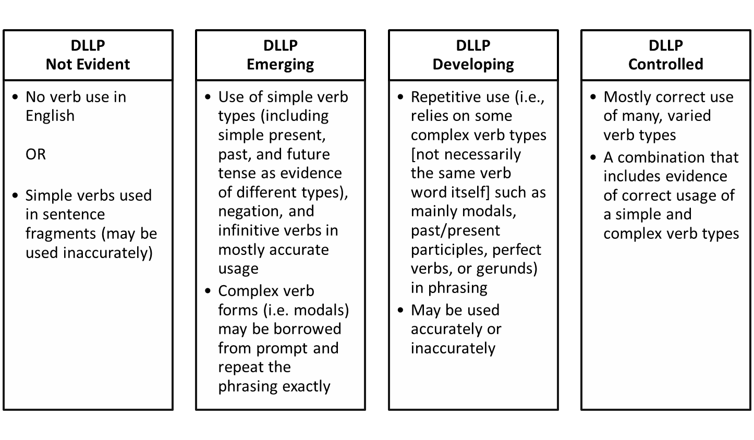Glossary of terms: Infinitive verb forms are not given a tense and occur with “to” in English (e.g., to move, to count); Modal verbs are verbs that convey mood in English (e.g., can, could, would, should, etc.); Gerund forms of verbs act as a noun by addung –ing (e.g., his adding was correct).

Expansion of Word Groups:
The Expansion of Word Groups DLLP focuses on the incorporation of a variety of different lexical characteristics: including derived words (e.g., electric – electricity), nominalizations (e.g., nouns formed from verbs or adjectives, such as multiplication, goodness), a range of adverbs, adjectives and prepositional phrases, and general academic vocabulary (e.g., words that cut across content areas yet are commonly encountered and acquired in academic contexts, for instance analyze, observation, examine).
- Tracing the progression of Expansion of Word Groups can provide teachers with information about how students are acquiring knowledge about a wider repertoire of vocabulary words and uses.

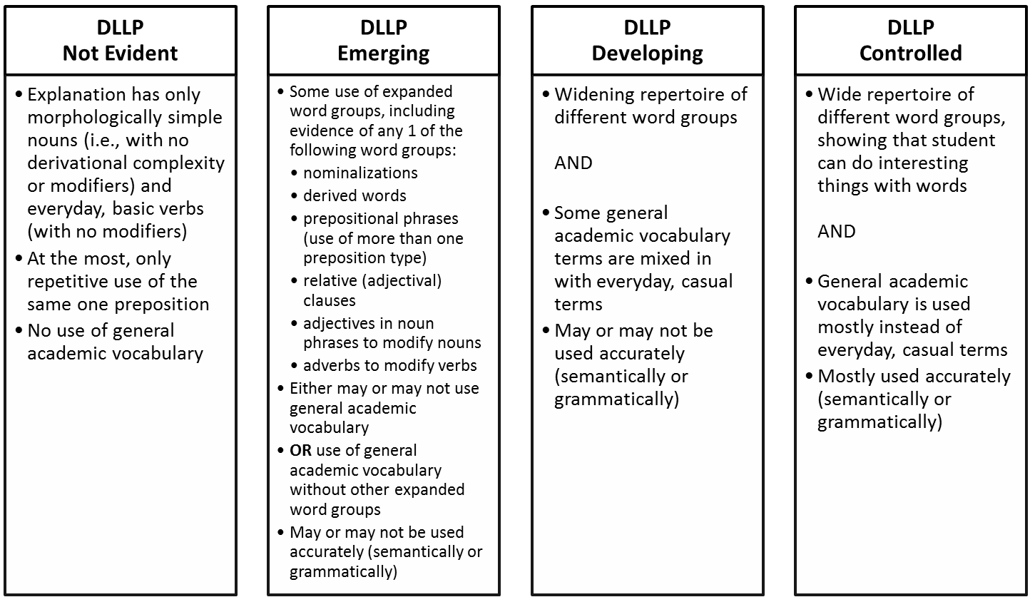
Glossary of key terms: Morphologically simple means the word is not formed (derived) by adding affixes to a root form; Derivational complexity refers to words that are made up of affixations on the root form; Semantically [accurate] refers to a word used correctly in terms of its meaning and contrasts with grammatically [accurate] word usage (i.e., used in correct word order, has correct verb ending, etc).

Sophistication of Sentence Structures:
The Sophistication of Sentence Structures DLLP focuses on how students formulate increasingly complex sentences.
- By tracing the progression of Sophistication of Sentence Structures teachers can monitor how students are developing in their grammatical and syntactic knowledge by moving from sentence fragments and simple sentences through to complex sentences that combine independent and dependent clauses (i.e., a subordinate clause embedded with a main clause such as “I counted all the cubes that I could see”).

Coherence/Cohesion:
The Coherence/Cohesion DLLP focuses on structuring and effectively organizing language for the listener both within and across sentences so that an explanation proceeds logically from beginning to end.
- By tracing the progression of Coherence teachers can become aware of how students are sequencing language in temporal and logical ways.
- Tracing the progression of Cohesion allows teachers to monitor how students are able to tie together the references they make in their explanations.
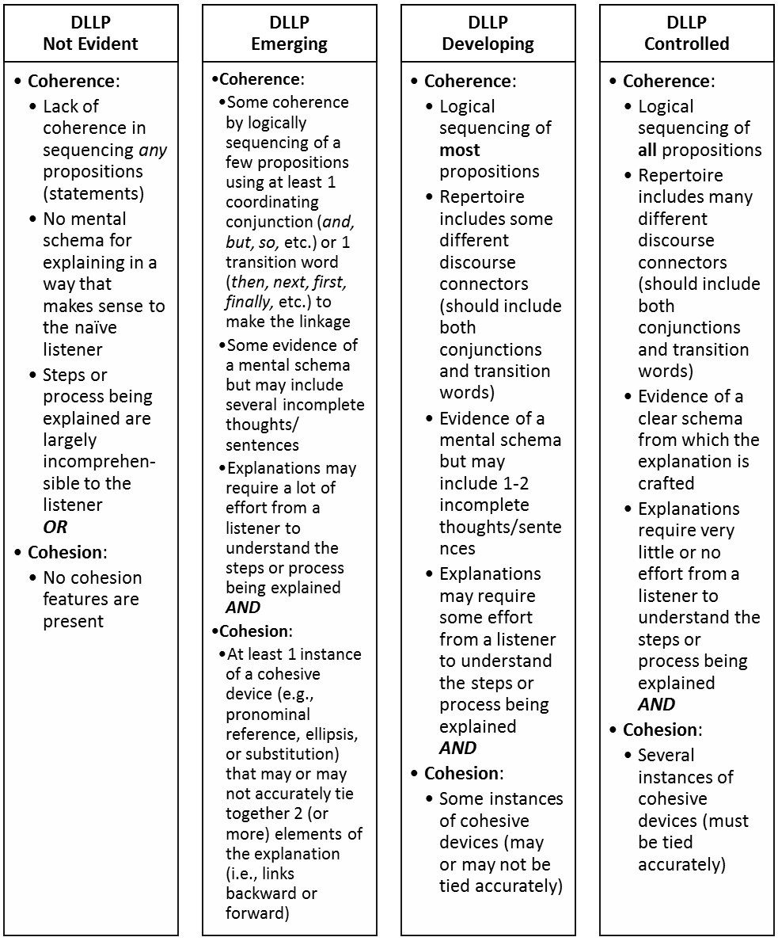
Glossary of terms: Pronominal reference is the use of pronouns to refer to established nouns; Ellipsis is the omission of words that are implied; Substitution is the use of synonymous or stand in terms for other nouns.
Establishment of Advanced Relationships between Ideas:
Establishment of Advanced Relationships Between Ideas DLLP captures how students linguistically conveying relationships between propositions (ideas) through the use of a range of different discourse connectors.
- Tracing the progression of Establishment of Advanced Relationships Between Ideas allows teachers to monitor how students are able to use causal connectors and contrastives among other kinds of linguistic devices for conveying conceptual relations.

Glossary of terms: Discourse connectors are words that connect sentences and clauses within sentences together (e.g., “However” – to introduce a contrast to what has been said or written earlier in the explantion; “Therefore” – to create a consquential link to what has come before in the explanational.

Stamina:
The Stamina DLLP focuses on the mental model (representation of knowledge) that students are working with, and their understanding of the need to provide a complete, explicit explanation to a listener who may not share a common viewpoint or the same knowledge with the student.
- By tracing the progression of Stamina teachers can monitor if a student is including all logical and expected elements of an explanation so that the explained process, procedure or actions, etc. is complete and can be readily replicated or understood by others

Perspective-taking:
The Perspective-taking DLLP requires students to assume a consistent or appropriately switched perspective in their discourse.
- By tracing the progression of perspective-taking progression teachers can make sure students are maintaining perspective taking that so they do not confuse a listener or a reader, or that they can overtly signal when they are appropriately changing perspectives within an on-going conversation or text.

