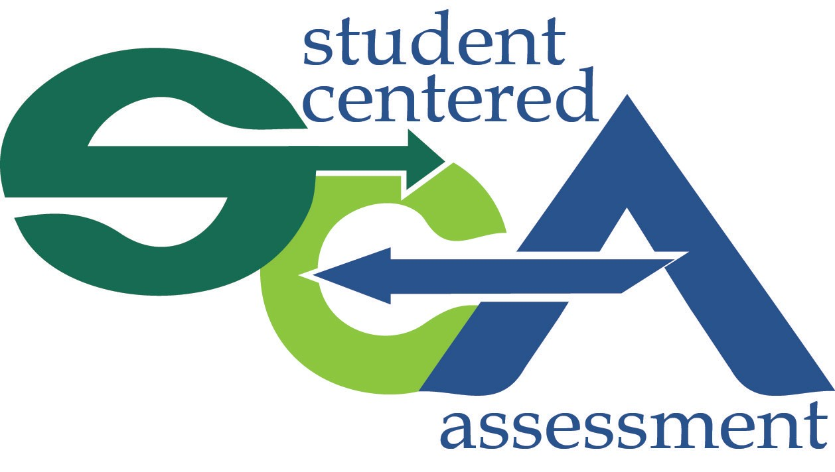

Social and Emotional Learning
to support Formative Assessment


Growth Mindset

Learning objectives

By the end of this session, participants will be able to: Define growth mindset
Understand the importance of growth mindset for
formative assessment
Feel familiar with the research base in this area Use actionable strategies to promote growth
mindset with students

Train other adults using the materials provided

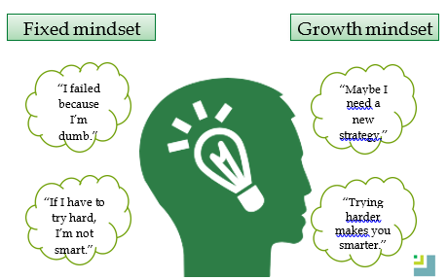

It’s NOT just about a student’s effort. The educational environment is important for changing mindset.





How does growth mindset relate to
formative assessment?

Formative assessment depends on students and teachers having growth mindsets
Both have to think of intelligence as something that can increase
Both have to expect that it will take time and effort for learning or mastery to happen
Both have to anticipate there will be challenges and mistakes as students learn new things, but those are just part of the learning process

The importance of growth mindset

Growth mindset has been linked to a number of academic and non-academic outcomes including:
- Grades
- Test scores
- Learning goals
- Motivation
- Persistence

- Engagement

For more research background, see Dweck, C., Walton G., & Cohen, G.(2014). Academic tenacity: Mindset and skills that promote long-term learning.Seattle, WA: Bill and Melinda Gates Foundation

Promoting growth mindset: What
can we do?
Small classroom changes can help a lot There is also evidence that interventions
in K‒12 settings have large and
enduring effects
Interventions can be low cost and easy to implement, such as reading articles, doing writing exercises, or playing games

“Most people don’t know that when they practice and learn new things, parts of their brain change and get larger, a lot like the muscles do. This is true even for adults. So it’s not true that some people are stuck being “not smart” or “not math people.” You can improve your abilities a lot, as long as you practice and use good strategies.”
– Excerpt from You Can Grow Your Brain by Lisa S. Blackwell and David S. Yeager

Visit Mindsetworks.com for more information about articles and other activities



Students read an article describing the brain’s ability to restructure itself through effort. The article focuses on the implications for students’ potential to become more intelligent through study and practice. This message is reinforced through several writing exercises.

Interventions were given to 1,594 students in 13 geographically diverse high schools.

The interventions were most beneficial for low-performing students. Among students at risk of dropping out of high school (a third of the sample), each intervention raised students’ semester grade point averages (GPA) in core academic courses and increased the rate of satisfactory performance in core courses by 6.4 percentage points.

Paunesku, D., Walton, G. M., Romero, C., Smith,
E. N., Yeager, D. S., & Dweck, C. S. (2015).

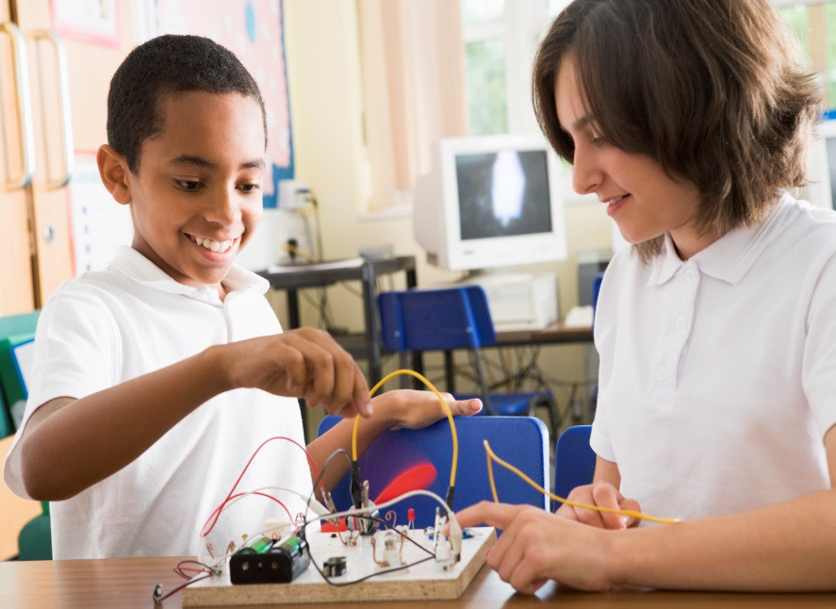

Focus on the process, not the outcome.

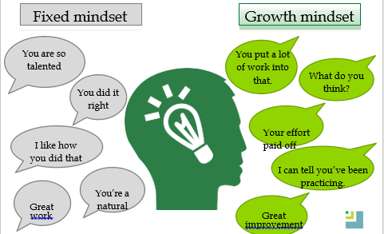

Classroom strategies to promote
growth mindset
- What is a growth mindset? Let them in on it!

- Share stories and observations about how you and other adults (including famous ones) have overcome challenges

- Model your own growth mindset:
  - Show how you can grow and improve with effort, feedback, and practice
  - Make changes in class based on student
feedback

Exercise To Promote Growth Mindset: The Mistake Game

This activity is adapted from resources found on MindsetKit.org, a site created by the Stanford Project for Education Research That Scales (perts.net)
- This game can be tailored to different
age groups or other subjects besides math

First, students work individually on math problems relevant to the lesson.
- Then, they share their solutions with a
group. The group chooses one solution to share with the whole class.
- IMPORTANT! Each group makes a
mistake on purpose while presenting.

The class spots the mistake and asks questions about it.

Thank You!

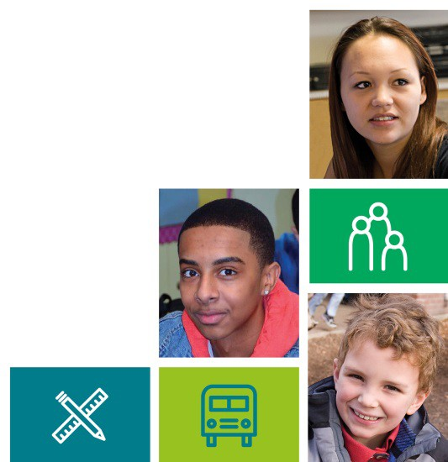
SEL for Formative Assessment by Davidson, S., Bates, L., McLean, C. and Lewis, K. is licensed under a Creative Commons Attribution-NonCommercial-ShareAlike 4.0 International License.

