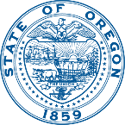 | HEALTH SYSTEMS DIVISION  Behavioral Health Services  Child and Family Behavioral Health | 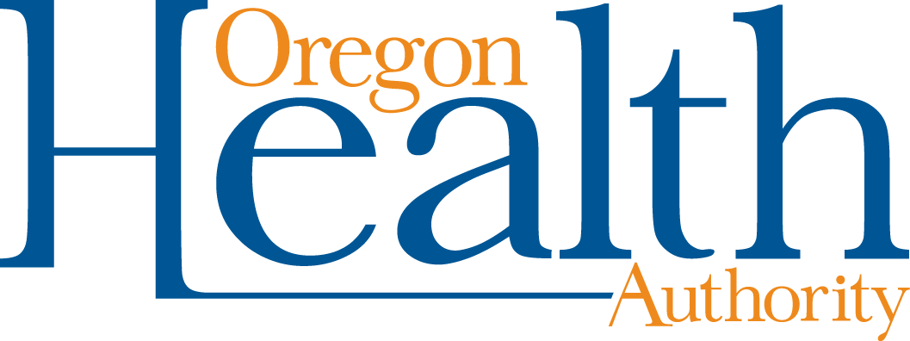
 | Kate Brown, Governor

500 Summer St.
Salem, OR 97301
COVID.19@dhsoha.state.or.us
healthoregon.org/coronavirus

April 23, 2020

Oregon Tribal Nation Information
Tribal Nations in Oregon and Oregon’s Urban Indian Health Program, Native American Rehabilitation Association (NARA), have a diverse array of services for youth and families. Each nation is unique. The best way to support or to learn about their programs is to reach out to them directly.
Oregon Tribes and NARA workforces are dedicated to the safety and well-being of their communities. During Oregon’s response to COVID-19, tribal staff and resources may be limited. They are working hard to support tribal people and continue to provide access to services.
Most tribes and NARA provide integrated services that include:
- Telehealth
- Behavioral health (substance use/abuse and mental health)
- Prevention
- Wellness
- Peer-delivered services
- Housing
- Emergency services
- Self-sufficiency
- Child welfare
- Crisis services and
- Culturally responsive suicide prevention, intervention and postvention.

You can click on each tribal name to link to its website for program details:
Burns Paiute Tribe
Confederated Tribes of Coos Lower Umpqua and Siuslaw Indians
Coquille Indian Tribe
Confederated Tribes of Grand Ronde
Klamath Tribes
Confederated Tribes of the Siletz Indians
Confederated Tribes of Warm Springs
Confederated Tribes of the Umatilla Indian Reservation
Cow Creek Band of Umpqua Tribe of Indians
Native American Rehabilitation Association
You can get this document free of charge in other languages, large print, braille or a format you prefer. Contact Mavel Morales at 1-844-882-7889, 711 TTY or OHA.ADAModifications@dhsoha.state.or.us.

