Background
Math in Real Life (MiRL) supports the expansion of regional networks to create an environment of innovation in math teaching and learning. The focus on applied mathematics supports the natural interconnectedness of math to other disciplines while infusing relevance for students. MiRL supports a limited number of networked math learning communities that focus on developing and testing applied problems in mathematics. The networks help math teachers refine innovative teaching strategies with the guidance of regional partners and the Oregon Department of Education.

There are four categories of outcomes related to this project.

- Student mathematics content knowledge:
  - Increase student mathematics achievement aligned to Oregon standards through implementation of applied mathematics problems.
  - Decrease the mathematics achievement gap between historically underserved students and their peers through implementation of applied mathematics problems.
- Student attitudes and beliefs that are correlated to higher achievement:
  - Increase student interest and enthusiasm in math by providing more opportunities to engage in interactive, student-centered problems that are based in applied mathematics.
- Teacher instructional practices:
  - Increase pedagogical preparedness of teachers to successfully implement inquiry-based practices within applied mathematics instruction.
  - Increase teacher knowledge of the application of mathematics.
- Teacher attitudes and beliefs about themselves and students:
  - Increase teacher enthusiasm and self-efficacy for mathematics to stimulate inclusion of more challenging open-ended applied mathematics activities within instruction.
  - Increase teacher beliefs that all their students are capable of doing mathematics.

Identifying Rich Context
At the center of MiRL identification of a context that has potential for exploring rich mathematical content. Math teachers connect with context experts either in the school or in the community. By interacting with these experts, math teachers are able to identify the potential connections to mathematics and applicability to grade-level expectations.

Purposeful Connection
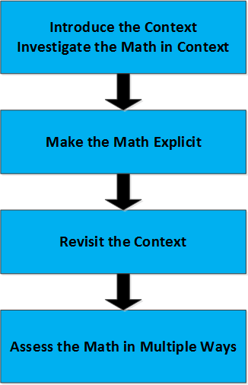
Application of mathematics does not insure improvements in student understanding. Teachers have to help students make connections between context and content. Each MiRL lesson uses an approach sandwiches explicit teaching of relevant math content between uses of that content in context (Figure 1). A MiRL lesson starts with the context, makes a case for needing mathematics, addresses key mathematical concepts, and returns to context for assessment and transfer. The model is described in materials available through the link in the resources section.
Figure 1 - Diagram shows the relationship between context and explicit math in a contextual math lesson.

Learning Communities
Teachers who have experienced MiRL lesson development find the process much more challenging than more familiar lesson planning. The context is often unfamiliar at first. Students are used to solving problems using simple algorithms and single types of mathematics. MiRL uses a learning community structure where teachers co-develop lessons, teach those lessons, and refine lessons based on their experience teaching.

Resources
Oregon Educator Network Math in Real Life

Contact
Mark Freed – Mark.Freed@ode.state.or.us

