Oregon Mathways Vision
The vision of the Oregon Mathways initiative is to strengthen the mathematical capacity of Oregon students while concurrently providing more options for students to pursue mathematics content that aligns closely with their learning and career goals. Related to that vision is a goal to increase the number of students who pursue and succeed in areas of study and employment that require using mathematics content.

Objectives of Oregon Mathways Initiative
- Identify, refine and disseminate best pedagogical resources and practices across 9-14 classrooms, to promote student actions needed for citizenship, college and career readiness, degree completion.
- Explicitly identify the two years of content expectations for all students to engage in after grade eight mathematics.
- Develop a framework for third credit options to guide school and district staff in the development of courses beyond the first two credits of high school mathematics.
- Align high school math pathways to entry-level college options for students.

Need for Change in Secondary Math
Increasing the number and percentage of students who meet high school graduation requirements in mathematics is critical to improving Oregon’s high school graduation rate. This need is evident because only about one third of Oregon’s high school students meet a level of proficiency based on statewide test scores. Even fewer students of color and English learners demonstrate proficiency. Today, the primary option for students is a single math pathway culminating with Calculus that does not align with the learning and career goals for the majority of Oregon’s students. Reimagining math pathway options that meet the needs of more students will require a focus on content and practices, rather than courses that students need for success.

Connections to National Conversations
The National Council of Teachers of Mathematics (NCTM) recognize the need to focus on high school mathematics and critically examine and improve the system and structures currently in place. In April 2018, NCTM released their publication Catalyzing Change in High School Mathematics: Initiating Critical Conversations that outlines the need for change, and recommendations to focus math content that lead to specialized pathways in high school.
Additional national conversations are occurring within professional math organizations that recognize the need to create more options for students that are contextual and connected to a student’s interest. The Common Vision Project is a joint effort of five national math organizations lead by the Mathematical Association of America (MAA) calling for a shift in entry level mathematics courses in college to introduce contemporary topics and applications and employ a broad range of examples and applications to motivate students and illustrate how math is used.

Elements of the Oregon Mathways Initiative
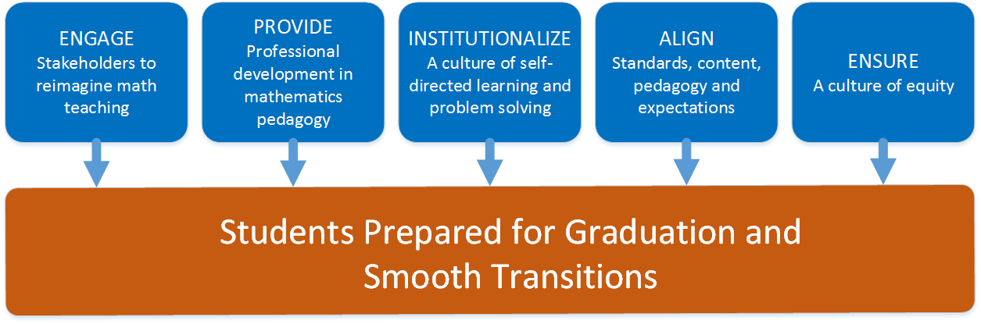
The Oregon Mathways Initiative is grounded in five elements illustrated in the diagram below. Activities such as Math in Real Life professional development and Finding Focus workshops are designed to support teachers, schools and districts prepare students for graduation and smooth transitions.

Stakeholder Engagement
Oregon Mathways will engage educational stakeholders from across the state to have conversations about reimagining the high school math experience, and working through issues of creating multiple pathways for students.

Pedagogy
Oregon Mathways will shift pedagogical practices while concurrently finding focus content in high school math.

Self-Directed Learning, problem solving, and critical thinking
Oregon Mathways will institutionalize a culture of mathematics that expects each and every secondary student be a lifelong and self-directed learner who can apply critical thinking and problem solving in mathematics.

Alignment
Oregon Mathways will aim to create smooth transitions for students within the math learning progression across K-8, high school, and post-secondary institutions.

Equity
Oregon Mathways will work to identify, promote, and implement strategies to ensure equitable mathematics learning opportunities for students of color, English learners and other traditionally marginalized groups.

Resources
Mathways Vision and Objectives, Theory of Action, Logic Model
NCTM President’s Message by Matt Larson in March 2018
MAA Common Vision Project report

Contact
Mark Freed – Mark.Freed@ode.state.or.us

