Lesson Plan for Frankenplants

A Middle School Life Science Lesson Featuring Engineering Design
Lesson Summary:
Grade Level: 6th – 8th Preparation Time: 2 hours (over 6 weeks)
Cost: $230-$330 initial cost Suggested Time: 200 minutes
$130-$175 recurring cost
Key Vocabulary: Clean Up Time: 20 minutes
Asexual Reproduction, Constraint, Cotyledon, Criteria, Engineer, Engineering Design Process, Grafting, Heirloom, Prototype, Rootstock, Scion, Selective Breeding, Trade-off, Vascular Bundles
Pre-Requisite Vocabulary:
Alleles, Genotype, Heterozygous, Homozygous, Hybrid, Phenotype
Contents
1—Lesson Overview 4
1.1—Introduction 4
1.2—Lesson Breakdown with Engineering Design 4
1.3—Pre-Requisite Knowledge 4
2—Teacher Background Information 5
2.1—Glossary of Terms 5
2.2—Scientific Concepts 5
2.3—Lesson Timeline 6
2.3.1—Overview Timeline 6
2.3.2— Lesson Preparation Timeline (6 weeks) 6
2.3.3—Part 1: Reading Activity (25 minutes) 6
2.3.3—Part 2: Exploration Activity (75 minutes) 6
2.3.4—Part 3 Engineering Design Activity (100 minutes) 7
2.4 —Lesson Materials 7
3—Preparation 8
3.0.1—Materials 8
3.0.2—Preparation Steps: Lesson Preparation 8
3.1—Preparation Part 1: Reading 9
3.1.1—Printed Materials 9
3.1.2—Activity Materials 10
3.1.3—Preparation Steps 10
3.2—Preparation Part 2: Exploration Activity 10
3.2.1—Printed Materials 10
3.2.2—Activity Materials 10
3.2.3—Preparation Steps: Part 2 10
3.3—Preparation Part 3: Engineering Design 11
3.3.1—Printed Materials 11
3.3.2—Activity Materials 11
3.3.3—Preparation Steps: Part 3 11
4—Activity Instructions 13
4.1—Activity Part 1: Reading 13
4.2—Activity Part 2: Exploration Activity 13
4.2.1—Activity Part 2: Day One 13
4.2.2—Activity Part 2: Day Two 13
4.3—Activity Part 3: Engineering Design 14
4.3.1—Activity Part 3: Day One 14
4.3.2—Activity Part 3: Days Two through Ten 14
4.3.1—Activity Part 3, Final Day 14
Appendix 1A: 2009 Standards Met With This Lesson 16
General Science 16
Engineering Design 16
Appendix 1B: 2014 (NGSS) Standards Met With This Lesson 17
Alignment to Next Generation Science Standards 17
Performance Expectations 17
Disciplinary Core Ideas 17
SCIENTIFIC AND ENGINEERING PRACTICES 18
Appendix 2: Material Breakdown 19
Printed Materials 19
Activity Materials 19
Buyer’s Guide: Basic Materials 20
Buyer’s Guide: Alternate Materials 21
Appendix 3: Growth Chambers 22
Cardboard Light Box Design 22
Materials 22
Directions 22
Materials 23
Directions 23
Appendix 4: After Grafting 25
Appendix 5: Additional Resources 26
Background Information 26
Growing Instructions 26
Grafting Instructions 26
Appendix 6: Engineering Design Extensions 27

1—Lesson Overview

1.1—Introduction
In this engineering lesson, students will design a tomato graft. Their ultimate goal is to create a viable tomato plant that is a combination of the bottom part of a rootstock and the top part of an heirloom tomato. The lesson is divided into three parts:
- Part 1—Students will use a reading activity to familiarize themselves with the key vocabulary and scientific concepts related to grafting, as well as develop a context for the rest of the lesson’s activities.
- Part 2—The teacher will facilitate an exploration activity, highlighting what the students probably need to know to successfully engage in the design activity that follows.
- Part 3—In this design activity, students will go through the Engineering Design Process themselves.

1.2—Lesson Breakdown with Engineering Design
Engineering Design Step | Related Activity | Relevant Documents | Product/Assessment
1. Define a problem or a need | Part 1: Reading | Vocab Alert Handout  Reading Handout | Class discussion
 | Part 3: Engineering | Engineering Design Handout | Engineering Design Handout
2. Propose a potential solution | Part 1: Reading | Reading Handout | Class discussion
 | Part 3: Engineering | Engineering Design Handout | Engineering Design Handout
3. Design a prototype | Part 2: Exploration | Exploration A Handout  Exploration B Handout | Exploration Handout A and B
 | Part 3: Engineering | Engineering Design Handout | A design
4. Design and construct a possible solution | Part 3: Engineering | Engineering Design Handout | Prototypes
5. Describe the cost, safety, appearance and environmental impact of the solution as well as what will happen if the solution fails. | Part 3: Engineering | Engineering Design Handout | Evaluation questions

1.3—Pre-Requisite Knowledge
Students should be familiar with plant life cycles, genetic inheritance, and monohybrid crosses. Pre-requisite vocabulary includes alleles, genotype, phenotype, homozygous, heterozygous, and hybrid.

2—Teacher Background Information

2.1—Glossary of Terms
Asexual Reproduction: A form of reproduction which produces identical offspring or clones because there is only one parent.
Constraint: In engineering, constraints are limits on possible solutions. A limited budget is a constraint, for example.
Cotyledon: A type of leaf that is part of the developing plant inside a seed. It is usually the first leaf to appear on an emerging seedling.
Criteria: In engineering, criteria describe what a solution should do or be; “must fit in someone’s pocket,” is an example.
Engineer: A person who solves problems using the Engineering Design Process.
Engineering Design Process (EDP): A process used to solve problems and develop technologies. The process as described by the Oregon Standards for eight-grade students is the following:
- Define a problem that addresses a need, and using relevant science principles investigate possible solutions given specified criteria, constraints, priorities, and trade-offs.
- Design, construct, and test a proposed solution and collect relevant data.
- Evaluate a proposed solution in terms of design and performance criteria, constraints, priorities, and trade-offs.
- Identify possible design improvements.
- Explain how creating a new technology requires considering societal goals, costs, priorities, and trade-offs.
Grafting: A technique that fuses two different trees or plants together.
Heirloom: A variety of plant that is still maintained by gardeners for a specific reason (taste, looks, etc.)
Prototype: In engineering, a first model of the solution to be tested or otherwise reviewed as one approaches the solution.
Rootstock: A variety of tomato that has been bred for disease resistance.
Scion: The name given to the top-portion of a grafting plant. It’s the scion’s genes (not the rootstocks’) that will be passed on to any offspring.
Selective Breeding: The deliberate cross of two parents to create offspring with certain desirable characteristics.
Trade-off: A trade-off occurs when making one part of the solution better makes another part worse.
Vascular Bundles: Plant tissues that can be fused together.

2.2—Scientific Concepts and Disciplinary Core Ideas
Note: For a complete list of scientific concepts and disciplinary core ideas covered in this lesson, see Appendix 1: Standards and Objectives Met with This Lesson.
Students will meet middle school life science standards 7.1L.2 by examining the genetics and reproduction of hybrid and heirloom tomatoes and their grafts. Students will also examine engineering and design standards by designing and testing grafts.

2.3—Lesson Timeline

2.3.1—Overview Timeline
This lesson consists of three parts (Reading, Exploration, and Engineering Design activities) which will take approximately 200 minutes of in-class time, but requires teacher preparation six weeks prior. Parts 1 and 2 can be done consecutively—but part three must be broken into a design day, and a results day that occurs about a week later.
Activity | Suggested Timeline 1  (50-minute classes) | Suggested Timeline 2  (90-minute classes)
Preparation: Growing Plants | 6 weeks before lesson | 6 weeks before lesson
Part 1: Reading Activity | Day 1—1st half of class | Day 1—1st half of class
Part 2: Exploration Activity Part 1 | Day 2—2nd half of class | Day 1—2nd half of class
Part 2: Exploration Activity Part 2 | Day 3—entire class | Day 1—1st half of class
Part 3: EDP Activity Part 1 | Day 4—entire class | Day 2—2nd half of class
Part 3: EDP Activity Part 2 | 7–8 Days Later—entire class | 7–8 Days Later—entire class

2.3.2— Lesson Preparation Timeline (6 weeks)
Although the growing time for the plants before grafting is around a month and half, the actual time setting up the growth chambers and planting the tomatoes is between 1 and 2 hours. During this time the teacher will do the following:
- Days 1: Set-up growth chambers
- Days 1–7: Plant tomato seeds
- Weeks 1–6: Tend and water tomato seedlings
- Week 4–6: Determine grafting pairs

2.3.3—Part 1: Reading Activity (25 minutes)
This activity will take an estimated total of 25 minutes, during which the teacher will do the following:
- Distribute Vocab Alert Handout and Reading Handout to all students.
- Vocab Alert exercise, part 1
- Read the article.
- Vocab Alert exercise, part 2

2.3.3—Part 2: Exploration Activity (75 minutes)
This activity will take an estimated total of 75 minutes; that total is divided below into two separate days. During this time, the teacher will do the following:

Day 1 (25 minutes)
- Distribute the Exploration A Handout to all students
- Discuss questions related to grafting.

Day 2 (50 minutes)
- Give students time to brainstorm grafting ideas.
- Distribute Exploration B Handout to all students
- Discuss grafting possibilities.
- Analyze grafting results.

2.3.4—Part 3 Engineering Design Activity (100 minutes)
This activity will take an estimated total of hundred minutes; that total must be divided into multiple, non-consecutive days. During this time, the teacher will do the following:

Day 1 (50 minutes)
- Distribute the Engineering Design Handout to all students
- Discuss the handout.
- Students design and make grafts in pairs.
- Clean up

Day 2 (50 minutes)
- Collect grafting results.
- Discuss results.
- Begin evaluation paragraphs.

2.4 —Lesson Materials
Note: For a complete and up-to-date listing of materials in a printable shopping list format, see Appendix 2: Material Breakdown.

3—Preparation
3.0—Preparation Part 0: Lesson Preparation
Note:
Rootstock seeds tend to germinate quicker (4-5 days under good conditions) than heirloom seeds (7-8 days under the same conditions). Therefore, we recommend planting rootstock seeds three to four days before heirloom seeds. We also recommend staggering both sets of plantings as well as planting extra heirloom seeds so there is a better chance of having a good stem fit with the rootstock. The most important factor for grafting success is that the rootstock and heirloom scion stems have the same diameter.

3.0.1—Materials
- Siberian Tomato Seeds (Heirloom variety)
- Maxifort or Beaufort Tomato Seeds (Rootstock varieties)
- Trays
- Fluorescent Lights
- Light Sockets
- Cardboard Boxes
- Aluminum Foil
- Box Knife
- Duck Tape
- Thermometer
- Seed Starter Soil
- Fertilizer Pellets
- Craft sticks
- Watering can or bottle

3.0.2—Preparation Steps: Lesson Preparation
- Set-up growth chambers according to the instructions in Appendix 3: Growth Chambers.
Note:
If you want to give students the option of tongue or side grafting you should plant both rootstock and heirloom seeds in some pots since they will need to be side by side for this kind of graft (see Figure 1).
- Plant rootstock tomato seeds in peat pots in staggered proportions over 3-4 days.
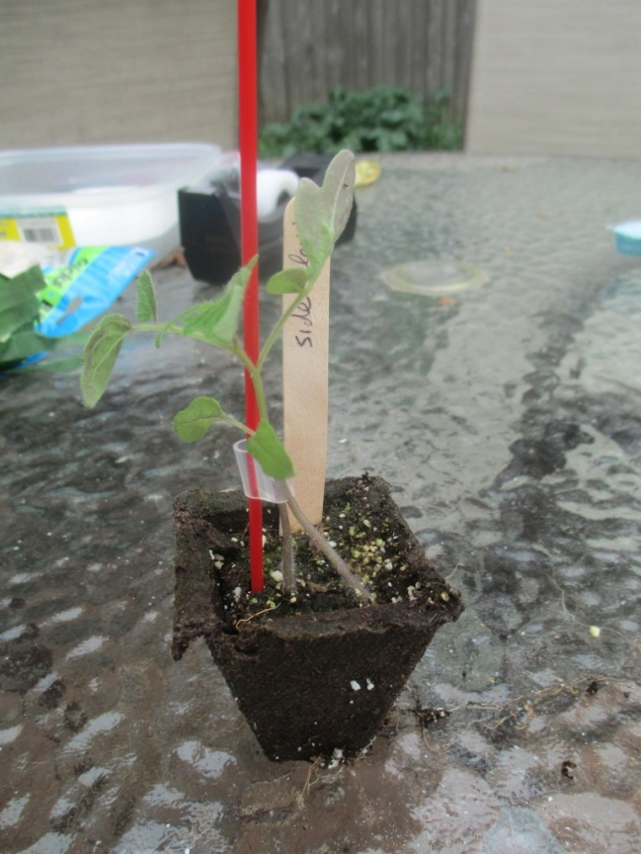
- Arrange and label peat pots in plastic trays. Use the craft sticks for labels.
Figure 1: A side graft is easiest to do when the rootstock and heirloom are already in the same pot.
- Fill each pot 3/4th of the way with seed starter then wet the soil throughout.
- Add a few fertilizer pellets to the pot and fill close to the top with seed started
- To be safe, plant at least two tomato seeds per pot. Cover planted seeds with ¼ inch of soil. Add more water to each pot so that the seed starter is thoroughly wet.
- Cover the trays with a clear lid and place in a growing chamber approximately 4 - 6 cm under the fluorescent light.
- Three days after planting the first wave of rootstock seeds, start planting heirloom seeds, again in staggered proportions using the procedure described in Step 2. Note: Because heirloom plants will not be using their own root systems they do not need fertilizer and they can be planted with less space (see Figure 2). If using peat pots two or three plants can grow per pot. We also used deli containers to grow heirlooms with great success (see Figure 3). Instructions for that system can be found at the Fast Plant website.
- 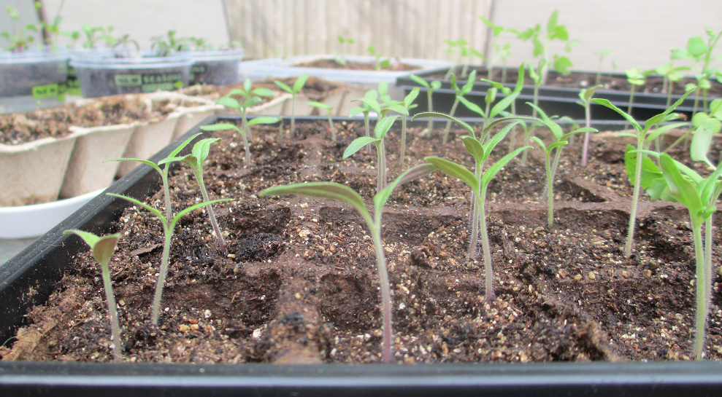Tomato plants need at least 8 hours of light a day for germinate. Also, never let them dry out.
Figure 2: Since heirloom seedlings will not use their own root systems, they can be planted at 2–3 to a pot.
- 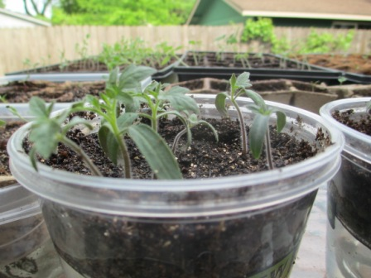Thin germinated seeds. Each rootstock pot should only have one seedling, where as the heirloom plants can have 2 or more seedlings per pot. Over the next few weeks as the plants continue to grow raise the light source as necessary to keep the original 10 cm distance. Lightly brushing your hand over the seedling tops 1 or 2 times a day has been shown to help the stems grow stronger. Again, never let the soil dry out.
Figure 3: One of the advantages of using deli containers is that they are bottom watered through a wick, which means they can go for several days without having to be manually watered.
- After 4-6 weeks, when seedlings have at least one set of true leaves above the cotyledon and a stem diameter close to 2 mm, they are ready for grafting. Before grafting you will want to match rootstocks and heirloom stems of the same diameter. To ensure good matches, slow down faster growing seedlings by moving them into a cooler spot and slightly limiting their hours of direct light. You can speed up slower growing seedlings by increasing their temperature and exposing them to more hours of light. If the rootstock and heirloom plants still have different stock sizes, you can choose slightly different heights on the stock of the rootstock and/or scion so the diameters at the cut locations are close as possible in size.

3.1—Preparation Part 1: Reading

3.1.1—Printed Materials
- Vocab Alert Handout—one per student
- Reading Handout—one per student

3.1.2—Activity Materials
- None

3.1.3—Preparation Steps
- Make copies of the Reading Handout and the Vocab Alert Handout for every student.

3.2—Preparation Part 2: Exploration Activity

3.2.1—Printed Materials
- Exploration A Handout—one per student
- Exploration B Handout—one per student
- Exploration Answer Sheet—one for the teacher

3.2.2—Activity Materials
- None

3.2.3—Preparation Steps: Part 2
- Make a copy of the Exploration A Handout and the Exploration B Handout for every student.

3.3—Preparation Part 3: Engineering Design

3.3.1—Printed Materials
- Engineering Design Handout—one per student
- Engineering Design Class Results Resource—one for the teacher

3.3.2—Activity Materials

Heirloom seedlings

1 per student

Rootstock seedlings

1 per student

Box knives

1 for every two students

Grafting clips

1 per student

Gusseted plastic bags (12” x 10” x 24”)

1 per chamber

See Grafting Chamber Preparation below

Binder clips

3 per chamber

Large and small trays

1 of each, per chamber

Craft sticks (for labels and staking)

Plastic coffee stirrers (for staking; one for each seedling)

Magnifying glasses (optional)

Trash bags (optional)

3.3.3—Preparation Steps: Part 3
General Preparation
- Make copies of the Engineering Design Handout for every student.
- Make an overhead copy, document-camera copy, or equivalent copy of the Engineering Design Class Results Resource to project in front of your students.
- Water all seedlings at least 3 hours before grafting.
- Match rootstock seedlings with scion seedlings of a similar diameter.

Grafting Chamber Preparation
- The purpose of the grafting chamber is to provide a dark, humid environment for the newly grafted seedlings to heal.
- Stand the gusset bags upright and place the larger tray on the bottom. This tray will be covered with warm water to establish high humidity inside the closed bag.
- The smaller trays will hold the newly grafted seedlings out of the water.
- 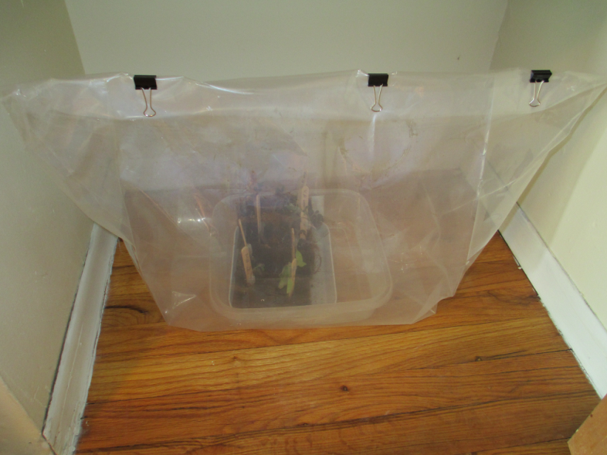Determine and set up the number of grafting chambers you will need and assign student groups to specific grafting chambers.
Figure 4: A basic grafting chamber set up.
    - Each student needs his or her own seedling, so divide the number of students by the number of seedlings you can fit into one chamber, and round up.
    - For example: a teacher preparing this lesson for seventeen students, who can fit eight seedlings into one chamber, would need three chambers.
- Once all plants are placed in the grafting chamber, turn over the edge of the bag several times and clamp it closed with binder clips. You don’t want the bag to be 100% airtight, but it needs to be tight enough to retain moisture (see Figure 4).
- You might need to keep the bag from collapsing by creating a support system either inside the bag with or outside the bag by tying a couple of strings from the clamps to a closet rod or similar feature.
- Grafting chambers should be placed where they will be undisturbed and in darkness. If you don’t have an available closet to use, you can cover the gusset bags with black garbage bags to block out light. Another option is to put the grafting chambers inside the cardboard light box growth chambers, with the lights off, of course.

4—Activity Instructions

4.1—Activity Part 1: Reading
- Pass out the Reading Handout to each student. Pass out the accompanying Vocab Alert Handout to each student.
- Explain to students that the words on this page are the important words to know for the upcoming story. Ask student to rate their knowledge of each word by circling a number in the “Before” column for the word.
- Read each word aloud and have the class repeat the word aloud.
- Explain the following rating system to the students:
1 — I have never heard of this word before now.
2 — I recognize this word, but I don’t know what it means.
3 — I sort-of know what this word means, but I would have a hard time explaining what it means.
4 — I can explain what this word means and use it in a sentence.
- Give students a chance to rank the word before moving on to the next word and repeating the process
- Read the article with the class.
- After you read and discuss the article with your students, have them re-rate each vocabulary word in the “After” column on the Vocab Alert! handout using the process from Step 2.
- Have students draw a picture of or describe examples of each word in the space provided on the Vocab Alert!

4.2—Activity Part 2: Exploration Activity

4.2.1—Activity Part 2: Day One
- Pass out the Grafting Exploration A Handout to students.
- Read the introduction to the students then give them time to think about and answer the accompanying discussion questions.
- Discuss answers with students using the Exploration Answer Sheet Resource as a reference.

4.2.2—Activity Part 2: Day Two
- Go over the brainstorming instructions and example on the Exploration A Handout.
- Give students 15–20 minutes to brainstorm ideas.
- Show students the following video, which explains the three main types of grafts:
“Grafting of Tomato Plants,” by TomatoLab.
- Pass out the Exploration B Handout. Go over the horizontal top cut example with students. Give them 10–15 minutes to fill-out the advantages/disadvantages of each graft type. This is part one of the handout.
- Discuss student answers using the Exploration Answer Sheet Resource as a reference.
- Have students analyze the data given in part two of the handout.
- Discuss student answers using the Exploration Answer Sheet Resource as a reference.

4.3—Activity Part 3: Engineering Design

4.3.1—Activity Part 3: Day One
- Students should work in pairs for this activity. Each pair should get two scions and two rootstocks for a total of two grafts.
Note:
It’s recommended that students cut their stems against a hard surface such as their table or desk as it is easier to control the cut that way. Since the soil will be moist they should be able to turn the peat pots on their side for the cutting without losing soil. It’s also recommended to first make a horizontal cut to remove excess plant material, before making the final cut if they are using a vertical or cleft graft.
- Pass out a copy of the Engineering Design Handout to every student.
- Give students time to brainstorm the problems, criteria, constraints, and priorities associated with this activity.
- Arrange students into pairs and pass out their rootstock and scion plants. Give them time to brainstorm grafting solutions.
- Once you approve a student pair solution, give them the necessary grafting and staking tools.
- Students should graft one plant at a time to avoid water loss. After all students have put their grafts in a grafting chamber, seal the bag with binder clips and put in an undisturbed, dark location.

4.3.2—Activity Part 3: Days Two through Ten
- Plants will remain in the grafting chamber for four to eight days. Check the chamber bags daily to ensure the bags remain upright with the appropriate amount of humidity. If you see condensation disappearing from the inside surfaces of the bag, close it a little tighter.
- After four days, open the grafting chamber a little bit more to allow for increased air circulation. After five days open it even. On the sixth day you can have the bag completely open but continue to keep it the dark. On the seventh or eight day plants can be removed from the grafting chamber but should not be exposed to direct daylight yet.

4.3.1—Activity Part 3, Final Day
Note:
Some failed grafts can be saved by re-cutting the stems. If the scion has begun growing root shoots from its stem, be sure to prune them before trying another graft. Often the scions will already be dried out and unusable, but the rootstock can be recycled for another graft. For this reason, we recommend have extra scion seedlings on hand so students with failed grafts can try again.
- On the final day of this activity, students will assess the effectiveness of their grafts and the class’ grafts in general.
- Have students collect their grafts and record their observations on the data table provided on the Engineering Design Handout.
- Have students record their observations on the Engineering Design Class Results overhead.
- Once all the class results have been recorded, discuss them with the class. Note: You also might want to make a copy of the results for each student depending on whether or not the evaluation paragraphs for this activity will be assigned for homework. Below are some common reasons why grafting fails:
- Seedlings stems were too thin for grafting clips.
- Selected seedlings were unhealthy to begin with or improperly matched in diameter.
- Poor grafting technique. In particular if there is too much of a gap between the cut-stems, adventitious root shoots might start growing off the scion.
- Grafting chamber is too hot which can dry plants out or slow graft union healing.
- Grafting chamber is has too much or too little humidity with can either soften and break down the graft union or allow it to dry out and heal poorly.
- Grafting chamber lets in too much light which weakens and dries out the newly grafted plants.
- Plants were bumped or jarred during the healing process.
- Plants were removed from the chamber before healing completely.

- If you let students re-graft, first collect the used grafting clips and sterilize them in a weak cleaning or bleach solution (1 part bleach to 9 parts water). Do not remove or touch the clips on the successful grafts. They will pop off naturally as the stems grow.
- Give students time to work on their evaluation paragraphs from the Engineering Design Handout.
- We do not recommend sending students home with their grafts at this time as they still need to be acclimatized. For full instructions on the acclimatization and planting of grafts see Appendix 4: After Grafting.

Appendix 1A: 2009 Standards Met With This Lesson

General Science
6.2L.1 Describe the relationships and interactions between and among cells, tissues, organs, and organ systems.
- Students will observe the fusion of plant tissues called vascular bundles and be able to explain what is happening at a cellular level.
7.1L.1 Compare and contrast sexual and asexual reproduction. Explain why reproduction is essential to the continuation of every species.
- Students will be able to explain how grafting is a form of asexual reproduction.
7.1L.2 Distinguish between inherited and learned traits; explain how inherited traits are passed from generation to generation, and describe the relationships among phenotype, genotype, chromosomes, and genes.
- Students will be able to identify the scion as the part of the graft that transmits its genetic information to offspring.
- Students will be able to distinguish between rootstock hybrids and scion heirlooms based on genetic inheritance.
- Students will be able to explain the advantages of grafting in genetic terms.
8.1L.1 Explain how genetics and anatomical characteristics are used to classify organisms and infer evolutionary relationships.
- Students will be able to distinguish between tomato varieties based on genetic heritage and anatomical characteristics.

Engineering Design
6.4D.1 Define a problem that addresses a need and identify science principles that may be related to possible solutions.
7.4D.1 Define a problem that addresses a need and identify constraints that may be related to possible solutions.
8.4D.1 Define a problem that addresses a need, and using relevant science principles investigate possible solutions given specified
criteria, constraints, priorities, and trade-offs.
- Students will identify the problems their tomato plants should address.
- Students will identify criteria, priorities, and constraints, of possible grafting solutions.
- Students will read a background article on tomato grafting and conduct an exploration of grafting possibilities so they can determine potential graft solutions.
6.4D.2 Design, construct, and test a possible solution to a defined problem using appropriate tools and materials. Evaluate proposed engineering design solutions to the defined problem.
6.4D.3 Describe examples of how engineers have created inventions that address human needs and aspirations.
7.4D.2 Design, construct, and test a possible solution using appropriate tools and materials. Evaluate proposed solutions to identify how design constraints are addressed.
8.4D.2 Design, construct, and test a proposed solution and collect relevant data. Evaluate a proposed solution in terms of design and performance criteria, constraints, priorities, and trade-offs. Identify possible design improvements.
- Students will design, build, and test two grafting solutions.
- Students will evaluate their solutions in terms of performance criteria, constrains, and priorities, and trade-offs.
- Students will identify possible design improvements.
- Students will test the effective of their grafts.
- Students will analyze the effectiveness of the class’s grafts to determine the best grafting techniques for home gardeners to use.

Appendix 1B: 2014 (NGSS) Standards Met With This Lesson

Alignment to Next Generation Science Standards

Performance Expectations
- MS-LS1-5. Construct a scientific explanation based on evidence for how environmental and genetic factors influence the growth of organisms.
- MS-LS3-2. Develop and use a model to describe why asexual reproduction results in offspring with identical genetic information and sexual reproduction results in offspring with genetic variation.
- MS-ETS1-1. Define the criteria and constraints of a design problem with sufficient precision to ensure a successful solution, taking into account relevant scientific principles and potential impacts on people and the natural environment that may limit possible solutions.
- MS-ETS1-2. Evaluate competing design solutions using a systematic process to determine how well they meet the criteria and constraints of the problem.
- MS-ETS1-3. Analyze data from tests to determine similarities and differences among several design solutions to identify the best characteristics of each that can be combined into a new solution to better meet the criteria for success.

Disciplinary Core Ideas

LS1.B: Growth and Development of Organisms
- Organisms reproduce, either sexually or asexually, and transfer their genetic information to their offspring. (secondary to MS-LS3-2)

LS3.A: Inheritance of Traits
- Genes are located in the chromosomes of cells, with each chromosome pair containing two variants of each of many distinct genes. Each distinct gene chiefly controls the production of specific proteins, which in turn affects the traits of the individual. Changes (mutations) to genes can result in changes to proteins, which can affect the structures and functions of the organism and thereby change traits. (MS-LS3-1)
- Variations of inherited traits between parent and offspring arise from genetic differences that result from the subset of chromosomes (and therefore genes) inherited. (MS-LS3-2)

LS3.B: Variation of Traits
- In sexually reproducing organisms, each parent contributes half of the genes acquired (at random) by the offspring. Individuals have two of each chromosome and hence two alleles of each gene, one acquired from each parent. These versions may be identical or may differ from each other. (MS-LS3-2)

SCIENTIFIC AND ENGINEERING PRACTICES
1. Asking questions (for science) and defining problems (for engineering)
3. Planning and carrying out investigations
4. Analyzing and interpreting data
6. Constructing explanations (for science) and designing solutions (for engineering)
8. Obtaining, evaluating, and communicating information

Appendix 2: Material Breakdown

Printed Materials
- Reading Handout—one per student
- Vocab Alert Handout—one per student
- Exploration A Handout—one per student
- Exploration B Handout—one per student
- Exploration Answer Key—one for the teacher
- Engineering Design Handout—one per student
- Class Grafting Results—one overhead copy

Activity Materials
- Siberian Tomato Seeds (Heirloom variety) or other Heirloom tomato seeds
- Maxifort or Beaufort Tomato Seeds (Rootstock varieties)
- Trays (“flats” -- starter kits may be more economical)
- Fluorescent Lights
- Light Sockets (1 socket & bulb per flat of 50 pots in one light box) – or –
- Clamp Lamp reflector fixture (if not using light box)
- Duct Tape
- Thermometers (1 per light box)
- Aluminum Foil
- Seed Starter
- Fertilizer
- Watering can or bottle
- Box knives
- Grafting Clips (selection of sizes is best)
- Gusseted plastic bags
- Small binder clips
- Craft Sticks
- Coffee Stirrers (plastic preferred, needs to fit through grafting clip stake hole)
- Cardboard box
- Magnifying glasses (optional)
- Trash bag (optional)

Buyer’s Guide: Basic Materials
Item | Cost | Found In | Notes
Maxifort or Beaufort Tomato Seeds (Rootstock) | $26 per 100 seeds. Also available in quantity 250 or 1000 at lower cost per seed.  S/H $11.82 | Paramount Seeds | Maxifort seeds work as well or better as Beaufort.  Maxifort can also be purchased from Johnny Selected Seeds for $23per 50 seeds.
Siberian Tomato Seeds (Heirloom) | $1.65-2.75 per 25 seeds  S/H $1.09 – $2.94 | Amazon | Siberian (also known as Red Siberian) are one of the earliest/fastest growing tomato varieties and are also cold resistant.
Grafting Clips | $25 for 50  $40 for 250  S/H $6. 95 | Neseed | These clips come in a variety of different diameters ranging from 1.4mm to 2.8 mm, we recommend using 1.7 mm (TC1.7) or 1.9 mm clips (TC 1.9).
Clear Gusset Bags | $61.43 per 250 bags.  S/H $22.53 | Pack and Seal | These bags are needed to create a high humidity grafting chamber. Any thick plastic bag however, such as a department store shopping bag could be used as a substitute.  These bags come in a variety of thicknesses ranging from 1.5 – 3 mm. We recommend using the 3 mm, 12x10x24-inch bags (PB3M1738) since thicker bags will hold in more humidity.
Fluorescent Lights | $8 per bulb | Amazon | We used Feit Electric’s High Wattage Daylight Bulbs (ESL40TN/D), but any 40 watt, cool white fluorescent bulb should work for this lab.
Light sockets with cords | $5.81 each | Amazon | These are needed for the cardboard box light set-up only.
Box Knives | $10 for pack of 5 | Amazon | Dissection scalpels also work for cutting stems.
Cardboard Boxes | $26.30 for 10  22” x 22” x 12” | Uline | At a minimum the cardboard box needs to be 22 inches long, 18 inches wide, and 12 inches tall to fit a tray of 50 plants with clearance between plants and the light bulb. Light box is built with the cardboard box on its side.
 | $31.95 for 15  22” x 18” x 12” | Uline
Seed Starter Greenhouse | $5.27 for 50 plants | Home Depot (Store Only) | This kit includes a black plastic tray, a clear plastic dome, and 50 peat pots.
 | $12.70 for 50 plants | Amazon
Seed Starter | $3.97 for 10 qt. bag | Home Depot (Store Only) | This mixture is specially formulated for seed germination. If you use regular soil you need to mix it with peat or sand to make it lighter. Without ample soil space, seeds have lower germination rates.
 | $14.02 for 16 qt. bag | Amazon
Fertilizer | $4.95 for 1.25 lb jar  S/H $4.38 | Amazon | Instead of slow release pellets, you could also fertilizer your plants once a week with Miracle-Gro Tomato Plant Food.
Thermometer | $2.98 ea | Home Depot | Tomatoes like a soil temperature that is around 80°F.

Buyer’s Guide: Alternate Materials
Item | Cost | Found In | Notes
Disposable scalpels, e.g. Medi-Cut Sterile Disposable Scalpels with Safety Guard |  | Amazon | Can be used instead of box knives above
Clear Plastic Dome | $7.60 for Low dome | Amazon | Plastic domes help keep humidity high and are recommended for all seed germination.
 | $5.99 for tall dome  S/H $8.00 | Amazon
Clamp Reflector Lamps | $7.40 per lamp | Amazon | If you do not use the cardboard light box growth chamber set up, we recommend using lamps with build-in reflectors to help concentrate the light on the plants.
Individual Black Trays | $1.16 for 50 plant tray  S/H $5.27 | Amazon
Square Peat Pots | $7.50 for 50 | Amazon | You can substitute a variety of growing containers including deli containers, and soda bottles for peat pots, but we like them for the rootstocks because although they come in groups of 10, they are easily cut so that each student can go home with their own tomato plant, which they can then plant directly into the soil.

Appendix 3: Growth Chambers
Tomato seeds need at least 8 hours of light per day, and a soil temperature between 72° – 85° F to germinate and grow. These conditions can be met in a variety of different ways and an extension of this lesson could be to have students participate in the growing of the seedlings by designing their own growing chambers (See Appendix 6: Engineering Design Extensions).

Cardboard Light Box Design
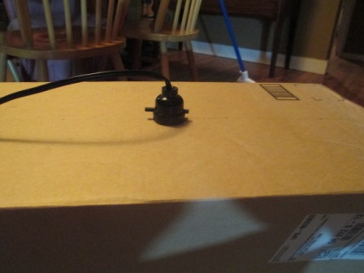We recommend using this cardboard light box design which is based off the Fast Plants Program—Plant Light Box Construction resource, over reflector lamps because the humidity is easier to control with boxes.
Figure 5

Materials
- Cardboard Boxes
- Fluorescent Lights
- Light Sockets with Cords
- Thermometer with Humidity Gauge
- Aluminum Foil
- Box Knives
- Duct Tape

Directions
- 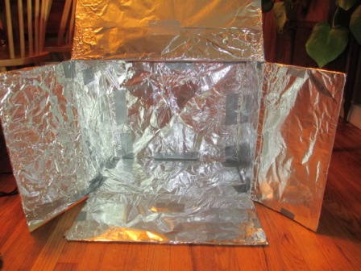Place the box on its side so that the flaps open towards you. Use a box knife to cut a 1” diameter hole in the center of the top of the box so that the light socket fits snugly (see Figure 5).
Figure 6
- Completely cover the inside of the box with aluminum foil (see Figure 6).
- Put the light socket through the hole at the top of the box and the aluminum foil below. It should fit snugly but duct tape it in place if it does not.
- Screw in the light bulb (see Figure 7)
- Tape the thermometer with the humidity gauge to the inside of the box. When the flaps of the box are completely closed, the humidity will reach upwards of 100% which is why you do not need to cover the tray with a plastic dome while the seeds are germinating.
- To lower or change the temperature you can adjust the flaps (see Figure 8)
- Tomato plants should always be 4–10 cm below the light. You can adjust their height by placing blocks or books underneath them.
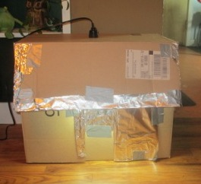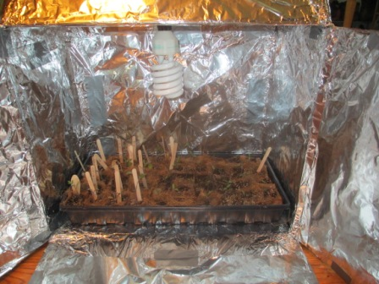
Figure 8: With the top flap partially opened as shown, the temperature inside the box is around 80°F.
Figure 7

Reflector Lamp Design
A very basic growth chamber set up.

Materials
- Fluorescent Lights
- Clamp Reflector Lamps
- Black trays and plastic domes

Directions
1. Place greenhouse trays 10cm under reflector lamps with lights (see Figure 9).
2. Since this is an open-air design you will need to use plastic domes with your trays at least while the seeds are germinating to create enough humidity. You can also substitute the gusseted bags for the domes.
3. To help concentrate the light you can set-up reflectors around the trays.
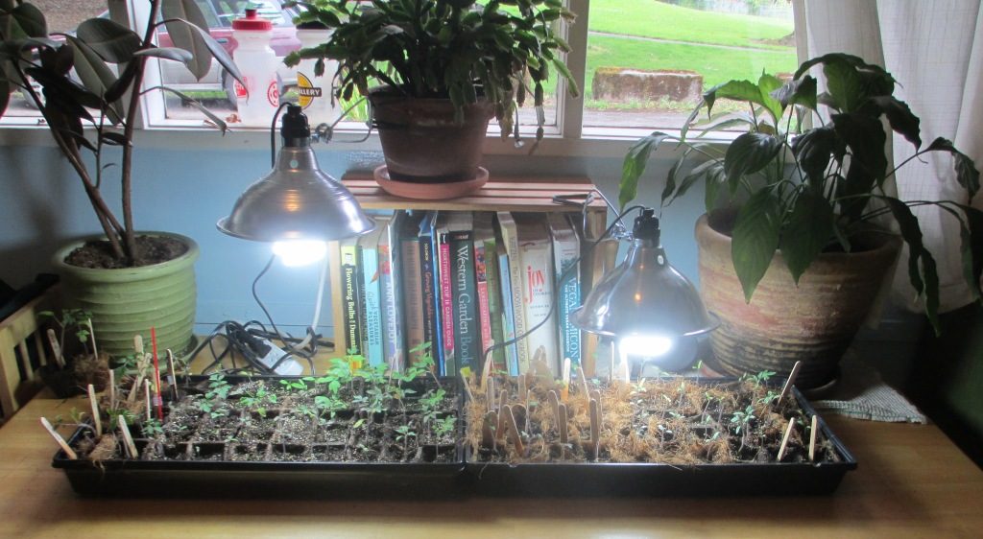
Figure 9: A very basic growth set-up.

Appendix 4: After Grafting
  - After the initial chamber period of 4 – 8 days, re-close the bag more loosely than previously, and move it into a room with a window and lights, but still keep the bag away from direct sunlight for at least two days.
- After 2 days, loosen the bag even more, only turning over the edge of the bag once and leaving a gap at the top so more air can circulate. You can also start exposing it to brighter light, but not direct sunlight light.
- After another 2 days, you can now open the bag remove the seedlings and treat them as you normally would except continue to be gentle during transportation. Do not touch the clips as they are designed to come off on their own as the stems expand.
- Let students take home their tomatoes to plant in their home gardens. Below are some tips for planting grafted tomatoes.
- Do not bury the stem of the grafted tomato! If you let the graft come into contact with the soil the plant will lose its disease resistance.
- Stake your tomato plant well so that the scion’s branches and leaves also never come in contact with the soil. Keep in mind these are indeterminate plants, which means they sprawl when they grow. The wire cages seen in many garden stores are designed for the smaller, bushier determinate varieties and are not sturdy enough for these super heirlooms.
- Mulch with plastic or other material to prevent the soil from accidentally splashing onto the graft when watered.
- It’s common for the scion stem to form root shoots from its stem that will reach for the soil. Prune all of these shoots to prevent them from reaching the soil, which would take away the plant’s disease resistance.
- It is also common for roots to grow from the cotyledon node if you made your graft above the rootstock’s cotyledon. These shoots won’t affect the disease resistance, but they can overwhelm the scion and diminish yield so they should also be pruned.
- Keep plants well watered. Never let them dry out completely or you will put them in danger of blossom end root.

Appendix 5: Additional Resources

Background Information
- The History of Grafting
  - http://www.hort.purdue.edu/newcrop/janick-papers/c09.pdf
- Genetics, breeding and selection of rootstocks for Solanaceae and Cucurbitaceae
  - http://naldc.nal.usda.gov/download/48832/PDF
- Heirloom Vs. Hybrid Seeds
  - http://cals.arizona.edu/yavapai/anr/hort/byg/archive/hybridseeds.html

Growing Instructions
- Quick and Easy Seed Starting
  - http://www.preen.com/articles/easy-seed-starting
- How To Start Seeds Indoors
  - http://awaytogarden.com/how-to-start-seed-indoors
- Tips for Growing Better Tomatoes From Seeds
  - http://awaytogarden.com/tips-for-growing-better-tomatoes-from-seed

Grafting Instructions
- Johnny’s Selected Seeds
  - http://awaytogarden.com/files/2009/12/grafting_tomatoes.pdf
- University of Vermont Extension how-to grafting video
  - http://www.johnnyseeds.com/t-video_tomato_grafting.aspx?source=E_1209_CGCM_Di
- Tomato Lab’s How to Graft
  - http://www.youtube.com/watch?v=tHnOYcI6B44
- Tomato Lab’s Grafting with Glue
  - http://www.youtube.com/watch?v=5Fd6tBQTTAg
- Ohio State’s Tomato Grafting Project
  - http://oardc.osu.edu/graftingtomato/grafting-methods/index.html

Appendix 6: Engineering Design Extensions
The focus on this engineering design lesson is on the graft itself however there are many places where more engineering design could included.
- Growth Chamber Design: Tomatoes need 14 hours of light and high humidity to germinate and grow. Below are possible design lessons:
- NASA’s Lunar Plant Growth Chamber Lesson: http://www.nasa.gov/offices/education/programs/national/summer/education_resources/engineering_grades7-9/E_lunar-plant-growth.html
- Grafting Clip Design: Many common household items can be substituted for grafting clips including twine, twist ties, paper clips, clothing clips, and even glue. The following blog describes several grafting attempts with household item: I dig you, plant. The following video gives a tutorial on grafting with glue:Tomato Lab
- Grafting Chamber Design: Grafting chambers need to hold in humidity and keep out light. They also need to stand upright so they do not touch the grafts.

URL: http://naldc.nal.usda.gov/download/48832/PDF
URL: http://youtu.be/tHnOYcI6B44
URL: http://www.fastplants.org/how_to_grow/growing_lighting/deli_container.php
URL: http://www.fastplants.org/how_to_grow/growing_lighting/recycled_bottle_program.php
URL: http://www.fastplants.org/resources/digital_library/index.php?P=FullRecord&ID=131
These are referred to as adventitious roots.
URL: http://idigyouplant.blogspot.com/2008/07/grafting-round-1-epiphytic-tomato.html
URL: http://www.youtube.com/watch?v=5Fd6tBQTTAg.

