Budget Workbook Guide
The “Why” and “How” in using the accompanying
Budgeting Workbook for
Engineering Design in Oregon Science Classrooms (EDOSC)

0—Terms Used
For those less familiar with Microsoft Excel, here are some terms we will use when explaining how to navigate and use this document.
- Workbook: EDOSC-Budget-Workbook.xlsx is, as a whole, one workbook. We refer to this as the Budget Workbook. It will be italicized, just like other documents we refer to.
- Worksheet: Any individual page is referred to as a Worksheet, sometimes a sheet. For example, the first sheet is referred to as the Workshop Assumptions Worksheet. It will be bolded, just like other subsections we refer to.
- Cell: Any individual location in a worksheet is referred to as a cell. Each has its own unique coordinates, given as an ordered pair—column, row. For example, the cell which contains the information for the “number of trainers” in the Workshop Assumptions Worksheet is referred to as cell B5. They will be bolded, since they are subsections.
- Dependents: Often, a cell in any particular worksheet will contain a reference to the data in another worksheet—for example, a lesson worksheet references and uses data from the Deployment Assumptions Worksheet. When speaking of these references, we use the term dependent. A dependent is a cell that is dependent on the data in the another cell.

1—General Purposes

1.1—Comprehensive Budgeting
Useful for EDOSC trainers, facilitators, and teachers alike, the Budget Workbook provides a means to quickly and thoroughly assess the cost of EDOSC lessons, broken down either by grade level, subject, or both. The Assumptions Worksheets and Material Cost Summary Worksheet give an overview of lesson and workshop costs. They can both be used without ever looking at the other, more complicated, sheets.

1.1.1—Assumptions Worksheets: What you will find
The Assumptions Worksheets contain data used in each of the lesson worksheets and the Material Cost Summary Worksheet, such as the number of teachers who will be attending your workshop—sorted by grade level. Further, you will find a cell to modify the number of trainers you will have, and the number of students for each teacher’s classroom.
Cells which you can change freely are highlighted in yellow. If you make a change in any of these cells, it will automatically be reflected on every other worksheet’s dependent cells. For example, if you change the class size for elementary school on the Deployment Assumptions Worksheet, the recommended purchase quantities and estimated costs for every elementary school lesson will be affected.

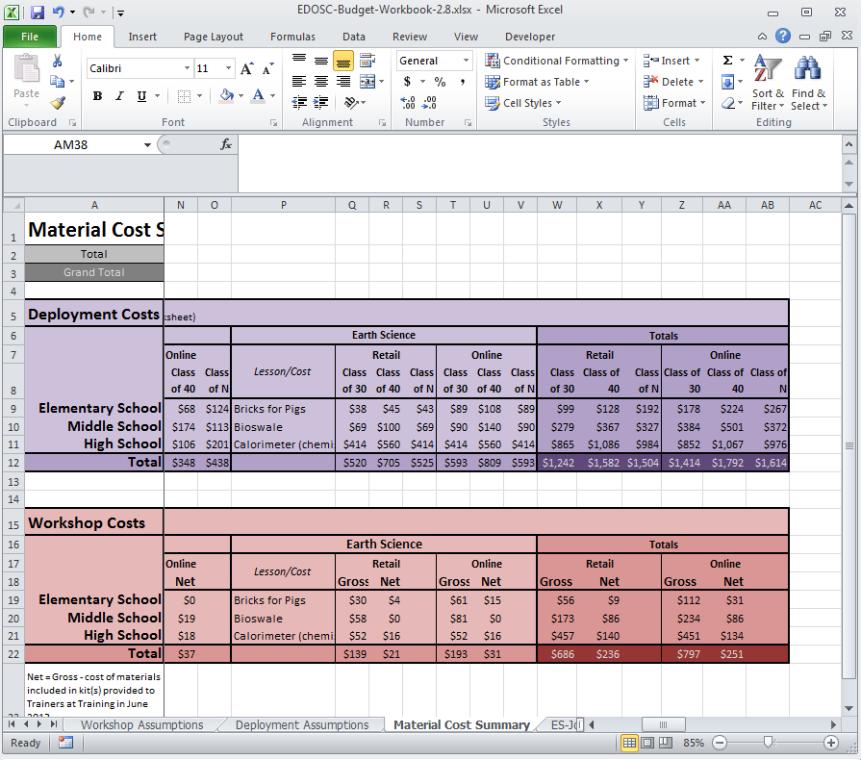
1.1.2—Material Cost Summary: What you will find
Figure 1-1: Totals cells in the Material Cost Summary Worksheet
The succinct Material Cost Summary Worksheet displays the costs of lesson activity materials, as well as workshop activity materials. They are broken down by both grade level and subject, making it easy for you to find the information they’re looking for.
Totals are given by subject at the bottom of either table (darker rows); totals for grade level are given on the right-hand side of the table (darker columns); grand totals are in the darkest cells. See Figure 1-1.
Cost summaries are given based on average class sizes of 30 and 40. In addition you can provide an estimate of the number of students in a class in the Deployment Assumptions Worksheet and the estimates costs for the class of “N students” will be updated.
You will find that the Workshop Costs table in this worksheet contains two types of totals: gross and net. The gross cost is an estimate of the total cost of all materials needed. However, you may already have some materials from a previous EDOSC workshop—because you don’t have to pay for these, their costs are subtracted from the gross cost, and producing the net cost columns.

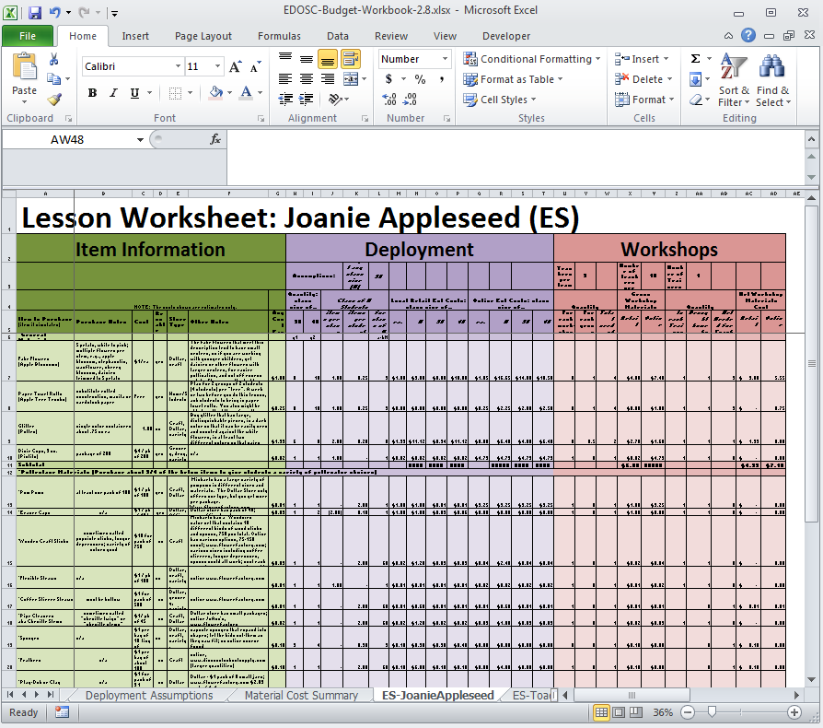
1.1.3—Lesson Worksheets: What you will find
Figure 1-2: A zoomed-out view of lesson worksheets will look like this.
The lesson worksheets contain lesson-specific data regarding lesson materials— a description of each item, where we recommend you purchase it, its cost, places you can find it, and so on—as well as the quantities you will need, and some calculations to make your budgeting and planning process easier.
Each lesson worksheet is separated into three primary columns: Item Information, which contains the general info for each item; Classroom Deployment, which calculates costs for conducting the lesson in a classroom (also using data from the Deployment Assumptions Worksheet); and Workshops, which calculates the costs for conducting a workshop (also using data from the Workshop Assumptions Worksheet).
See Figure 1-2 for an overview.
Further to the right, usually starting around column AB, you will find printable information sheets. Do not edit these! See section 2.2: Printable Sheets for more information.

1.2—Customization
Another benefit of the Budget Workbook is having the ability to localize and store data for lesson costs. Often, material costs will vary by region or your shopping preferences. We’ve done our best to provide a comprehensive and diverse built-in budget, but if you find that material costs are different in your region, you can easily change the costs of those items on any of the Lesson Worksheets.
To customize your copy of the Budget Workbook, just edit any yellow-highlighted cells in either Assumptions worksheet. You may also edit any of the information under the Item Information header (highlighted green—see Figure 1-2) including unit costs in any Lesson Worksheet.

2—Methods of Use

2.1—Customizing, Changing, and Updating Information
We have provided you with a great deal of budgeting and shopping information, which we accumulated over our many months of EDOSC development. This information gives you starting point planning materials purchase for workshops or for using the sample lessons in a classroom. You can customize your own copy of the Budget Workbook. This section will provide you instructions for modifying the Budget Workbook to best fit your particular needs.

2.1.1—Enabling Editing
- Download the latest version of the Budget Workbook from the EDOSC Materials webpage under the General Materials header of the webpage, and open the file.
- You may notice that the document is in “Protected View” (Figure 2-1). To disable this, click the “Enable Editing” button at the top of the window, to tell Microsoft Excel that you trust this file not to have any viruses (after all, you downloaded it from us!)
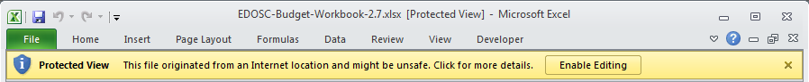
Figure 2-1 — Protected View Status

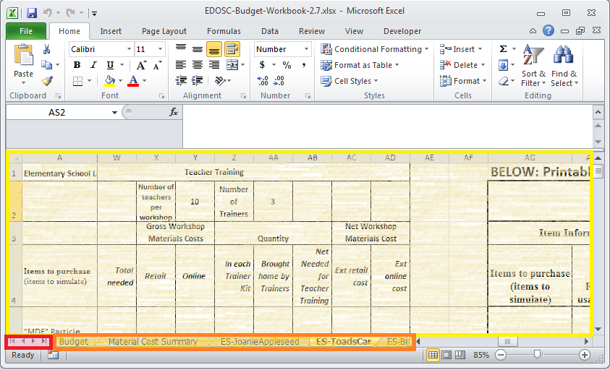
2.1.2—General Worksheets & Navigation
Figure 2-2 — Workbook Navigation

See Figure 2-2 for this step. Along the bottom of the window, you will see several tabs (outlined in orange). These are the individual worksheets—the two Assumptions Worksheets and Material Cost Summary Worksheet are three general sheets that can be used for overview purposes, for example. Next to these tabs are navigation arrows (outlined in red in Figure 2-2) which you can use to move along the list of available worksheets. Finally, whichever sheet you have selected will show up in the main area (outlined in yellow in Figure 2-2), for you to view and edit.

2.1.2—Lesson Worksheets
First, we will go through navigating the lesson worksheets. As an example, select the ES-ToadsCar Worksheet and take a look at it. Along row 2, you will see a number of different top headers, which separate the worksheet by section.
- Below the very first section (the name of the lesson), you will see another header called Item Information. This section is highlighted green, and usually makes up the first seven or eight columns of any lesson worksheet (columns A–H in this lesson). Below this header you will find a description of each item used in a lesson:
  - The name of the item itself
  - Any important notes we found for purchase
  - The cost of the item we found, per purchasable unit (often a package), and the size of the purchasable unit
  - Whether it can be re-used
  - What sort of store typically carries it
  - Any other important notes
  - The estimated unit cost per item purchased at retail.
  - The estimated unit cost per time purchased online.
- Under the next top header, labeled Classroom Deployment, which typically takes up the next 12 or so columns (columns I–S in this lesson), you will find information regarding the quantity needed for any particular class size, a derived per-class/student need for various classroom sizes, and extended costs for those class sizes, based on where you purchase materials.
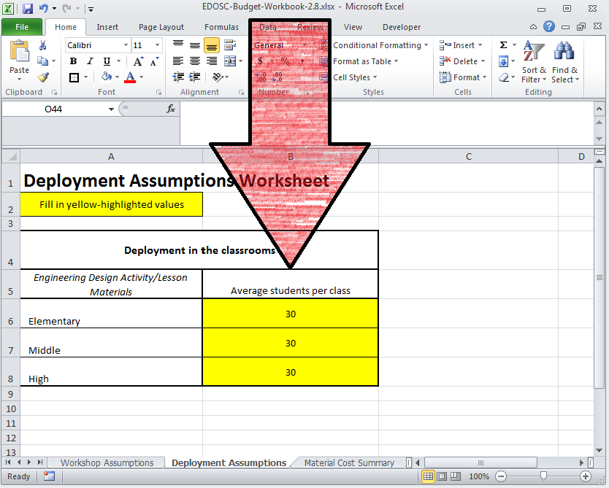
  - Per-class items are those that the teacher uses, or the whole class can use in common. Per-student items are those whose quantities are directly affected by classroom size. Typically, this table will calculate quantity per-class and per-student based on given information for class sizes of 30 and 40. The numbers in these columns estimates— you can edit all four columns (columns I–L) with your own information.
Figure 2-3 — Changing “N” students
  - Under the Class of N Students sub header, you will find calculations for item quantity based on N students (default 30). To change N, navigate to the Deployment Assumptions Worksheet, cells B6–B8, where you can change this to your particular classroom size (Figure 2-3, red arrow).
  - Under the next two sub headers, you will find expected extended costs for the various class sizes, based on whether you purchase materials at a retail store, or online. If you want to change this information, edit columns G and H, or the “Unit Cost” sub header. The remaining columns will recalculate themselves automatically, based on this information.
- The final top header in the primary table of any lesson worksheet labels the Teacher Training section, which takes up about 10 columns (columns T–AC in this lesson). If you are a trainer, you can use this section to plan a budget for your workshops.
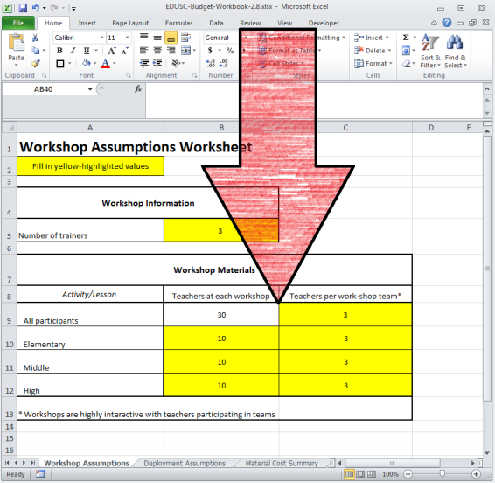
  - This section uses information from the Workshop Assumptions Worksheet, cells B28–B30 and C28–C30 (Figure 2-4, red arrow), where you can change the number of teachers attending your workshop, and the size of teams into which you will split your attendees. Changing this information through the Budget Worksheet will automatically apply to all lesson worksheets. You can see any changes you make reflected in ES-ToadsCar, for example, in cells V2–AC2.
Figure 2-4 — Changing Workshop Attendance
  - In order to make changes to this section, modify the For Each Workshop and For Each Group columns under the Quantity sub header (columns T & U).
  - The column labeled In Each Trainer Kit (column Y) estimates the materials you will need to hold a workshop. The column labeled Brought Home By Trainer (column Z) reflects what trainers received from the EDOSC workshop. Finally, the column labeled Net Needed for Teacher Training (column AA) estimates what a trainer will have to buy to hold his or her own workshop.

2.2—Printable Sheets
If you scroll farther to the right in any of the lesson worksheets—past the primary data table—you will find two printable-format tables. The first table (columns AF–AP in the ES-ToadsCar Worksheet) summarizes the costing information for each item, and the second (columns AR–AS) formats the item’s important notes, to help buyers find the correct item. We use these two tables as the source for appendices of each lesson’s Lesson Plan Resource.
Both of these tables draw data directly from the sheet—do not edit them manually! Instead, refer to section 2.1.2 of this document for step-by-step instructions for customizing your lesson and assumptions worksheets. The data in these printable sheets will update automatically to reflect your changes.

EDOSC Materials webpage URL — http://opas.ous.edu/EDOSC/Materials.php

