Discovering Native Histories along the Lewis and Clark Trail
Summer Institute for K-12 School Teachers
June 30-July 31, 2019
The National Endowment for the Humanities is underwriting this professional development opportunity for K-12 school teachers from across the U.S., who will assemble in Billings, MT, for a short seminar, followed by a two-week bus tour through "Indian Country" in Montana and North Dakota, and concluding with a short seminar in Bismarck. This immersive educational journey will take the group through reservations, state and national parks and landmarks, sacred rock formations, a battlefield, tribal colleges, a powwow, and more. Indigenous elders and professors will share their expertise with the group, all along the way, so that we will find balance for a history that has often emphasized Euro-American perspectives.

Twenty-five teachers will be chosen from among all applicants, and a stipend of $2,700 will be provided to each one with the hope that these funds will cover most of their expenses of getting to Billings and home from Bismarck, costs of shared hotel rooms, and cover their meals during the institute. The institute aims to have a collaboration between Indigenous and non-Native teachers, who will come together to create new lessons about the shared history of the coming of Europeans into the Plains region and its impact on Native American communities. Applications must be postmarked by March 1, 2019.
Please visit this website for more information about the schedule and instructions for applying: Native Histories Summer Institute 2019
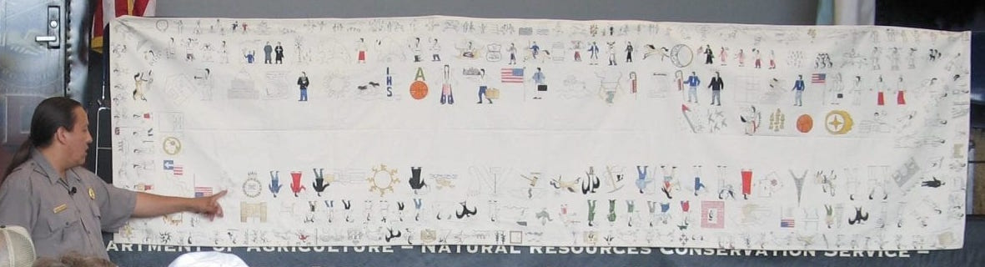
Dakota Goodhouse (Hunkpapa Lakota/Yanktonai) of Bismarck explains Winter Counts.

