Appendix A: Community Partner Engagement

Process for Engagement
Broad and ongoing engagement of community partners is a key theme for CTE under Perkins V. Our goals for engagement included:
- Refine and refocus Oregon’s CTE State Plan to meet the current needs of Oregon’s education and workforce development systems and the communities they serve.
- Refine and refocus Oregon’s CTE State Plan to meet the needs of learners, families, and communities with particular attention on our focal learners identified in the Aligning for Student Success process and priority populations identified in Future Ready legislation.
- Communicate, engage, and refine the outcomes of our CTE State Plan:
- Career connected learning that is systemically integrated with education and workforce development
- Increased equitable participation in high-quality CTE and career connected learning
- Expanded communication, transparency, and diversity of voices and contributors connected to education and workforce development partnerships
- Communicate the role of CTE within the education and workforce development ecosystem and share the progress to date on Oregon’s CTE Strategic Plan.

The state created a steering committee team of staff from the Secondary-Postsecondary Transitions team (SPST), Office of Community Colleges and Workforce Development (CCWD), and CTE leaders. This steering committee met regularly and was re-established in April 2023. This team has focused on intentional engagement with constituents throughout the state to inform the renewal of Oregon’s statewide plan. The steering committee managed the creation of the CTE State Plan and Community Partner Engagement Plan. During the development of the CTE State Plan, ODE and CCWD engaged all the required community partners as outlined in Perkins V.
In addition, we partnered with leaders of the Student Success Plans, focusing on success for specific focal student groups. Community partners included the Workforce and Talent Development Board, STEM hubs, Youth Development Division, Title II Adult Basic Skills, and Every Student Succeeds Act to align the CTE State Plan with local investments and statewide initiatives focused on elevating the student learning experience. The creation of statewide CTE Programs of Study will continue to align with our workforce sector strategies.

Phase 1: Revisiting Our Vision
(April 2023- June 2023)
Oregon started engagement activities before drafting the State Plan. We started by listening to what community partners wanted in CTE (April 2023-September 2023). Community partners included:
- Students, Families, and Community Partners (students, families, representative student advocate groups, statewide student advisory groups, Oregon’s tribes and tribal education centers, culturally specific organizations, and out-of-school partners)
  - This group included parents, mentors, CTE students and student leaders, members and representatives of special populations, representatives of federally recognized Indian tribes and tribal organizations located in or providing services in the state (AI/AN Advisory Committee) and individuals with disabilities and representatives from special education.
- Career Connected Learning Partners (business/industry, local workforce development boards, Workforce and Talent Development Board, STEM hubs, STEM Investment Council)
  - This group included local government and chambers, representatives of business and industry (e.g., Governor's Construction Production Workgroup), small business representatives, and community organizations (e.g., Working Together conference).
- Education Partners (ESD leaders, community colleges, schools, districts, K-12 educators, higher education faculty, secondary and postsecondary CTE coordinators, focal group partners)
  - This group included representatives of secondary and postsecondary CTE programs, teachers, faculty, school leaders, specialized instructional support personnel, career and academic counselors and advisors, Youth Development Division, the state coordinator of the McKinney-Vento Homeless Assistance Act.

The state’s Every Student Succeeds Act also informed our vision, as did interactions with CTE regional coordinators, STEM hubs, workforce development, and business and industry partners including trade associations.
Through these engagements, we heard some common themes:
- Equitable opportunities for students in all areas of the state to benefit from high-quality CTE leading to high-skill, in-demand careers that provide a living wage.
- Expanded opportunities for students in both secondary and postsecondary pathways, including opportunities for youth to gain experience and apply their knowledge and skills in work-based learning.
- Career exploration and intentional advising for younger students to learn about career opportunities.
- Interest in multiple pathways into and out of CTE that accommodate individual needs.
- More skilled educators, advisors, and mentors to guide CTE for youth and adults, including high-quality support for CTE teachers.
- Strong alignment to business and industry and strong partnerships between schools, colleges, and communities

Phase 2: Identifying Outcomes
(April 2023-June 2023):
We targeted communication about Perkins V to community partner groups interested in CTE, such as the CTE regional coordinators, K-12 administrators, CTE deans, CTE teachers and faculty, school counselors, business and industry partners on the CTE Revitalization Advisory Committee, Oregon tribes, the Youth Development Division, the state homeless coordinator, the Office of Enhancing Student Opportunities, the Office of Education Innovation and Improvement, and leadership at ODE and HECC to hear about their hopes for our renewed CTE State Plan. As part of the discussion with our key community partners, we framed the requirements of federal law and shared the need to center equity in the work we do, as follows:
- Online surveys, developed in collaboration with ACTE (236 respondents) distributed via email to CTE networks around the state.
- A literature review of online and print CTE, education, and workforce development documents produced by ODE, CCWD, and other Oregon state agencies, and resources by third-party organizations addressing Oregon CTE and the broader economic and social context in Oregon.
- Recommendations gleaned from an in-person community partner meeting of CTE leaders, business representatives, educators, tribes, special population representatives, workforce development, Adult Basic Skills providers, homeless education coordinators, and state agency staff.

Phase 3: Identifying Recommended Strategies and Activities
(May 2023-December 2023)
During the third phase of community partner engagement, we began connecting with community partners about how to flesh out a plan to build a CTE system in the state that works for Oregon based on the results of the statewide needs assessment. CTE federal funding is meant to address equity issues, and our CTE State Plan needs to address these issues and be consistent with our value of creating inclusive systems. To help meet this goal, we prioritized engaging historically and currently underserved and marginalized groups in the process. We connected with tribal leaders; our homeless student liaison; the student success coordinators for Oregon’s focal student groups; Office of Education Innovation and Improvement; Office of Enhancing Student Opportunities; Office of Equity, Diversity and Inclusion; directors in the Office of Teaching Learning and Assessment; our postsecondary WIOA Title II director; Office of Workforce Investments; and Oregon business and industry groups. We also intentionally connected with student leaders in our Career and Technical Student Organizations (CTSOs) and focus groups with CTE students throughout the state.
We placed a strong emphasis on engaging with the sovereign nations within Oregon’s borders by fostering meaningful connections with the nine federally recognized tribes. Collaborating closely with our Office of Indian Education, the career connected learning and CTE tribal liaison facilitated interactive meetings with tribal leaders and staff. Leveraging both virtual platforms and in-person gatherings, we also actively engaged with the Government-to-Government Education Cluster convening and the American Indian/Alaska Native (AI/AN) Student Success Advisory Committee, enabling us to share our draft plan and gather valuable feedback. Our ongoing dialogue with members of the nine federally recognized tribes allowed us to gain a deep understanding of the unique needs and aspirations of our tribal communities. This input was incorporated throughout the CTE State Plan and influenced programs and practices.
A broader group of community partners, which included 236 interested individuals, also had the opportunity to give input over the summer and through the fall through additional short surveys administered online. Throughout this process, steering committee staff continued to engage with other key agency staff from within ODE and HECC to maintain alignment and connection with our WIOA Plan and our Every Student Succeeds Act (ESSA) plan.
There were a total of 42 specific, intentional listening sessions with community partners described above between July and November, with over 1,000 individuals from these groups providing specific input on the development of this state plan. This ongoing community engagement will also provide valuable feedback in our implementation and evaluation phases.

Phase 4: Refining Our Strategies and Activities and Building Our Plan
(September 2023-March 2024)
After creating draft components of the CTE State Plan, the CTE team solicited further public input to validate, refine, and hone the draft CTE State Plan. This engagement included in-person presentations to groups such as the CTE Youth Advisory Committee and virtual sessions to connect with CTE educators, Oregon Business and Industry Education Committee, Oregon State Board of Education, HECC, American Indian Education Advisory Group, Community College CTE Leaders meeting, Regional CTE Educators Professional Learning Committees, the Confederation of School Administrators (COSA) Conference, Community College CTE Leaders, Career Pathways program directors, Apprenticeship Coordinators, Chief Academic Officers, and Student Services Administrators. In addition to in-person feedback opportunities, draft documents were posted online, and invitations to provide comments were sent to target community partners such as CTE educators, student leadership organization members, tribal education coordinators, English learner coordinators, homeless liaisons, school counselors, recipients of youth reengagement grants, dual credit coordinators, business and industry associations, Parent Teacher Association members, and student associations. The state team offered webinars for the public highlighting draft plan goals and actions, and the Governor’s Office was also apprised of the plan and planning process. All of these engagements helped refine and hone the CTE State Plan.
Representatives of these diverse advisory groups have been invited to participate in our CTE advisory council and engage as we implement our CTE State Plan.

Engagement on State Determined Performance Levels:
State staff recruited and convened a special workgroup to help set the State Determined Performance Levels.
In October, state staff reviewed our current actual performance targets and prepared a data brief to help a workgroup representing postsecondary and secondary leaders and accountability specialists to help refine and set Oregon’s State Determined Performance Levels (SDPLs). Staff convened this group in November and December. During the first session, the group learned about the purpose of accountability in Perkins, the federal requirements for setting State Determined Performance Levels, Oregon’s performance definitions, and our current performance levels as well as actual performance. They provided a local and regional context to Oregon’s actual performance as well as discussed extenuating circumstances that may impact future years’ data. Between sessions, they consulted other colleagues and professionals to bring more context to our SDPLs and compared Oregon’s performance levels and definitions with other state SDPLs. They encouraged state staff to set realistic performance levels given the current uncertainty in student participation in state assessments, educator burnout, and lingering impacts from COVID.
Our State Determined Performance Targets were published and formal public comment around the CTE performance targets was open from February through mid-April (more than 60 days). The proposed targets were shared with all community partner workgroups sent through the Oregon Department of Education and Community College and Workforce Development’s communications team to all community partners.

Phase 5: Public Comment
ODE presented the CTE State Plan to the State Board of Education for a first read on February 15, 2024. The plan became available for public comment on February 15, 2024, and was available through April 15, 2024. ODE also sent a Notice of Public Comment to all community partners who had been involved in the plan development, and ODE announced public opportunities to provide comment via our listservs, X (formerly known as Twitter), Facebook, and education partners. ODE also provided notice through ODE’s listservs, X feed, State Board announcements, and formal public hearing processes, and through HECC’s listservs and news feeds. ODE staff summarized and addressed public comments in the final CTE State Plan adopted by the Oregon State Board of Education on April 18, 2024. ODE submitted the amended CTE State Plan to the governor for signature in May 2024.
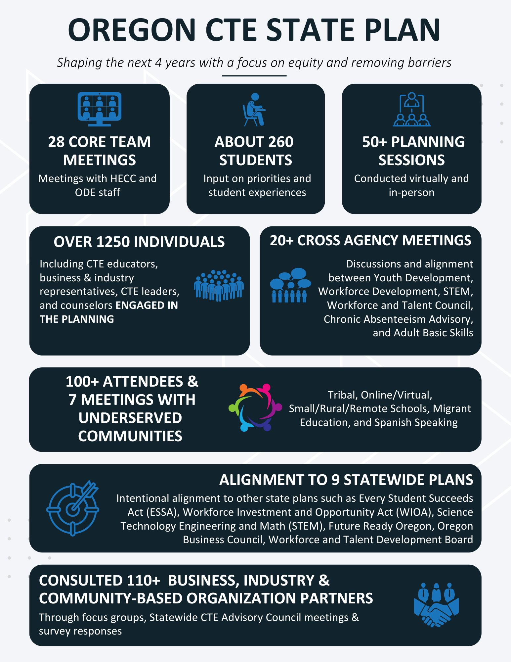

Oregon Public Comment Overview
There were no comments received during the sixty-day public comment period. There were two open hearings and an email feedback submission process. We did receive two questions during the Higher Education Coordinating Commission (HECC) Board presentation and some feedback from the CTE Student Advisory Council, to which we responded.
- Success Metrics: Both the HECC Board and the CTE Student Advisory Council were interested in what we were going to use to measure our success/progress.
  - Response: We are developing a list of metrics that we will bring to our key partners for validation on a yearly basis. Once validated, those metrics will be included in our reporting mechanisms. We are also keeping a close eye on how CTE work might align with the new Key Performance Metrics being developed agencywide.
- Math Assessment: The HECC Board wanted to know why the math performance target was so low.
  - Response: Low state test participation is impacted by a number of factors: the opt-out legislation, lack of assessment literacy, and a pull especially at the HS level toward college entrance examinations that are not aligned with standards, which means that the systems check portion based on vertical alignment of standards, for example, would not be possible. To address some of these factors, we have done the following:
- A communication toolkit differentiated by audience that describes the purpose of the state summative test in the context of the state summative test.
- Spring 2023 - required each district to submit a plan indicating actions they are planning to take to increase test participation; each district also received a response from our team as well, with feedback.
- We also continue to communicate about the HECC policy that uses the HS summative test scores to impact course placement.
In addition to increasing test participation, Oregon has focused on the following supports to improve math performance:
    - Oregon has allocated $7 million from the ESSER III funds to support educators in addressing unfinished learning, particularly in literacy and mathematics.
    - Partnering with Oregon State University, the Oregon Department of Education (ODE) aims to enhance instructional leadership, create educator resources, and offer professional learning opportunities. The Equitable Accelerated Learning Project will empower teachers and leaders to address educational inequities exacerbated by the pandemic; additional information is available on the Working Group Projects page. While these projects focus on K-8 learning, this will impact future math success of CTE participants.
    - Additionally, the state board adopted a mathematics instructional materials list in September 2022, emphasizing the importance of high-quality, standards-aligned materials for student learning. Districts will be working to implement updated K-12 materials between Fall 2023 and Fall 2025.
    - Continue to use Perkins funds and CTE Programs of Study focus on contextualized math instruction within their CTE courses.
- Additional CTE Student Advisory Feedback: The CTE Student Advisory Council also made some suggestions to increase the flow and readability of the CTE State Plan Narrative.
  - Response: We collapsed three graphs into one, added more context, and added another figure into the content of the Narrative. We are also collaborating on a student-focused one-pager that will explain the CTE State Plan and how students can engage in the implementation.

