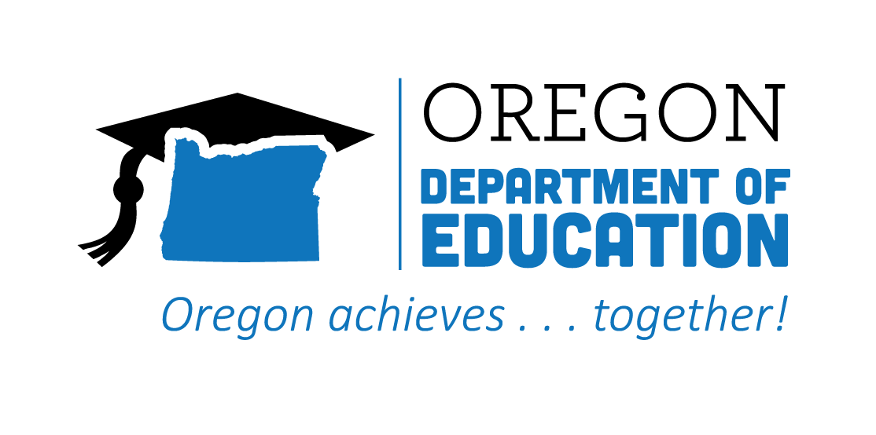
CTE STATE PLAN ACCOMPLISHMENTS 2022-2023
Flexible Learning

The Oregon CTE State Plan is a high level, four-year strategic plan that integrates state and federal priorities to implement the "Strengthening Career and Technical Education for the 21st Century Act" (commonly known as Perkins V). Providing myriad options for learners to access, experience, and complete critical CTE learning opportunities supports choice and career preparation across Oregon. The following are Local and State accomplishments made around Flexible Learning goals during the third year.
2021-2022 ACCOMPLISHMENT HIGHLIGHTS
Provided eDynamic Learning opportunities, along with funding and a licensed eDynamic Learning teacher, so that students can take complete pathways into health, computer science, and business.

Overcame barriers resulting from COVID, fires, and teacher shortages by supporting virtual schools when traditional, bricks-n-mortar approaches presented accessibility issues.

Developed technology centers that support pre-apprenticeship training opportunities, combining flexible learning career education, with housing options for people displaced by wildfires.

Supported rural high schools by developing a Grow-Your-Own educator program that leverages the capabilities of a virtual charter school.

Utilized the AWS Think Big Space to create opportunities for students from Engineering, Information & Communications Technology, and Digital Arts programs to explore projects within their fields.

Provided multiple options to obtain work experience placements, internships, or work-based learning opportunities, building diverse kinds of partnerships within the community.

