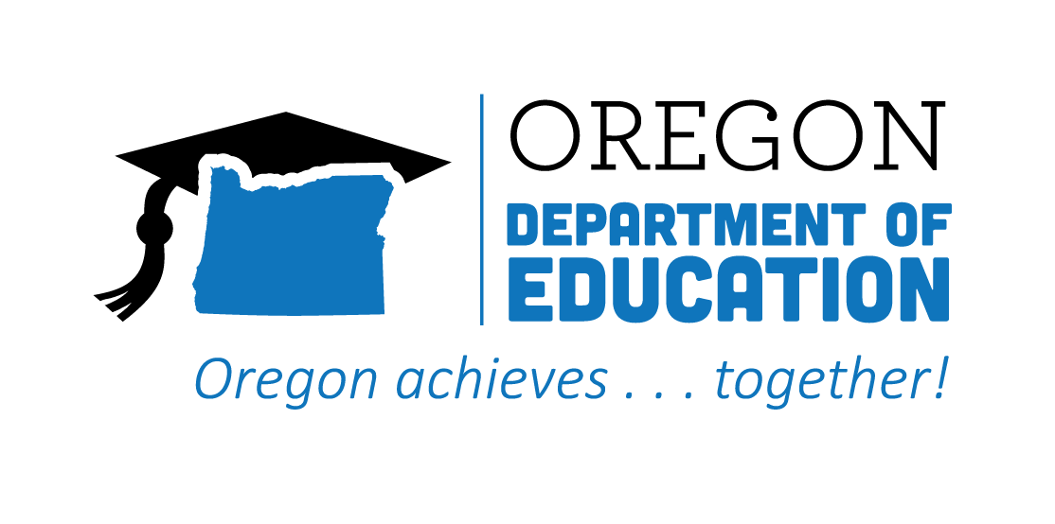
CTE STATE PLAN ACCOMPLISHMENTS 2022-2023
High Quality Programs of Study

The Oregon CTE State Plan is a high level, four-year strategic plan that integrates state and federal priorities to implement the "Strengthening Career and Technical Education for the 21st Century Act" (commonly known as Perkins V). High Quality, Integrated Curriculum and Instruction informed by labor market information, student interest, technology, industry standards, and real-world engagement through relevant work-based learning opportunities are essential to prepare students. The following are Local and State accomplishments made around High Quality Programs of Study goals during the third year.
2021-2022 ACCOMPLISHMENT HIGHLIGHTS
Supported engagement with the High Quality Program of Study rubric through CTE teachers’ self-evaluation of their programs, and by sharing the rubric with district leaders as they completed their integrated application.
Gathered CTE teachers by career cluster as they were renewing for the Statewide cycle and invited community college faculty and industry partners, creating focused professional development and networking opportunities.

Created PLC groups for education and automotive programs to discuss alignment with one another on how to better serve the students, and how to teach the new standards that were developed for the following year.

Conducted one-on-one, collaborative reviews of each Program of Study in the district to evaluate the quality of the programs and develop plans for increased implementation of WBLs and IRCs.

Designed a Webinar for CTE Programs of Study, including sub webinar videos such as, What is CTE? What is a Program of Study? What is a High Quality Program of Study and Getting State Approval of Your CTE Program of Study.

Presented the HQPOS rubric to teachers during professional development–many of whom have not previously seen the rubric–providing an opportunity for teacher learning, goal setting, and overall program improvement.

