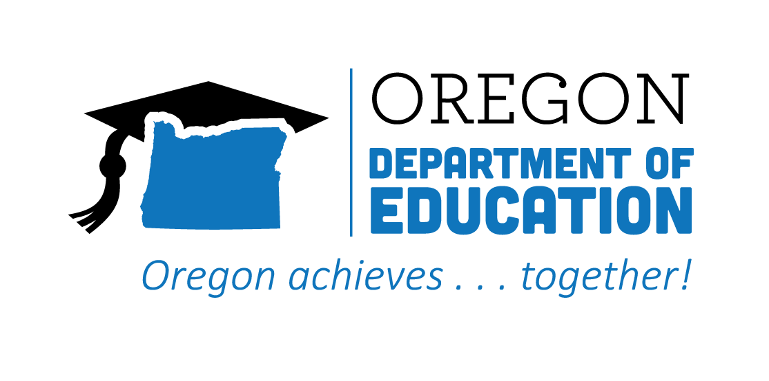
CTE STATE PLAN ACCOMPLISHMENTS 2022-2023
Work-Based Learning

The Oregon CTE State Plan is a high level, four-year strategic plan that integrates state and federal priorities to implement the "Strengthening Career and Technical Education for the 21st Century Act" (commonly known as Perkins V). Work-Based Learning (WBL) strategies and initiatives provide learners with vital access to workplace skills, practical experience, and the social networks and connections needed to unlock opportunity. The following are Local and State accomplishments made around Work-Based Learning goals during the third year.

2022-2023 ACCOMPLISHMENT HIGHLIGHTS
Collaborated with local industry partners to host a multi-day work-based learning experience at a postsecondary site, inviting secondary students to manufacture a part to specifications called for in blueprints.
Hosted Oregon Employability Skills training at the regional level, promoting to districts throughout the region to provide rigorous, relevant, and approved curriculum for students.
Supported student completion of pre-apprenticeships which lead to preferred entry into the Ironworkers Union apprenticeship program and direct entry into the Bricklayers Union apprenticeship and Cement Masons apprenticeship programs.

Created Industry Classroom Connected Projects, which allowed CTE teachers to bring work-based learning to the classroom in a simulated format, gave opportunity for more students to experience work-based learning, and created strong relationships with industry partners.
Expanded pre-apprenticeships programs at four correctional institutions and facilities, establishing partnerships with community college partners and Trade Unions.
Released the first 6 modules in the WBL Canvas course to provide a consistent way to share resources and offer asynchronous professional development around the planning and implementation of WBL experiences.

