
The Career Connect Oregon Hub launched, providing tools, resources, and a platform for collaboration to support Career Connected Learning (CCL) statewide.

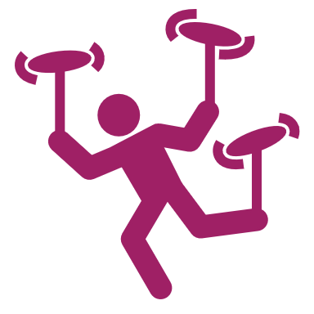
Oregon’s employability skills curriculum for K-12 and eLearning schools was introduced, offering age-appropriate lessons to help students develop workforce skills, with over 19,000 views in its first year.


Career Journey Videos highlighted diverse career pathways, emphasizing underrepresented voices and Tribal perspectives to foster equity and inclusivity in learning.

The Oregon CTE State Plan is a four-year strategy aligning state and federal priorities under Perkins V. It emphasizes career exploration to expand opportunities, diversify pathways, and support student success. The plan reflects meaningful collaboration, including input from the nine federally recognized tribes in Oregon, whose contributions have shaped both the CTE State Plan and CCL program design. Here are highlights of the fourth-year accomplishments in Career Exploration.
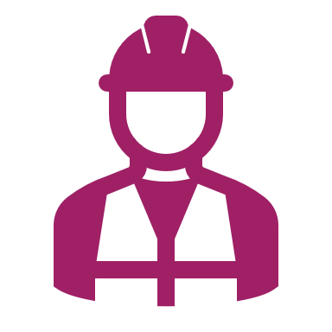
Team Oregon Build engaged over 11,000 students in hands-on construction projects, producing 400+ structures that benefited communities while introducing learners to career pathways.


Events like Manufacturing Day and career showcases provided students with opportunities to connect with technical programs, work-based learning, and industry partners, supported by aligned professional development and resources.

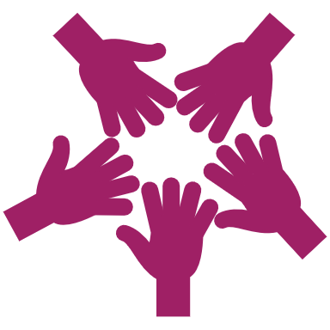
Collaborative efforts between educational institutions, local businesses, and tribal nations created meaningful career and technical education experiences, including summer camps that introduced students to various career pathways through hands-on learning and industry exposure.

