Reflection
2023-2024 Highlights:
CTE State Plan Accomplishments
The Oregon CTE State Plan is a comprehensive, four-year strategic initiative aligning state and federal priorities under the "Strengthening Career and Technical Education for the 21st Century Act" (Perkins V). Below are accomplishments from each team during the fourth year.

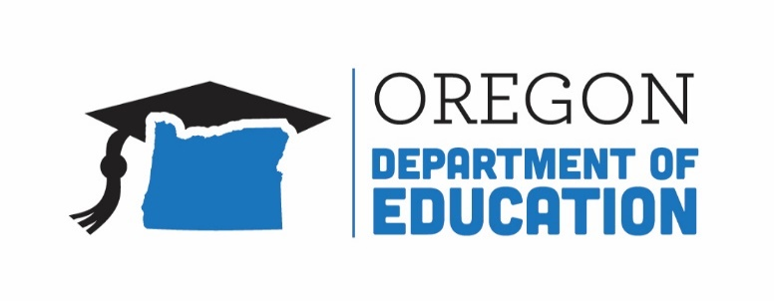
Educator Recruitment and Retention
Oregon achieves . . . together!
Strengthened collaboration with TSPC, CTE Regional Coordinators, and school district CTE leaders, to maintain frequent communication, responsiveness, and flexibility within a complex licensure system to better support qualified CTE teachers.
Initiatives such as CTE-specific mentoring, professional development opportunities, and paid externships have supported new educators, reduced turnover, and contributed to a more stable educator workforce.

Equity and Civil Rights
Oregon achieves . . . together!
The team has reviewed numerous state resources and is developing Oregon-specific materials to assist educators in creating inclusive, welcoming classrooms that support all students, with a particular focus on underrepresented focal groups.
Resources were allocated to schools and programs serving historically underserved populations to ensure equitable access to advanced coursework and industry certifications.

Career Exploration
Oregon achieves . . . together!
Team Oregon Build engaged over 11,000 students in hands-on construction projects, producing 400+ structures that benefited communities while introducing learners to career pathways.
The Career Connect Oregon Hub launched, providing tools, resources, and a platform for collaboration to support Career Connected Learning (CCL) statewide.

Work-Based Learning
Oregon achieves . . . together!
Partnered with BOLI, SAIF, and ODE Legal Affairs to develop accessible guidance on youth workplace laws, ensuring safe and compliant WBL environments for students and business partners.
Supported CTE educators in a year-long professional learning journey, the “Simulation Squad,” to design and implement impactful project-based Work-Based Learning experiences, culminating in statewide panel presentations.

Data Literacy and Accountability
Convened secondary and postsecondary CTE leaders to advise on state-determined performance levels, reviewing Perkins V terminology, indicators, student cohorts, and disaggregated data to guide future targets.
Utilized CTE Participation Explorer, a data visualization dashboard, to address gaps in access and achievement, and to ensure equitably achievable goals within CTE Participant and CTE Concentrator statuses.

High Quality Programs of Study
ODE and HECC completed the review and update of Oregon Skill Sets and developed Statewide POS templates to ensure uniformity across Career Clusters. This four-year project concluded with updates to the Agriculture, Finance, Government and Public Administration, Health and Biomedical Sciences, and Human Services clusters.
ODE and HECC refined the High Quality Program of Study Rubric to better support smaller schools, positioning it as a planning tool to guide the development of new and potential programs.

Flexible Learning
The CTE Without Limits Advisory Committee unites state agencies and community partners to focus on youth corrections, tribal advocacy, small/rural schools, online CTE, alternative education, and the Oregon School for the Deaf, addressing barriers, promoting flexible policies, and closing equity gaps in CTE Programming.
A community college expanded its Perkins-eligible CTE programs by 10%, offering remote, online, and hybrid classes. It also provides stackable Career Pathways Certificates, giving students entry-level skills while pursuing their degrees.

Oregon’s Vision for CTE: The Next Four Years
Oregon will reimagine and transform learner experiences to enhance learners’ future prospects; empower their communities; and ensure equity in an inclusive, sustainable, innovation-based economy.
Outcome 1: Career connected learning that is systemically integrated with education and workforce development.
Outcome 2: Increased equitable participation in high-quality CTE and career connected learning.
Outcome 3: Expanded communication, transparency, and diversity of voices and contributors connected to education and workforce development partnerships.

