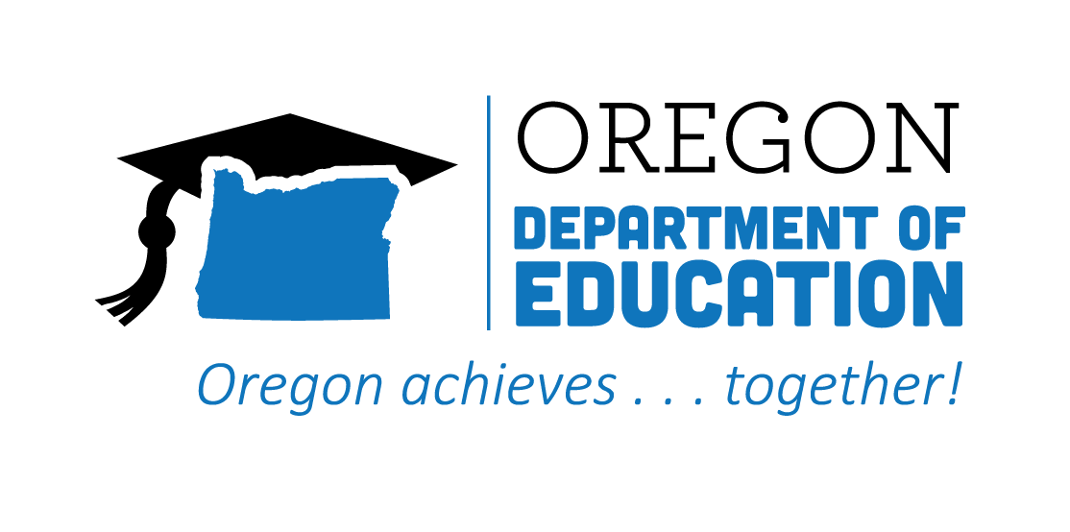
REFLECTION
2021-2022
CTE State Plan

The Oregon CTE State Plan is a high level, four-year strategic plan that integrates state and federal priorities to implement the "Strengthening Career and Technical Education for the 21st Century Act" (commonly known as Perkins V). The following are two accomplishments from each action team made during the second year, along with their respective goals for 2022-2023.
2021-2022 ACCOMPLISHMENT HIGHLIGHTS
The collaboration of the Teacher Standards and Practices Commission, CTE Regional Coordinators, and K-12 school district CTE leaders continued to strengthen. Constant communication and flexibility were paramount in navigating the licensure system to support the recruitment and retention of qualified CTE teachers.

Educator Recruitment & Retention
A new CTE Teacher cohort and office hours were created to support and encourage all teachers, and specifically new CTE teachers coming from the private sector, to prevent teacher burnout.

Used a new data system to create reports for the Civil Rights selection, investigation, engagement, and inclusion audit processes. Data from these reports showed an increase in the diversity of students and a decrease in equity gaps within CTE Programs.
Several regions were able to create web pages and social media posts in multiple languages to increase access and equity.

Equity &
Civil Rights

A cross-agency collaboration between the Oregon Department of Education (ODE) Secondary Postsecondary Transitions Team (SPST) and the Higher Education Coordinating Commission (HECC) Office of Community College and Workforce Development (CCWD) provided technical assistance in creating access and opportunity for historically and currently marginalized student populations in WBL.
The Perkins Performance target for Work-Based Learning was exceeded across all career clusters and focal student groups statewide during the first year of WBL implementation.
Work-Based
Learning

Launched the CTE Information System (CTE IS) that collects CTE Program of Study applications and houses program, course, and teacher information. This is the interface where the annual Program Update occurs.
Provided four separate professional development series and related technical assistance for local data preparers and submitters on reporting for the CTE site and student collections.
Data Literacy & Accountability

Wildfires brought unintended learning for students, where they quickly addressed the needs of the community and stepped into action. Their work involved community engagement, practical applications of design, construction knowledge and skills, and real-world experiences that supported learning and closely mimicked the workforce experiences.
Cross-cutting relations have evolved within an Education Service District to create programming that both addresses education and career objectives and also assists the region in addressing houselessness and transitional housing needs.
Flexible Learning

The High Quality Programs of Study (HQPOS) Rubric is a tool for educators and administrators to assess existing CTE Programs of Study. This tool was revised and improved during the past year and is being used to inform local/regional needs assessments, strategic planning, and continuous improvement processes.
A collaboration of educators and industry partners developed the first eight Statewide Programs of Study Frameworks. Included are knowledge and skill statements that create standards for community colleges and secondary programs to follow.

High Quality
Programs of Study

The Career Connected Learning (CCL) Resource Hub was created to help develop systems and support the expansion of career-related learning down into the middle grades.
The Career Connected Learning team has expanded, and cross-agency connections, communication, and collaboration in support of CCL has increased.
Career Exploration

2022-2023 GOALS
Goal 1: Improve the recruitment and retention of CTE teachers, including individuals in groups underrepresented in the teaching profession and those transitioning from business and industry.
Goal 2: Align systems of educator licensure and initial and ongoing professional development to enhance access to business and industry experts and currently licensed teachers who want to add a CTE endorsement.
Goal 1: Implementation of the MOA State Plan.
Goal 2: Center on equity in rule making, budgeting, and resources allocation through a close examination of data and partner feedback to identify and interrupt patterns of inequity.
Goal 3: Pursue meaningful collaboration with communities and students to provide comprehensive outreach and communication for those who are impacted by decisions regarding CTE.
Goal 1: Create an Oregon work-based learning (OWBL) website.
Goal 2: Adopt a vision for work-based learning in Oregon.
Goal 3: Implement a work-based learning data collection system with clear definitions and measurements for Oregon.
Goal 1: Improve the use of data to inform continuous improvement in CTE with a specific focus on equitable access, participation, and outcomes for currently and historically marginalized students.
Goal 2: Improve data reporting systems for various end users of the data.
Goal 3: Improve data quality.
Goal 1: Incentivize innovative approaches to creating multiple on-ramps and off-ramps to CTE programs in Perkins Reserve Fund Grants provided regionally.
Goal 2: Support at the state-level creation of online CTE Programs of Study as appropriate while ensuring high quality to broaden opportunities for students to participate in and benefit from CTE.
Goal 3: Support and share practices such as competency-based education, credit for prior learning, and accelerated learning.
Goal 1: Continue to focus on building and improving strong CTE Programs of Study by strengthening our commitment to increase the enrollment of students in programs leading to high-wage, high-skill, and in-demand careers.
Goal 2: Create voluntary statewide Program of Study Frameworks that will promote greater consistency in quality across the state, ensure more geographical equity, intentionally engage business and industry in a very tangible manner in the development of CTE programs across the state, and allow for resources to be more efficiently shared.
Goal 3: Focus on a continuous improvement usage and ensure they are of sufficient size, scope, and quality.
Goal 1: Provide learners with career experiences earlier in secondary grades.
Goal 2: Develop systems and support for Oregon career education for all learners.
Goal 3: Build a scope and sequence for career exploration and development, map resources and assets, and integrate with comprehensive counseling programs and community college guided pathways.
Goal 4: Provide K-12, postsecondary, and adult learners systems of support and professional learning about career opportunities and the paths to entering those careers in Oregon.

