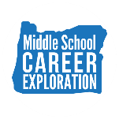

Conducted middle school Career Exploration Pilot Project with 5 Oregon regions. (2020-2021)

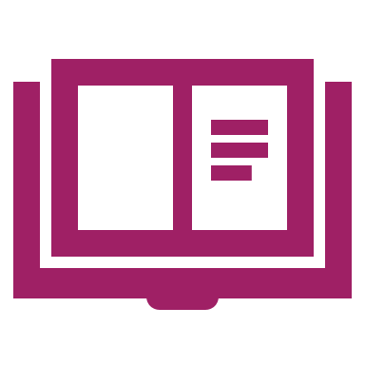
Formed a strategy and guidance group with regional and partner representation, conducted research on existing Career Connected Learning activities through surveys, focus groups, and interviews, and synthesized findings to identify key takeaways and additional support needs. (2020-2021)

Developed and approved the Career Connected Learning Framework and launched the Career Exploration Resource Hub as a summer project in 2021. (2020-2021)
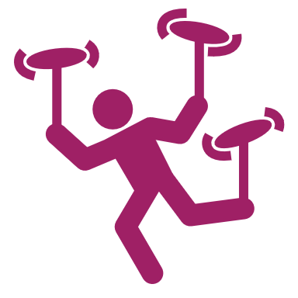
The Career Connected Learning (CCL) Resource Hub was created to help develop systems and support the expansion of career-related learning down into the middle grades. (2021-2022)
The Oregon CTE State Plan is a high level, four-year strategic plan that integrates state and federal priorities to implement the "Strengthening Career and Technical Education for the 21st Century Act" (commonly known as Perkins V). A robust system of career exploration enables students to gain insight into potential careers. Expanding career exploration will help diversify options, increase participation and success of focal students, and create a brighter future for all learners. These highlights are Local and State accomplishments made around Career Exploration goals during the 2020-2024 years.
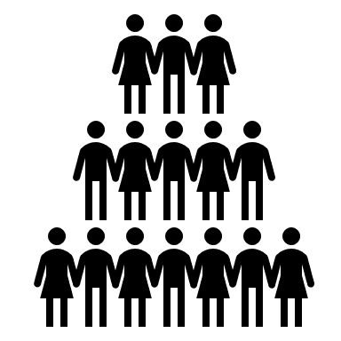
The Career Connected Learning (CCL) team has grown, bringing fresh energy and capacity to the work. Alongside this expansion, cross-agency connections, communication, and collaboration have significantly increased, strengthening statewide efforts to support and advance CCL initiatives. (2021-2022)

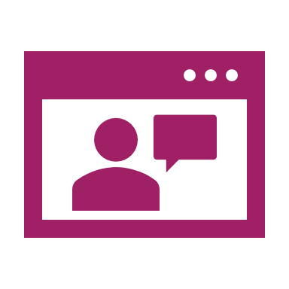
Collaboration with CCL and regional STEM Hubs and hiring of new staff—specifically Career Navigation Specialists, CCL Program Managers, and CCL Coordinators at multiple districts and Education Service Districts statewide—have provided additional opportunities for students. (2021-2022)
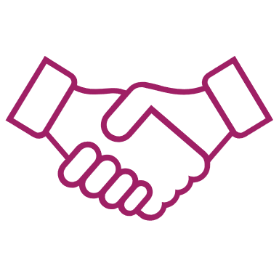
Established partnerships within the Career Connected Learning team and the K-12 system, community colleges, workforce, STEM Hubs, and student support entities, such as C3 and the Aspire program. (2022-2023)
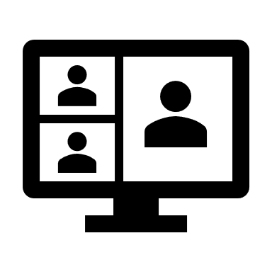
Created resources to support early career awareness– including Career Journeys Videos, YouScience, eDynamic–for rural, remote and frontier schools. (2022-2023)
The Career Connect Oregon Hub launched, providing tools, resources, and a platform for collaboration to support Career Connected Learning (CCL) statewide. (2023-2024)
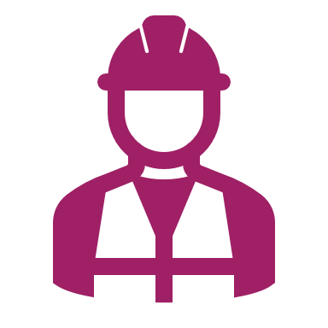
Team Oregon Build engaged over 11,000 students in hands-on construction projects, producing 400+ structures that benefited communities while introducing learners to career pathways. (2023-2024)

Career Journey Videos highlighted diverse career pathways, emphasizing underrepresented voices and Tribal perspectives to foster equity and inclusivity in learning. (2023-2024)

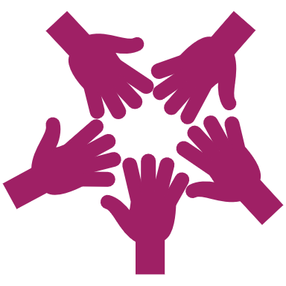
Collaborative efforts between educational institutions, local businesses, and Tribal organizations created meaningful career and technical education experiences, including summer camps that introduced students to various career pathways through hands-on learning and industry exposure. (2023-2024)

Oregon’s Vision for CTE:
Oregon’s CTE State Plan outlines a shared vision to prepare every learner for meaningful, living-wage careers through equitable access to high-quality career learning. With a focus on removing barriers and expanding opportunity regardless of race, gender, or zip code, CTE helps boost educational outcomes and build a skilled, inclusive workforce—essential for Oregon’s future prosperity.

