
Strengthened the Methods of Administration (MOA) Civil Rights Team by hiring and training new members, creating updated checklists and resources, and providing technical assistance on Voluntary Compliance Plans for secondary and postsecondary partners. (2020-2021)

Advanced equity efforts by hosting monthly Equity Roundtables, launching a digital equity resource library, and fostering ongoing dialogue and support across educational communities. (2020-2021)


Inter-agency collaboration with teams who work with student focal groups* to aid in understanding systems and rulemaking. Creation and training of the Secondary Postsecondary Transitions Team (SPST) Equity Decision Tool. (2021-2022)

Several regions were able to create web pages and social media posts in multiple languages to increase access and equity. (2021-2022)
The Oregon CTE State Plan is a high level, four-year strategic plan that integrates state and federal priorities to implement the "Strengthening Career and Technical Education for the 21st Century Act" (commonly known as Perkins V). Equity has been infused as an important consideration in all aspects of the state plan, and we have identified specific goals to help support this important work. These highlights are Local and State accomplishments made around Equity and Civil Rights goals during the 2020-2024 years.

Used a new data system to create reports for the Civil Rights selection, investigation, engagement and inclusion audit processes. Data from these reports showed an increase in the diversity of students and a decrease in equity gaps within CTE Programs. (2021-2022)
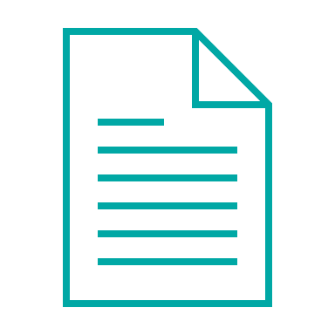
Worked with a cross-agency team to create the document, Supporting Gender Expansive Students: Guidance for Schools in support of schools, families, and the community. (2022-2023)


Increased support of CTE among target population by partnering with affinity groups, such as Migrant Education, African American Black Student Success, and Native Youth Wellness. (2022-2023)

Provided program-level demographic data to each program and school to help identify where programs were not meeting student needs; followed up with guidance to help districts build capacity in equity work. (2022-2023)

Team members delivered presentations at various webinars and conferences statewide, focusing on advancing equity and civil rights initiatives. (2023-2024)

The team has reviewed numerous state resources and is developing Oregon-specific materials to assist educators in creating inclusive, welcoming classrooms that support all students, with a particular focus on underrepresented focal groups. (2023-2024)

The Methods of Administration (MOA) team updated and submitted a revised state plan, provided targeted technical assistance, and enhanced resources to support districts, schools, and colleges in ensuring equitable access for all students. (2023-2024)


The MOA team conducted reviews of ten school districts and one community college during the 2023-24 period. These reviews included the implementation of multiple corrective actions and the provision of targeted technical assistance to ensure equitable access to CTE programs statewide. (2023-2024)

Oregon’s Vision for CTE:
Oregon’s CTE State Plan outlines a shared vision to prepare every learner for meaningful, living-wage careers through equitable access to high-quality career learning. With a focus on removing barriers and expanding opportunity regardless of race, gender, or zip code, CTE helps boost educational outcomes and build a skilled, inclusive workforce—essential for Oregon’s future prosperity.

