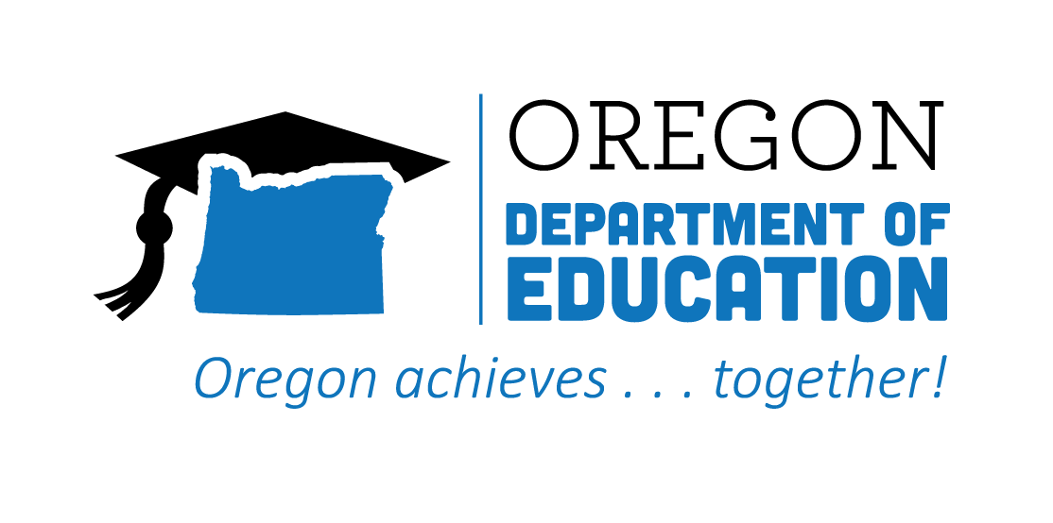
CTE STATE PLAN REFLECTION
2021-2022
Career Exploration

The Oregon CTE State Plan is a high level, four-year strategic plan that integrates state and federal priorities to implement the "Strengthening Career and Technical Education for the 21st Century Act" (commonly known as Perkins V). A robust system of career exploration enables students to gain insight into potential careers. Expanding career exploration will help diversify options, increase participation and success of focal students, and create a brighter future for all learners. The following are Local and State accomplishments made around Career Exploration goals during the second year.
2021-2022 ACCOMPLISHMENT HIGHLIGHTS
YouScience assessment participation has grown exponentially across the state. One region saw a 240% increase in school engagement with the career aptitude and exploration platform.
The Career Connected Learning (CCL) team has expanded, and cross-agency connections, communication, and collaboration in support of CCL has increased.
The integration of YouScience, collaboration with CCL and regional STEM Hubs, and the hiring of new staff—specifically Career Navigation Specialists, CCL Program Managers, and CCL Coordinators at multiple districts and Education Service Districts statewide—have provided additional opportunities for students.

The Career Connected Learning (CCL) Resource Hub was created to help develop systems and support the expansion of career-related learning down into the middle grades.

Successful planning in the last twelve months has resulted in several initiatives and projects that will be implemented through a braided model including ESSER, Perkins, and Federal Title funds.
Formation of partnerships with middle school teachers who will infuse their work in alignment with CTE programs at the high school level to further career development opportunities.

2022-2023 GOALS
Goal 1: Provide learners with career experiences earlier in secondary grades.

Goal 2: Develop systems and support for Oregon career education for all learners.

Goal 3: Build a scope and sequence for career exploration and development, map resources and assets, and integrate with comprehensive counseling programs and community college guided pathways.

Goal 4: Provide K-12, postsecondary, and adult learners systems of support and professional learning about career opportunities and the paths to entering those careers in Oregon.

