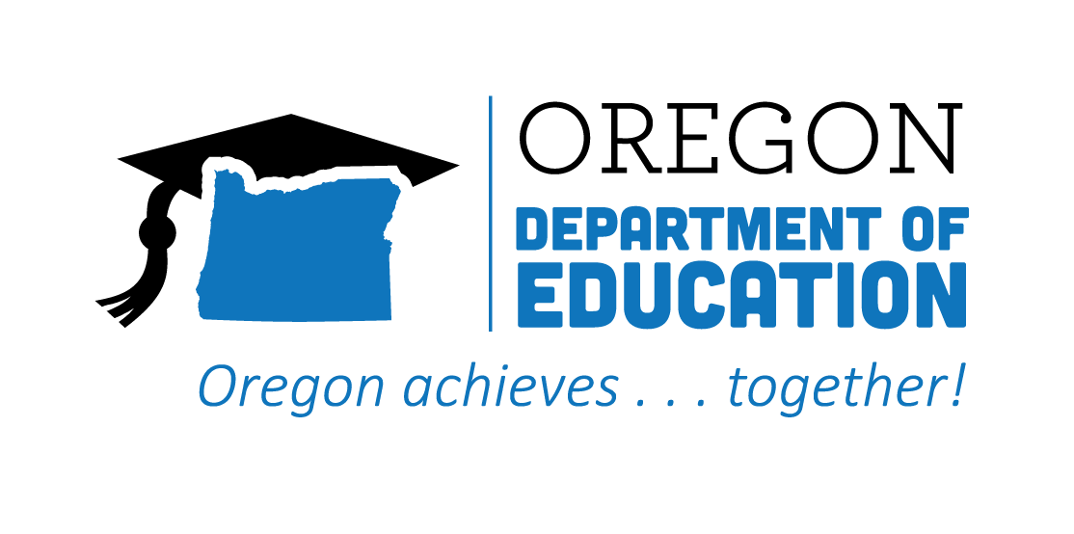
CTE STATE PLAN REFLECTION
2021-2022
Equity & Civil Rights
CTE STATE PLAN REFLECTION

The Oregon CTE State Plan is a high level, four-year strategic plan that integrates state and federal priorities to implement the "Strengthening Career and Technical Education for the 21st Century Act" (commonly known as Perkins V). Equity has been infused as an important consideration in all aspects of the state plan, and we have identified specific goals to help support this important work. The following are Local and State accomplishments made around Equity and Civil Rights goals during the second year.
2021-2022 ACCOMPLISHMENT HIGHLIGHTS
A Community College was able to create an equitable student success program that identified six priority areas to improve equitable access to higher education. This new focus brought substantial changes in support for students in several ways and provided equitable access to educational opportunities and career pathways in CTE programs within their region.
Cultivation of the cross-agency collaboration between the Oregon Department of Education Secondary-Postsecondary Transitions Team and the Higher Education Coordinating Commission Office of Community College and Workforce Development strengthened systems, improved the experiences of CTE students, and provided equity focused technical assistance.
Used a new data system to create reports for the Civil Rights selection, investigation, engagement, and inclusion audit processes. Data from these reports showed an increase in the diversity of students and a decrease in equity gaps within CTE Programs.
Inter-agency collaboration with teams who work with student focal groups* to aid in understanding systems and rule-making. Creation and training of the Secondary-Postsecondary Transitions Team (SPST) Equity Decision Tool.
Several regions were able to create web pages and social media posts in multiple languages to increase access and equity.

Business and Industry partners offered a wide variety of in-person experiences—on and off campus—to meet students where they are, increase their skills, and bridge the gap of Career Distance Learning (CDL).

2022-2023 GOALS
Goal 1: Implementation of the MOA State Plan.
Goal 2: Center on equity in rule making, budgeting, and resources allocation through a close examination of data and partner feedback to identify and interrupt patterns of inequity.
Goal 3: Pursue meaningful collaboration with communities and students to provide comprehensive outreach and communication for those who are impacted by decisions regarding CTE.

