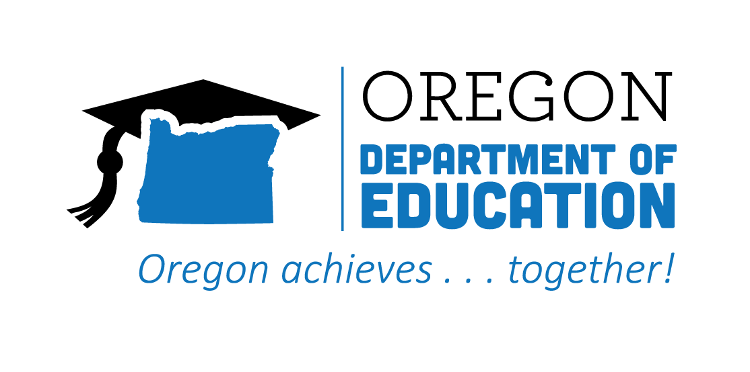
CTE STATE PLAN REFLECTION
2021-2022
Flexible Learning

The Oregon CTE State Plan is a high level, four-year strategic plan that integrates state and federal priorities to implement the "Strengthening Career and Technical Education for the 21st Century Act" (commonly known as Perkins V). Providing myriad options for learners to access, experience, and complete critical CTE learning opportunities supports choice and career preparation across Oregon. The following are Local and State accomplishments made around Flexible Learning goals during the second year.
2021-2022 ACCOMPLISHMENT HIGHLIGHTS
Wildfires brought unintended learning for students, where they quickly addressed the needs of the community and stepped into action. Their work involved community engagement, practical applications of design, construction knowledge and skills, and real-world experiences that supported learning and closely mimicked the workforce experiences.
A Community College was able to create an innovative manufacturing center that will offer prospective students the opportunity to try out a series of free, hosted, and introductory courses. These offerings are a way to support secondary partners and the community with connections to high-quality pathway experiences.

The cross-agency Flexible Learning team was able to survey work going on within the state to identify what is and is NOT happening. This work added value by showing the team where opportunity and impact can be created to support learners and communities.

2022-2023 GOALS
Goal 1: Incentivize innovative approaches to creating multiple on-ramps and off-ramps to CTE programs in Perkins Reserve Fund Grants provided regionally.
Goal 2: Support at the state-level creation of online CTE Programs of Study as appropriate while ensuring high quality to broaden opportunities for students to participate in and benefit from CTE.
Goal 3: Support and share practices such as competency-based education, credit for prior learning, and accelerated learning.
A region was able to create a program that blended traditional CTE programming with a tech center approach and linked to pre-apprenticeship opportunities to give students advantages early on.
Cross-cutting relations have evolved within an Education Service District to create programming that both addresses education and career objectives and also assists the region in addressing houselessness and transitional housing needs.
Members of the Virtual CTE Pilot are working together on how the needs of each online charter school can be achieved in a statewide synchronized manner, with the goal of providing access to high-quality CTE programming in the virtual education environment.

