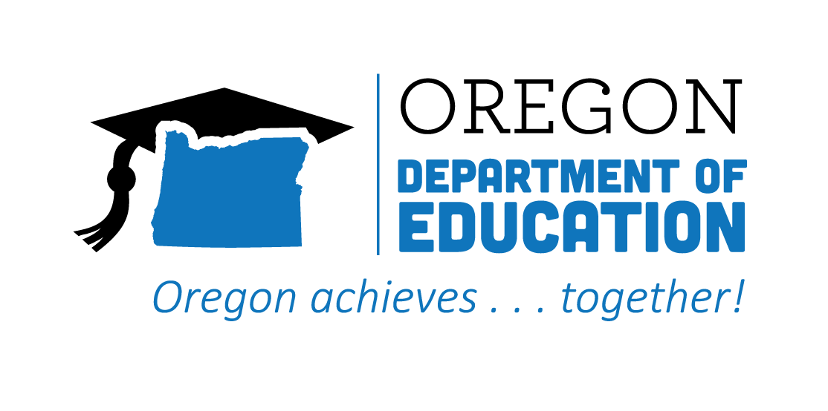
CTE STATE PLAN REFLECTION
2021-2022
High Quality Programs of Study

The Oregon CTE State Plan is a high level, four-year strategic plan that integrates state and federal priorities to implement the "Strengthening Career and Technical Education for the 21st Century Act" (commonly known as Perkins V). High Quality, Integrated Curriculum and Instruction informed by labor market information, student interest, technology, industry standards, and real-world engagement through relevant work-based learning opportunities are essential to prepare students. The following are Local and State accomplishments made around High Quality Programs of Study goals during the second year.
2021-2022 ACCOMPLISHMENT HIGHLIGHTS
Regional conversations and partnerships continue to improve alignment of CTE Programs of Study to community needs.
The High Quality Programs of Study (HQPOS) Rubric is a tool for educators and administrators to assess existing CTE Programs of Study. This tool was revised and improved during the past year and is being used to inform local/regional needs assessments, strategic planning, and continuous improvement processes.

A collaboration of educators and industry partners developed the first eight Statewide Programs of Study Frameworks. Included are knowledge and skill statements that create standards for community colleges and secondary programs to follow.

The new Secondary CTE Information System (IS), which streamlined the entire CTE Program of Study application, renewal, and approval processes into a single system, went live this year. Professional development webinars and monthly technical assistance for new users were provided.

The HQPOS team identified the team projects and activities supporting High Quality Programs of Study, and where connections with each element of the rubric are taking place in the work of the team. The group is designing a communication structure that will keep the team and partners in the field informed and updated about these connections and how to use the HQPOS Rubric.

Creation of Professional Development resources made available for educators, partners, and internal staff to support the use of HQPOS rubric.

2022-2023 GOALS
Goal 1: Continue to focus on building and improving strong CTE Programs of Study by strengthening our commitment to increase the enrollment of students in programs leading to high-wage, high-skill, and in-demand careers.
Goal: Create voluntary statewide Program of Study Frameworks that will promote greater consistency in quality across the state, ensure more geographical equity, intentionally engage business and industry in a very tangible manner in the development of CTE programs across the state, and allow for resources to be more efficiently shared.
Goal 3: Focus on a continuous improvement usage and ensure they are of sufficient size, scope, and quality.

