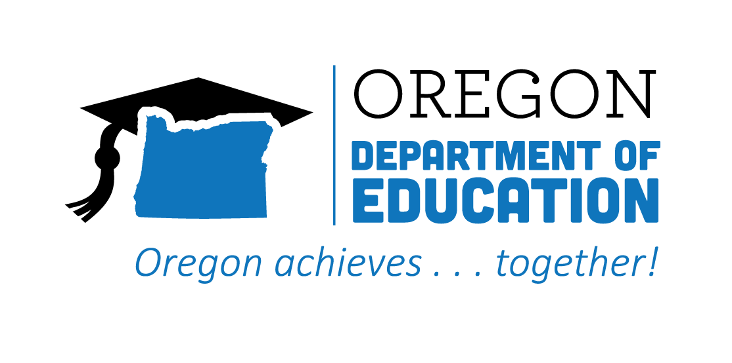
CTE STATE PLAN REFLECTION
2021-2022
Work-Based Learning

The Oregon CTE State Plan is a high level, four-year strategic plan that integrates state and federal priorities to implement the "Strengthening Career and Technical Education for the 21st Century Act" (commonly known as Perkins V). Work-Based Learning (WBL) strategies and initiatives provide learners with vital access to workplace skills, practical experience, and the social networks and connections needed to unlock opportunity. The following are Local and State accomplishments made around Work-Based Learning goals during the second year.

2021-2022 ACCOMPLISHMENT HIGHLIGHTS
The Perkins Performance target for Work-Based Learning was exceeded across all career clusters and focal student groups statewide during the first year of WBL implementation.
Supported high quality work-based learning experiences by collaborating with the Career Awareness Action Team to develop and communicate the vision for the Career Connected Learning (CCL) Systems Navigator positions. The Navigators, who will be housed at all 17 Community Colleges, will work closely with regional CCL partners to build systems, supports, and resources to build a strong CCL infrastructure that will include high quality WBL experiences.

A cross-agency collaboration between the Oregon Department of Education (ODE) and the Higher Education Coordinating Commission (HECC) provided technical assistance in creating access and opportunity for historically and currently marginalized student populations in WBL.

Conducted listening sessions with all Regional and Secondary Direct Coordinators to gather individual strengths, barriers, and needs to support continuous improvement around WBL.
HECC and ODE staff completed an 18-month National Governors Association Policy Academy for states on Scaling Work-Based Learning which led to a cross-agency convening to build a shared vision and priorities for Career Connected Learning and WBL across state agencies.

Provided resources and support for middle school practitioners to help build a foundation for younger students to prepare for work-based learning.

2022-2023 GOALS

Goal 1: Create an Oregon work-based learning (OWBL) website.

Goal 2: Adopt a vision for work-based learning in Oregon.

Goal 3: Implement a work-based learning data collection system with clear definitions and measurements for Oregon.

