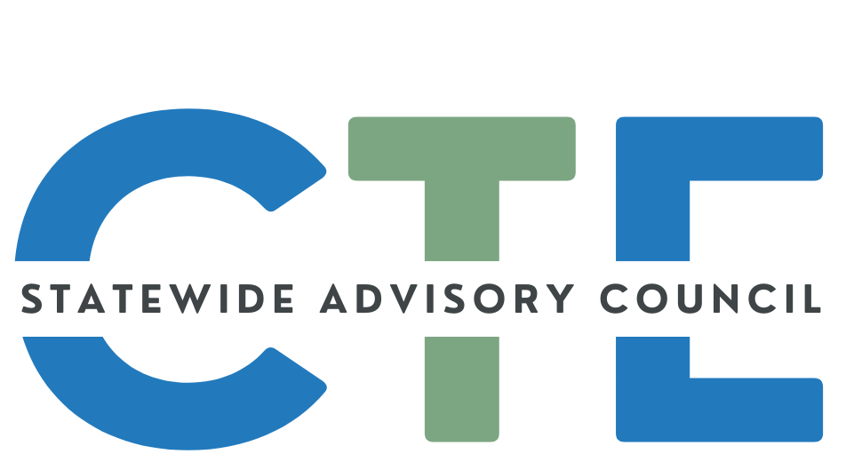
Meeting Minutes

Date: 1/15/25
Time: 2:00 PM - 4:00 PM

List of Attendees
Group Norms

Please note: Meetings will be recorded for those that are unable to attend and will be posted on the Council website (along with the agenda/notes for future reference.)
Time/Topic | Notes
Reminders | Cameras on if possible.  Rename yourself to include full name and School/Organization.  David is not able to attend today.
2:00pm  Public Comment | Presenters: CTE around the State, Regional partnerships, How do we consistently and successfully fund CTE  - Kelle Hildebrant (OAESD), Joe Morelock (WESD)  - Kelle: Link to proposal: (just a draft) https://drive.google.com/file/d/1umXTPUHUx61NcdWHBUNaybf2dtDg7D9R/view  - Job is to represent the ESD’s in Oregon  - A lot to consider and manage and organize to meet different and all needs to continued to see CTE grow in Oregon  How do we improve consistent funding, grow centers and more to think about to move us all forward.  Dr. Joe Morelock: We need better opportunities for students to grow in skills and support to help students be successful. Runs Willamette Career Academy.  Three-pronged approach:  - Building a statewide network  - Funding to build staffing and equipment needs, opportunities for teachers to partner with CColleges and more  - Matching grant to build or remodel facilities. Look at ways to fund and match grants. Projects ready to go but lack resources  - How do we get different school district to work together  - Oregon spends 9% of what other neighboring states are spending  - Looking at housing this through ESD’s Having several ESD collaborate and work together.  - CC, Military etc should not matter what high school you attend should be available to all  - Bill Trying to find ways to have cohesion and sustainability  - Students at Career academy know what their next steps are and what other students are doing in the same program.  - Doner have $ for resources. Willamette Career Academy dental program funded by local donors and CTE Revitalization Grant.  - Want this across the whole state  - In Canby building a campus for CTE when other areas were not. It was a great success and a lot of options to explore  - Looking for feedback  - Connect with Joe or Kelle: kelle.hildebrandt@lblesd.k12.or.us with feedback  - joe.morelock@wesd.org  - Question: what is an Ideal timeline - it depends on where you are doing it . IF space and equipment is available it is quicker but if it is being built from scratch it takes much longer. If we know it is funded we will launch these programs.  - Questions: what is the timeline of funding - it is in the legislative concept bill is not ready yet. It is in process and in creation. Have Lobbyists support.  - What can this group CTE counsel, what can we do to help and advocate. - If there are people we need to talk to and figure out systems. - as we get a legislative concept we will need some letters of support.  - Is there a preferred feedback and timeline? Connect with Adam and Kelle and we will make sure to make that available- by the end of next week is a good timeline for feedback  - We have smaller counties and districts working together. Part of this is about the coordination piece and problem solving.  - This is part of our OAESD concept  - Going to be meeting with president counsel and colleges spoken with industry and legislators to collaborate.  - Part of this is about getting this started  - Caitlin: not all coordinators are at the ESD some at the Community colleges where there central hub is not at ESD how does that get coordinated. Different relationships and making connections. Would be great to have a person of all trades to say, this is what we need.  - I wonder if these centers are for 9-12 or 11-12? - If this bill is successful then we would like to start sooner but now we work with students on track to graduate. We don’t have this for students that don’t know what track they want so starting earlier would be better. Would like this program to cover all of the needed skills to be employable.  - All can digest this information and then reach out to presenters with any feedback  - Who is the best person to communicate back to? Caitlin or Malinda for ESD ‘s to reach out to from CTE
Opener  (Caitlin) | Welcome/Introductions/Announcements  - Thank you for filling out the Feedback Form for 2025 Meetings!  - Meetings will be the same as we have been doing
Council Business (Caitlin) | Council Charter Teaser  - Current Version→Where we started and where we are going-Time to update charter and add anything we want to add  - Looking for volunteers to form Charter Review Committee - Send email and we can get people on a list when those meetings start.  Asset Mapping Follow-up-  SCAC Dashboard Draft (Malinda) - Screen Share  - Not yet in shareable format, but will be sending out for feedback  - All needed information will be located here. Trying to put things in one spot so that all the things you find useful are easy to find.  - On the dashboard will have a spot for suggestions and feedback as well
2:30pm  State Director Updates  (Shalee) | ODE  - Digest and discuss guest content (CTE funding)  - Time to read the document or just think about it?  - Many would like to have time to read. 10 mins to read and then check back in to comment.  - Would have liked to see it sooner. Language of bridging the gap between industry and …  - So much of the state is rural and funding is being cut, how is that going to serve the small remote areas? How can they get to some of the bigger centers?  - Center brings to mind a brick and mortar setting. It does not need to be that it can be a centralized force to work to increase access.  - Great point that there are going to be all levels of what schools in a particular are and what they can do and what they need. Most might be brick and mortar, Transportation and scheduling can be a huge barrier to success if it is not figured out.  - The interplay between schools and the regional center that has the capacity to take away students and who works with them. What does it mean that these schools will no longer have CTE in their building because they now go to a more regional center?  - It is exciting. I would love this to be more of a focus. Great mobile welding lab that could go up and down our region. Excited for possibility  - I agree - this could result in HUGE, POSITIVE progress toward more equitable access to CTE.  - We do have a few online charter schools providing CTE. Pilot program to get access to all schools.  - In some of our very rural regions of the State, I wonder if a hybrid approach could work? A "mobile teacher" who could provide foundational content at the home school coupled with transporting the students to the nearest community college once a week (all day) for hands-on implementation utilizing college with the most up-to-date equipment. Agree, think that it should be open to more than just ESDs, we have similar types of programs currently with community colleges providing remote labs, learning, etc for high school students  - Putting out a non exhaustive list of how funds can be used. IT makes you think what else is missing and not sure that piece needs to be out there yet if it is not exhaustive.  - Are the stem hubs located throughout the state near an ESD? - Not all stem hubs operate under the umbrella of an ESD  - Some Hubs have a CTE STEM hub in their program  - Should this involve more than just a K-12 funding? ARe there any potential shift to serve Community Colleges serve more …..  - Is this the best solution for the whole state, to allocate all the funds? Maybe set up an early college model. Dual credit, flexible, Different alternatives, facilities and staffing that are already there. Want to make sure that CTE is available to more students. It may just lead to more advanced students having access to more resources. Is that best practice?  - Perkins funding in our state prioritizes CTE programs of study, this proposal does not.  - It does sounds more focused on the “Center” and not “backbone” funding. Because we don’t have that funding it is being used for sustaining what we have and salaries and running the process.  - I like that the funding might be used for either approach (mobile solutions vs brick and mortar, tech-heavy vs staff-heavy, or some combination). It'll be different in each region.  - There is a similar house bill that has dropped House Bill 2580 to address CTE funding. Rep Mcintyre  - There is a lot of interest in CTE this year  - Regional centers can not be a replacement for programs in schools, It is a limited amount of students that can attend. It is a “Yes, and” conversation. -Feedback from tribes where students would need to be on a bus half day there and back and limit participation for those more rural areas.  - A lot of focus on building up resources. There are things happening throughout the state but there are some huge gaps.  - I agree that the end result must be an expansion of opportunity rather than a shifting of opportunity from some students to others.  - Sat in a lot of meetings with great ideas and today feels like the same idea. WA allocates about $4000 per student and Oregon is more like $350 per student. Is it just a dream or can this be a real discussion without a level of funding. Is there anything that anyone can come up with about the environment we are living in in the CTE world? I would love to see a team to sit in front of committees and lay out this is what we are looking at. Oregon is not moving in the best direction in order to fund all of these great ideas. Describe the Oregon CTE Landscape and address upping the funds to make a viable difference. Otherwise they are just great ideas. How can we get the state to see what other states are doing.  - Share your feedback to Kelle and Joe or share with Caitlin.  Slide deck from Econ Development meeting - https://www.oregon.gov/workforceboard/Documents/4.0%20-%20Regional%20Career%20Centers.pdf  HECC  - HECC’s New Strategic Plan - used to guide development and implementation of higher education and workforce development funding and policy initiatives that impact Oregonians statewide  - 5 goals are linked for student access  - Governor’s Budget - largely in alignment with current service levels  - Legislative Session - CTE-related bills - See Oregon Legislative Information System for additional details  - HB 2044 - ODE and STEM Investment Council recommend standards for tech-based competitive student activities may satisfy HS diploma or CTE program requirements  - I promise it is a quick question  - HB 2406 - ODE to study CTE  - HB 2580 - Statewide Education Initiatives Account - CTE funding eligibility  - HB 2681 - CTSO and CTE Funding - Activities leading to high-wage/high-demand jobs  - HB 3038 - Eligibility for STEM Education Grants  - HB 3181 - Task Force on Youth Apprenticeship  - Feedback to Shalee  - Question tracking bills for the session: how many people are doing that and how to see all the bills- connect with Shalee Hodgson to get details.  - Shalee said she would check internally to see how others feel about sharing.  - Making sure that the bill trackers are tracking each other.  - ODE is welcome to share as well.
BREAK
3:15pm  CTE Student Advisory Council Updates & #ThisIsCTE  (Junnie) | - CTE State Plan 1-pager - Student Version  - finalized flyer- what CTE is and how to be involved. It also includes what the CTE state plan is and their goals.  - Help raise awareness about CTE programs.  - #ThisIsCTE Social Media Campiagn  - Flyer- Updating and getting ready for submissions.  - 2025 Submission Form  - Student Newsletter → CTE Student Ambassador Program  - Hope to release our first edition in February  - Goal is to release the first on in Feb for CTE month and then continued quarterly  - Other students across the state to share their voice throughout the state.  - If the student advisory counsel had any questions on bills or give a testimony etc.  - Legislators love it when students stop by and give testimony... maybe an opportunity...  - Malinda. We have dipped our toes into doing that and starting connecting the students with the process. Right now students have been focused on the things listed above but there are more plans to do more. Talked about bringing in someone to present about advocacy. Trying to find ways to compensate students for travel and time. If you have ideas on where that could and would come from. Build a foundation so that all over the state can connect and collaborate . Looking for ideas to find funding.  - Workforce might be a place to look into . OWP is the umbrella and worth looking into for that.  - Our new youth advisory leader is looking into that funding as well.
CTE State Plan (Malinda / Shalee) | (In the interest of time, the first item below was tabled until the next SAC meeting, and will likely be addressed via email in the interim.)  2023 - 2024 State and Local Accomplishments - Slide Deck  (from the 2020 - 2024 plan)  - Review Individually for 5 minutes  - Breakout rooms 15 minutes  - Populate Room Slides (starting on slide 15)  - Large group discussion 10 minutes  2024 - 2027 CTE State Plan Communication Materials  (Main goal is to raise awareness of the new CTE State Plan and to encourage engagement by getting folks to fill out the Support Form)  - Review & Utilize in your work: FOLDER- state staff has received. Contains a variety of materials to share in meetings or email in the course of your work and spread the word on CTE and the importance of the work. As we get feedback we will be adding things into the folder. If people do utilize the materials. Use the tracker below to keep data to show where we were able to share that form and in what settings.  - Complete: Communication Tracker FORM  - Create an Email Signature:  - SAMPLE:  - Read the Oregon CTE State Plan. Complete the CTE State Plan Support Form.
3:50-4:00pm  CTE Month Celebrations  (ALL) | Slide Deck  - Please add a celebration/highlight from your area  - Way to collect the cool things that other groups are doing. We want to increase the celebration around CTE so that we can widen the reach. Share a link to something that is already created. EX PCC sent a link to their CTE program. This can all be added to the slide deck. You can also add #thisisCTE as well. CTE update that goes out through go delivery. Hope that all will take some time to populate the slide deck. Anything that is related to CTE. It can be highlighting a teacher or students.  Wider Distribution:  - CTE Update (monthly GovDelivery from ODE)  - Submit by the first working day of the month to ODE.ctecommunications@ode.oregon.gov  - #ThisIsCTE (submission form linked above)  - Share out to Region 5 and National ACTE - Oregon ACTE Board Members will work on this
Oregon ACTE Conference | April 16 - 18 in Seaside, Oregon -  Reunite, Excite and Ignite CTE Potential  Keynote: Justin Shaifer, Mr. Facinate  - Registration is open  - Call for presenters is open - closes January 31st  - Sponsorship packages and sponsorship sign up  - Schedule of events  Note: There will be a CTE Without Limits Track within the conference. Join us to learn more about this initiative and be part of the discussion to increase access to CTE programming for youth corrections, online/virtual, small/rural/remote, alternative, and Tribal students.
Announcements / Good of the Order  (ALL) | You are encouraged to add things to this section to share with the group! Please add your name so we know who added the info for future reference!  ========================================================  Reminder: SCAC communication Content Submission Deadline is  - Submission FORM  ========================================================  ========================================================  ========================================================

