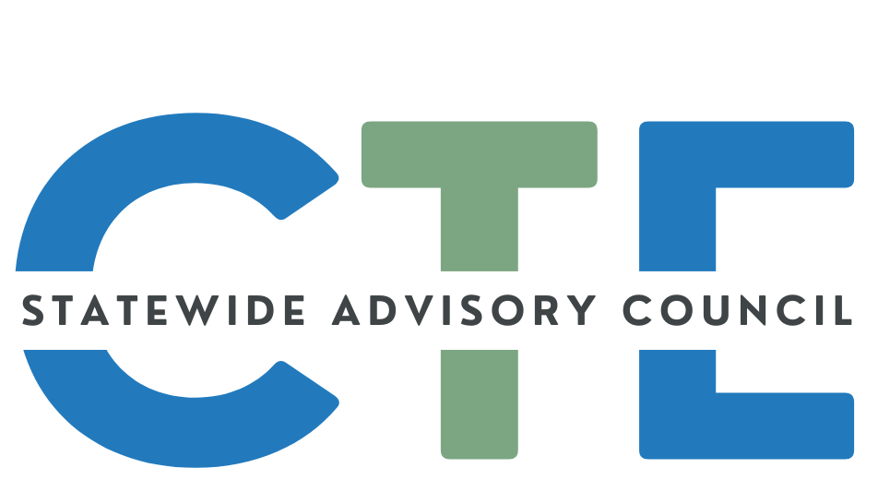
Working Agenda/Meeting Minutes

Date: 1/21/2026
Time: 2:00 PM - 4:00 PM

List of Attendees
Group Norms

Working Agenda
Please note: Meetings will be recorded for those that are unable to attend and will be posted on the Council website (along with the agenda/notes for future reference.)

Reminders: Cameras on, if possible.
Rename yourself to include full name and school/organization
Time | Topic | Notes
2:00 | Public Comment  (Caitlin / David) | Guest Introductions:  - Katrina Stein (PCC)  - Carol Matsuzaki (ODE)  - Christiaan Desmond representing Karen Paez (PCC)  - Jan Osborn (PCC)
2:02 | Opener  (Caitlin / David) | Welcome/Introductions/Announcements  Welcome new SPST Director, Welcome Jenni Newby  Member Slide Deck - Review All we do and all the members list  Slide Deck  Discussion Notes:  Caitlin updated how things will be different with new director and ask HECC and ODE to see what they need this group across sectors to do for the good of Oregon and the good of CTE. We are going to find out what came and comes out of that discussion. Donna is going to talk to us about the workforce system. Next month is CTE Month  Malinda introduces Jenni Newby, the new ODE SPST Director, and shares that there is a slide in the member slide deck if you want to learn more about them.  Jenni shares they started on December 1 and other introductory comments. Excited to be here and to learn from you all. David’s question:  - Since you’ve been in education what are your hopes and dreams for CTE in the state of Oregon?  - Discuss what “Postsecondary” and CTE fits and how it helps students.  - CTE being an important space. It is academic.
2:30 | Oregon’s Workforce Ecosystem  (Donna) | Summarize State Workforce System  Summarize New Federal and State Policy Documents  Context for SAC Charter and Vision  Discussion:  - Reaffirmation that we did hear about needing to know how your work on this advisory counsel advise and effect change. From a staff perspective, how do we ground ourselves in the overall landscape? In Oregon …. Workforce innovation and Opportunity  Act (WIOA) That students get what they need in the workforce and that a one size does not fit all.  - Identifies and brings together the core programs of Federal investment in skill development (see list in slide)  - Calling this out because PS CTE is a mandatory partner  - WIOA envisions the American Job Centers - Oregon’s WorkSource Centers - Described in slide what they do and how they do it.  - Over of the Nation’s Workforce System Slide  - Highlights different offices and programs to overview how our state agencies map to the US Departments involved in the Workforce System  - Local Delivery of Services to Customers slide  - High level overview of what our WorkSource Centers provide and who helps provide the services  - Donna provides examples of various programs offered for individuals within the table on the slide.  - Connecting service groups with related services  - What skills need to be built to begin to build a career  - DHS can do case management if needed especially for those who have differing needs to get the support, accommodations and technology they might need.  - Work with Blind or visually impaired.  - Local and regional groups to inform and connect other work source partners.  - Oregon’s Local Workforce Boards - set up to make sure we are using federal funds effectively to support local needs  - Goal to cover who is your local workforce board  - Oregon’s Local WOrkforce Boards with Sector Partnerships  - Highlights that the sector partnerships are what LWB identify as their main focus.  - You might see alignment between CTE Programs of Study and the sector partnerships  - Caitlin - Are others on the call aware of your local sector partnerships?  - Chat shared indicated first time.  - Deron may have seen the graphic before but formal awareness has come from getting connected via email and subscribing to the LWB newsletters. Still hard to figure out and how to work together on a regular basis.  - Donna shares that just knowing their focus might help be an entrance into a discussion  - Ben…asking about a previous LWB leader and has experience with work in the past with LWB but not sure if involved currently.  - Donna shares - WorkSource SYstems Inc. is your Title 1 recipient and Local workforce board  - Kate - The Gorge has a positive relationship with EastCascade Works (our regional Board) and we have received funding to help support Career Awareness events for middle and high school students over the years that I have worked for the CG STEM Hub. I was surprised that Advanced Manufacturing wasn't highlighted as one of our region's priorities.  - Luis - It would be interesting to see how many programs in these same sectors from all 9 boards are being submitted for state approval  - Caitlin Russell | Oregon 2:35 PM  - Luis-are you thinking at the CC level or HS level?  - Luis Juárez, HECC 2:36 PM  - Postsecondary/.  - Deron - I think it would be interesting to see the data for both levels. Alignment?  - Unfortunately, I think most CTE programs of study are a result of industry needs from long ago (which may very well still be relevant) and available instructors (more so on the secondary side). It is soooo hard to recruit CTE teachers at the secondary level. We've got 6 schools looking right now and not having much luck so far.  - David - Going back to the original intent for this. This is a two way street. We may collectively or individually may not know and what they are going on the ground. HOw do we work together and get some scaled economy of this.  - Donna - Having Jenni in this role is great news because she has great understanding of what those partnerships can look like and how you can build them to have seamless path for students. What you all share will be taken to heart by Jenni and I. The local boards are represented by OWP and I could see statewide collaboration between this group and OWP and how do we roll up our sleeves as we look at WIOA state plan and CTE state plan. We did a great start this last time, but more could be done.  - Jenni - Love the idea. Thinking about how to better interface with workforce boards. Was on a workforce board in the past.  - Federal and State Performance Under WIOA  - Identifies some aligned performance metrics that are of interest/could be used more in the future.  - CTE and WIOA State Plan Alignment  - Oregon Aligns these plans and highlights of that alignment are listed on the slide  - Find the list of Integrated Education and Training programs on the HECC’s Eligible Training Provider LIst  - Adult Education Attainment Goal and Governor’s Priorities  - Describes the graphic on the slide  - Priorities, Workforce Strengths and Projections, and Partnerships  - Donna overviews alignment between the different documents highlighting the alignment of housing and homelessness with the four different categories of efforts.  - Pause for questions  - Health Sciences  - Constructions  - Education  - Ripe for partnerships  - Caitlin - how do these align with the Industry Consortia.  - Donna - They were formed under FRO. Healthcare, Manufacturing, and Technology. They are being informed by the sector strategies and the governor’s interest in early learning. Educate folks on technology etc. Manufacturing helps produce what is needed for housing. There is alignment. The industry consortia going forward may be working more closely with WTDB  - Caitlin - Another great visual, what came first. The governor set priorities or are these projects set?  - Donna - Hard to answer for governor, but a little of both.  Context for SAC Charter and Vision  - Donna presents the CTE State Plan Vision  - Updated in 2024 as part of federal submission of our plans for Perkins funding  - We want the advisory council to be a group for feedback and sounding board for this vision to occur  - Guiding Principles  - Donna - We heard you through Caitlin and David and that you are ready for the next step.  - Overviews Learners at the center with our partners  - CTE Statewide Advisory Council Charter  - Donna and Jenni reviewed the CTE Statewide Advisory Council charter as part of the process  - Decision Making  - Advisory Council Charter  - New Developments Entering the Landscape  - Donna shares about the new documents  - Whitnie: I would love a piece that touches on how soon do these discussions start and who is in charge of making sure that high schools and even middle schools are introducing these discussions, especially as they relate to people with disabilities. how do we start those conversations and create and insure that Possibility and the thought that everyone can work and a place can be found and or developed for all especially if those conversations happen early in school career. Just some thoughts.  - Caitlin: I would like to see you and other heavy hitters in this area have some design ownership in this, too! But...I'm just a regional coordinator ;)  - Proposed Work Plan Slide  - Donna highlights the need to go back and forth with the advisory council members to mutually identify how we should work with this group.  - David shared thank you to all the thought that went into this. Thank you for hearing us as a council.  - David asks how does this land with the council?  - Need for system alignment  - Need for clear next steps  - Review the Prosperity Roadmap  - Review the Economic (didn’t get the full title of this)  - Review the CTE State Plan  - Create a map of some sort  - ODE/HECC staff take a first stab at that and present to the Council to help with prioritization  Other Notes:  - Caitlin: I know that ODE is embarking on a research process for the Modernized Career Clusters - how can this group engage in that work?  - Clay plans to watch recording and catch up on where things are at and add input on the plan moving forward.  - Deron: Without a consistent pool of professionals available to recruit as CTE instructors, we cannot develop and expand CTE programs to provide more equitable access to CTE learning at the secondary level. So anything this council can do to streamline the licensure/endorsement process, reduce costs, and pay CTE teachers more than teachers that don't have their significantly extra responsibilities (safety, equipment & lab maintenance & operation, etc.) would be very high on my priority list.  - Marshall: wanted to bring up that any time it is relevant to draft a follow up message and package up all links and slides and we can pass it on to all of the counsel members and offer to ask any questions and any concerns or things that they would like to have added or discussed.  - David: great idea to pass up for communication and keeping all in the loop.
~3:00 | BREAK
3:10 | Other State Director Updates  (Donna / Jenni) | ODE  - Updates: WE do not make budget reductions for any state agencies. The budget was submitted and the legislature makes final decisions.Cuts are not being made right now and any updates will happen later.  - Required to submit a joint legislative report for CTE Link Add:  - A permanent director was hired. More hires will be happening in the near future  - Plans across state, There will be a new strategic plan and where CTE fits into the space of that plan.  - Working on a Perkins consolidated plan should be happening soon.  - David : are the updates and Annual things. Malinda said been here for 5 years and this is the first time to update.  - Plans across all different offices, Plan was to look across those plans and align plans to address and align all plans.  - Working and focusing on Post secondary and graduation  - Starting the recruitment process sometime in March.  HECC  - Federal Updates. CTE Visioning Meeting in February Participating nationally. Setting the vision of CTE in the future 2030-2050  - Earlier this week. Mini omni bus build with regards to budget appropriation Perkins was funded in the bill, funded flat but it was funded.  - State plan and WIOA and align with the submission of that in the areas discussed and finding new and innovative areas where we might strengthen relationships.  - Luis is retiring and moving on to bigger and better things. Retiring in June. Call out and thank him for being a part of CTE for over a decade.  - Have aWayne Fanno is rejoining the team and HECC family Excited to have him join again.  - Share any questions and concerns. Reach out and we will do our best to share and provide feedback as needed.  - State Updates Governor’s Prosperity Report and will be digging into that deeper in future meetings.  - Legislative updates . Feb 2nd  - Oregon was selected as one of 4 states to submit a jobs education grant. 30 applicants and we 1 of 4 selected and are waiting to get contracts but work with residents of people in correctional facilities.  - Development Education Redesign update  - Integrated Education and Training (IET) Professional Learning Series. Can register for training if want to learn more.  - David : Jenni you noted on the budget update what was submitted and wondering if there were items in that budget package that were directly connect to CTE that are a concern to you Career tech ….. Any red flags on where the conversation is going?  - Jenni, Yes there wre things related to CTE need to be careful but it is part of the discussion . Docs are public and can be looked at. Each office had to look at all of the budgets and realign. Mine was in regards to career pathways and CTE. Student funding for organizations. CTSOs.  - Donna: Our agency is describing them not as recommendations but scenarios. We don’t make the cuts, we are just in charge of implementing them.  - Jenni: A lot that is being discussed and considered .  - David: a :”peanut butter approach” but it covers all instead of zeroing in on one or two things.  - David on the federal side of things. When Donna shared the news that things were kept “flat” ARe you tracking anything from the federal landscape. Programs, Dept of Labor where there were cuts or reappropriation or anything good news or bad news.  - Donna. This was one of 4 that went through this week. Because it leveled funds Perkins we turned out fairly well. There were conversations for other groups that were not as positive. Even though there continues conversations on workforce development there were title one funds that were cut. Tracking and it translates into a cut. You can’t keep providing the same when expenses go up and income does not so the discussion will still continue and need to double down on future conversations on this and budget issues.
3:40 | CTE Student Advisory Council Updates & CTE Month  (Malinda) | - #ThisIsCTE  - CTE Ambassador Program  - Virtual Job Shadow  February is CTE Month!!  Discussion:  - Malinda shares the Student Council Report  - Students are encouraging everyone to generate content.  - Goal to do one post per day in February and then once per week following that.  - Overviews CTE Student Ambassadors  - Overviews the Job Shadow program  - Ideas for February as CTE Month - Check out these easy ways to build awareness for CTE.  Mahrus introduces themselves
3:40 -  4:00 | Announcements / Good of the Order  (ALL) | You are encouraged to add things to this section to share with the group! Please add your name so we know who added the info for future reference!  =====================================================  Reminder: If you’d like to submit content to the SCAC communication, the deadline is the end of the first week of each month  - Submission FORM  =====================================================  Share your CTE “Bright Spots” with a wider audience:  - #ThisIsCTE (social media) and the CTE Students In Action Newsletter - Submission Form  - CTE Update (monthly GovDelivery from ODE)  - Submit by the first working day of the month to ODE.ctecommunications@ode.oregon.gov  =====================================================

# # #

