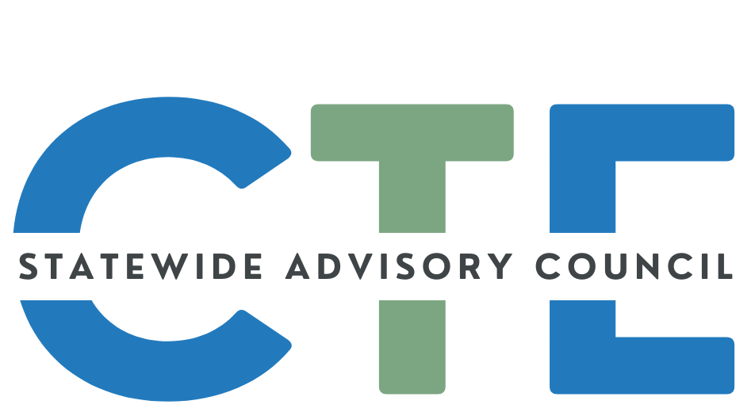
Working Agenda/Meeting Minutes

Date: 10/22/25
Time: 2:00 PM - 4:00 PM

List of Attendees
Group Norms

Working Agenda
Please note: Meetings will be recorded for those that are unable to attend and will be posted on the Council website (along with the agenda/notes for future reference.)

Reminders: Cameras on, if possible.
Rename yourself to include full name and school/organization
Time | Topic | Notes
2:00 | Public Comment  (Caitlin / David) | Guest Introductions:  - None at this time
2:05 | Opener  (David) | Welcome/Introductions/Announcements  - Member Slide Deck  - Review your slide  - Look at other slides  - Who on this call have you interacted with in the last month? CTE, professional and/or personal  - Good of the order announcements  Meeting Slide Deck
2:20 | CTE Data Conversation Cont’d  (Caitlin / David) | Facilitated Discussion: Storytelling Through Oregon’s CTE Data  - Let’s Measure Ready highlights - Charlie Hopewell  - Please read beforehand or after the meeting for our future work on this topic.  - How do we hold ourselves accountable to the students?  - Oregon CTE continues to be underfunded/under valued  - Oregon Ranks among the bottom 5 states  - How do we measure success and to whom are we accountable?  - LG - WORKing Together Conference - benchmarking with WA (who has so much more funding)  - How and how much of what we do gets to our state legislature  - JH - Feel similar to transportation funding. Three groups who meet with legislatures and they meet regularly. We do little to zero.  - I don’t know what they do in Washington, but they have a program.  - We assume legislature understands our work.  - We need someone to lead CTE advocacy work  - At OSU have a program where after a year or two they are work ready.  - Promoting that summer CTE learning experience.  - Having some measurement of the students ability would be beneficial. Some CTE teachers may not know how they are measured. Whether what they are writing matters. Having some consistency on this issue would be a positive.  - Brandi Clark - We do require CTE programs to provide WBL, we do collect data. There are specific criteria and types. They require student experience must include sustained communication with an employer. Happy to share that data in the future.  - Charlie - Know there is data collecting.  - When on a national stage, we didn’t participate.  - Why were we not included in this study?  - Does that say anything about the institution?  - Susan - We collect many of the data points included in the Let’s Measure Ready methodology.  - Question is similar to Charlie’s. Did the state have to opt into one of these data points as the CCR? I am guessing that is why we were not included in the report as we could have been.  - Deron - was there an Oregon Contact for this report?  - David - I wonder if we might have a definition, shared threshold of what is Career Ready.  - How do we analyze it?  - For what purpose?  - Charlie - How is that aggregated out into the public space?  - Deron -  - The report seems to be about using the data "for accountability requirements" - need to understand what that means in the context of this report.  - May include in the report that there was needed a definition used in the study for what it means for using the data for accountability requirements. Maybe that is the missing link.  - Kate- Are we actively and consistently tracking our HS graduate placements after graduation - college, military, apprenticeship, employment?  - Karin - I think a big part of the discussion is whether or not it has been legislated, so that the definitions, participation, funding are aligned? We are doing so much of this work, however it is often in isolation  - Susan - It appears to have a relationship to adopting one of the measures as an accountability measure : ...the state has at least one CCR indicator in its high-school accountability system.  - Deron -Susan - I agree, but I'm still not sure what that means in practical terms.  - What matters to you?  - Council Input on Oregon’s CTE Story  - What story do we want Oregon’s CTE data to tell—about our students, programs, and communities—over the next five years?  - Additional prompts: What are the key messages we want others to understand about Oregon CTE? Whose voices or outcomes should be highlighted most?  - Charlie - as industry I want to know how many are graduating with CTE Certificates  - What our trend is  - What are focus is in terms of industry  - David asks - What would that data mean to you?  - Charlie - As an employer, it would serve my hiring needs. Show that we are receiving the attention we need.  - What is your demand? What is the supply?  - Not just for courses of study, but success  - We lose the student when they graduate.  - We don’t know if they have successfully been employed in their interest field.  - Use that as an outcome measure to hold our systems accountable  - Susan- It appears to have a relationship to adopting one of the measures as an accountability measure : ...the state has at least one CCR indicator in its high-school accountability system.  - Luis - Employment matters. To Kate's point above, I'm not sure we (state and colleges) are doing enough to track our postsecondary graduates in CTE and how soon (if ever) they enter the workforce that they studied to enter..  - David - want to have everyone have a prosperous life and we need to make strategic investment with our dollars.  - Luis shares about his comment in the chat  - Potentially find a program in other states that tracks people well.  - Deron - I want to know the % of CTE completers who have positive employment outcomes (we have to define) in the year after completing school, then possibly at 3 years and 5 years, etc. Tough to track accurately, I know.  - Susan - i think that could be done using ODE to HECC to OED data  - Clay - And also the state longitudinal data system  - But it will take new resources  - Kyle - At Oregon Business Council we do a lot of work in Consortiums.  - Working with industry and k-post secondary education.  - Opportunity to think about in each partners perspective  - What I see is that Oregon does not have a firm definition of what it means to be career ready.  - If we think about this from the students perspective….  - If we think about from employer - we want curious and problem solving students.  - For some students they will put them on a career track to get credentialed and continue in the specific pathway.  - For others it can be to explore future pathways.  - How do we best define it?  - Who is responsible for career readiness is something I’ve asked in my consortium and the room gets quiet. It is all of us.  - Was on the accountability group with Travis R. at Hillsboro school district. Advocated for career readiness accountability measure.  - David asks Kyle about the accountability group. What prevented you?  - Partly it wasn’t clearly defined  - Didn’t want too many measures  - Clay - We do have a definition of CCR, but it has not been updated for some time.  - Eric shared a version in chat. Marshall mentioned the CCWD Policy book  - Looking at the data we currently collect, what parts of that story are already being told well—and what key elements are missing or underrepresented? - Malinda and Marshall (slides 4 - 12)  - Additional prompts: Which current measures are most helpful? Where do we see gaps - such as equity, local innovation, or long-term outcomes?  - Malinda shares Secondary CTE Data collected  - What CTE Programs are approved to run in the state  - CTE Program Update in the fall  - CTE Student report Spring and summer  - CTE Course spring and summerDeveloping some new CTE information displays - see slides for more details  - Marshall shares the Postsecondary CTE Data  - PS program approval - continuous  - PS Student - all CC not just CTE students  - Annual CTE Data federal reporting definitions  - How can our data better illustrate the real-world outcomes of CTE participation—such as student success, equity of access, and workforce readiness?  - Additional prompts: What stories do our numbers not yet tell about students’ lives and futures? How can we balance quantitative data with qualitative or narrative insight?  - Susan - i think this is of note to include in future conversations https://www.oregon.gov/ode/students-and-family/OregonDiploma/Documents/FINAL%20HECPS%20Standards_AdoptedAccessible.pdf  Future work: Imagine Oregon had the perfect system to tell our CTE story  - If we could design the ideal CTE data dashboard or story for Oregon, what would it include to capture program quality and student impact?  - What partnerships, tools, or data improvements would help us move closer to telling Oregon’s ideal CTE story—one that is both authentic and actionable?
~3:00 | BREAK
3:10 | CTE Student Advisory Council Updates & #ThisIsCTE  (Malinda) | - New Student Council Members  - 10 new members and EXCITED  - #ThisIsCTE  - Annual campaign HS and college - school projects or work  - CTE Ambassador Program  - May not be part of council but opinions matter  - Spread the word of CTE and encourage  - CTE In Action Newsletter - began last year working on flow
3:25 | Council Business (David) | Membership Status Form - Please fill out if you haven’t already  Charter Review Update  Call for Reviewers: CTE Revitalization Grant  ODE is seeking volunteers to serve as proposal reviewers for the soon-to-be-launched 2025-27 CTE Revitalization Grant.  Ideally, reviewers will represent a variety of backgrounds--business, industry, education, trades, labor organizations--and come from a wide range of experiences and perspectives, including partnerships, equity, sustainability, counseling, community representation, etc.  The review period will run approximately November 6-17, 2025; each reviewer is projected to review between four and eight applications (estimated time to review is two to three hours per application). There will be an in-person calibration meeting in Salem on Thursday, November 20 (hybrid options will be available).  If you are interested in serving as a reviewer, please submit the reviewer application form no later than October 27, 2025. Thank you!  ORACTE Call for Presenters is OPEN!  →Be Future Ready: Innovate. Inspire. Impact.
3:30 | State Director Updates  (Zalika / Celia) | ODE  - ODE Response to Federal Actions  - Continuing operations as usual  - All for the time being  - Committed to clear and timely communication  - State CTE Director recruitment process update  - In the middle of recruitment and hiring  - Council recruitment support  - Career Cluster framework - getting community engagement is next step and working with HECC  HECC  - Response to Federal Actions  - Movement from OCTAE in DOE to DOL  - Has moved.  - Overview in July 2025, launched agreement to align  - Title V and Title II (Adult Basic Ed)  - Change was stated as to better integrate with WIOA  - Program guidance is expected soon.  - Governors Update  - Similar to what Zalika provided  - Pausing hiring  - Holding most state and all out of state travel  - Dev Ed Redesign  - Working with colleges to review work which is set to begin this fall.  - Integrated Ed and Training who focus on IET professional Development  - The link gives you opportunity to learn more about the sessions.  - Five more sessions scheduled  - IET: PY25-26 IET Professional Learning Series - Google Docs  - HECC Commission and other meetings on slides with links to learn more.  - Bachelor of Applied Science and Bachelor of Science in Nursing occurring with Community Colleges  - HECC is participating with SPST Director position  Reminder to fill out the membership status form!  https://docs.google.com/forms/d/e/1FAIpQLSeadxruqb_cjkj7qLdzF7dITygTk24fZq95ModqqV7Pj8Y62A/viewform?usp=header
3:45 -  4:00 | Announcements / Good of the Order  (ALL) | You are encouraged to add things to this section to share with the group! Please add your name so we know who added the info for future reference!  =====================================================  Reminder: If you’d like to submit content to the SCAC communication, the deadline is the end of the first week of each month  - Submission FORM  =====================================================  Share your CTE “Bright Spots” with a wider audience:  - #ThisIsCTE (social media) and the CTE Students In Action Newsletter - Submission Form  - CTE Update (monthly GovDelivery from ODE)  - Submit by the first working day of the month to ODE.ctecommunications@ode.oregon.gov  =====================================================

# # #

