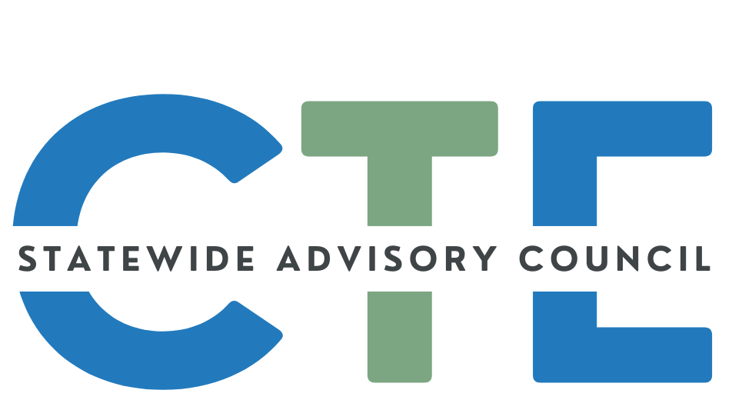
Working Agenda/Meeting Minutes

Date: 4/15/2026
Time: 2:00 PM - 4:00 PM

List of Attendees
Group Norms

Working Agenda
Please note: Meetings will be recorded for those that are unable to attend and will be posted on the Council website (along with the agenda/notes for future reference.)

Reminders: Cameras on, if possible.
Rename yourself to include full name and school/organization
Time | Topic | Notes
2:00 | Public Comment  (Caitlin / David) | Meeting started at 2:02PM  Guest(s):  - Amy Hodge  - Kayla Lowery
2:00 | Sad News  (Malinda) | Council member Carla Arciniega’s son passed away recently  - Memorial Information  - gofundme
2:02 | Opener / Business  (Caitlin / David) | Welcome/Introductions/Announcements  - Feedback Form  - Thank you to those who responded with great response  - Talked about feedback and reminding everyone to add thoughts  - Discussion around quarterly meeting schedule  - Next Meeting is typically scheduled for July (poor attendance)  - Current Schedule:  - January  - April  - July- Several said July was not good. Some said it was good and some said that August was good as well.  - October  - Slide Deck  Notes  - Next Meeting Conversation  - Should we have it in July? Polled the group  - Responses (2-3 responded)  - Discussed August as priority to consider over July  - Caitlin and Leadership team to consider August
 | State Director Updates  (Celia / Jenni) | ODE  Notes  - Jenni Introduces herself and role and updates  - Federal Budget Update  - Overview of the new accountability measures (see slides for details)  - Metrics required of all  - Some metrics defined locally  - David asks about the local measure at 2:17pm  - Jenni sees it as the fact that they are “on the board”  - Staffing  - Jenn Beachy is new Administrative Specialist - Congrats!  - In process with hiring business management education specialist  - Career Clusters  - Jenni emphasizes the importance of the work  - Goal to align with national movement  - Working in partnership together  - CTE State Plan  - Highlights federal encouragement to submit a joint CTE State Plan combined with WIOA Plan.  - David requests the opportunity for this group on the advisory council to help think about the strategic alignment and drafting. Come back to us with big chunks of questions so we can figure them out as the council  HECC (Marshall Curry and Eric Juenemann  - CCLSN Grant Ending  - Federal Expansion of Workforce Pell  - Integrated Education & Training (IET) Professional Learning Series  - Meeting schedule on slide
 | Career Clusters  (Marshall) | - Overview  - Shared the Screen for Advanced CTE website and different areas to look at for help  - ODE/HECC Work Plan Timeline  - Career Cluster update  - Next Steps - Crosswalks  - Discussion  - Please respond to these prompts sometime before May 15. They will be sent out as an email for everyone to respond. Email is on the slide to access.  - Questions from Chat:  - This timeline makes me ansty and ready to break the barrier! Are there any small tests happening around the state? Official or unofficial pilots?  - Not yet, working through  - Curious - in the current HECC system for post secondary programs, is there a place for the community college to identify secondary partnerships/program alignment? Secondary's system requires declaring a community college program alignment.  - Prompt for Statewide Advisory Council Members to Respond:  - Do you have the information you need to understand our current workforce system to contextualize the new career cluster framework? (Yes/No)  - Is there a specific area of our workforce system where you need more information? (Yes/No)  - What additional information about our current workforce system would give you what you need to advise us about the new career cluster framework? (List)  If you have additional context you’d like to share regarding your answers to help advise state staff in implementing the Career Clusters. Please email your ideas here: ODE Career Clusters <ode.careerclusters@ode.oregon.gov>
~3:00 | Break
3:00 | CTE Month Celebration  (Malinda) | - #ThisIsCTE Summary  - How did YOU Celebrate CTE Month?
 | State Plan Update  (Malinda) | - Implementation & Reporting Overview  - Year 1 Progress 24-28 CTE State plan  - What is different  - 3 buckets of work instead of 7  - Implementation process  - Project Mangers  - Smartsheet  - Stayed the same.  - Combination of state and local accomplishments  - Sharing highlight of 24-25  - Outcomes  Breakout Room Discussion Questions:  - From your perspective, what stands out as the most meaningful accomplishments from Year 1 of the State CTE Plan?  - Where do we need to strengthen employer or community involvement?  - How can we better track and communicate student success stories?  - Where are we seeing strong alignment across systems? Where are there disconnects?  - What additional supports, tools, or guidance would improve implementation of the CTE State Plan?  - What strategies could improve outreach and engagement?  - Based on Year 1 progress, what should be our top priorities moving forward?  - What should we continue, stop, or adjust?  - If you could recommend one change that would have the biggest impact on Oregon CTE, what would it be?  - What does success look like by the end of the 4-year plan?  Notes after the break out room  - Appreciation for the list of specific local accomplishments  - Sharing about the school level change from student  - Expanding the student awareness  - Posters up but more should know  - When students think about their secondary career as 4-year plan it can be really intimidating. BUild awareness that students can choose just one course and then go from there.  - Who is providing reports from the local levels  - Perkins grantee recipients  - Other grants like Nontraditional student pops  - Led to discussion about the messy landscape  - Challenging for industry partners to interface  - Led to separate regional advisory committee in partnership with RC launched one.  - But causes confusion. Stem Hubs too.  - Can’t solve, but could help minimize duplication of effort and improve coordination if we could figure out those lines.  - Working with Local Talent and Development board started asking about Career Connected Learning because it is nebulous.  - CCL is my case in point that is similar to the geography lines.  - Coming at this from industry instead of education partners, so I may need to, as the youth person, rethink and retool how we are partnering and dedicating funds instead of continuing same old funding model.  - Not something I’ve dived into in the past. Need to be more intentional.  - Support of other members curiosity shared.  - Goal to move to lower grades is done in CCL, but it is a struggle.  - CTE Programs of Study funding not allowable in elementary/middle school. Leads to lack of awareness.  - In the CCL field, we know that is a problem because we know if they have that intro, there is more that can be done at the high school level.  - Changing focus to think about those younger than 18 year olds  - High School challenge is in a natural cycle of continuing current CTE Programs of Study with teachers we have who are great, but then they leave, so we look to replace rather than explore how movement should occur based on LMI. Could see that more in the field, but it is much harder.  - Agreement from others  - Hard for funders to start new programs. Finding partners, trust new system, establish a realistic sustainability plan.  - Received email from middle school program request and looking to return to that after this discussion.
3:40 | CTE Student Advisory Council Updates & CTE Month  (Malinda) | - Combined ODE Youth Recruitment (More info below)  - CTE Ambassador Program  - Advisory Focus Moving Forward  - Member recruitment  - ODE Combined Effort  - Advisory VS Project - Based focus  - Student Driven Projects  - CTE Student Ambassador Program  - Meeting list  - CTE Students in Action newsletter  - #This isCTE  - A lot of engagement  - Positive feedback  - Shared examples of posts and projects  - Gigi Introduction  - Question  - has the partnership with ORACTE come to fruition yet? Or still in conversations?  - Wanted instagram but have not gotten that approved. Working with another partner such as Oregon ACTE but trying to grow that partnership.
3:50 -  4:00 | Announcements / Good of the Order  (ALL) | You are encouraged to add things to this section to share with the group! Please add your name so we know who added the info for future reference!  =====================================================  Reminder: If you’d like to submit content to the SCAC communication, the deadline is the end of the first week of each month  - Submission FORM  =====================================================  Share your CTE “Bright Spots” with a wider audience:  - #ThisIsCTE (social media) and the CTE Students In Action Newsletter - Submission Form  - CTE Update (monthly GovDelivery from ODE)  - Submit by the first working day of the month to ODE.ctecommunications@ode.oregon.gov  =====================================================

# # #

