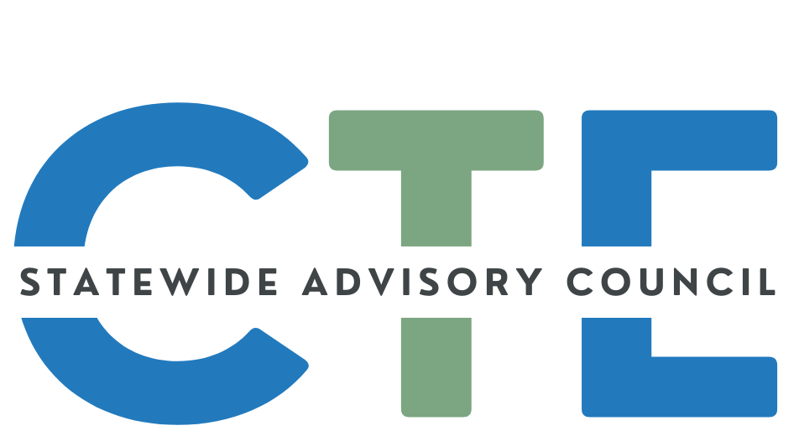
Meeting Minutes

Date: 4/23/25
Time: 2:00 PM - 4:00 PM

Meeting Attendance
Group Norms

Working Agenda
Please note: Meetings will be recorded for those that are unable to attend and will be posted on the Council website (along with the agenda/notes for future reference.)

Reminders: Cameras on, if possible
Rename yourself to include full name and school/organization
Time | Topic | Notes
2:00 | Public Comment  (Caitlin / David) | Guest Introductions:  - Didgette McCracken - No Comments  - Brandi Augenstein - Comments?  - Kerry Stern - Comments?  (Note: these individuals requested and were sent the meeting Zoom link, but were not in attendance.)
 | Opener  (Caitlin / David) | Welcome/Introductions/Announcements  - John Hickey: Billboard competition. Deadline is May 2. Share with Marketing/Graphic Design teachers/students. $250 Scholarship. ODOT Billboard Design Contest - ODOT. Contact John  - Charlie Hopewell: OES will be incorporated into work of Clean Energy PAC. Outreach continuing to business and education. Thanks to Beth Molenkamp! Bulk of support comes from CTE world.  - Kate Wurster: Columbia Gorge Advisory Committee Meeting. 50+ attendees from secondary education, community and industry partners. Columbia Gorge STEM Hub is launching an industry engagement campaign.  - Deron Fort: LBCC held 9th annual letter of intent signing day. 126 students signed up. Of those committing to CTE: 35% female, 31% first gen college, 17% adult learners. Higher numbers attributed to better promotion, snowball effect, etc.
 | National Career Clusters  Framework  (Johnie Ferro) | Slide Deck  Interest Form: https://tinyurl.com/CareerClusterTeam  Questions: reach out to johnie.ferro@ode.oregon.gov
 | Council Business (Caitlin / David) | Council Charter Teaser  - Current Version→Where we started and where we are going-Time to update charter and add anything we want to add  - Looking for volunteers to form Charter Review Committee - Send email and we can get people on a list when those meetings start.  - Thank you to those who volunteered! We are still looking for workforce development rep  The Statewide CTE Advisory Council Dashboard is LIVE!!  - Please use the form on the Dashboard to alert us to things that need to be changed or to make content suggestions
2:20 | State Director Updates  (Jennell / Shalee) | Jennell is attending the Advance CTE Spring Meeting in DC  - Legislative Updates  - Most bills are waiting in ways and means and many have gone away. Waiting for May revenue forecast. Approx. 20 are CTE-related.  - CTE Regional Centers Bill  - CC Student basic needs  - Program definitions switch  - Dual enrollment policy  - Bill Tracker: https://docs.google.com/document/d/1B6sRlaUs412dwQ-sUpzFtRivgVKHsvjX/edit  - Higher Education Benefits Navigators  - Funding has ended for colleges and public universities, but may return in final budget, depending on Ways and Means discussions, etc.  - Postsecondary CTE Math  - It IS college level, just not numbered as such.  ODE’s Update on Federal Actions Page  Federal Changes and HECC's Mission
2:40  ~ 3:05 | CTE State Plan  (Malinda)  BREAK | 2023 - 2024 State and Local Accomplishments - Slide Deck  (from the 2020 - 2024 plan)  - Breakout Rooms:  - Review Individually for - 5 minutes  - Group Discussion - 10 minutes  - What stood out to you?  - What questions do you have?  - What do you want to know more about?  - How might your work tie into things that the state or local Perkins recipients are doing?  - Populate the Slide that corresponds to your breakout room (starting on slide 15) - 5 minutes  - Designate a spokesperson to share highlights  - NOTES:  - People want metrics; was there more objective data?  - Identification of AI/AN+ within the data - expanding that collection  - Where programs are available across the state  - Is it possible to share the CAR report?  - Having the Data Team come to future Council meeting  - Comparison to participation rates around the state  - Are we collecting data on post-HS placement of CTE concentrators? Yes–a related Perkins Performance Metric exists…we’re trying to get better at collecting/sharing this type of data.  - Could we partner with Business & Industry or Chambers of Commerce to help in this area?  - What are other states doing?  - More detail or a way to connect to more information about some of the bullets would be useful  2024 - 2027 CTE State Plan Communication Materials  (Main goal is to raise awareness of the new CTE State Plan and to encourage engagement by getting folks to fill out the Support Form)  - Review & Utilize the communication materials in this FOLDER in your work with colleagues/partners. The folder contains a variety of materials to share in meetings or email in the course of your work and help spread the word about CTE and the importance of the work. We will be adding things into the folder as they are requested/created  - Complete: Communication Tracker FORM (to keep data to show where we were able to share that form and in what settings)  - An Easy Step: Create an Email Signature:  - SAMPLE:  - Read the Oregon CTE State Plan. Complete the CTE State Plan Support Form.
3:10 | Protecting Student Privacy- OAR Changes  (Karin Moscon) | We would like your input on some changes to the Oregon Administrative Rules for Protecting Student Privacy and a definition on Attendance  Slides  OAR 581-021-0220 and OAR 581-021-0371  Protecting Student Privacy Survey
3:20 | CTE Student Advisory Council Updates & #ThisIsCTE  (Malinda) | #ThisIsCTE Social Media Campaign  - 1 post every working day in February for CTE Month  - Still posting content on a weekly basis  - Post Screenshots  - Need help increasing reach  - FOLLOW ODE’s Facebook and/or X (Twitter) Accounts  - LOVE and SHARE, COMMENT or REPOST #ThisIsCTE content  - ADD #ThisIsCTE to your school/organization’s social media posts  CTE Student In Action Newsletter  - Volume 1 - “Hot off the press”  - Combined #ThisIsCTE and Student Newsletter content Submission Form  - First step in the CTE Ambassador Program  - Please help us share this with students  Spring Membership Recruitment  - We are looking for students to join the Council for the 25 - 26 School year  - Application Form - Due May 14
3:50-  4:00 | Announcements / Good of the Order  (ALL) | You are encouraged to add things to this section to share with the group! Please add your name so we know who added the info for future reference!  ========================================================  Reminder: If you’d like to submit content to the SCAC communication, the deadline is the end of the first week of each month  - Submission FORM  ========================================================  Share your CTE “Bright Spots” with a wider audience:  - #ThisIsCTE (social media) and the CTE Students In Action Newsletter - Submission Form  - CTE Update (monthly GovDelivery from ODE)  - Submit by the first working day of the month to ODE.ctecommunications@ode.oregon.gov  ========================================================  ========================================================

