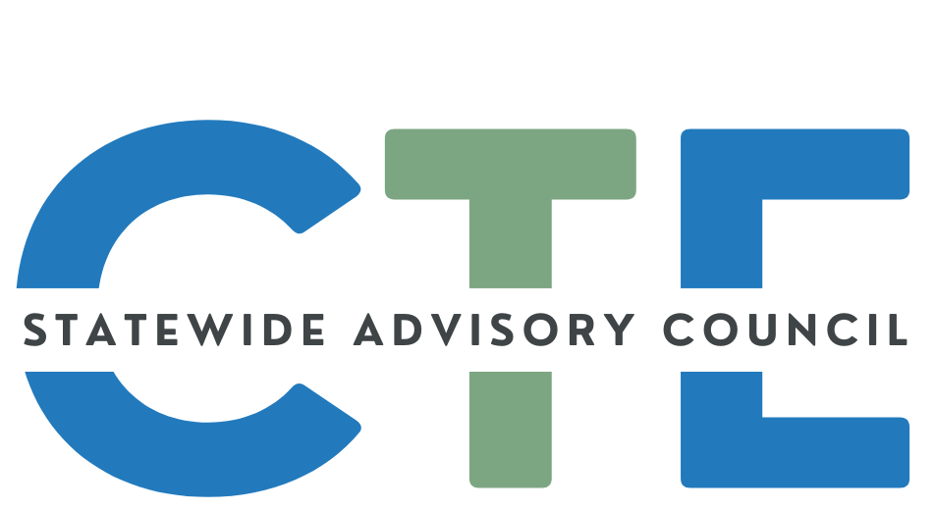
Working Agenda/Meeting Minutes

Date: 7/16/25
Time: 2:00 PM - 4:00 PM

List of Attendees
Group Norms

Working Agenda
Please note: Meetings will be recorded for those that are unable to attend and will be posted on the Council website (along with the agenda/notes for future reference.)

Reminders: Cameras on, if possible.
Rename yourself to include full name and school/organization
Time | Topic | Notes
2:00 | Public Comment  (Caitlin / David) | Guest Introductions:  - Brandi Augenstein  - Jennifer Blalock (not in attendance)
 | Opener  (Caitlin) | Welcome/Introductions/Announcements  - Welcome Zalika Gardner, Interim Director of SPST (Secondary-Postsecondary Transitions – ODE’s CTE Team)  - Member Slide Deck
 | Council Business (David) | SLIDE DECK  Council Charter Review Update  - Updated Outcomes for state plan:  - Malinda created the first version of the charter in 2021,and had the current membership provide feedback/edits. It hasn’t had major review/updates since that time  - Does the charter still hold true?  - What is our primary role?  - Specific language around the scope. Does wording need updating?  - Focus more on policy level rather than operational level.  - Data is a topic of interest  - If you have interest in being included in this discussion, reach out to Caitlin or David.  - How can we also leverage our partnership with Oregon ACTE and this Council  - Maybe have a space at the conference  Membership Status Form - Please fill out NOW  Please fill out during meeting and update your info
 | State Director Updates  (Zalika / Shalee) | ODE  - ODE Response to Federal Actions Page  - New team member that has come on board  - Work streams are being evaluated in light of staff retirements, etc.  - There will be a more detailed update at the next meeting  HECC  - HECC Budget (current service level)  - Response to Federal Actions  - Bachelor of Applied Science Degrees - Commission Notification  - Klamath Community College: Business Management – Salon Emphasis, Bachelor of Applied Science (BAS)  - Bachelor of Applied Science Education Consortium  - Columbia Gorge Community College: Education, Bachelor of Applied Science (BAS)  - Chemeketa Community College: Education, Bachelor of Applied Science (BAS)  - Linn Benton Community College: Education, Bachelor of Applied Science (BAS)  - Rogue Community College: Education, Bachelor of Applied Science (BAS)  - Treasure Valley Community College: Education, Bachelor of Applied Science (BAS)  - Behavioral Health Talent Council and Talent Assessment  - Future Ready Oregon commissioned a report  - Recommendation by January to the Governor  - HECC is staffing the Education Subcommittee  - New WIOA Eligible Training Provider List (ETPL) system  - New face and interface for colleges and providers to upload and access  - Perkins being moved at federal level from education to labor department - currently, this is an interagency agreement that is focused on collaboration  - https://www.ed.gov/media/document/ed-dol-fact-sheet-110396.pdf  - https://ctepolicywatch.acteonline.org/2025/07/supreme-court-clears-the-way-for-perkins-move-from-ed-to-labor.html
2:30  ~ 3:00 | Legislative Report Recommendations  (Brandie Clark)  BREAK | Slides  - Brandie is Work-Based Learning specialist on the CTE Team  - This is a required annual report – collaboration between ODE/CTE Team, HECC and BOLI  - Highlight progress on 7 goals and recommendations to the legislature  - Recommendations to the legislature are generally included as part of the report  - How to bring the Council’s voice into these conversations  - CTE courses as a grad requirement (ultimate goal)  - How do we connect and collaborate on initiatives (work is currently siloed)  - Do we need a marketing strategy?  - Who are we to withhold CTE opportunities from students when we have that data that shows that when they get CTE they are significantly more likely to go to school, engage, graduate, go on to post secondary and thrive careers because THEY are employable?  - Recommendation Form  - Please submit input by July 23
3:10 | CTE Student Advisory Council Updates & #ThisIsCTE  (Malinda) | Summer Break  Membership Recruitment  - Short Search Committee process this summer  - Fall Recruitment Push  - Application Form - Due September 30  - High school students, Community college students and recently graduated students- workforce connection  - Prelim conversations with Oregon ACTE re possibly setting up a student-facing Instagram account  - Current social media efforts are on ODE’s X and Facebook accounts (limited student exposure)
3:20 | CTE Data Conversation  (Rebecca Amodeo) | - Rebecca is a Data Analyst with ODE  - How-to: View Secondary CTE Programs in Oregon  - Overview: CTE Data Collections  - CTE Program Update - Fall  - CTE Student - Spring & Summer  - CTE Course - Spring & Summer  - Data collected is used in a number of ways:  - Formula funding Secondary Career Pathways  - Compiling Perkins reports  - CTE Course info is used internally in MOA process (civil rights monitoring)  - Question: Do we have data that follows students from secondary to postsec?  - Currently limited access, but moving toward improvement in that area.  - CTE Data Transparency: Continuous Improvement  - ODE is developing additional CTE information displays, including  - Aggregation of data for service to AI/AN+ students  - Centralized landing page answering OR CTE questions  - Expanded, interactive dashboards  - Clearly linked spreadsheets to data underlying visualizations  - Comparison of CTE and non-CTE participation rates  - Collection and reporting cycle infographics  - https://www.ode.state.or.us/apps/CTEReports/ApprovedPrograms/Details shows multiple years of Secondary CTE Program offerings across Oregon.  - Specific PS questions, please reach out to Kelly Zinck kelly.zinck@hecc.oregon.gov  - PS video  - Is the Oregon Longitudinal Data Collaborative - https://www.oregon.gov/highered/strategy-research/pages/oldc.aspx - still active, and does it include reports specific to CTE students?  - There is space for the Council to suggest data points/sets to look at  - It would be a good step for the Council to come up with a list of what data points we would like to see
3:45 -  4:00 | Announcements / Good of the Order  (ALL) | You are encouraged to add things to this section to share with the group! Please add your name so we know who added the info for future reference!  =====================================================  Reminder: If you’d like to submit content to the SCAC communication, the deadline is the end of the first week of each month  - Submission FORM  =====================================================  Share your CTE “Bright Spots” with a wider audience:  - #ThisIsCTE (social media) and the CTE Students In Action Newsletter - Submission Form  - CTE Update (monthly GovDelivery from ODE)  - Submit by the first working day of the month to ODE.ctecommunications@ode.oregon.gov  =====================================================

# # #

