5S Organizational System: Creating a Safer and More Productive Workspace
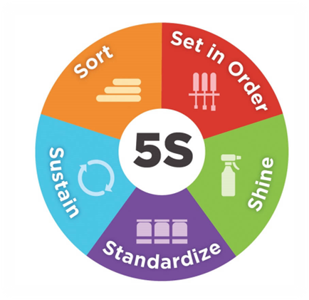
The 5S Organizational System is a proven method to enhance safety, efficiency, and productivity in learning environments like CTE classrooms and workshops. By following the five principles—Sort, Set in Order, Shine, Standardize, and Sustain—this system helps create a well-organized and visually intuitive workspace. While implementing 5S may seem challenging in environments with limited time and resources, starting small and building incrementally can yield significant benefits.

The 5S Principles
1. Sort
The first step in 5S focuses on reducing clutter by removing unnecessary items. Everything in the learning space must have a clear purpose and a designated place, or it should be removed. Tools like red tagging (for items to be disposed of) and yellow tagging (for items to be stored off-site temporarily) help streamline the process.
- Pro Tip: Sorting gives educators an opportunity to evaluate every item in the space. This hands-on process creates a foundation for the following steps.
2. Set in Order
Once essential items have been identified, organize them logically to maximize accessibility and maintain a clear line of sight for supervising students. Arrange tools, equipment, and materials so they are easy to locate and return to their proper place.
- Examples: Use labeled shelves, shadow boards to outline tool locations, and floor markings to define work zones and pathways.
- Pro Tip: Effective visual management not only saves time but also allows teachers to quickly spot missing items or unsafe practices.
3. Shine
With the space sorted and organized, the third step focuses on cleanliness. Regular cleaning prevents hazards, promotes safety, and maintains a welcoming and functional workspace.
- Activities: Dusting, wiping down surfaces, removing debris, and inspecting equipment for damage or wear.
- Pro Tip: Preventive cleaning measures (e.g., covering tools when not in use) can extend the life of equipment and reduce the chance of injury.
4. Standardize
Standardization creates consistent procedures to ensure the first three steps become routine. Develop and document best practices, assign roles and responsibilities, and use visual reminders to keep the workspace organized.
- Examples: Use checklists, conduct routine inspections, and hold team discussions to review progress and address challenges.
- Pro Tip: Standardization is about making the system sustainable—create simple, clear processes that are easy for everyone to follow.
5. Sustain
The final step, and often the most challenging, ensures that 5S practices become ingrained habits. Sustaining requires regular audits, ongoing training, and reinforcement of procedures.
- Examples: Form committees to periodically review the workspace, update processes, and celebrate successes.
- Pro Tip: Motivation is key—emphasize the long-term benefits of 5S for safety, efficiency, and overall classroom experience.

5S Considerations for CTE Classrooms
To implement 5S effectively, keep the following considerations in mind:
- Visual Management: Arrange the workspace to maintain clear line of sight for supervising students. This helps teachers monitor safety, ensure compliance with protocols, and respond quickly in emergencies.
- Labeling: Clearly label tools, storage areas, and equipment to ensure easy identification and accessibility.
- Shadow Boards: Use shadow boards to display tool outlines, making it easy to see when something is missing or misplaced.
- Floor Markings: Define pathways, work zones, and safety areas with colored floor markings to reduce congestion and guide movement.
- Color Coding: Use consistent color schemes for hazard levels, tool types, and zones (e.g., red for high-hazard areas, green for low-hazard zones).
- Ergonomics: Arrange workstations to minimize strain and discomfort, accommodating diverse student needs and promoting safety.
- Signage: Place clear, well-designed signage for safety guidelines, emergency exits, and the location of critical items like eyewash stations and first aid kits.

By incorporating the 5S principles and tailoring them to the unique needs of CTE programs, educators can create organized, safe, and productive spaces. Even small steps, like labeling tools or marking pathways, can make a big difference in promoting safety and efficiency, allowing teachers and students to focus on learning in a secure environment.

