Conducting a CTE Hazard Assessment: Equipment Hazard Ranking
In Career Technical Education (CTE) programs, students often use various tools, machinery, and equipment that present unique safety challenges. A systematic approach to identifying and ranking equipment hazards is essential for creating a safe learning environment. This process, known as equipment hazard ranking, involves evaluating the risks associated with each piece of equipment, assessing their severity and probability, and implementing targeted safety measures.
By following a structured hazard assessment methodology, educators can ensure that limited resources are effectively allocated, high-risk equipment is addressed promptly, and students receive the training necessary to operate safely. This approach enhances the classroom's safety and promotes a culture of vigilance and accountability.

How to Use the Hazard Evaluation Chart

(Sample chart at the end of this section)
Step 1: Identify Hazards
Create a comprehensive list of all equipment used in CTE classrooms. For each item, identify potential hazards, including:
- Mechanical Risks: Moving parts, pinch points, or sharp edges.
- Electrical Risks: Exposure to live wires or faulty wiring.
- Chemical Risks: Hazardous materials or fumes.
- Ergonomic Risks: Strains from improper use or handling.
Step 2: Assess Severity
Determine the potential impact of an accident involving each hazard using the following scale:
- S1: Minor injury or property damage.
- S2: Minor medical treatment required; minimal environmental impact.
- S3: Injury requiring medical treatment or moderate property/environmental damage.
- S4: Major injury requiring hospitalization; significant property/environmental damage.
- S5: Fatality or total disability; major property/environmental impact.
Step 3: Evaluate Probability
Evaluate the likelihood of the hazard occurring based on existing controls:
- P1: Multiple verified/documented controls in place.
- P2: One verified/documented control (engineering, administrative, or PPE).
- P3: One verified/documented administrative control or PPE.
- P4: Controls are not consistently applied or unverified.
- P5: No controls in place.
Step 4: Calculate Risk Score
Using a Risk Ranking Matrix, combine the severity (S1-S5) and probability (P1-P5) to calculate a risk score.
- Low Risk (Green): Scores <4
- Medium Risk (Yellow): Scores 4-9
- High Risk (Orange): Scores 10-13
- Critical Risk (Red): Scores >14
Step 5: Prioritize Risks
Rank the equipment based on their risk scores:
- Critical and High Risks: Require immediate attention and safety interventions.
- Medium and Low Risks: Review for potential improvements, but address less urgently.
Step 6: Implement Controls
Apply the Hierarchy of Controls to reduce risks effectively:
- Elimination: Remove the hazard entirely.
- Substitution: Replace the hazard with a less dangerous one.
- Engineering Controls: Isolate people from the hazard with physical changes.
- Administrative Controls: Update work practices, training, and procedures.
- PPE: Use personal protective equipment as a last line of defense.
Step 7: Train Staff and Students
Provide training tailored to the users’ level of responsibility:
- Awareness Training: Basic understanding of hazards and safety protocols.
- Operational Training: Focused training on safe operation of specific equipment.
- Competency Training: Advanced knowledge for maintaining safety compliance.

Example Application
Equipment: Table Saw
- Hazard Identification: Risk of severe cuts or amputations.
- Severity: S4 (Major injury requiring hospitalization).
- Probability: P3 (One verified/documented administrative control or PPE).
- Risk Score: High (12)
- Controls:
  - Engineering: Install blade guards and automatic shut-off features.
  - Administrative: Develop clear operating procedures and schedule regular training sessions.
  - PPE: Require safety goggles, tight fitting gloves, and hearing protection.

By following these steps, CTE programs can systematically evaluate and rank equipment hazards, ensuring that high-priority risks are addressed effectively. This structured approach fosters a safer learning environment, minimizes accidents, and prepares students and staff to navigate risks with confidence.

SAMPLE WORKSHEET
Severity | Impact (one or more) | Probability | Controls
S5 | Fatality. Total disability.  Property damage/monetary loss more than $100,000.  Irreversible environmental impact.  Operations not able to continue. | P5 | No controls.
S4 | Hospitalization. Partial disability.  Property damage/monetary loss of more than $50,000 but less than $100,000.  Reversible environmental impact.  Operations stopped more than 1 week. | P4 | Controls not consistently applied – OR –  Unverified/undocumented engineering controls  Unverified/undocumented administrative controls  Unverified/undocumented PPE
S3 | Injury requiring medical treatment or illness resulting in lost days.  Property damage/monetary loss of more than $25,000 but less than $50,000.  Environmental impact reportable to DEQ.  Operations stopped up to 5 days. | P3 | One verified/documented administrative control  – OR –  Verified/documented PPE control
S2 | Injury requiring minor medical treatment or illness not resulting in lost days.  Property damage/monetary loss of more than $1,500 but less than $25,000.  Minimal environmental impact.  Operations stopped no more than 1 day. | P2 | One verified/documented engineering control  – OR –  One verified/documented administrative control  – AND –  Verified/documented PPE control
S1 | Injury or illness resulting in first aid only.  Property damage/monetary loss less than $1,500.  No environmental impact.  No or very temporary impact to operations. | P1 | More than one of the following:  Verified/documented engineering controls  Verified/documented administrative controls  Verified/documented PPE

Risk Ranking Matrix — Severity x Probability Risk Score
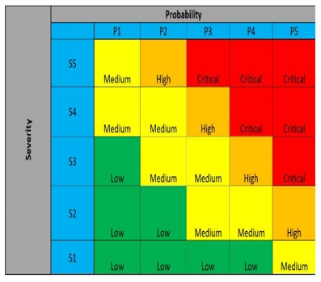
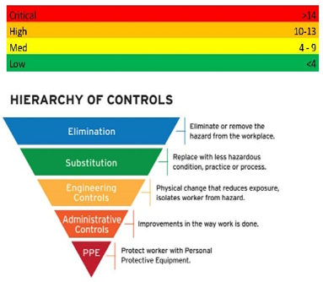

Training Level

- Awareness: Training regarding the topic but not a certification. Ability to identify hazardous situation. When encountered, staff will request assistance from other staff.
- Operational Level: Knowledge in expected application of skill and knowledge in the scope of work.
- Competent or Qualified Person: Regulatory agency requirement. Knowledgeable, competent and authorized to set or maintain compliance or safety standards.

