Hierarchy of Controls: A Foundation for Safety in CTE Programs

The Hierarchy of Controls is a systematic framework for managing workplace safety risks. It prioritizes measures that eliminate or mitigate hazards at the source, progressing through layers of controls to ensure comprehensive protection. In Career Technical Education (CTE) programs, this approach is essential to safeguard students and educators in diverse, hands-on learning environments.
By addressing hazards from the most to the least effective control measures, the Hierarchy of Controls promotes sustainable safety improvements while minimizing reliance on less effective measures like personal protective equipment (PPE).

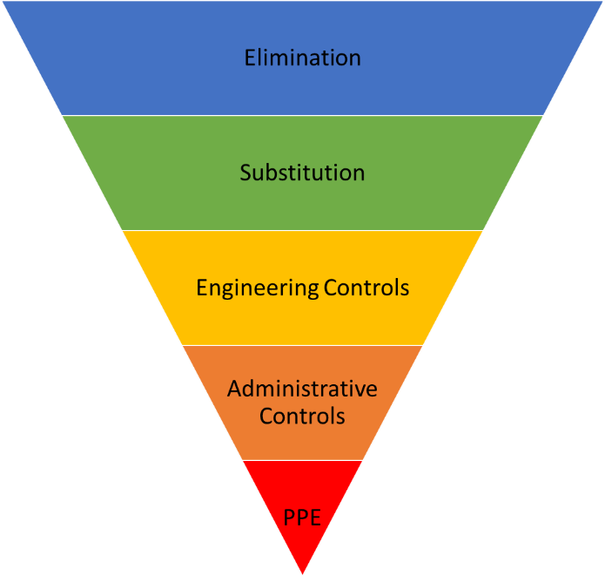

The Five Levels of Control
Young workers and students enrolled in Career and Technical Education (CTE) programs face higher rates of injury compared to their adult counterparts. According to the U.S. Department of Labor's statistics, young workers aged 16 to 19 experience more than 200,000 work-related injuries annually, with a significant portion occurring in high-risk CTE fields like construction, manufacturing, and culinary arts. In fact, the National Institute for Occupational Safety and Health (NIOSH) reports that students in hands-on programs like woodshop and welding are more likely to suffer injuries from machinery accidents, burns, and cuts. By incorporating robust safety protocols and emphasizing preventive education, we can reduce these incidents and ensure that CTE environments remain safe for all participants.
1. Elimination
The most effective way to control a hazard is to remove it entirely. By eliminating the source of risk, exposure is completely avoided.
- Example: Replace a high-risk table saw with a "SawStop" model, which features automatic blade-stopping technology, or remove tasks involving hazardous chemicals from the curriculum entirely.
2. Substitution
If elimination isn’t feasible, substitution involves replacing a hazardous material, tool, or process with a safer alternative.
- Example: Use a water-based cleaner instead of a solvent-based one to reduce inhalation hazards. Alternatively, replace manual lifting tasks with mechanical aids to minimize ergonomic strain.
3. Engineering Controls
Engineering controls focus on isolating people from hazards or redesigning systems to reduce exposure. These measures physically change the environment or equipment to make tasks safer.
- Example: Install machine guards on saws, drills, or other high-risk equipment to create barriers that prevent accidental contact with dangerous components.
4. Administrative Controls
Administrative controls involve adjustments to work practices, policies, or procedures to reduce hazard exposure. While not as effective as engineering controls, they can significantly improve safety when paired with other measures.
- Example: Implement mandatory safety training for students and staff, covering equipment operation and hazard awareness. Place clear safety signage near machinery to remind users of proper protocols.
5. Personal Protective Equipment (PPE)
PPE serves as the last line of defense, providing a physical barrier between the individual and the hazard. It is the least effective control because it does not eliminate or reduce the hazard itself but mitigates its impact.
- Example: Require students to wear safety goggles and gloves when working with sharp tools or handling hot materials.

Pro Tips for Effective Use
- Implement Interim Controls: If more time is needed to apply long-term solutions, use the Hierarchy of Controls as a guideline for implementing interim safety measures. Start from the top to ensure maximum effectiveness.
- Avoid Introducing New Hazards: Conduct thorough safety analyses before implementing any controls to ensure that new risks are not inadvertently created.
- Combine Controls: When no single method fully mitigates a risk, use a combination of controls. For example, pair engineering controls with administrative policies and PPE for comprehensive protection.

