Swiss Cheese Model: Building Resilient Safety Systems

The Swiss Cheese Model, developed by Dr. James Reason, is a powerful framework for understanding and mitigating safety risks. This model visualizes hazards on one side and potential losses on the other, with slices of Swiss cheese in between representing layers of defense. Each slice—a safety measure or line of defense—serves to catch or prevent hazards from progressing toward a catastrophic outcome.
How the Model Works
- Layers of Defense: Each slice of Swiss cheese symbolizes a control, such as training, policies, monitoring systems, or backup components. These layers work together to create a system of overlapping defenses.
- Holes in the Layers: The holes in each slice represent weaknesses or gaps in that specific safety measure—whether it's outdated policies, malfunctioning equipment, or human error.
- Alignment of Holes: When the holes in multiple layers align, a hazard can pass through all defenses, leading to an accident.
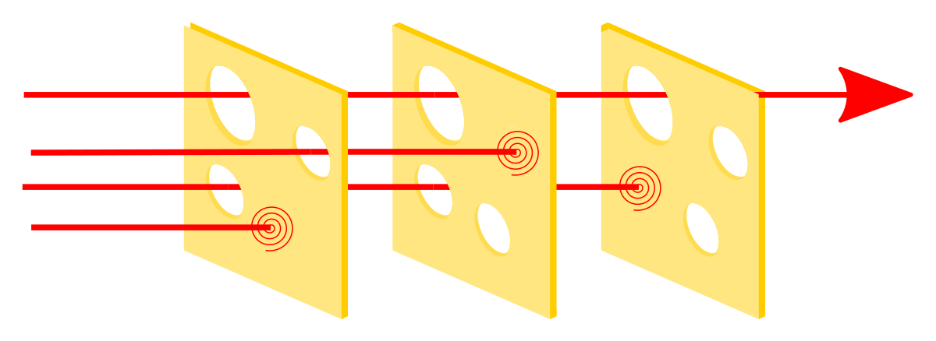
This model highlights the importance of a “defense-in-depth” strategy, where multiple, diverse layers of safety work together to prevent incidents. If one layer fails, others remain in place to catch the hazard before it causes harm.

Applying the Model in CTE Programs
While the Swiss Cheese Model is often used to analyze accidents after they occur, it is equally valuable during the design phase of a safety system. Proactively applying this model can help CTE programs create resilient systems by addressing potential gaps early on.
- Add Layers Thoughtfully: Although adding more layers (or slices of cheese) may seem like an easy solution, doing so can become costly, time-consuming, or even counterproductive. Instead of simply adding layers, focus on minimizing the holes in each layer or replacing weak layers with stronger, more effective measures.
- Simplify Where Possible: Choose solutions that reduce complexity and the likelihood of user error. For example, replacing a complex oxygen regulation system with one that delivers 100% oxygen reduces potential risks.

Designing Resilient Systems
The most effective safety systems are designed with resilience built in from the beginning. Incorporating multiple safety measures during the planning stages is far more effective than trying to retrofit them later. For example:
- User-Friendly Systems: Design tools and processes that are intuitive and simplify tasks. For instance, a maintenance system that pre-fills documentation after a part is scanned can improve accuracy and reduce workload.
- Continuous Evaluation: Regularly review and refine the layers of defense to ensure they remain robust and effective.

Balancing Risk and Reality
No system can be entirely risk-free. The goal is to quantify risks, control them to the greatest extent possible, and accept the residual risk. In doing so, CTE programs can create safety systems that are not only effective but also practical and sustainable.
By incorporating the Swiss Cheese Model into their safety planning, CTE programs can develop comprehensive, layered systems that reduce the likelihood of accidents and build resilience against unforeseen challenges.
Here are specific examples of how the Swiss Cheese Model can be implemented in both Manufacturing and Health Sciences classrooms within a Career and Technical Education (CTE) program:

Manufacturing Classroom Example

Context:
Students are learning to operate CNC machines. Key hazards include machine malfunctions, improper use, and lack of familiarity with safety protocols.

Layers of Defense:
- Training and Certification (First Layer)
  - All students must complete a safety training course and pass a certification exam specific to CNC operations.
  - Regular safety drills and demonstrations reinforce proper techniques.
  - Potential Hole: Some students might not fully grasp the training content or might rush through the material.
- Physical Safeguards on Equipment (Second Layer)
  - Machines are equipped with automatic shut-off systems and guards to prevent access to moving parts during operation.
  - Emergency stop buttons are accessible and clearly marked.
  - Potential Hole: Guards might not be used correctly, or emergency buttons could be obstructed.
- Monitoring and Supervision (Third Layer)
  - Instructors and trained assistants actively monitor students during machine operation to catch unsafe practices.
  - A monitoring system tracks machine usage and flags irregular patterns.
  - Potential Hole: Supervisors might overlook certain behaviors during busy class periods.

Alignment of Holes:
An accident could occur if:
- A student didn’t fully understand the training (first layer),
- The machine guard wasn’t secured properly (second layer), and
- The instructor was distracted or unable to intervene in time (third layer).
By addressing these gaps—e.g., through more engaging training, regular equipment checks, and structured observation schedules—the likelihood of an incident decreases.

Health Sciences Classroom Example

Context:
Students are practicing administering injections on mannequins and preparing materials for patient care. Hazards include needle stick injuries, contamination, and improper technique.

Layers of Defense:
- Detailed Instruction and Competency Checks (First Layer)
  - Students undergo thorough instruction on handling sharps and must demonstrate competency through hands-on assessments.
  - Clear protocols for disposal of sharps and managing exposure incidents are provided.
  - Potential Hole: Some students may become overconfident or fail to follow protocols under pressure.
- Controlled Environment with Safety Supplies (Second Layer)
  - The classroom is equipped with puncture-resistant sharps containers, gloves, and alcohol swabs to ensure sterile practices.
  - Only practice needles are used, and real sharps are introduced in later stages with close supervision.
  - Potential Hole: Supplies may run out or not be used correctly.
- Incident Reporting and Immediate Response Plan (Third Layer)
  - A clear reporting system for near-misses or minor incidents ensures that risks are identified early.
  - First-aid kits and a clear action plan for needle stick injuries are always accessible.
  - Potential Hole: Students may not report incidents promptly due to fear of judgment or lack of awareness.

Alignment of Holes:
An injury could happen if:
- A student skipped a critical step during training (first layer),
- Used a practice needle improperly or without gloves (second layer), and
- Failed to report a near-miss, delaying corrective action (third layer).
Improving each layer—e.g., adding engaging real-world scenarios in training, conducting daily equipment checks, and fostering a culture of safety reporting—helps mitigate risks.

Both examples demonstrate how the Swiss Cheese Model provides a proactive framework for safety in CTE programs, ensuring multiple, effective defenses are in place to reduce risks and promote resilience.

