Collaboration by State Agencies on Issues Related to Career and Technical Education
ORS 344.125
December 2022

Table of Contents
Executive Summary 2
Background 5
Progress on Goals Outlined in ORS 344.125 6
Recommendations 21
Conclusion 24

Executive Summary
In 2011, the Oregon Revised Statute 344.125 obligated representatives from the Department of Education, the Office of Community Colleges and Workforce Development, and the Oregon Bureau of Labor and Industries (hereafter: Partnering State Agencies) to collaborate on issues related to Career and Technical Education (CTE). Over the past year, these agencies continued to partner on the goals outlined in ORS 344.125. This joint report highlights the progress on the development and implementation of the goals and identifies recommendations related to Career and Technical Education.
ORS 344.125 Goals
- Ensure that career and technical education programs are available at the public schools of this state and through youth job development organizations as defined in ORS 344.415 (Definitions for ORS 344.415 to 344.425), are founded on partnerships with business and industry and receive appropriate investments of time, money and other resources.
- Develop regional centers that establish any appropriate partnerships between public schools, community colleges, public universities, businesses, unions and other entities and that ensure that every student of this state has access to a regional center in person or online.
- Encourage the establishment of joint high school and community college advisory committees that may include representatives of public schools, community colleges, public universities, businesses and unions.
- Address academic requirements and regulatory barriers that inhibit successful movement of students in career and technical education from high schools to post-secondary school programs and the workforce.
- Implement accelerated college credit programs that allow students to move seamlessly from public schools to post-secondary education or training to the workforce.
- Increase professional development opportunities for teachers and learning opportunities for students through industry mentorships, internships, summer programs, after-school programs and career-based student leadership opportunities.
- Establish partnerships between public and private entities for the purpose of educating students, parents, teachers, school advisors, policymakers and the general public about the benefits and opportunities related to career and technical education.
Progress on Goals
- Ensure that Career and Technical Education Programs are Available
During the previous school year, the Partnering State Agencies supported over 159,000 secondary students in 1,026 approved CTE Programs of Study, over 42,000 postsecondary students in 280 CTE Programs of Study, over 500 pre-apprentices in 38 Pre-Apprenticeship Training Programs, and 10,656 apprentices in 156 Registered Apprenticeship Programs. The secondary participation represents a significant growth in the number of students served over the previous year.

- Develop Regional Centers
The Willamette Education Service District opened a regional hub to provide access to Career and Technical Education programs for students across 11 school districts. The Medford Pre-Apprenticeship Construction Training program is also working to expand connections between high school CTE students across the region and registered apprenticeship training programs and community college pathways for the skilled trades.
- Encourage the Establishment of Joint Advisory Committees
The Partnering State Agencies expanded engagement with advisory committees by forming a new Statewide CTE Advisory Council, developing sector-specific advisory groups, and issuing updated guidance around the creation of regional advisory committees.
- Address Academic Requirements and Regulatory Barriers
Oregonians have a strong interest in mitigating barriers that inhibit students' preparedness for college and career, which is made clear by the Community-Informed Recommendations for Equitable Graduation Outcomes from the Senate Bill 744 Report. In alignment with their recommendations, the Partnering State Agencies have been developing a statewide CTE Program of Study framework that establishes new pathways for secondary CTE students to move into postsecondary CTE programs and workforce across the state.
- Implement Accelerated College Credit Programs
A key feature of the new statewide CTE Program of Study framework includes the design and implementation of expanded dual-credit opportunities. To explore the impacts of accelerated learning participation, ODE partnered with Education Northwest to launch the Oregon Accelerated Learning Dashboard. The dashboard provides information about public high school students who participate in accelerated learning and their high school and college outcomes compared to students who do not participate in accelerated learning.
- Increase Professional Development Opportunities for Teachers and Learning Opportunities for Students
Extensive professional development opportunities were offered by the Partnering State Agencies with a focus on implementing Career Connected Learning in middle schools, offering CTE work-based learning in high schools, and expanding connections to apprenticeship/pre-apprenticeship programs for all learners. Middle school students in 28 schools engaged in Career Connected Learning activities through YouScience, and 3,273 graduating CTE concentrators across all career clusters engaged in work-based learning experiences. A Harvard Fellows Report praised Oregon’s work-based learning data, highlighting that female students, Hispanic students, Pacific Islander (including Hawaiian Native) students, and English language learner students performed above the overall statewide performance. The Bureau of Labor and Industries approved the first Registered Youth Apprenticeship Program for manufacturing students in the Hillsboro School District.
- Educate Oregonians about the Benefits and Opportunities Related to Career and Technical Education
The Partnering State Agencies shared new approaches to messaging, such as a CTE Communications Tool Kit and a series of Career Journeys profile videos, and developed a Resource Hub for the upcoming release of digital curriculum, lesson plans, and other resources in support of Career Connected Learning.
Oregon defines the stages of career development through a system of Career Connected Learning—a framework of career awareness, exploration, preparation, and training that is both learner-relevant and directly linked to professional and industry-based expectations.
Recommendations
The recommendations identified in this report promote opportunities related to Career and Technical Education in alignment with the Career Connected Learning framework.
Career Awareness and Exploration - Support ongoing funding for Career Connected Learning, including middle school career awareness and exploration and marketing of the value of CTE and the pathways that are available to students across the state through continued support of agency budgets and continuation of projects developed with Elementary and Secondary School Emergency Relief (ESSER) Funds.
Career Preparation - Provide infrastructure and ongoing investment in postsecondary CTE and registered pre-apprenticeship programs to improve the ability of our community colleges and local apprenticeship committees to partner and support CTE education and the building of successful and seamless transitions into postsecondary training and employment.
Career Training - Continue the Future Ready Oregon investments in registered apprenticeship opportunities for health care and manufacturing industries and provide supportive services (including childcare subsidies and hardship assistance) to improve retention and completion of registered apprentices, including those who graduate from postsecondary CTE and pre-apprenticeship programs, with an emphasis on meeting the requirements of the Oregon Plan for Equal Employment Opportunity in Registered Apprenticeship Programs and Future Ready Oregon.
Interagency Partnerships - Create a clear statement and commitment to interagency collaboration and cross-agency alignment around Career Connected Learning through the Career Connect Oregon group. This group’s goal is to provide learners with clear and flexible on- and off-ramps between education and workforce development to support their unique journeys and to provide the quality and availability of workers needed for Oregon’s economy to thrive.

Background
Over the past year, the Department of Education (ODE), the Office of Community Colleges and Workforce Development (HECC), and the Oregon Bureau of Labor and Industries (BOLI) (hereafter: Partnering State Agencies) moved from development to implementation of the Oregon CTE State Plan and the Oregon Apprenticeship Strategic Plan. The three agencies continue working to align education, training, and workforce development in support of equitable prosperity for all Oregonians. A centerpiece of these efforts is supporting educators and workforce partners in expanding quality career preparation and training through Career and Technical Education (CTE), Oregon registered apprenticeship, and pre-apprenticeship opportunities.
Registered apprenticeship is an industry-driven, high-quality career pathway that allows participants to earn an income while receiving on-the-job and classroom training in a particular occupation or trade. Apprenticeship assists Oregon employers with meeting workforce demands while providing Oregonians with paid work experience that leads to a nationally recognized career credential and careers that earn family wages. Youth apprenticeship programs provide the same paid learning opportunities for individuals ages 16-18 who are enrolled in secondary education and successfully progressing toward high school completion.
Pre-apprenticeship training is designed to prepare individuals who have not traditionally been represented in apprenticeship (as defined in the Oregon Plan for Equal Employment Opportunity in Registered Apprenticeship Programs and Future Ready Oregon) to enter and succeed in registered apprenticeship. This training offers students opportunities to explore different apprenticeable occupations through hands-on activities and exploration activities. Pre-apprenticeship also focuses on career readiness skills. Over the past year, the Oregon Apprenticeship Collaborative has worked to strengthen the connection between secondary CTE programs and the registered apprenticeship system by assisting CTE programs to develop into certified pre-apprenticeship training programs and youth apprenticeship programs.
Career and Technical Education is a bridge between education and workforce development. Partnership, collaboration, and coordination among education and workforce partners is essential to providing high quality CTE Programs of Study. Approved CTE Programs of Study span K-12 and community college, incorporating standards-based academic content, business and industry identified technical skills, and workplace behaviors necessary for success in 21st century careers. CTE supports learners’ development of higher-order reasoning and problem-solving skills, work attitudes, general employability skills, technical skills, occupation-specific skills, and knowledge of all aspects of an industry, including entrepreneurship. CTE in Oregon is organized in six broad career clusters: Agriculture, Food, and Natural Resources Systems; Arts, Information, and Communications; Business and Management; Health Sciences; Human Resources; and Industrial and Engineering Systems.
The combined efforts of the Partnering State Agencies remain focused on removing barriers and ensuring access to CTE for all learners. In Figure 1, Advance CTE illustrates the reasons the agencies must function together.
Figure 1 - CTE Works for Everyone
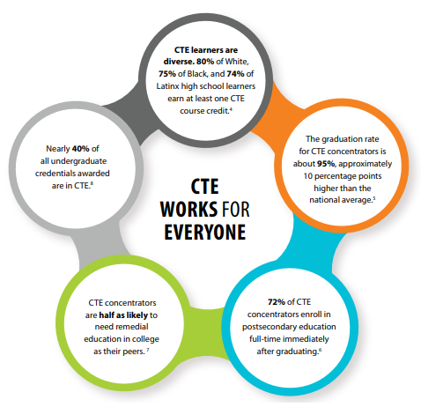

Progress on Goals Outlined in ORS 344.125
Goal #1 | Ensure that career and technical education programs are available at the public schools of this state and through youth job development organizations as defined in ORS 344.415 (Definitions for ORS 344.415 to 344.425), are founded on partnerships with business and industry and receive appropriate investments of time, money and other resources.
The past year brought continued efforts by state agencies, in partnership with business and industry, to create robust, well aligned, and equitable pathways for Oregon’s learners both into CTE, and from CTE into postsecondary opportunities and/or the workforce. On the postsecondary side, 133 new CTE certificate and degree offerings were approved by HECC during 2021-2022. Figure 2 represents the breakdown of these new postsecondary CTE options by career area.
Figure 2 - 2021-2022 New Community College CTE Certificate and Degree Offerings
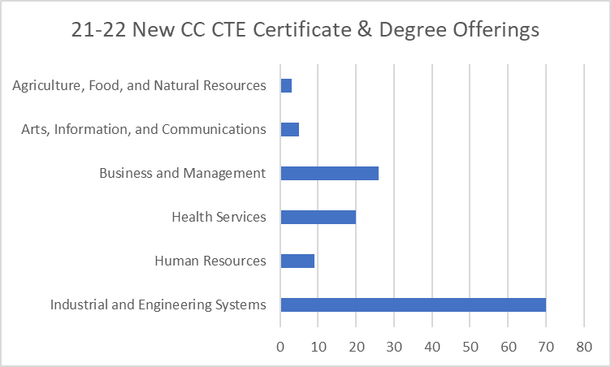
Over 11,000 postsecondary students concentrated in CTE programs at Oregon community colleges, and nearly 160,000 secondary students engaged in CTE in 2020-2021, as shown in Figure 3. (Please note: the 2021-2022 CTE data will be released in January 2023.)
Figure 3 - CTE Student Participation and Concentration in Secondary and Postsecondary Programs 2020-2021
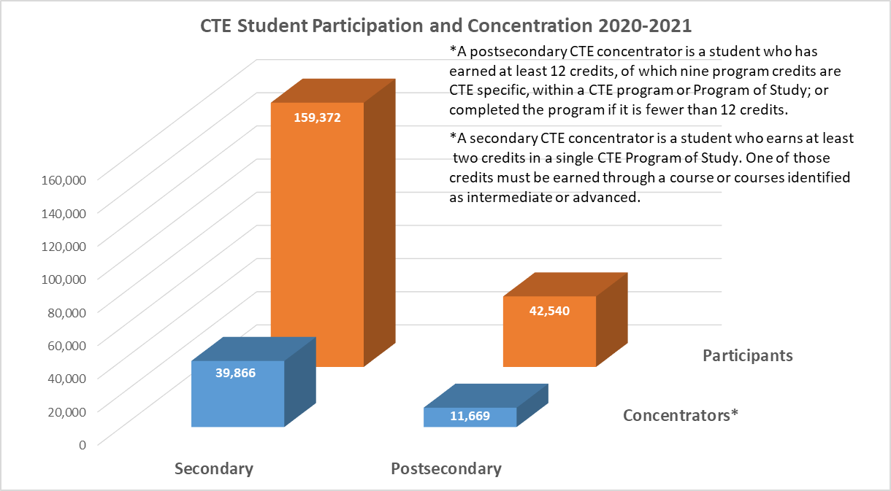
Great effort was undertaken to maintain and support secondary CTE Programs of Study during remote and hybrid instruction, despite staffing shortages and the challenges of COVID. The Arts, Information and Communications career area was even able to establish six new programs, as shown below.
Figure 4 - Number of Secondary CTE Programs of Study from 2020-2021 to 2021-2022
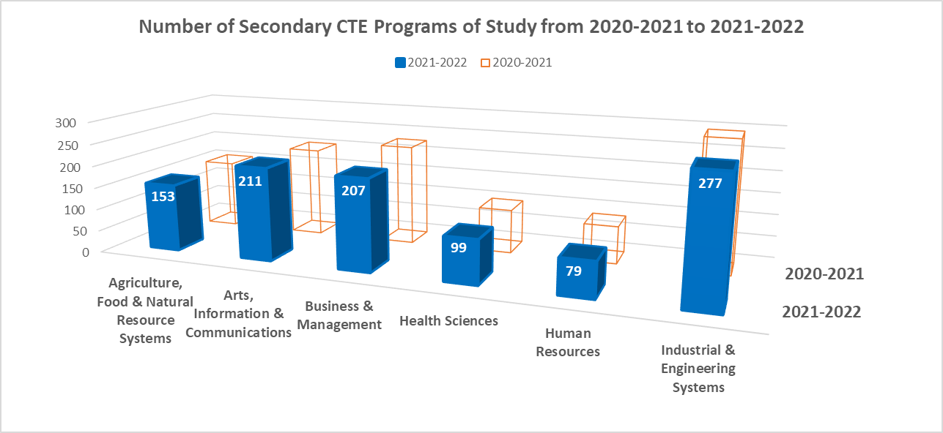
In July of 2021, Oregon received a $3.9 million federal State Apprenticeship Expansion, Equity, and Innovation (SAEEI) grant for the expansion and diversification of apprenticeship. Oregon chose to target the healthcare, construction, and information technology industries for focus of the grant. As of September 2022, five programs have been created, serving a combined 84 pre-apprentices and apprentices, as shown in Figure 5.
Figure 5 - 2022 Apprentices and Pre-Apprentices Served by SAEEI Grant Developed Training Programs
Pre-apprenticeship programs partner with registered apprenticeship programs to offer facilitated entry once they complete. Short-term investments in pre-apprenticeship feed long-term diversity in registered apprenticeship, which is a main component of the grant. The Partnering State Agencies are also accomplishing this by prioritizing veterans, women, and other priority populations defined by Future Ready Oregon in program selection, expanding pre-apprenticeship programs to rural areas, and registering new behavioral health programs to meet more of the state’s critical workforce needs.
The commitment from state agencies, educational institutions, and business and industry partners to ensure all learners have access to high-quality CTE programs remains strong.
Goal #2 | Develop regional centers that establish any appropriate partnerships between public schools, community colleges, public universities, businesses, unions and other entities and that ensure that every student of this state has access to a regional center in person or online.
The development of regional centers requires a long-term commitment that few organizations have the people, time, and money to move forward. Fortunately for students from across Marion, Polk, and Yamhill counties, the Willamette Education Service District, with partner funding, was able to bring its vision to life. The Willamette Career Academy welcomed its first students in the fall of 2021. The regional hub is operated by the Willamette Education Service District and provides access to CTE programs for students across 11 school districts. The Willamette Career Academy was developed through partnerships with regional school districts and local business partners. In 2021, students attended the academy for a morning or afternoon session in their chosen CTE program area: Diesel Technology, Cosmetology, or Health Services. In the fall of 2022, students were also able to join a Manufacturing Technology, Computer Science/Information Technology, or Construction Technology program, whose new spaces were partially funded by a lottery bond allocation. The new hub provides students with access to high-wage, high-demand career pathways that would otherwise be unable to be supported within their own smaller schools. Other regions continue to explore the creation of a regional CTE hub as an opportunity to expand CTE access for students in their communities.
Another approach to providing broader access to CTE is developing in Jackson County and the Rogue Valley. The Medford Pre-Apprenticeship Construction Training (MPACT) program continues to emerge as a central player in creating a regional center connecting high school CTE students with registered apprenticeship training programs and community college pathways for the skilled trades. MPACT currently serves 18 high school students across the Medford School District and has partnered with registered apprenticeship programs administered by IBEW Local 659, UA 290 Plumbers, Steamfitters, HVAC/R, Laborers’ International Union of North America (LiUNA), and the Pacific Northwest Carpenters to minimize barriers for youth participants to enter the skilled trades. MPACT has played a principal role in consulting with regional education and training providers and local non-profit service organizations to assist them with developing new pre-apprenticeship programs in more industries to serve Southern Oregon. In the coming year, the Partnering State Agencies will work to formalize a regional hub for trades education in Southern Oregon as they seek to welcome students from across multiple districts.
Goal #3 | Encourage the establishment of joint high school and community college advisory committees that may include representatives of public schools, community colleges, public universities, businesses and unions.

Collaboration between CTE Programs of Study and business and industry partners is critical to ensuring learners are prepared to transition to their next steps in their chosen career. Advisory committees provide the foundation for intentional partnerships that support, guide, and assist the development and implementation of CTE Programs of Study. Expanded engagement with advisory committees took place last year through the formation of a new Statewide CTE Advisory Council, establishment of sector-specific advisory groups supporting statewide Program of Study (POS) development, and issuance of new guidance around regional advisory committees.
A new Statewide CTE Advisory Council was established to build transparency and broaden the voices that contribute to Oregon's CTE State Plan development and implementation. The inaugural meeting was held in July 2021, engaging students, counselors, educators, administrators from secondary and postsecondary education institutions, workforce development, and business and industry partners. Statewide CTE Advisory Council membership prioritizes equitable representation from urban and rural communities, individuals from various racial and ethnic groups, Indigenous and immigrant populations, and individuals from the LGBTQ2IA+ community. Leaders of the Partnering State Agencies serve as ex officio members of the Statewide CTE Advisory Council.
The Council is an advisory body, with members providing knowledge, suggestions, and recommendations to advise ODE/HECC on issues related to Career and Technical Education, including the recommendations shared in this joint report. The Statewide CTE Advisory Council met four times over the 2021-2022 school year to provide ongoing advice, guidance, and feedback on the strategies and corresponding progress being made throughout the implementation of the CTE State Plan and its goals. The Statewide CTE Advisory Council will continue to meet at least once per quarter for approximately two to four hours, with additional workgroup meetings as needed. Meetings are open to the public.
Sector-specific advisory groups representing the four industry clusters of Architecture and Construction, Information Technology, Manufacturing, and Business, Management and Administration gathered to advise on the development of a statewide CTE Program of Study framework throughout the 2021-2022 school year. The purpose of the framework is to ensure equitable CTE program quality across the state, more consistent connections to college credit, and better alignment with business and industry needs. The participants included Oregon employers and professional associations, CTE advisory committee members from community college and secondary programs, community college and secondary CTE programs, CTE Regional Coordinators, and CTE administrators. The Oregon Department of Education contracted with Education Northwest to guide the work, with feedback from HECC and BOLI.
In the spring of 2022, the sector-specific advisory groups finalized lists of industry validated knowledge and skill statements to be used by secondary and postsecondary educators in CTE Program of Study design. The development of the new standards helped ensure that current industry workforce needs are central to CTE program design and that curriculum is kept current while promoting alignment and articulation between high school and postsecondary CTE programs. ODE and HECC hope to continue to find ways to partner with the sector-specific advisory partners as work progresses to develop and sustain the statewide CTE Program of Study framework. Sector-specific advisory groups representing the four industry clusters of Automotive and Heavy Equipment, Law and Public Safety, Education and Training, and Natural Resources/Forestry will embark on the same work in 2022-23.
Another key component of a CTE Program of Study is the alignment between secondary and postsecondary programs. High school and community colleges can strengthen relationships among educational institutions and with local partners by establishing joint advisory committees working toward the same goals for students across their community. In order to encourage more CTE Programs of Study to engage in regional advisory committees, representatives from ODE and HECC began revising the guidance in the CTE Policy Guidebook regarding advisory committees. They reviewed current guidance, statutes, and existing policies and procedures, and met with individuals facilitating advisory committees in the field within a variety of structures. They received feedback from both secondary and postsecondary programs relating to current practices, strengths, and challenges.
One example of regional advisory committees was established through a contract between Lane Community College and the Lane Education Service District and a local nonprofit, Connected Lane County. The organization now coordinates and facilitates advisory committees across all career learning areas for all 16 school districts in Lane County and Lane Community College. They bring together business and industry, postsecondary, and secondary representatives who focus on providing students in CTE Programs of Study with access to industry standard equipment, curriculum aligned to postsecondary and workforce, and access to work-based learning experiences. Beginning in 2023, Lane Community College will pick up the facilitation and leadership associated with these regional meetings. After looking at examples from the field, the committee drafted a proposal outlining guidance to promote regional advisory committees while still allowing local advisory committees. BOLI also engaged in the final recommendations of the committee. Local advisory committees can continue to provide direction and guidance to a specific CTE program offered by a district or institution. Regional advisory committees will provide direction and guidance for multiple CTE programs within the same career area across multiple districts or institutions. Postsecondary Programs of Study will be encouraged to lead regional advisory committees and include members from their aligned secondary Programs of Study.
The updated guidance will be released to CTE programs by the end of 2022 and will be included in the 2023-24 updates to the CTE Policy Guidebook. The CTE Advisory Committee Resource Handbook will also be updated to reflect the new guidance, with a scheduled release in 2023.
The Partnering State Agencies will continue the efforts to engage partners through advisory committees in support of each agency’s goals of strengthening workforce and educational systems.
Goal #4 | Address academic requirements and regulatory barriers that inhibit successful movement of students in career and technical education from high schools to postsecondary school programs and the workforce.
Ensuring that all of Oregon’s students gain the knowledge and skills needed to successfully transition to their next steps after graduation remains a long-standing commitment. The Partnering State Agencies are encouraged by the potential of the Community-Informed Recommendations for Equitable Graduation Outcomes from the Senate Bill 744 Report and the new statewide CTE Program of Study framework to mitigate barriers and generate progress.
The recently released SB 744 Report—Community-Informed Recommendations for Equitable Graduation Outcomes—contains recommendations from substantial community engagement efforts, including those with HECC partners. The recommendations get to the heart of academic requirements and regulatory barriers that are creating challenges for successful CTE student transitions from high school to postsecondary training and the workforce. One example of this pertains to Career-Related Learning Experiences (non-credit, structured educational experiences that connect learning to the world beyond the classroom).
- SB 744 Report Recommendation #7: Revise the Career-Related Learning Experiences requirement so it aligns with the updated “Essential Skills” list and definitions, and academic standards and/or continuing technical education (CTE) skill sets; establish increased accountability for schools to provide instructional time and support for students to complete the Career-Related Learning Experiences.
Another example of potential future efforts to remove barriers that inhibit successful student transitions from secondary to postsecondary and workforce is found in the recommendation for a new Future Planning course.
- SB 744 Report Recommendation #2: Add a 1.0 credit requirement for a Future Planning course (within the existing 24 credit requirement) that includes financial planning, interviewing, resume building, Free Application for Federal Student Aid (FAFSA) and Oregon Student Aid Application (ORSAA) completion, and other post-secondary preparation that will impact future success.
Some students receive support with these future planning activities already, but they are not currently graduation requirements. This recommendation would establish dedicated time for all students to receive such support. A substantial theme during engagement was that students need an opportunity to acquire a variety of real-world skills. Providing time for these skills will help students successfully transition to career, college, and adult life.
Finally, SB 744 also recommends changes to the Education Plan and Profile that will support smooth career and college transitions for Oregon’s learners.
- SB 744 Report Recommendation #3: Expand the Education Plan and Profile requirement to include a two-year post-graduation plan; establish increased support and accountability for schools to provide instructional time and support for students to complete the Education Plan and Profile; revise the Education Plan and Profile to function as a means of tracking all graduation requirements.
One approach in support of the clear desire from Oregonians to mitigate barriers that inhibit students' preparedness for college and career revolves around the development of a statewide CTE Program of Study framework, as noted in Goal #3 above. As CTE Programs of Study adopt the new skill sets and join the statewide framework, some of the barriers that hinder the transition of CTE students from secondary to postsecondary school programs will be lessened. The new statewide framework helps ensure more geographic representation in CTE program offerings through stronger alignment of education and workforce development across key industry clusters and more consistent connections to college credit for CTE students. Along with the skill validation with partners, the work also focuses on alignment between secondary and postsecondary programs through course sequencing.
In the spring of 2022, ODE released the knowledge and skill statements and applications to approve new statewide CTE Programs of Study in Architecture and Construction, Information Technology, Manufacturing, and Business, Management and Administration. The new framework supports student transition to career and further education and training by aligning course standards to industry-validated skills so that all students have access to consistent, high-quality CTE with opportunities to gain college credit and skills in high-demand occupations.
Over the upcoming years, the new statewide framework will continue to be developed across other industry clusters that inform Oregon’s CTE system. With expanded support, the new framework will strengthen collaboration between secondary and postsecondary partners, prompt the sharing of resources, and expand the skills and experiences provided to students through work-based learning opportunities and the integration of industry recognized credentials into courses. Statewide Programs of Study promote transition to postsecondary programs and employment for students across the state.
There is reason to be hopeful that the state can create opportunities for more students to transition from secondary to postsecondary CTE to workforce. Professional development, such as the series of CTE equity data trainings supported by Education Northwest, continue to help address barriers and increase access and opportunity in CTE as leaders review data, identify disproportionate outcomes, determine root causes, and plan improvements. However, the funding constraints of community college CTE remains a challenge for both student support and partnership efforts. To build on these promising efforts to remove barriers for students to access CTE, addressing CTE investments for community colleges will be paramount.
Goal #5 | Implement accelerated college credit programs that allow students to move seamlessly from public schools to post-secondary education or training to the workforce.
Dual credit opportunities in secondary CTE continue to be vital for student transitions into postsecondary education and the workforce. The CTE dual credit opportunities that are offered by high school instructors who meet community college instructor qualifications must be aligned to postsecondary CTE offerings and follow Oregon’s guiding principle for accelerated college credit partnerships—“credits with a purpose.” This means that participation in accelerated college credit in CTE is not random, but is purposeful and guided by alignment with a student’s postsecondary pathway goals and with strong advising/counseling support. Two areas of cross-agency innovation with direct connection to accelerated college credit in CTE from AY21-22 are further highlighted below:
- Statewide Programs of Study, as described under Goal #4: Accelerated college credit opportunities are a key feature of this collaborative, cross-sector work using a statewide framework for secondary and postsecondary alignment in CTE, as highlighted with one of the outcome statements for this work: “Reflect and provide feedback on how new dual-credit opportunities could be designed and implemented.”
- Launch of the Oregon CTE Dashboard and Accelerated Learning Dashboard:
- The Oregon CTE participation dashboard explores high school students’ participation in CTE Programs of Study across the state from 2015-2016 to 2020-2021. CTE program providers and educators can use these data for completing comprehensive local needs assessments (CLNAs) or engaging in program improvement. CTE participation and retention data in the CTE Dashboard can be compared by career area, levels of participation/credits earned in CTE, English Language Learner (ELL) status, Free and Reduced Price Lunch recipients, Gender, and Individual Education Plan (IEP) status.
- The Oregon Accelerated Learning Dashboard provides participation rates of high school students in accelerated learning courses from 2016-2017 to 2020-2021. It also compares outcomes such as high school graduation, immediate and 16-month college enrollment at Oregon community colleges and public universities, developmental education course enrollment, and college persistence for immediate and 16-month enrollees between students who participated in accelerated learning and those who did not. Data in the accelerated learning dashboard can be disaggregated by Gender, Race/Ethnicity, English Language Learner status, and by students with Individualized Education Programs.
In the fall of 2022, a two-part training was offered to regional teams of educators by ODE and HECC staff, in partnership with Education Northwest, to provide an orientation to these data dashboards as well as for regional teams to develop strategies to support equitable access and engagement in CTE and college credit opportunities while in high school.
Goal #6 | Increase professional development opportunities for teachers and learning opportunities for students through industry mentorships, internships, summer programs, after-school programs and career-based student leadership opportunities.
The Partnering State Agencies provided a variety of professional development opportunities for school personnel and other organizations, as well as learning opportunities for students, with a focus on Career Connected Learning throughout the 2021-2022 school year. Oregon defines the stages of career development through a system of Career Connected Learning—a framework of career awareness, exploration, preparation, and training that is both learner-relevant and directly linked to professional and industry-based expectations. The framework encompasses four key stages:
- Career Awareness—learning ABOUT work
- Career Exploration—learning FOR work
- Career Preparation—learning THROUGH work
- Career Training—learning AT work
Engaging younger students in Career Connected Learning (CCL) allows them to explore different careers and better plan their next steps from high school to postsecondary to workforce. To support partners in implementing Career Connected Learning in middle schools, several professional development opportunities were provided.
- Professional learning opportunities were delivered to guide schools toward providing learners with career experiences earlier in secondary grades. Twenty-eight schools engaged in a YouScience pilot program to help middle school students identify their aptitudes and the careers and educational pathways aligned with them. Through self-discovery, students explored broader ranges of careers, made connections to CTE programs, and undertook more purposeful course selection. Over 180 schools will continue the YouScience pilot program in 2022-2023, further expanding the career guidance of young learners and our ability to diversify Oregon’s workforce.
- Monthly updates with the Comprehensive School Counseling Program Leadership Network occurred to overview CCL efforts with regard to ESSER spending, share about tool and resource development, encourage conversations to engage administrators in developing a school culture of CCL, and align the American School Counselor Association (ASCA) Career Conversations with resources to be housed in the CCL Resource Hub for all practitioners.
- Professional learning around Career Connected Learning was offered at C3 (Career College Collaborative), HECC’s Office of Student Access and Completion mentorship program, ASPIRE, STEM, CTE/STEM Network, Workforce Talent and Development Board, individual school districts, and Education Service Districts (ESD). Additional opportunities to promote and develop partnerships around Career Connected Learning took place through presentations at the Coalition of Oregon School Administrators conference, CTE State Conference, Career College Collaborative, ASPIRE, and ESDs.
Students who are exposed to a wide variety of careers throughout their elementary and middle school experience through career awareness and career exploration are more prepared to engage in a deeper dive through a CTE Program of Study in high school. CTE students are prepared to apply their skills by engaging in career preparation and training, specifically work-based learning experiences. Through the combined efforts of the Partnering State Agencies, a variety of professional development opportunities were provided to support CTE partners in implementing work-based learning (WBL) for students.
- Facilitated a series of three statewide WBL and Equity trainings for K-12 that focused on creating access and opportunity for historically and currently marginalized student populations in WBL.
- Worked with three regions (Multnomah ESD, Clatsop/North Coast, and Douglas ESD) to organize individual follow-up sessions from the WBL and Equity trainings themed “Highlighting Equitable Implementation of WBL.”
- Presented two sessions at the 2021 ASPIRE Conference on WBL and Apprenticeship.
- Provided three technical assistance workshops (Sabin-Schellenberg, Portland Public School District, and South Coast ESD) focused on the continuous improvement of WBL.
The 2021-2022 school year represents the second year of implementation of CTE work-based learning in alignment with the CTE State Plan. Work-based learning is defined as structured learning in the workplace or simulated environment that provides opportunities for sustained interactions with industry or community professionals that foster in-depth, firsthand experience of the expectations and application of knowledge and skills required in a given career field. Year one experiences for students included a Cooperative Work Experience, Clinical/Internship/Practicum, School-Based Enterprise, Service Learning, or Workplace Simulation. Year two experiences expanded to include Pre-Apprenticeship.
The Partnering State Agencies broadened support and promotion of pre-apprenticeship programs aligned to CTE Programs of Study throughout the past year. The Oregon State Apprenticeship and Training Council approved four new secondary Registered Pre-Apprenticeship Training Programs—in the areas of electrical, construction, and medical assistant—which serve high school youth in Rogue, Marion, Polk, Linn, Southern Yamhill, and Washington counties in 2021-2022. BOLI also approved the first Registered Youth Apprenticeship program. In the fall of 2022, the Hillsboro School District welcomed its first cohort of student apprentices from its Industrial and Engineering Systems CTE program to become manufacturing technicians. Providing students ages 16-18 with hands-on, paid training is a key strategy for supporting students who have historically experienced disparities in Oregon’s schools and growing a diversified skilled workforce. The momentum is continuing as more schools are exploring the development of pre-apprenticeship programs; the Oregon Community Colleges Apprenticeship Consortium also seeks to support the growing efforts.
Two workshops were provided to further expand connections to apprenticeships/pre-apprenticeships:
- To promote apprenticeship as an option after high school, the state apprenticeship team identified a goal of embedding apprenticeship into the ASPIRE program. Staff worked to identify training needs for the ASPIRE mentors and targeted specific conferences and webinars for this purpose. More work will occur to strengthen the partnership and ensure ASPIRE mentors are knowledgeable about apprenticeship.
- To provide training and technical assistance to support the rapid expansion of apprenticeship and secure future funding, HECC and BOLI-ATD held a convening with the Local Workforce Development Boards. The May 2022 convening provided professional development with the goals of gaining a solid understanding of the apprenticeship model and the current landscape of apprenticeship programs, as well as learning how local boards can be facilitators in apprenticeship expansion.
The new Perkins V Performance Indicator around work-based learning measures the percent of CTE concentrators graduating from high school in the given year with at least one CTE work-based learning experience. Statewide performance in year one was at 33.97%. The work-based learning requirement is greatly increasing student engagement with business and industry.

Figure 6 - Secondary CTE Work-Based Learning Participation by Career Cluster 2020-2021
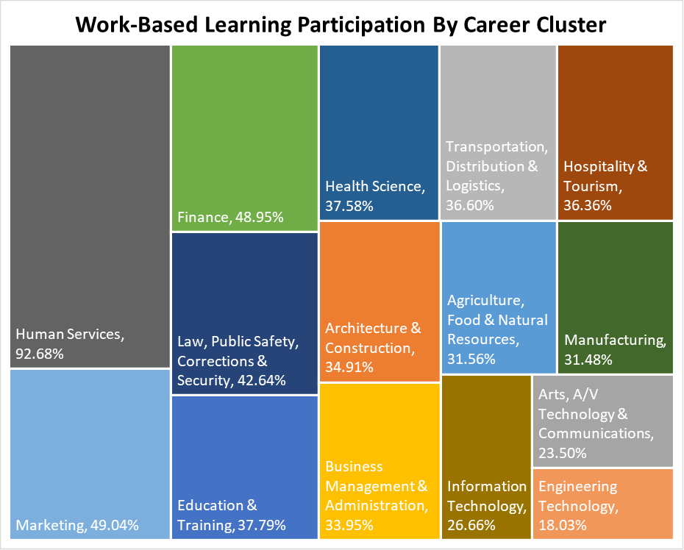
The state performance target for work-based learning was exceeded across all career clusters and special populations during the first year of implementation. As a result, Oregon was featured in a Harvard Fellows Report, “Promising Practices to Closing Equity Gaps in Career Technical Education.” The case study highlighted that, relative to other states, Oregon reported fewer equity gaps, with female students, Hispanic students, Pacific Islander (including Hawaiian Native) students, and English language learner students performing above the overall statewide performance.
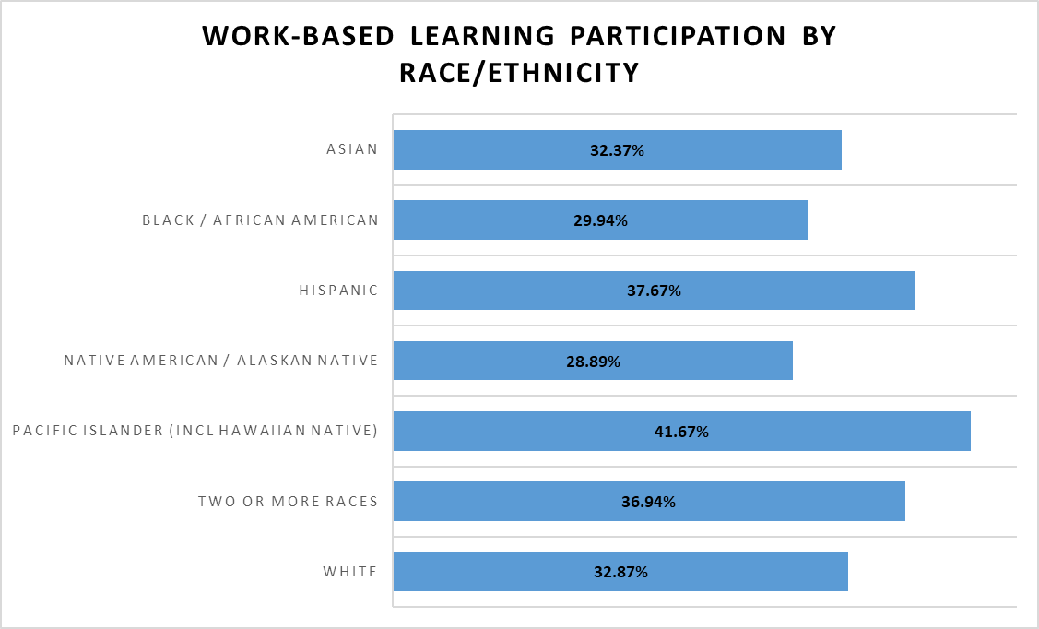
Figure 7 - Secondary Work-Based Learning Participation by Race/Ethnicity 2020-2021
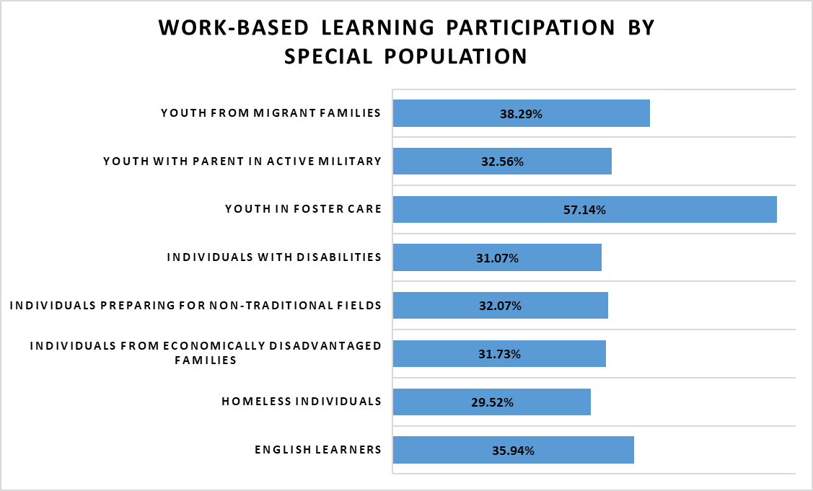
Figure 8 - Secondary Work-Based Learning Participation by Special Population 2020-2021
Year two data will be available in January 2023 with expectations that it will continue to reveal expanded access to work-based learning opportunities for all students. The effort will be supported by Career Connected Learning Systems Navigators at each of Oregon’s 17 community colleges. The hiring began in the summer of 2022 to support an aligned system from K-14 for Career Connected Learning. The positions have been funded through the 2023-24 school year, along with a CCL Tribal Liaison. The Tribal Liaison is responsible for developing and maintaining relationships with members from Oregon’s nine federally recognized tribes, representing ODE’s CTE and CCL programs before the Government-to-Government Education Cluster and, as needed, ODE’s American Indian/Alaska Native Education Advisory Council, and fostering collaborative projects with the Tribes to implement CTE and CCL program services. The new staff will support systems to connect workforce and schools within their regions and across the state while boosting equitable Career Connected Learning opportunities for all learners.
In addition to the support around Career Connected Learning and work-based learning, important efforts were undertaken to improve outcomes for the newest CTE teachers. A plan for a statewide CTE mentoring framework was developed in 2021-2022. It will be released in the fall of 2022 to support CTE teacher mentorship in high need areas of the state. The plan includes a Guide for CTE Mentors and creating a cadre of statewide CTE mentors who can virtually support new CTE teachers. CTE teachers come to education with experience in their specific field that they are ready to share with students, but they may not have the needed background in the pedagogy of teaching. Positive outcomes for CTE students begin with effective teachers. The Partnering State Agencies are also exploring opportunities for an apprenticeship pathway for classroom teachers in collaboration with the Teacher Standards and Practices Commission (TSPC) and other interested partners.
Goal #7 | Establish partnerships between public and private entities for the purpose of educating students, parents, teachers, school advisors, policymakers and the general public about the benefits and opportunities related to career and technical education.
The agencies are continuously working to improve the experiences of students in Oregon’s CTE Programs of Study. However, in order to grow a qualified workforce and prepare students with the skills needed for success, we need to continually motivate them to engage in Career and Technical Education. The work of connecting students to the opportunities available within CTE is far from over. New approaches to messaging were produced and shared last year to reach students, parents, teachers, school advisors, and the general public.
In early 2022, ODE released a CTE Communications Tool Kit. The tool kit provides a set of resources to equip schools and districts throughout Oregon with the messaging and tools they need to communicate about their school or district’s CTE program(s) to help attract future students as they select courses for the next school year. The tool kit includes content for students, families, staff, and local news media about CTE, including information that can help dispel outdated ideas about what CTE is, through examples of current CTE pathways. ODE also ran a social media campaign to help lift awareness and access around CTE programming among students historically and currently marginalized in CTE programming. ODE also created a more forward facing CTE web home page, (www.oregon.gov/CTE). This resource serves as an important starting point, but there remains more work to communicate the value and importance of CTE and encourage participation statewide, including among special populations.
In the spring of 2022, ODE released a series of 10 Career Journeys videos created in partnership with the Journalistic Learning Initiative based out of the University of Oregon School of Journalism. Each video highlights a barrier or obstacle that a person overcame in their life or in their studies while in pursuit of completing school or entering a high-wage, high-demand career across the state. The profiles allow middle and high school youth to see and hear the stories of diverse Oregonians near to their age, who attended Oregon middle, high, and postsecondary schools or training opportunities. An additional 20 Career Journeys videos will be released by the end of 2022.
In October of 2021, the Adult Learner Advisory Committee (ALAC) presented it definition and pilot methodology for identifying which credentials are “valued in the workforce” to the Higher Education Coordinating Commission and Workforce and Talent Development Board (WTDB). Members of HECC and the WTDB co-chaired the committee and were joined by representatives from business and industry, postsecondary education and training, labor, the HECC Equity Council, and others. The methodology for identifying their Credentials That Work includes weighted factors around demand and wages for associated occupations, whether the credential prepares a completer for direct entry into a high-wage, high-demand job, whether the credential is competency-based, and whether the credential is stackable to additional education and training.
Through a grant from Advance CTE, HECC was able to improve the methodology and present updated results in May 2022. The analysis resulted in a list of the top 100 occupations representing over 800 credentials offered at all 17 community colleges in the state. The new lists serve as a starting point for reducing attainment gaps by connecting learners to valued community college certificate programs and applied associate degrees. The next steps are to continue to refine and improve the methodology, measure actual earnings of those who completed a Credentials That Work, and provide annual updates of the Credentials That Work analysis as program offerings, wage, and demand data change. The work is paused, seeking resources for next steps.
Oregon has been invited to present its work under the Advance CTE grant with partners across the country. The session will highlight our next step to exploring the potential for shifting from static, PDF format data reports to more interactive displays. The interactivity would enable users to view trend data for all or selected colleges, explore program-level reports, and disaggregate results at the learner level based on gender, race/ethnicity, and special population as defined by Perkins V.
Throughout the past year, educators, counselors, career and college specialists, and community partners collaborated to produce Career Connected Learning materials focused on career awareness and exploration strategies and approaches. The partners engaged in multiple CCL Strategy and Guidance Groups and curriculum and professional development CCL Design Teams worked closely with partnering ESDs in the construct of the CCL system and framework, including Southern Oregon, High Desert and Willamette ESDs, and Dialogues in Action. The resources include access to platforms, digital curriculum, communication templates, guidebooks, professional development, scope and sequence, and lesson plans directly related to the four domains of Career Connected Learning: Awareness, Exploration, Preparation, and Training. The CCL Resource Hub should be available in late 2022 to guide middle and high school administrators, educators, counselors, and volunteer/mentors in helping students find their career pathway.
Career Connected Learning has the opportunity to connect all young learners to CTE in high school and beyond. The effort still needs a great deal of attention to further develop and sustain the Resource Hub; expand the resources for parents, students, business and industry partners; support professional development; and provide marketing and communication tools/resources on the availability and implementation of CCL.

Recommendations
Through collaborative efforts, the Partnering State Agencies have advanced the goals outlined in ORS 344.125. The work has also given rise to the following recommendations for improving opportunities related to Career and Technical Education developed in collaboration between the three agencies, the Oregon CTE Advisory Council, and CTE leaders across the state. These recommendations are aligned with the key stages of the Career Connected Learning framework.
Recommendation #1 Career Awareness and Exploration | Support ongoing funding for Career Connected Learning, including middle school career awareness and exploration and marketing of the value of CTE and the pathways that are available to students across the state through continued support of agency budgets and continuation of projects developed with Elementary and Secondary School Emergency Relief (ESSER) Funds.
Career Connected Learning brings K-12 education, postsecondary education, business and industry, and community based organizations together toward the same goal of connecting learning across all subjects to each student’s future. Students who are exposed to a process of self-discovery, occupational visioning, goal-setting, self-reflection, and consistent guidance by caring adults are able to find and pursue career path opportunities in line with their strengths and passions, giving the workforce access to a diverse pool of employees. CCL focuses on all aspects of the education and training system, and the adults working within, to help all students to fully engage in their academic, technical, and employability skill development so they can successfully transition from school to work in satisfying and viable pathways.
In order to provide meaningful CCL to students and engage industry in developing their own talent, Oregon needs time, commitment, and investment across education and workforce. Backing for this recommendation is also evident in the Open Letter that was distributed, inviting action from leaders in Oregon to expand support of Career Connected Learning. The letter originated from the CCL Strategy Guidance Team, who shared it with other contacts. As of October 2022, 62 people had signed on and noted why they are in support of CCL. If we want to prepare Oregon students to thrive after graduation, we need employers to partner with the educational system to identify, inspire, and invest in the development of an individual student’s talent. We further need schools and the entire education system to embed a culture of career focus across all curriculum and instruction. When students realize how their learning applies to the real world, they are more motivated to engage in their learning, develop and apply self-agency, and connect with their community, which results in a system that benefits students, employers, and communities.
The Statewide CTE Advisory Council strongly supports expanding efforts to educate Oregonians about the benefits and opportunities related to Career and Technical Education. They would like to see an elevation of existing communication strategies, alongside additional funding for dedicated personnel and promotional strategies to support the ongoing marketing of CTE. They also propose funding a statewide interactive navigation/information map to help multiple audiences understand CTE, the connections and alignment that exists (or could exist), and the pathways that are available for students across the state. The Partnering State Agencies support the recommendation of the Statewide CTE Advisory Council.
Recommendation #2 Career Preparation | Provide infrastructure and ongoing investment in postsecondary CTE and registered pre-apprenticeship programs to improve the ability of our community colleges and local apprenticeship committees to partner and support CTE education and the building of successful and seamless transitions into postsecondary training and employment.
Completion of postsecondary CTE and registered pre-apprenticeship programs provides pathways to high-wage, high-demand careers in Oregon through community college certificates and degrees and registered apprenticeship journey worker credentials. Investment in postsecondary CTE and registered pre-apprenticeship programs can provide opportunities for out-of-school youth and mid-career workers who need on-ramps back to postsecondary training and employment. Together, these investments can help Oregon to meet the middle-40 of its 40-40-20 education goal, which a recent OPB report found is missing the mark: “The bad news: Oregon has a lot of work to do when it comes to that middle 40%.”
In a 2021 study from the Georgetown University Center on Education and the Workforce, research showed that associate degree holders in CTE fields like architecture and engineering, health practitioner, skilled trade, and computer occupations can earn more than $2 million over their lifetimes, up to $2.8 million— the same as the median lifetime earnings for workers with bachelor’s degrees. Postsecondary CTE completers also help to fill the nationwide skills gap. According to a 2020 study from the U.S. Chamber of Commerce Foundation, nearly three-fourths of employers surveyed nationwide (74%) agreed that a “skills gap” in the skills they need and the skills workers have persists in the current U.S. labor and hiring economy. CTE programs help bridge this skills gap. Recent state investments in CTE have elevated the importance of, and focus on, CTE at the secondary level as a critical lever for learners’ future economic prosperity, creating healthy communities, and meeting labor market needs now and in the future. However, postsecondary CTE investments have lagged behind.
In the Portland Metro Region Construction Workforce Market Study (2018), it was estimated that thousands of additional pre-apprentices would need to be trained in order to meet the projected need of public owners for a diverse construction workforce. Future Ready Oregon made a down payment on this investment, but funding for the BOLI-managed pre-apprenticeship expansion efforts was committed only for the remainder of the 2021-2023 biennium.
HECC’s legislatively approved budget for 2021-2023 does not contain any specific investments for postsecondary CTE, which creates a barrier in meeting the performance metric for all CTE Programs of Study related to learner transition from secondary to postsecondary enrollment. In program year 2020-2021, 36.14% of CTE concentrators were enrolled in a postsecondary opportunity in the second quarter after exiting the secondary environment, which is short of the statewide performance target of 49.30%. When students do enroll in postsecondary CTE opportunities, they are successful in earning recognized postsecondary credentials during participation in a CTE POS or within one year of program completion. In the program year 2020-2021, 48.46% of postsecondary CTE concentrators met this performance metric, well above the statewide target of 39%. With further investment in postsecondary CTE, community colleges will be able to invest in high quality CTE programs that include up-to-date industry equipment and facilities, excellent faculty and staff, wraparound support for students, recruitment and marketing to expand access, and removal of fees that currently hinder equitable participation.
Recommendation #3 Career Training | Continue the Future Ready Oregon investments in registered apprenticeship opportunities for health care and manufacturing industries and provide supportive services (including childcare subsidies and hardship assistance) to improve retention and completion of registered apprentices, including those who graduate from postsecondary CTE and pre-apprenticeship programs with an emphasis on meeting the requirements of the Oregon Plan for Equal Employment Opportunity in Registered Apprenticeship Programs and Future Ready Oregon.
The Future Ready Oregon investments in promoting new registered apprenticeship programs in healthcare and manufacturing were committed for only the remainder of the current biennium. In the past, apprenticeship programs in emerging industries have faltered when funding was not available to sustain apprenticeship programs after they were developed and approved, which has resulted in lost opportunities in the workforce system.
For the past 12 years, BOLI has partnered with the Oregon Department of Transportation (ODOT) to provide supportive services to registered apprentices in highway construction trades—e.g., carpenters, cement masons, inside electricians, ironworkers, laborers, operating engineers, and painters. As a result of this, completion rates have improved for diverse apprentices, resulting in a larger share of completing apprentices from groups targeted in the Oregon Plan for Equal Employment Opportunity in Registered Apprenticeship Programs. To replicate this success, funding should be made available for supportive services to registered apprentices in other occupations and trades to improve opportunities for Oregonians throughout the Career Connected Learning framework.

Recommendation #4 Interagency Partnerships | Create a clear statement and commitment to interagency collaboration and cross-agency alignment around Career Connected Learning through the Career Connect Oregon group. This group’s goal is to provide learners with clear and flexible on- and off-ramps between education and workforce development to support their unique journeys and to provide the quality and availability of workers needed for Oregon’s economy to thrive.
Staff from HECC, ODE, and the Governor’s office completed the National Governors Association’s (NGA’s) series of work-based learning multi-state learning labs. These labs provide the Oregon state team with opportunities to engage with staff from other states seeking to grow and strengthen their work-based learning and, more broadly, career-connected learning systems, as well as receive direct technical assistance from NGA staff. Oregon’s overarching goal for the labs was to strengthen statewide alignment around CCL/WBL. Three key state-level principles for successful and equitable scaling of WBL and CCL in Oregon emerged from the two-year learning lab:
Principle 1: WBL and CCL are aligned and coordinated across state agencies and sectors via a shared vision and agency-specific goals.
Principle 2: WBL and CCL have sufficient and coordinated data to measure existing efforts and their impact, especially related to equity.
Principle 3: WBL and CCL have dedicated partners across state agencies and sectors to coordinate these efforts and make progress on addressing system challenges.
In October 2021, staff from five different state agencies met as a cross-agency group to review these principles and the learning from the NGA lab, create a vision for how Oregon state agencies can work together to realize these principles through a set of shared goals and deliverables, codify this in a Career Connect Oregon group charter, and agree to continue meeting quarterly to make progress. This Career Connect Oregon group, while still informal, has continued to meet and maintain its commitment to cross-agency collaboration and systems alignment to support WBL and CCL, both within and outside of the CTE sphere. The Partnering State Agencies recommend that the legislature recognize the importance of these cross-agency Career Connect Oregon efforts by establishing a Career Connected Learning Network of agencies, using the model of the Interagency Compliance Network established in ORS 670.700.

Conclusion
The Department of Education, the Office of Community Colleges and Workforce Development, and the Oregon Bureau of Labor and Industries are committed to their continued collaborations in support of strengthening Career and Technical Education. The cross-agency collaboration around Career Connected Learning strengthens our CTE efforts by connecting them to other education and workforce goals and thereby expanding the ability of CTE to transform students’ outcomes and educational experience while developing a talented workforce. The improved employment and earnings of CTE students benefit families and strengthen local communities. Through the support of the Oregon State Legislature, the agencies have expanded their efforts to coordinate their long term plans and align CTE and workforce development while focusing on the best interests of Oregon’s future workforce. The Partnering State Agencies are particularly excited this year about the shared progress they’ve made toward addressing the goals set forth in ORS 344.125, with accomplishments including, but not limited to:
- Robust statewide access to both secondary and postsecondary CTE opportunities
- Increased access to Pre-Apprenticeship and Registered Apprenticeship opportunities for Oregon learners
- Support for innovative, regionally-specific, and sector-specific initiatives that bring educational and workforce partners together to provide opportunities for students who bridge the classroom to local workforce needs
- Development of a CTE Advisory Council to build transparency and broaden the voices that contribute to Oregon's CTE State Plan development and implementation
- Collaboration with secondary and postsecondary educators on the development of statewide CTE Program of Study frameworks that are built from industry-validated skill sets
- Partnership with Education Northwest to deliver equity-focused tools and training using a data dashboard to identify and address root causes in disparities around participation in CTE and accelerated college credit opportunities
- Growth in Career Connected Learning and work-based learning opportunities for middle and high school students and supports for educators and business and industry partners who help create learner pathways into high-wage, high-demand careers
- Development of resources such as the CTE Communication Tool Kit that are helping to elevate the benefits of CTE to students, educators, families, and business and industry partners
- Support for educator retention and professional development through new CTE Teacher Mentorship program
Through the implementation of the recommendations outlined in this report, the Partnering State Agencies look forward to building upon these accomplishments and further creating more aligned and collaborative CTE systems that will lead to a more equitable and prosperous future for Oregonians.

The Oregon Plan is incorporated into rule at OAR 839-011-0200. Senate Bill (SB) 1545 (2022) created the Future Ready Oregon framework that uses the term Priority Populations to mean communities of color, women, low-income communities, rural and frontier communities, veterans, persons with disabilities, incarcerated and formerly incarcerated individuals, members of Oregon’s nine federally recognized Indian tribes, individuals who disproportionately experience discrimination in employment on the basis of age, and individuals who identify as members of the LGBTQ+ community.
The Oregon Plan is incorporated into rule at OAR 839-011-0200. Senate Bill (SB) 1545 (2022) created the Future Ready Oregon framework that uses the term Priority Populations to mean communities of color, women, low-income communities, rural and frontier communities, veterans, persons with disabilities, incarcerated and formerly incarcerated individuals, members of Oregon’s nine federally recognized Indian tribes, individuals who disproportionately experience discrimination in employment on the basis of age, and individuals who identify as members of the LGBTQ+ community.
The Carl D. Perkins Career and Technical Education Improvement Act of 2006 as amended by the Strengthening Career and Technical Education for the 21st Century Act (Perkins V), (Public Law 109-270): The term ‘‘special populations’’ means— (A) individuals with disabilities; (B) individuals from economically disadvantaged families, including low-income youth and adults; (C) individuals preparing for non-traditional fields; (D) single parents, including single pregnant women; (E) out-of-workforce individuals; (F) English learners; (G) homeless individuals described in section 725 of the McKinney-Vento Homeless Assistance Act (42 U.S.C. 11434a); (H) youth who are in, or have aged out of, the foster care system; and (I) youth with a parent who— (i) is a member of the armed forces (as such term is defined in section 101(a)(4) of title 10, United States Code); and (ii) is on active duty (as such term is defined in section 101(d)(1) of such title).
Oregon leaders wanted 40-40-20 by 2025. What does it mean and how close are we? (Report accessed at https://www.opb.org/article/2022/10/10/oregon-leaders-wanted-40-40-20-by-2025-what-does-it-mean-and-how-close-are-we/)
Anthony P. Carnevale, Ban Cheah, Emma Wenzinger. The College Payoff-More Education Doesn’t Always Mean More Earnings (2021) (Report accessed at https://cewgeorgetown.wpenginepowered.com/wp-content/uploads/cew-college_payoff_2021-fr.pdf)
U.S. Chamber of Commerce Foundation, Hiring in the Modern Talent Marketplace (Report accessed at https://www.uschamberfoundation.org/sites/default/files/2020_USCCF_ModernTalentMarketplaceHiring.pdf)
Portland Metro Region Construction Workforce Market Study 2018 (Report accessed at https://www.oregonmetro.gov/sites/default/files/2018/07/02/C2P2-regional-construction-workforce-market-study-07022018.pdf)
The Oregon Plan is incorporated into rule at OAR 839-011-0200. Evaluation reports dating back to 2011 can be found at Professor Maura Kelly’s webpage (http://maura-kelly.com/)

