Collaboration by State Agencies on Issues Related to Career and Technical Education
ORS 344.125
December 2024
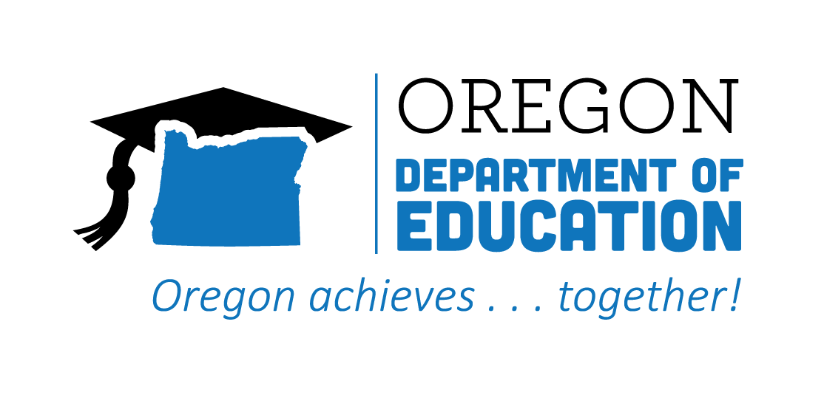
Table of Contents
Executive Summary 2
Background 5
Progress on Goals Outlined in ORS 344.125 8
Goal #1 8
Goal #2 14
Goal #3 15
Goal #4 16
Goal #5 18
Goal #6 21
Goal #7 26
Recommendations 29
Recommendation #1 29
Recommendation #2 30
Recommendation #3 31
Conclusion 31

Executive Summary
We are pleased to present this year's report on behalf of the Oregon Department of Education (ODE), the Higher Education Coordinating Commission’s Office of Community Colleges and Workforce Development (HECC/CCWD), and the Oregon Bureau of Labor and Industries (BOLI), collectively referred to as the Partnering State Agencies. This report serves as an update on the progress made in advancing Career and Technical Education (CTE) in Oregon per the goals outlined in ORS 344.125.
ORS 344.125 Goals
Goal #1—Ensure that career and technical education programs that are available at the public schools of this state and through youth job development organizations as defined in ORS 344.415 (Definitions for ORS 344.415 to 344.425) are founded on partnerships with business and industry and receive appropriate investments of time, money, and other resources.
Goal #1 Key Highlights
- Expanded CTE programs statewide, adding 25 secondary CTE Programs of Study across all career learning areas and 76 new CTE certificate and degree programs at community colleges.
- Achieved an 85.6% graduation rate in Oregon’s 34 pre-apprenticeship programs, with 2,195 participants successfully completing their training.
- Provided substantial funding—approximately $17.5 million ($6.5 million RAP and $11 million PATP)—through the Future Ready Oregon initiative to expand pre-apprenticeship and apprenticeship programs, serving over 1,100 participants across key industries such as construction, healthcare, and manufacturing.
Goal #2—Develop regional centers that establish any appropriate partnerships between public schools, community colleges, public universities, businesses, unions, and other entities and that ensure that every student of this state has access to a regional center in person or online.
Goal #2 Key Highlights
- Many regions are interested in establishing regional centers; the Partnering State Agencies identified challenges related to funding, geography, and coordination among partners.
- Committed to exploring innovative solutions—such as online, hybrid, and mobile offerings—to ensure equitable access to CTE programs for all students in Oregon.
Goal #3—Encourage the establishment of joint high school and community college advisory committees that may include representatives of public schools, community colleges, public universities, businesses, and unions.
Goal #3 Key Highlights
- Expanded sector-specific advisory groups into Hospitality, Tourism & Recreation; Arts, A/V Technology & Communications; Marketing; and Engineering Technology to ensure curriculum alignment with workforce demands.
- Strengthened connections between education and industry through the third year of the Statewide CTE Advisory Council, providing valuable guidance for the 2024-2027 CTE State Plan.
Goal #4—Address academic requirements and regulatory barriers that inhibit successful movement of students in career and technical education from high schools to postsecondary school programs and the workforce.
Goal #4 Key Highlights
- Launched the CTE Without Limits initiative to address challenges faced by online/virtual, youth corrections, small/rural/remote, tribal, and alternative education environments in providing CTE programming.
- Revised Oregon's Credit for Prior Learning Standards to provide guidance to higher education institutions as they work to enhance opportunities for students to receive academic credit for prior learning experiences.
- Strengthened apprenticeship programs by actively supporting youth apprenticeship and conducting ongoing reviews of the Federal Notice of Proposed Rulemaking to enhance apprenticeship opportunities, ensuring successful transitions into registered apprenticeships.
Goal #5—Implement accelerated college credit programs that allow students to move seamlessly from public schools to postsecondary education or training to the workforce.
Goal #5 Key Highlights
- Launched a study on Oregon’s Sponsored Dual Credit model to expand access and address teacher qualification barriers.
- Collaborated with national leaders through a state policy academy to address CTE dual enrollment challenges.
- Monitored early data showing a rebound in CTE dual credit participation to near pre-pandemic levels.
Goal #6—Increase professional development opportunities for teachers and learning opportunities for students through industry mentorships, internships, summer programs, after-school programs, and career-based student leadership opportunities.
Goal #6 Key Highlights
- Launched a statewide CTE Mentorship Framework to support and retain new teachers by providing structured mentoring and a robust support network.
- Established Professional Learning Communities across six career areas to enhance professional development and collaboration among CTE educators.
- Expanded Work-Based Learning opportunities by focusing on high-impact practices and strengthening connections between students and industry.
- Provided monthly Lunch & Learn sessions for sharing best practices, celebrating successes, and connecting with statewide partners to enhance Career Connected Learning initiatives.
Goal #7—Establish partnerships between public and private entities for the purpose of educating students, parents, teachers, school advisors, policymakers, and the general public about the benefits and opportunities related to career and technical education.
Goal #7 Key Highlights
- Launched the #ThisIsCTE social media campaign through the CTE Student Advisory Council.
- Focused outreach efforts on American Indian/Alaska Native students that included the development of a recruitment toolkit and marketing materials tailored for priority populations.
- Established Team Oregon Build (TOB), a cross-agency initiative that fostered partnerships among education, industry, and community organizations, engaging nearly 4,000 students in hands-on construction projects that address community needs.

Recommendations
As we reflect on the achievements and challenges of the past year, this report also reiterates the Partnering State Agencies’ 2023 recommendations to the legislature for further enhancing Career and Technical Education in Oregon.
- Allocate targeted funding to support and expand CTE programs across the state.
- Reaffirm and strengthen commitments to the intentional alignment of education and workforce development priorities, projects, and processes.
- Change Oregon Revised Statutes and Oregon Administrative Rules impacting youth apprenticeship to encourage program development by aligning youth apprenticeship to the K-12 system.

Background
This year marked the launch of Oregon’s new four-year CTE State Plan, which continues the state’s vision for Career and Technical Education (CTE) from 2024-2027:
Oregon will reimagine and transform learner experiences in order to enhance their future prospects, empower their communities, and ensure equity in an inclusive, sustainable, innovation-based economy.
The development of this strategic plan was informed by extensive consultation with over 1,000 CTE partners, including students, families/caregivers, tribal leaders, educators, administrators, regional coordinators, grant managers, advisory council/board members, business and industry leaders, workforce development partners, and community-based organizations.
The state conducted more than 50 engagement sessions, both virtual and in-person, along with tailored sessions for specific audiences, such as small/rural/remote schools, Spanish-speaking audiences, and tribal schools. In addition, 236 survey responses and feedback from 257 students were collected to ensure that the revised plan reflects the needs of diverse communities across Oregon. This four-year strategic plan is designed to guide Oregon’s continued efforts in building high-quality CTE programs that align with the state’s economic and workforce development goals.
The new CTE State Plan sets the stage for enhanced collaboration and alignment between education and workforce systems across the state. Building on the foundation established by the plan, the Partnering State Agencies continued their joint commitment to preparing Oregon’s students for the evolving demands of the workforce. Working collaboratively, these agencies play a critical role in ensuring that students have access to high-quality CTE and apprenticeship programs that offer clear pathways to postsecondary education and employment.
Career and Technical Education Programs
Career and Technical Education (CTE) serves as a vital bridge between education and workforce development in Oregon. CTE programs span K-12 and community college, combining academic standards with business-identified technical skills and the workplace behaviors essential for success in the modern economy. See Figure #1 - Number of CTE Programs of Study in 2023-24.
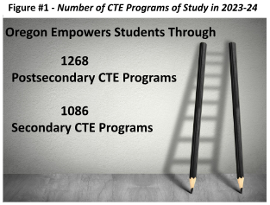
CTE programs equip students with the knowledge and skills necessary for high-wage, in-demand careers, while ensuring their readiness for postsecondary education or direct entry into the workforce. CTE students engage in Career Connected Learning and Work-Based Learning experiences, explore student leadership opportunities, and earn recognized postsecondary credentials. CTE programs are offered within six career clusters:
- Agriculture, Food & Natural Resources Systems
- Arts, Information & Communications
- Business & Management
- Health Sciences
- Human Resources
- Industrial & Engineering Systems
Registered Pre-Apprenticeship Training Programs
Pre-apprenticeship training is designed to prepare individuals—particularly those from underrepresented populations, as outlined in the Oregon Plan for Equal Employment Opportunity in Registered Apprenticeship Programs and Future Ready Oregon—to enter and succeed in registered apprenticeship programs. See Figure #2 - Number of Apprenticeship Programs 2023-24.
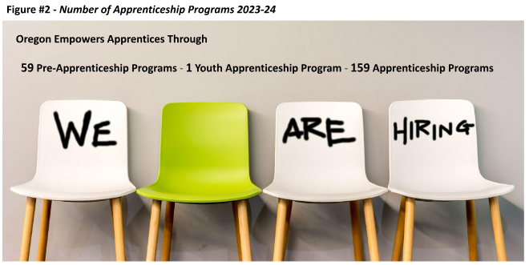
Pre-apprenticeship provides opportunities to explore various apprenticeable occupations through hands-on activities and career exploration, with an additional focus on career readiness skills.
The Partnering State Agencies have worked collaboratively to support CTE programs in aligning with pre-apprenticeship requirements, providing students with a clear, supported pathway toward registered apprenticeships. As a result, some CTE programs are also registered pre-apprenticeship programs, offering students the opportunity to develop basic occupational competencies, earn industry recognized credentials or dual credit, and ensure a smooth transition into apprenticeship.
Registered Apprenticeship Programs
Registered apprenticeship is an industry-driven, high-quality career pathway that combines supervised, paid on-the-job training with classroom instruction to prepare individuals for high-demand, high-skill jobs. These programs require apprentices to complete a minimum of 144 hours of classroom instruction per year and 2,000 hours of on-the-job training, alongside a mentor. Apprentices earn structured wage increases and receive a nationally recognized occupational credential upon completion. Youth apprenticeship programs offer similar opportunities for students ages 16-18, allowing them to earn while progressing toward high school completion. Oregon has one Registered Youth Apprenticeship Program in Advanced Manufacturing, aligned with the Industrial and Engineering Systems CTE cluster in the Hillsboro School District. Oregon's apprenticeship opportunities span industries such as:
- Construction
- Healthcare
- Manufacturing
- Utilities
Through their collective effort to support these programs, the Partnering State Agencies are equipping the next generation of Oregonians with the skills they need to succeed in a rapidly changing economy.

Progress on Goals Outlined in ORS 344.125

Goal #1
Ensure that career and technical education programs that are available at the public schools of this state and through youth job development organizations as defined in ORS 344.415 (Definitions for ORS 344.415 to 344.425) are founded on partnerships with business and industry and receive appropriate investments of time, money, and other resources.

The past year saw continued collaboration between the Partnering State Agencies in expanding access to Career and Technical Education (CTE) and apprenticeship programs across the state. These programs are providing students with clear pathways from secondary education to postsecondary institutions and into the workforce.
The 2023-2024 academic year saw a modest increase in the number of secondary CTE Programs of Study across most career learning areas (see Figure #3), apart from Arts, Information & Communication. This discrepancy may soon be mitigated by the Computer Science Education Statewide Implementation Plan, released in December 2023, which aims to expand access, participation, and engagement in computer science education in the coming years.

Figure #3 - Number of Secondary CTE Programs of Study from 2020-21 through 2023-24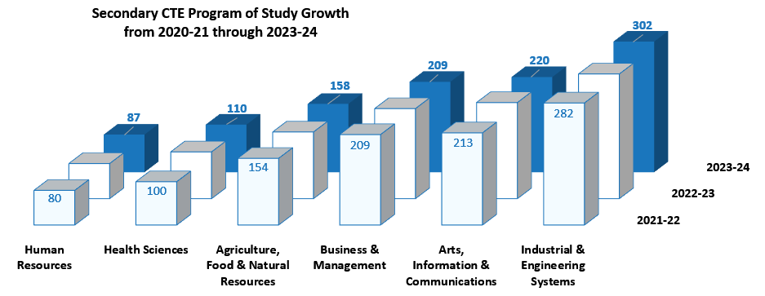
As presented in Figure #4, CTE participation among high school students has shown a consistent upward trend over the past few years, while participation among community college students has remained stable. (Please note: the 2023-2024 CTE data will be released in January 2025.)

Figure #4 - Secondary and Postsecondary CTE Student Participants and Concentrators
Note: The cohort of secondary participants may include students participating in multiple programs, resulting in some duplication within the data.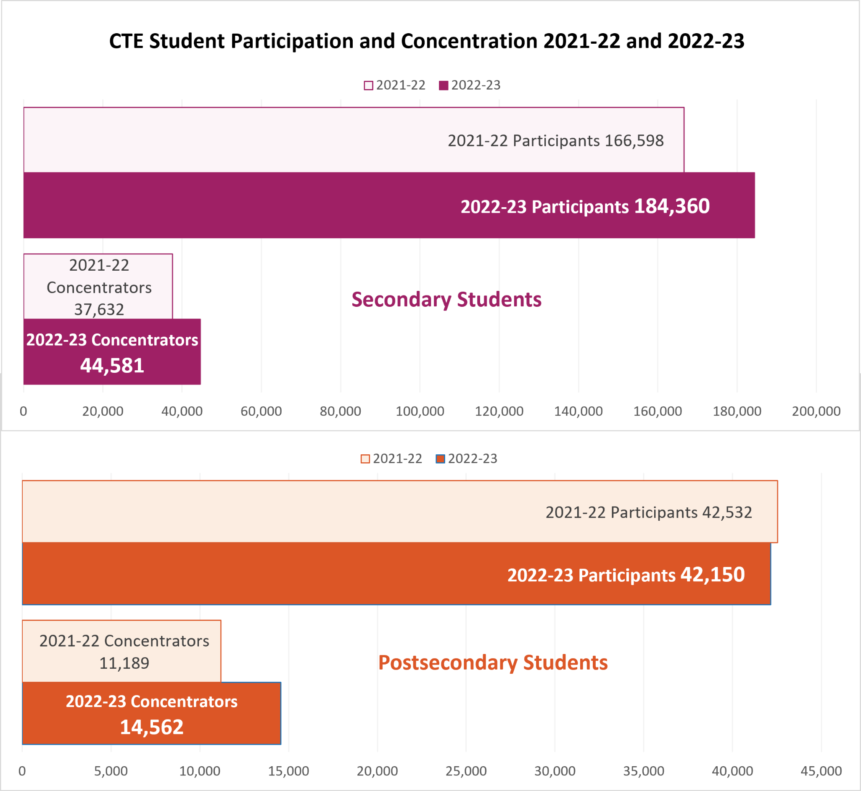
The 2022-2023 data marked a significant milestone with a remarkable increase in CTE concentrators: a growth of 18.5% at the secondary level and 30.1% at the postsecondary level, as illustrated in Figure #5. 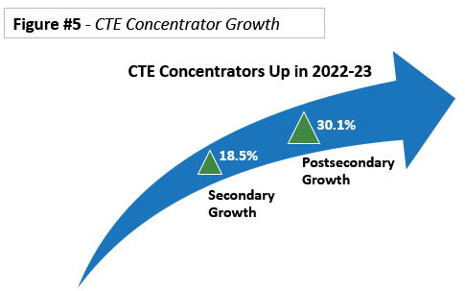
Moreover, the four-year graduation rate for secondary CTE concentrators remains exceptionally high. 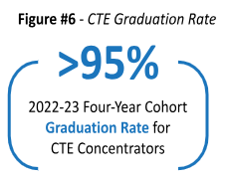
As highlighted in Figure #6, over 95% of CTE concentrators in the adjusted four-year cohort earned a diploma, GED, or other Oregon-recognized equivalent, underscoring the effectiveness of CTE programs in preparing students for their future careers.
As shared in the 2022-2023 Oregon Statewide Report Card, students of color enrolled in Oregon public schools increased to 41% , an increase of 2.5% since the 2019-20 school year. Secondary schools have seen similar increases in the students of color participating in CTE Programs of Study, with an increase of about 1.7% from 2019-20 to 2022-23.
At the postsecondary level, between 2019-20 and 2022-23, the number of CTE participants solely self-identifying as students of color increased by 2.9%, while the number of CTE concentrators self-identifying solely as students of color increased by 30.3%. When comparing CTE-engaged students of color with students of color in Oregon community colleges for program year 2022-23, there is a higher percentage of students of color engaged in CTE than in community colleges overall:
  - 26.0% of all community college students were students of color
  - 27.6% of all CTE participants were students of color
  - 27.9 % of all CTE concentrators were students of color
From 2021-22 to 2022-23, the number of postsecondary CTE concentrators self-identifying as students of color increased by over 61%. Figure #7 further highlights the change in CTE concentrators who self-identify as students of color from 2019-20 through 2022-23.

Figure #7 - Growth in Postsecondary CTE Concentrators of Color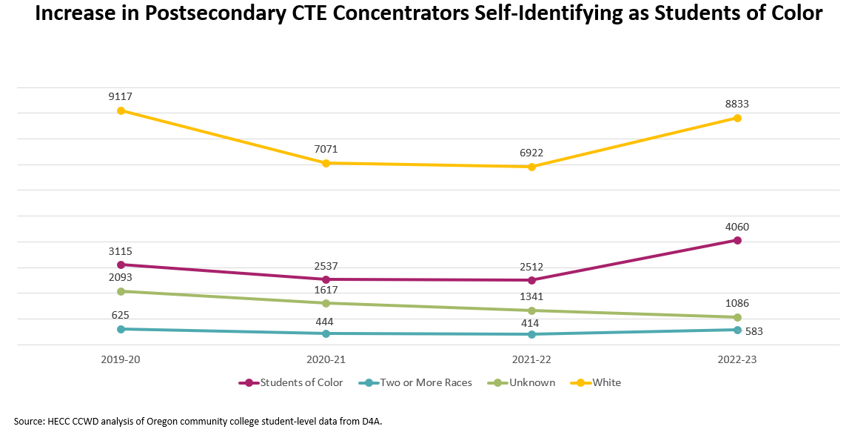
Oregon’s 17 community colleges continue to prioritize opportunities for students to experience education and training through CTE programs that lead to high-wage, in-demand careers. In the 2023-24 academic year, HECC approved 76 new community college CTE certificate and degree programs. The total amount of 1,268 CTE certificate and degree offerings from Oregon’s community colleges in 2023-24 is represented by career area in Figure #8.
Figure #8 - Total Community College CTE Certificate and Degree Offerings 2023-24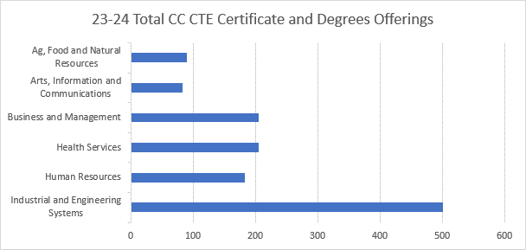
These positive trends reflect the ongoing commitment to ensuring that CTE programs are available to Oregon’s students. By fostering strong partnerships with business and industry and making appropriate investments of time and resources, we continue to pave the way for all students to succeed in their chosen careers.
Oregon's pre-apprenticeship programs continue to support the transition from education to the workforce, helping students build foundational skills and competencies. Recent data reveals that pre-apprenticeship programs in Oregon have a high completion rate, with an overall graduation rate of 85.6%, as shown in Figure #9.
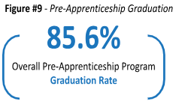
Of the 2,564 pre-apprentices who completed or left a program during the period studied, 2,195 successfully graduated. However, only 14.5% of pre-apprentice graduates have transitioned into registered apprenticeship programs, translating to 319 registered apprentices out of the 2,195 graduates.
The data highlights significant variation in placement rates among different pre-apprenticeship programs. Programs with above-average placement rates, such as NECA-IBEW 48 Electrical PATP and Oregon Tradeswomen, achieved a 28.2% placement rate overall. In contrast, programs with below-average placement rates had an overall placement rate of just 2.5%, with some programs reporting no placements at all. Apprenticeship representatives are committed to providing ongoing technical support to assist programs in improving their placement rates.
Despite the challenges in transitioning from pre-apprenticeship to registered apprenticeship, retention rates for those who do make the transition are promising. Apprentices who graduated from a pre-apprenticeship program have shown above-average retention rates, particularly among female apprentices and male apprentices of color. For apprentices registered in 2022, the retention rate is 72%, which compares favorably to the 56% retention rate for apprentices receiving services through other workforce programs. On average, pre-apprentices take about 4.5 months to transition into a registered apprenticeship, with an average age of 27 for those making the transition—just slightly younger than the overall average age for new apprentices in Oregon.
As part of Oregon’s ongoing commitment to workforce development, Future Ready Oregon provided significant funding to support pre-apprenticeship and apprenticeship programs across three key industries: Construction, Healthcare, and Manufacturing. BOLI has provided guidance and technical assistance to support programs in identifying sustainable funding beyond the Future Ready Oregon grant. As shown in Figure #10, the data reveals differing levels of investment, program expansion, and participant engagement across these sectors.

Figure #10 - Future Ready Oregon - Industry Specific Apprenticeship Data
Apprenticeship Type | Construction | Healthcare | Manufacturing
Pre-Apprenticeship Training Programs | 28 | 2 | 3
Creation of New Registered Apprenticeship Programs | 0 | 1 | 3
Expansion of Existing Registered Apprenticeship Program | 0 | 3 | 2
Development Toward Creating New Registered Apprenticeship Program | 0 | 2 | 4
Total Programs | 28 | 8 | 12

Industry Data | Construction | Healthcare | Manufacturing
Total Funding | $8,926,619.76 | $3,026,091.86 | $2,132,262.26
Total Participants Served | 1102 | 79 | 79
Cost Per Apprentice | $8,100.38 | $38,304.96 | $26,990.66
Construction Industry
The Construction industry currently boasts the highest number of Pre-Apprenticeship Training Programs, with 28 programs serving 1,102 participants. The high participation rate reflects a strong demand for training and preparation in construction trades, which are critical to meeting the state's infrastructure needs.
Healthcare Industry
With eight programs, including pre-apprenticeship and new Registered Apprenticeship Programs, the Healthcare sector has seen a strategic investment of $3 million, serving 79 participants. This relatively modest participant count is offset by the sector’s focus on expanding and developing programs to meet the growing demand for healthcare professionals in areas such as nursing, medical technology, and allied health services. The investment in program development indicates a proactive approach to addressing future workforce needs in healthcare.
Manufacturing Industry
The Manufacturing industry, which received $2.1 million in funding, has implemented 12 programs, including three new Registered Apprenticeship Programs and four additional programs in development. Like Healthcare, Manufacturing served 79 participants, but the variety of programs highlights the sector’s emphasis on both entry-level and advanced technical skills. The investment supports the growing need for skilled workers in advanced manufacturing roles.
Each sector demonstrates a unique return on investment (ROI) based on participant count and funding allocation. In Construction, the per-participant investment is approximately $8,100, reflecting a high ROI due to the immediate applicability of skills in high-demand trades like carpentry, plumbing, and electrical work. The high participation count reflects a strong demand for training in construction where apprentices can earn while they learn, potentially leading to long-term employment and addressing industry labor shortages. For Healthcare, the per-participant investment is significantly higher, at approximately $38,300, but the return is also substantial given the critical shortage of healthcare professionals and the direct path to employment in essential roles. Apprentices in healthcare programs can move directly into in-demand, well-paying jobs, which helps to alleviate staffing shortages in hospitals, clinics, and care facilities, especially as the population ages. The Manufacturing sector shows a per-participant investment of about $27,000, supporting a range of technical skills development that is crucial to Oregon's economic growth in high-tech and production-based industries. Like Healthcare, the ROI in Manufacturing is expected to be high as apprentices can immediately contribute to production lines, fill skills gaps, and transition into higher-level roles as they complete their programs.
The strides made in CTE and apprenticeship programs underscore the importance of collaboration between educational institutions, industry partners, and state agencies. By continuing to strengthen these partnerships and making targeted investments in career pathways, Oregon is ensuring that students from all backgrounds have the opportunity to thrive in high-wage, in-demand careers. The ongoing efforts to expand program access and improve outcomes will pave the way for the next generation of skilled workers who are well-prepared to meet the demands of Oregon’s evolving workforce needs.

Goal #2
Develop regional centers that establish any appropriate partnerships between public schools, community colleges, public universities, businesses, unions, and other entities and that ensure that every student of this state has access to a regional center in person or online.

From the north coast to southern Oregon, various regions have actively engaged partners in discussions about establishing regional centers aimed at expanding CTE access. However, significant progress has been hindered by several challenges, including the following:
- Funding Limitations: Financial constraints hinder the ability to develop and expand regional centers across the state. Without dedicated funding streams, building the necessary infrastructure and sustaining the operational costs required for these centers has proven difficult.
- Geographic Barriers: Oregon’s vast rural and remote areas present challenges in ensuring equitable access to regional centers. The logistical complexities of establishing physical locations in all areas often stall discussions, particularly in underserved regions and high-traffic corridors where transportation time poses a barrier. Any regional model would need to be flexible to account for Oregon’s diverse landscape and perhaps offer a mobile or residency option.
- Coordination Across Entities: Establishing partnerships between multiple groups—such as public schools, higher education institutions, businesses, and unions—requires significant coordination. Variances in priorities, resources, staffing, and available partnerships in each region have contributed to slow development.
These challenges underscore the need for a coordinated strategy that fosters collaboration and provides essential support to ensure the successful implementation of regional centers throughout the state.
Despite these obstacles, the Partnering State Agencies remain committed to advancing this goal. Looking ahead, many regions continue to explore online, hybrid, or mobile offerings that could provide students access to the opportunities available through these partnerships without the need for physical centers in every area. Should funding opportunities arise, these regions would be well-positioned to allocate resources and accelerate progress.

Goal #3
Encourage the establishment of joint high school and community college advisory committees that may include representatives of public schools, community colleges, public universities, businesses, and unions.

Collaboration between educational institutions, businesses, and industry leaders is essential to ensuring that Oregon’s CTE programs remain responsive to workforce needs and aligned with industry expectations. During the 2023-2024 academic year, joint advisory efforts continued to strengthen the connection between high schools, community colleges, and employers. These advisory committees play a critical role in guiding CTE program development, creating clear pathways for students, and ensuring that the curriculum is relevant to current workforce demands.
Building on the success of previous years, this year saw an expansion of the statewide CTE Program of Study framework to new industry sectors. Sector-specific advisory groups from Hospitality, Tourism, & Recreation; Arts, A/V Technology & Communications; Marketing; and Engineering Technology convened to develop their framework. These groups, consisting of Oregon-based employers, professional associations, CTE advisory committee members from both community colleges and high schools, CTE regional coordinators, and CTE administrators, worked collaboratively throughout the year. Oregon Team Ag Ed (Agricultural Education) continued its leadership role as the statewide advisory committee for Agriculture CTE programs, involving organizations and groups including community colleges, Oregon State University, and industry partners.
The Oregon Department of Education, in partnership with Education Northwest and with input from HECC and BOLI, facilitated this process. The objective was to promote uniform program quality, create clearer pathways to college credit, and ensure programs align with industry expectations. In the spring of 2024, the advisory groups published updated knowledge and skill statements for secondary and postsecondary CTE programs. The new benchmarks keep the CTE curriculum relevant to the evolving demands of the workforce and enhance the continuity and progression between high school and community college CTE programs. The ongoing focus on sector-specific advisory groups maintains the alignment of CTE programs with industry standards and responsiveness to workforce needs.
Additionally, in the third year of the Statewide CTE Advisory Council, leaders from the Partnering State Agencies continued to serve as ex officio members, working alongside a diverse group of students, counselors, educators, administrators from secondary and postsecondary institutions, workforce development experts, business and industry partners, and representatives from community-based organizations. The Council met quarterly throughout the year, providing welcome advice, guidance, and feedback with a focus on developing the revised 2024-2027 CTE State Plan. Upcoming meetings, meeting minutes, recordings, and a membership list are available on the Statewide CTE Advisory Council web page.
The support from these advisory committees and their ongoing collaboration demonstrates Oregon’s commitment to strengthening the connection between education and industry. Moving forward, these collaborative efforts will remain essential in sustaining high-quality CTE programs that prepare students for successful careers in a rapidly changing job market.

Goal #4
Address academic requirements and regulatory barriers that inhibit successful movement of students in career and technical education from high schools to postsecondary school programs and the workforce.

The collaborative efforts of the Partnering State Agencies are vital in creating smooth transitions from high school to postsecondary education and the workforce. Addressing academic and regulatory barriers is crucial for providing equitable access to high-quality learning experiences, especially for students from underserved backgrounds. Over the past year, several key initiatives were implemented to tackle challenges and enhance student success.
One such initiative, led by ODE and HECC, focuses on addressing the unique challenges faced by schools with constraints in providing CTE programming, including online/virtual, youth corrections, small/rural/remote, tribal, and alternative education environments. CTE Without Limits seeks to overcome the challenges by
- identifying and working to remove barriers.
- exploring policies and structures/systems and identifying areas of flexibility.
- supporting schools in recognizing and valuing all learning that occurs, wherever and whenever it happens, in alignment with OAR - 581-022-2025 which provides guidance on credit for proficiency and the recognition of nontraditional learning experiences.
- striving to translate competencies and credentials into portable credit.
- working to close equity gaps in education outcomes and workforce readiness.
- building and leveraging partnerships and fostering collaboration.
- ensuring that CTE programming/opportunities are quality, equitable, and meaningful for learners.
During the 2023-2024 school year, the focus was on building the foundation of the CTE Without Limits Advisory Committee and its associated workgroups. This effort culminated in the first annual CTE Without Limits Summit, held at the Oregon ACTE Conference in April. With over 70 participants, the Summit provided a platform for sharing best practices, networking, and learning about available resources. As the CTE Without Limits initiative continues to evolve alongside the new 2024-2027 CTE State Plan, ODE and HECC will provide ongoing updates on the progress of various projects.
In addition to these efforts, the Partnering State Agencies have been actively involved in shaping and supporting youth apprenticeship programs to help students seamlessly transition into high-demand careers. Collaborative work on the Federal Notice of Proposed Rulemaking (NPRM) and direct support for programs like Hillsboro’s Advanced Manufacturing Apprenticeship underscore Oregon's commitment to apprenticeship as a critical pathway for CTE students.
Over the first quarter of 2024, a cross-agency group from ODE, BOLI, and HECC met regularly to discuss the Notice of Proposed Rulemaking (NPRM) on National Apprenticeship System Enhancements. The members planned and submitted joint comments to the U.S. Department of Labor in support of apprenticeship programs and advancing opportunities for CTE students in Oregon, ensuring their successful transition into postsecondary programs and the workforce. The group identified areas of concern, provided evidence to support their positions, suggested language changes, emphasized the need for adequate funding across multiple agencies to support the rule, and posed questions aimed at enhancing opportunities and fostering the success of apprentices while promoting excellence within programs. The members continue to discuss identified issues, track the NPRM, and collaborate on potential next steps. They appreciated the opportunity to contribute to the NPRM and hope additional resources will be provided to address challenges, bolster apprenticeship initiatives, and support their continued growth and equitable impact in our communities.
Over the past year, the Partnering State Agencies have continued to collaborate on the challenges of implementing youth apprenticeship programs. Oregon’s only Youth Apprenticeship Program, the Hillsboro School District's Advanced Manufacturing Apprenticeship, was approved by the Oregon State Apprenticeship and Training Council (OSATC) in July 2022. Current efforts have focused on supporting the program's goal for students to complete the two-year apprenticeship and earn a nationally recognized certified credential as manufacturing technicians.
To assist students in earning their occupational certificates under the competency-based approach, the program sought a waiver of the 2,000 hours of on-the-job training. At the quarter 1 OSATC meeting on March 21, 2024, the Hillsboro Advanced Manufacturing program presented their proposal for a standard change. They requested that the 2,000-hour requirement be removed from the competency-based model in favor of a more flexible approach that emphasizes concept knowledge and skill mastery over time. This change would allow apprentices to proceed at their own speed and complete the program in high school. The proposal was recommended for approval by BOLI Apprenticeship & Training Division (ATD) with the suggestion that the Council require the sponsor to continue to work with ATD to establish a standard that meets federal requirements by the quarter 2 OSATC cut-off date of April 19, 2024.
On May 8, 2024, ODE issued a memorandum regarding their interpretation of ORS 344.745 and ORS 344.750 to address whether students are “enrolled in a CTE program” during school breaks and can work 40 or even 20 hours during those weeks. The memo was shared with the Hillsboro Advanced Manufacturing program and BOLI ATD and presented to the OSATC during their quarter 2 meeting on June 13, 2024. This clarification allows youth apprentices to maintain their status and work more than 20 hours per week when school is not in session.
As a result, the first cohort of the program saw significant success: of the five participants, four completed the program in the spring and obtained their certificates. The fifth apprentice, while just short of completing the required competencies, is still employed with the company, demonstrating the program’s flexibility in supporting individual progress. In preparation for the Fall 2024 cohort, the program saw strong interest, with six excellent applicants who worked over the summer on résumé building, mock interviews, and preparation for their official interviews.
While the program’s current capacity is limited by the availability of the one remaining partner, the Hillsboro School District onboarded four new apprentices, including one female, for their second cohort. Efforts are underway to expand partnerships with additional companies to increase opportunities for students. The team also worked closely with the selected apprentices on onboarding, scheduling, and employability skills, ensuring they were well-prepared for their late September start dates.
Looking ahead, the Hillsboro School District remains focused on expanding its candidate pool within the aligned CTE programs, recruiting new partners to increase capacity, and ensuring that every participant has the support and resources they need to succeed. All parties are committed to exploring solutions to the challenges of youth apprenticeship and paving the way for future programs. The Partnering State Agencies will continue to collaborate on addressing barriers without amending statutory language. They anticipate a thoughtful review of current statutes and rules if the January 2024 Notice of Proposed Rulemaking on National Apprenticeship System Enhancements moves forward. By working to grow quality programs, enhance access, meet community and workforce demands, and foster the success of young apprentices, we can further the equitable impact in our communities.
Beyond youth apprenticeships, Oregon's revised Credit for Prior Learning (CPL) Standards, adopted by HECC in April 2024, aim to address another crucial barrier by expanding opportunities for students to receive academic credit for skills gained outside traditional education. The 2024 CPL Standards represent a significant accomplishment in addressing barriers that impact successful movement of students in postsecondary CTE programs. The CPL Standards build upon expanded CPL efforts across Oregon public institutions from 2022’s Future Ready Oregon investment of $10 million in one-time funding to increase opportunities for students from Priority Populations to receive academic credit for prior experience or skills gained outside of traditional higher education institutions. The 2024 CPL Standards also responded to recent regional higher education accreditation changes that removed the 25% cap on credit for prior learning in a degree and implemented recommendations identified by colleges and universities through other related initiatives. This work was guided by the goals in ORS 350.110 and conducted by a HECC appointed and convened Credit for Prior Learning Advisory Committee, and with a collaborative approach that was guided by principles of access, equity, inclusion, rigorous assessment, and transparency.
By working to address barriers and implement new initiatives, the Partnering State Agencies are creating clearer pathways for students to move seamlessly from secondary education to postsecondary programs and into the workforce. These efforts are integral to preparing students for success while ensuring that every learner, regardless of background or educational setting, has access to quality CTE programs that align with industry needs and promote equity in education outcomes.

Goal #5
Implement accelerated college credit programs that allow students to move seamlessly from public schools to postsecondary education or training to the workforce.

Several measures were taken in the last year to support accelerated college credit programs and to respond to trends of declining CTE dual credit participation highlighted in the 2023 ORS 344.125 joint report.

Feedback Solicited from Community Colleges
In October 2023, community college partners were surveyed to gather feedback on the root causes of CTE dual credit participation declines. As illustrated in Figure #11, the survey revealed that teacher turnover or shortages of qualified teachers represented the strongest area of agreement for the root cause of this decline, followed by ongoing impacts from the COVID-19 pandemic.
Figure #11 - Root Causes of Drop in CTE Dual Credit Participation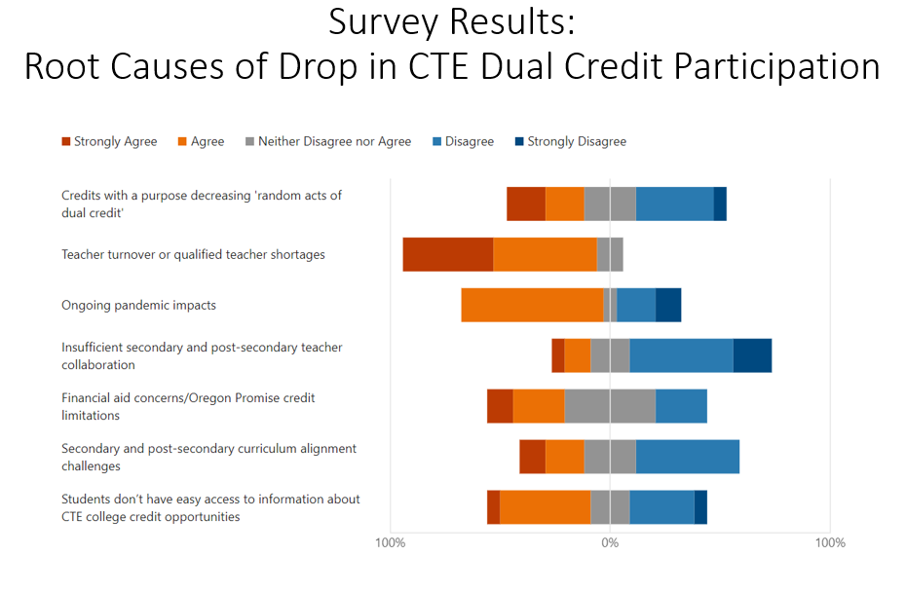
Launch of the Sponsored Dual Credit Research Study
Partly as a result of the strong agreement around the correlation between drops in CTE dual credit participation and teacher turnover/qualified teacher shortages, HECC and ODE worked with research partner Education Northwest to apply for an opportunity through the Dual Enrollment Research Fund to study Oregon’s unique Sponsored Dual Credit (SDC) model. SDC courses must be taught by a high school teacher who, in partnership with a sponsoring college or university faculty member, meets the qualifications to teach the course for the college or university. SDC helps more high school instructors to meet the postsecondary partner’s instructor qualification requirements and also includes CTE courses, though this innovative model is primarily used outside of CTE. Oregon’s Dual Enrollment Research Fund proposal, Studying Oregon’s Sponsored Dual Credit Model to Advance Equitable Dual Enrollment Access and Success, was one of six funded proposals and will have implications for Oregon and the nation as states consider how to increase the number of teachers qualified to teach dual credit in an effort to expand access for students. Although the study is in its early stages, we are optimistic that it will ultimately result in policy and systems improvements that will expand access to college credit opportunities for high school students.
Participation in State Policy Academy
Accelerated college credit team members from HECC and ODE applied for, and were accepted to participate in, a state policy academy sponsored by the College in High School Alliance, entitled “Dual Enrollment Academy: Policy Issues Impacting CTE Dual Enrollment.” As part of this experience, Oregon’s team collaborated with state leaders from several other states to examine state policies and local-level practices that may be contributing or are root causes for our drop in CTE dual credit participation rates. Specific areas of collaboration included instructor recruitment, credentialing and support systems, counseling and advising practices, impacts of program accreditation standards, and state policies that may have unintended consequences that limit CTE dual credit enrollment.
The information learned from the Policy Academy was brought back to the accelerated college credit team in Oregon and informed ongoing work at both state agencies, the team’s work with the High School Based College Credit Oversight committee, and the team’s work with the Dual Credit Coordinators group. Through these partnerships, continued research focuses on CTE enrollment trends that explore student and teacher perceptions regarding college credit opportunities in CTE programs and the challenges of pairing secondary and postsecondary faculty for dual credit opportunities.
Expansion of Cross-Agency Accelerated College Credit Team
The cross-agency accelerated college credit team meets weekly to support policy alignment efforts around college credit opportunities for high school students. In 2023-24, this team was expanded to include two additional members of the Secondary-Postsecondary Transitions (CTE) team in order to bring an expanded focus on issues related to college credit earning opportunities in secondary CTE programs.
In addition to these efforts, HECC and ODE received some welcome news that showed an increase in CTE dual credit participation in the most recent data sets from 2021-22. Figure #12 shows that CTE dual credit participation bounced back almost to levels seen at the start of the COVID-19 pandemic. Once released, the 2022-23 data sets will be reviewed closely to see if this increase has continued.

Figure #12 - 6-Year Trend CTE Dual Credit Participation
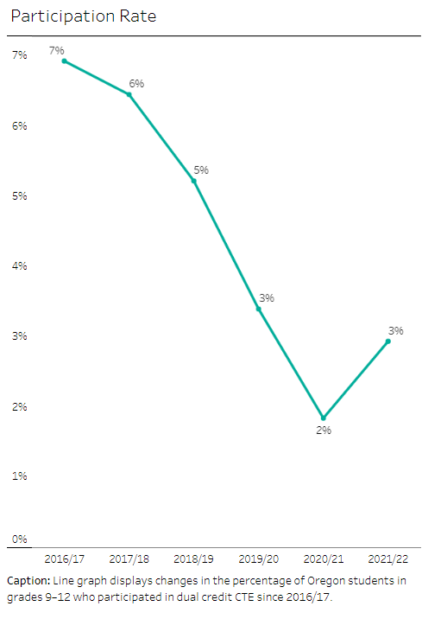
These efforts underscore Oregon’s commitment to ensuring that students have seamless pathways from high school to postsecondary education and the workforce. By addressing the barriers that have contributed to declines in CTE dual credit participation, expanding research on innovative models like Sponsored Dual Credit, and collaborating through state policy academies, Oregon is working to provide equitable access to accelerated college credit programs. As these initiatives continue to evolve, they will play a vital role in preparing students for postsecondary success and contributing to our workforce.

Goal #6
Increase professional development opportunities for teachers and learning opportunities for students through industry mentorships, internships, summer programs, after-school programs, and career-based student leadership opportunities.

The 2023-2024 school year saw significant progress in advancing Oregon’s efforts to provide professional development opportunities for teachers and expand learning experiences for students. These efforts are vital in ensuring that students are prepared to transition from high school to postsecondary education and the workforce with the skills and knowledge necessary for success in their chosen fields. This year’s initiatives—driven by collaboration between ODE, HECC, and various educational and industry partners—have laid the groundwork for stronger CTE programs and more meaningful student engagement in Career Connected Learning.
Central to these efforts is the recognition that onboarding support and mentoring programs are essential for the success and retention of new CTE teachers. As teachers play a pivotal role in shaping students' career readiness, it is crucial to equip them with the tools and support needed to thrive. Teaching in CTE environments presents unique challenges compared to other industries, including:
- Workload stress
- Limited professional development opportunities
- Need for collegial support
- Classroom management difficulties
- Feelings of isolation
To address these challenges, ODE collaborated with a variety of partners to create a CTE Statewide Mentorship Framework. This framework provides structured mentoring and a robust support network aimed at retaining high-quality teachers within CTE programs. Mentors are committed to effectively and consistently coaching adult learners to ensure the success of every student in their programs.
The InterMountain CTE Consortium successfully piloted the framework beginning in January 2024. In the 2024-25 school year, the program will be expanded to include a more comprehensive support system that incorporates the framework, professional learning communities, events, networking opportunities for new teachers, and resources. These programs offer significant value that extends beyond individual teachers, continuously enhancing teacher retention, job satisfaction, collaboration, collegiality, and teaching practices.
In addition to onboarding and mentoring, ODE also made significant strides in enhancing professional development for CTE teachers by establishing statewide Professional Learning Communities (PLCs). See Figure #13 for insights from some of our participating educators.

In the spring of 2023, ODE hosted the inaugural statewide PLC gathering at the Oregon Association for Career & Technical Education (ACTE) Conference. Since then, 11 PLCs have been formed across six career areas.
Throughout the 2023-24 school year, the PLCs convened regularly, providing CTE teachers with collaborative spaces to share best practices, align curricula with industry standards, and address challenges. Each PLC focused on improving instructional practices and strengthening alignment and professional relationships between secondary and postsecondary CTE programs. By ensuring that teachers have the resources and support they need, Oregon is better prepared to deliver high-quality CTE Programs of Study that help students transition smoothly from high school to postsecondary education and the workforce, preparing them for successful careers.
Alongside efforts to strengthen professional development for teachers, expanding hands-on, practical opportunities for students has remained a top priority. Work-Based Learning (WBL) remains a cornerstone of Oregon’s vision for CTE, providing students invaluable real-world experiences that bridge the gap between education and employment. During the 2022-2023 academic year, over half of graduating high school CTE concentrators within most career areas participated in Work-Based Learning, as shown in Figure #14.

Figure #14 - 2022-23 Work-Based Learning Participation by Career Area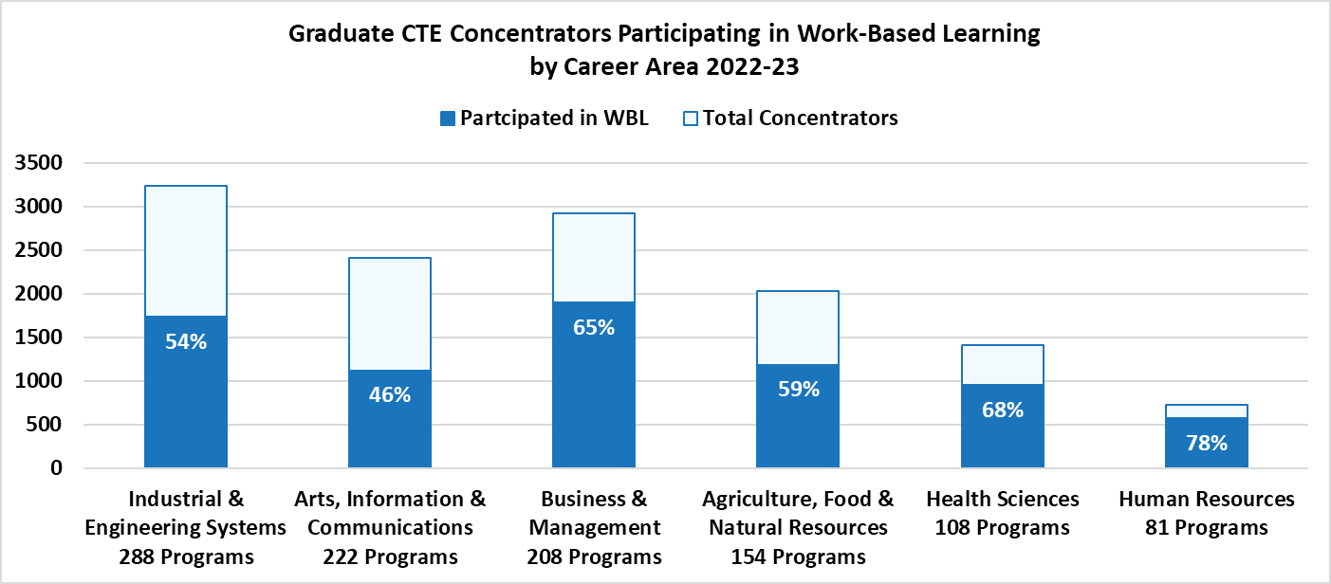
The participation rates in WBL feature strong engagement among students from diverse racial and ethnic backgrounds and various focal student groups. The broad participation highlighted in Figure #15 underscores Oregon’s commitment to equity in providing all students with quality WBL experiences.
Figure #15 - 2022-23 Work-Based Learning Participation by Race/Ethnicity and Focal Student Group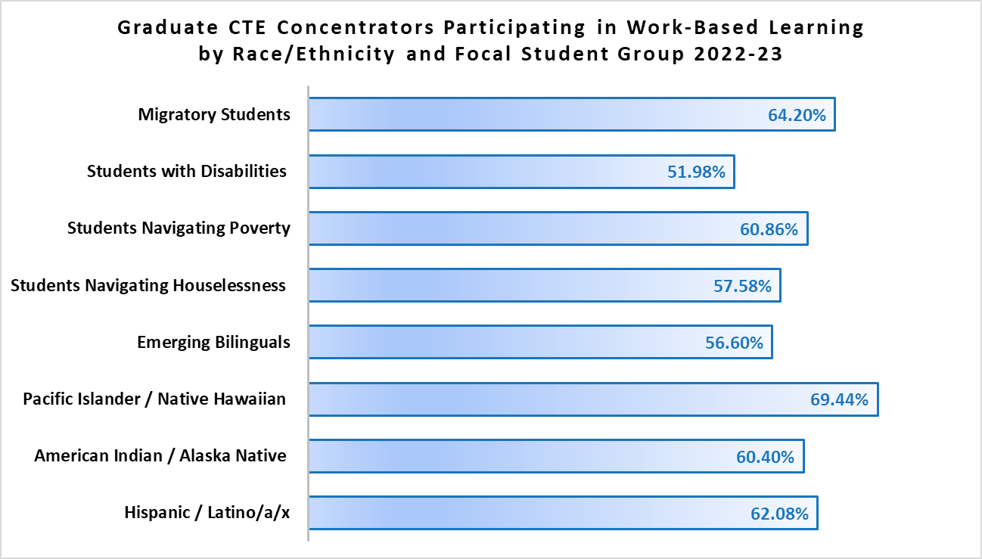
Workplace simulations remained the predominant type of WBL, accounting for nearly 44% of all reported experiences. This high level of engagement reflects the effectiveness of workplace simulations in helping students develop essential skills in a protective environment while providing practical, real-world experiences that mirror actual job scenarios, informed by industry and professional insights. Additionally, workplace simulations effectively bring industry partners to students, reducing barriers such as transportation and the number of partners needed to directly support students. Recognizing the effectiveness and accessibility of workplace simulations, the professional development efforts in 2023-2024 emphasized this type of WBL. Targeted professional development was offered to further enhance educators' abilities to create and implement high-quality workplace simulations, with a focus on reducing gaps in WBL participation.
One notable example of these professional development efforts is the cohort of dedicated CTE educators from various school districts and career areas who participated in a transformative opportunity facilitated by ODE with input from HECC. This opportunity aimed to enhance educator understanding of WBL and support their implementation of workplace simulations.
The journey began with a virtual three-day workshop in the summer of 2023 where educators explored project based learning and designed workplace simulations. This set the stage for hands-on classroom implementation throughout the 2023-24 school year. Teachers partnered with business and industry professionals to provide students with high-quality, real-world learning experiences. Regular virtual professional learning sessions allowed for ongoing collaboration, reflection, and support. One highlight was presenting their workplace simulations at the Oregon ACTE conference, showcasing their innovative work, exchanging insights with colleagues, and inspiring others to embrace WBL in their classrooms. The cohort also recorded a webinar detailing their experiences, offering a valuable resource for educators unable to attend the workshop. Initial project plans are available for sharing statewide.
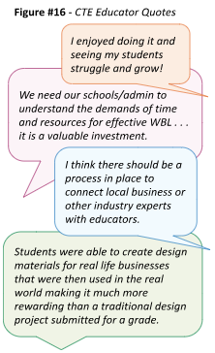
The success of this cohort, as conveyed by the quotes from CTE educators in Figure #16, underscores the impact of professional development, industry partnerships, and statewide collaboration in advancing Work-Based Learning. By investing in these opportunities, ODE and HECC are shaping the future of CTE education and equipping students with the skills and knowledge needed for workforce success.
Regardless of the type of WBL, our focus remains on ensuring that WBL experiences meet the criteria for a high-quality student experience, offering all learners equitable access to meaningful, relevant career exploration; skill development; and connections to business and industry. By providing students first-hand engagement of tasks within a career field, reinforcing the skills they are developing in their CTE Program of Study, and fostering sustained interactions with professionals, we aim to prepare students for success in their chosen fields and contribute to a diverse and skilled workforce.
To further support and expand opportunities for students, ODE fostered collaboration and professional growth through Career Connected Learning Lunch & Learn sessions. The monthly gatherings, previously known as CCL Office Hours, took place throughout the 2023-24 school year, providing a structured and engaging platform for professional development, technical assistance, question and answer sessions, sharing of promising practices, and connecting with statewide partners. These meetings were divided into Career Awareness & Exploration sessions and Work-Based Learning (WBL) sessions. The informal sessions— supported by ODE, HECC, BOLI, Willamette ESD, Oregon Career Information System (CIS), High Desert ESD, YouScience, and others—have become a vital resource for educational partners committed to enhancing Career Connected Learning opportunities for students across Oregon.
The WBL Lunch & Learn provided a platform for participants to celebrate achievements, connect with each other, and receive support. Discussions covered WBL tracking, shared examples, and elevated challenges, such as finding and connecting with partners. One highlight included a presentation on the Hillsboro School District Advanced Manufacturing Youth Apprenticeship program, highlighting our efforts to expand WBL aligned to Registered Youth and Pre-Apprenticeship, which currently accounts for the lowest percentage of all reported experiences.
The Career Awareness & Exploration Lunch & Learn supported participants waiting to learn more about integrating CCL into their teaching. The meetings explored resources that were supported through Elementary and Secondary School Emergency Relief funding and those being created by Oregonians. Tools such as Oregon CIS, YouScience, the CCL Resource Hub, and Oregon Employability Skills were shared. These Lunch & Learns are a great opportunity for participants to gather information as well as ask questions and collect strategies for integration of CCL around the state. The Lunch & Learn gatherings will continue to provide support and inspiration in the upcoming school year.
As we look ahead, the ongoing development of professional learning communities, new teacher mentorship, and Work-Based Learning opportunities will continue to play a crucial role in shaping the future of CTE in Oregon. The Partnering State Agencies remain committed to supporting teachers and students in their professional growth, equipping students for success in a dynamic and evolving workforce.

Goal #7
Establish partnerships between public and private entities for the purpose of educating students, parents, teachers, school advisors, policymakers, and the general public about the benefits and opportunities related to career and technical education.

Through the combined efforts of state agencies, industry leaders, community organizations, and educational partners, several initiatives were launched and expanded to engage students, educators, and the public around the benefits of CTE. The activities aimed to raise awareness, provide hands-on learning opportunities, and ensure that students are equipped for high-demand careers. This year, efforts like the CTE Student Advisory Council’s #ThisIsCTE campaign, targeted outreach to underserved communities, and cross-agency collaborations such as Team Oregon Build, illustrate the impact of partnership and collaboration in promoting CTE.
In its second year, the CTE Youth Advisory Council changed its name to the CTE Student Advisory Council to better resonate with postsecondary students. The Council met regularly during the 2023-24 school year and launched the #ThisIsCTE social media campaign. During CTE Month in February, the dedicated students received 37 submissions from across the state and used these stories to make posts every weekday except President’s Day. (See sample post in Figure #17.) The posts aimed to educate people on the benefits and opportunities related to CTE. ODE’s Facebook and X (formerly known as Twitter) accounts saw a significant increase in followers and engagement during that time. The campaign continued with weekly posts throughout the remainder of the year.

Figure #17 - #ThisIsCTE Facebook Post February 9, 2023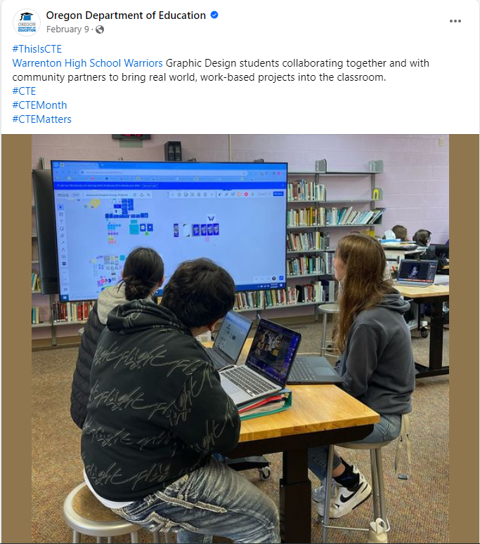
Building on the success of the #ThisIsCTE campaign, other collaborative efforts focused on outreach to specific priority populations, including American Indian/Alaska Native students, to ensure equitable access to CTE programs. CTE team partners from HECC and ODE, along with staff from the Office of Indian Education at ODE, are participating in an Advance CTE sponsored learning opportunity for state agencies that is focused on building systems and resources to promote CTE to state-selected priority populations. Oregon selected to focus its efforts on outreach and promotion of CTE to the nine federally recognized tribes, with a focus on supporting successful secondary to postsecondary CTE transitions for American Indian/Alaska Native learners. Current project deliverables due this year include:
- Develop a recruitment toolkit with a directory of Oregon community college CTE programs as well as scholarship and financial aid information
- Create a one-pager marketing CTE with messaging for American Indian/Alaska Native learners and families
- Conduct focus group with American Indian/Alaska Native learners to hear about perceptions of CTE and get feedback on flier/recruitment toolkit
- Conduct focus group with at least one American Indian/Alaska Native parent group to hear about perceptions of CTE and get feedback on flier/recruitment toolkit and messages

In addition to outreach and awareness initiatives, hands-on learning opportunities through programs like Team Oregon Build have provided students with valuable skills while addressing critical community needs across the state. Team Oregon Build (TOB) is a cross-agency initiative that engages and inspires youth through hands-on construction projects that address critical needs (as highlighted by the quote in Figure #18 from the Lane Workforce Partnership).
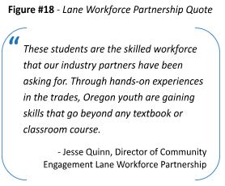
Inspired by successful initiatives like Future Build in Eugene 4J, Lane Education Service District's Constructing a Brighter Future, and Southern Oregon Education Service District's Bus Build Project, TOB leveraged a $2.6 million grant from the ODE's Elementary and Secondary School Emergency Relief III fund to expand this impactful work into a statewide effort. Spearheaded by a core team of partners from Oregon Community Housing Services (OCHS), Lane Education Service District (Lane ESD), Southern Oregon Education Service District (SOESD), Mid-Willamette Education Service District (WESD), Lane Workforce Partnerships, Pivot Architecture, Everyone Village, and ODE, Team Oregon Build benefits from the collaboration of numerous education, industry, and community partners.
The partnerships and grant funding allow TOB to provide professional development to teachers, along with the supplies necessary for programs in those regions to build sheds, cottages, and accessories such as benches and planters. The completed projects support schools, community-based organizations, and emergency services by addressing critical needs like disaster recovery, reducing homelessness, and building resilient communities, all while teaching young people valuable and needed skills in the construction industry (as illustrated in the quote from a Prospect Charter School Instructor in Figure #19).
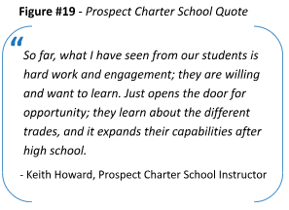
Nearly 4,000 middle and high school students from 39 schools built more than 125 units in the spring of 2023. Many more units will be built in classrooms throughout the 2024-25 school year. Eighty teachers attended professional development over the summer to explore the curriculum and blueprints, become familiar with the projects through hands-on building, refine the skills needed to lead a successful project in their region, and most importantly, mentor over 6,000 students. These efforts to raise awareness and engage students, educators, and communities in CTE demonstrates the importance of partnerships in driving the success of Oregon’s CTE programs.
Oregon’s CTE programs continue to provide students with opportunities for career exploration and skill development, while addressing critical workforce and community needs. The collaboration between state agencies, industry, and community partners is vital in promoting the benefits of CTE and ensuring that students are prepared for the future. As these partnerships grow and evolve, they play an essential role in shaping the state’s workforce and fostering a stronger, more connected community of learners and professionals.

Recommendations
As we continue our journey to strengthen Career and Technical Education in Oregon, the Partnering State Agencies reiterate the recommendations presented in our 2023 report. These recommendations aim to build upon the progress made and ensure that CTE programs continue to meet the evolving needs of students and the workforce.

Recommendation #1
Allocate targeted funding to support and expand CTE programs across the state.

Career and Technical Education is a vital pathway in preparing Oregon's students for high-wage, in-demand careers. Yet, Oregon lags behind many states in providing dedicated state-level funding for CTE, relying primarily on foundational education funding that is discretionary. This contrasts with states like Washington, Florida, and Georgia, which use weighted student formulas to ensure CTE programs receive necessary financial support. For example, in 2021, the state of Washington spent over $684,000,000 of state funds on CTE in grades 9-12 compared to Oregon’s expenditure of roughly $63,000,000 of state funds on K-12 career related learning.
To maintain and expand high-quality CTE programs, Oregon must increase state funding to meet the growing costs of program administration, consumables to adequately prepare our youth, and essential support structures. For example, additional funding is needed to sustain CTE regional coordinators, who bridge the gap between secondary and postsecondary education and industry needs. Despite their critical role, these positions remain unfunded at the state level. Moreover, the temporary funding for Career Connected Learning Systems Navigators, essential for expanding K-12 Career Connected Learning opportunities, will expire at the end of the year.
Additionally, CTE programs often require ongoing investment in resources and materials to remain current and effective. Some states, such as Delaware and Idaho, use weighted formulas or unit-based methods to allocate additional funding to CTE programs due to the higher costs of delivering these services. Oregon should similarly explore dedicated funding mechanisms that support the practical, hands-on nature of CTE. By doing so, the state can ensure that students receive real-world training that aligns with industry standards and equips them for the workforce.
Investing in CTE is essential not only for educational success but also for sustaining and growing Oregon’s economy. Oregon has the opportunity to strengthen its workforce pipeline, ensuring that its educational system adequately prepares students for the challenges of today’s and tomorrow’s job market.

Recommendation #2
Reaffirm and strengthen commitments to the intentional alignment of education and workforce development priorities, projects, and processes.

Oregon's future talent development success hinges on the strength of its educational pathways, particularly through Career and Technical Education, youth apprenticeships, and Career Connected Learning. While these programs are intrinsically linked to workforce needs, there is a need to enhance this synergy through deliberate and strategic alignment.
To drive meaningful progress, it’s crucial that our education and workforce initiatives work in tandem, each reinforcing the other through structured partnerships and streamlined processes. This alignment must bring together education providers, the Workforce and Talent Development Board, and industry leaders under a shared vision. Such collaboration will ensure that students’ preparation is in lockstep with industry demands, facilitating smoother transitions from education to employment.
A clear example of this alignment can be seen in the collective focus by the Workforce and Talent Development Board, Higher Education Coordinating Commission, and Oregon Department of Education to generate the list of desired employability skills. By integrating these practical skills into CTE programs and youth apprenticeships, we ensure that students emerge not only with technical expertise but also with the mindsets necessary to thrive in diverse workplaces. This holistic approach will better prepare students for their future careers and position them as key contributors to Oregon’s economy.
Advancing these efforts requires targeted investment in youth development resources that bridge education and workforce priorities. Allocating funding that directly supports CTE programs and their alignment with talent development is essential. For instance, investing in initiatives like ORS 344.753 or other efforts to expand CTE Work-Based Learning will enhance collaboration between ODE, HECC, BOLI, and employers, thereby creating more opportunities for students to gain the skills and experiences critical for success.
Aligning education with workforce development is more than a strategic choice; it is an essential commitment to Oregon's economic prosperity. By elevating the connections between these systems and ensuring they reinforce one another, we can ensure that students are not only ready to start their careers but are also well-equipped to meet the dynamic needs of industries across the state.

Recommendation #3
Change Oregon Revised Statutes and Oregon Administrative Rules impacting youth apprenticeship to encourage program development by aligning youth apprenticeship to the K-12 system.

To build a more seamless connection between education and career opportunities for Oregon’s youth, it is essential to revise existing Oregon Revised Statutes and Oregon Administrative Rules that impact youth apprenticeships. This revision should prioritize stronger integration with the K-12 system, allowing for the creation of apprenticeship programs that are more accessible, adaptable, and aligned with student learning outcomes.
By rethinking and updating these regulatory frameworks, we can remove barriers that currently hinder schools from establishing effective youth apprenticeship programs. This will not only expand access but also improve the alignment of these programs with educational goals, ensuring that students can move through their educational journey with clear, supported pathways into the workforce.
The goal is to create an environment where youth apprenticeships are a natural extension of the K-12 experience—where participation in these programs leads to high rates of completion and smooth transitions into adult registered apprenticeships or other career opportunities. This approach will better prepare students for careers while also addressing the evolving needs of Oregon’s industries.

Conclusion
As we wrap up the year, the Partnering State Agencies—ODE, HECC, and BOLI—remain steadfast in our commitment to advancing Career and Technical Education in Oregon. The progress highlighted throughout this report is the result of strong collaboration between educational institutions, industry leaders, community organizations, and public agencies. Together, we have worked to expand CTE and apprenticeship programs, create new opportunities, and address the barriers that limit equitable access to high-quality career pathways.
Moving forward, our focus will remain on building upon these successes, deepening partnerships, and ensuring that every student in Oregon, regardless of their background or geographic location, has the tools and opportunities needed to thrive in the careers of tomorrow. CTE and apprenticeship hold the key to shaping a more inclusive, dynamic, and innovative workforce, and we are committed to supporting this vision through continued collaboration, strategic alignment, and dedicated investment. The Partnering State Agencies will continue working with partners to ensure Oregon’s talent is well-prepared to meet the challenges and seize the opportunities of the future.

The Oregon Plan is incorporated into rule at OAR 839-011-0200. Senate Bill (SB) 1545 (2022) created the Future Ready Oregon framework that uses the term Priority Populations to mean communities of color, women, low-income communities, rural and frontier communities, veterans, persons with disabilities, incarcerated and formerly incarcerated individuals, members of Oregon’s nine federally recognized Indian tribes, individuals who disproportionately experience discrimination in employment on the basis of age, and individuals who identify as members of the LGBTQ+ community.
*A postsecondary CTE concentrator is a student who has earned at least 12 credits, of which nine program credits are CTE specific, within a CTE program or Program of Study; or completed the program if it is fewer than 12 credits. A secondary CTE concentrator is a student who earns at least two credits in a single CTE Program of Study. One of those credits must be earned through a course or courses identified as intermediate or advanced.
The data on CTE concentrators within this report reflects the old definition of a CTE concentrator.
Source: Oregon Accelerated Learning Dashboard

