Collaboration by State Agencies on Issues Related to Career and Technical Education
ORS 344.125
December 2025
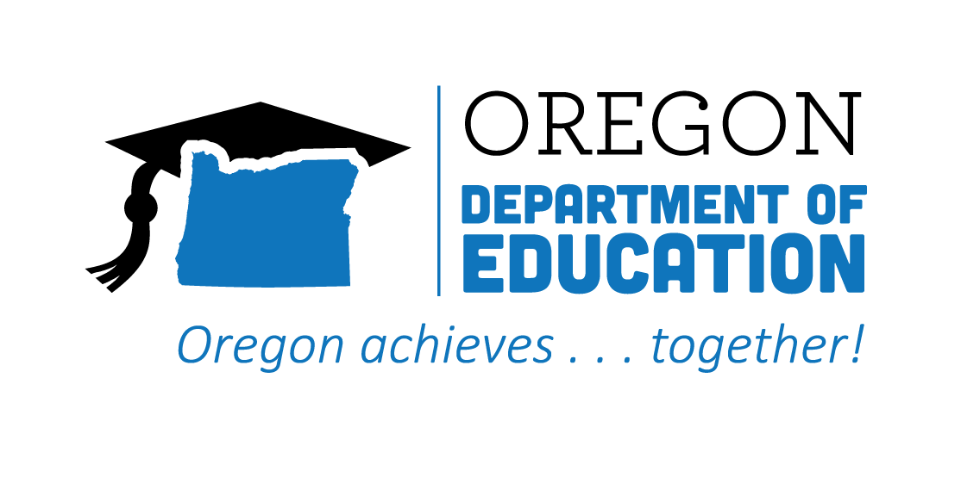
Table of Contents
Executive Summary 2
Background 5
Progress on Goals Outlined in ORS 344.125 7
Goal #1 7
Goal #2 15
Goal #3 16
Goal #4 19
Goal #5 24
Goal #6 26
Goal #7 33
Recommendations 37
Recommendation #1 38
Recommendation #2 38
Recommendation #3 39
Conclusion 40

Executive Summary
Over the past year, the Oregon Department of Education, the Higher Education Coordinating Commission’s Office of Community Colleges and Workforce Development, and the Oregon Bureau of Labor and Industries (collectively, the Partnering State Agencies) have worked in collaboration with educators, employers, regional leaders, and learners to expand access to high-quality Career and Technical Education (CTE) Programs of Study and strengthen alignment between education, registered apprenticeship, and workforce systems.
This report provides an overview of key accomplishments and progress made in 2024–25, organized around the goals outlined in ORS 344.125. It also reaffirms the Partnering State Agencies’ shared legislative recommendations for 2025, reflecting both continuity and refinement to support equitable, high-impact CTE opportunities statewide.
Goal #1 - Ensure that career and technical education programs that are available at the public schools of this state and through youth job development organizations as defined in ORS 344.415 (Definitions for ORS 344.415 to 344.425) are founded on partnerships with business and industry and receive appropriate investments of time, money, and other resources.
Key Accomplishments: Advancing CTE Access and Industry Partnerships
- Oregon approved 34 new secondary CTE Programs of Study in 2024-25, each aligned to postsecondary pathways—a 3.1% increase and the largest annual gain since 2019-20—demonstrating renewed statewide momentum and investment in CTE.
- Postsecondary CTE concentrators who identify as students of color increased 35% since 2019-20, showing that Oregon’s CTE investments are broadening participation and persistence from diverse learners.
- Oregon’s 10,000 registered apprentices—who are earning while they learn and supported by a growing network of 55 pre-apprenticeship programs in 50 high schools and 13 community colleges—are strengthening the bridge from classroom learning to high-wage, in-demand careers.
Goal #2 - Develop regional centers that establish any appropriate partnerships between public schools, community colleges, public universities, businesses, unions, and other entities and that ensure that every student of this state has access to a regional center in person or online.
Key Accomplishments: Expanding Regional CTE Collaboration and Access
- Hampton Lumber’s $1 million investment in Sheridan’s new Barbara Roberts CTE Center demonstrates how regional coordination and private-sector commitment can expand high-quality CTE access in rural Oregon.
- The Willamette Career Academy’s new Dental Assisting program—launched through state and philanthropic support—filled all 30 student slots immediately, reflecting strong regional demand and employer engagement.
Goal #3 - Encourage the establishment of joint high school and community college advisory committees that may include representatives of public schools, community colleges, public universities, businesses, and unions.
Key Accomplishments: Strengthening Joint Advisory Committees
- The Statewide CTE Advisory Council and CTE Student Advisory Council continued to amplify educator, industry, and student perspectives—advancing Oregon’s vision for equitable, high-quality CTE and informing the implementation of the 2024-27 CTE State Plan.
- Through the Future Ready Oregon Industry Consortia, CTE leaders contributed to statewide workforce priorities in healthcare, manufacturing, and technology—advancing innovation in career pathways and strengthening alignment between education and industry.
Goal #4 - Address academic requirements and regulatory barriers that inhibit successful movement of students in career and technical education from high schools to postsecondary school programs and the workforce.
Key Accomplishments: Reducing Barriers Across Education and Workforce Systems
- Updated Credit for Prior Learning standards and new college frameworks—such as Rogue Community College’s GED-to-credit model—are reducing academic and financial barriers to postsecondary participation.
- The Future Ready Oregon Apprenticeship investments supported K-14 pre-apprenticeship growth and deeper education-industry partnerships that are strengthening the bridge from high school to registered apprenticeship pathways.
- The Qualified Mental Health Associate Pilot Project is reimagining certification pathways through applied learning and registered apprenticeships, reducing time-to-credential and expanding equitable access to Oregon’s behavioral health workforce.
Goal #5 - Implement accelerated college credit programs that allow students to move seamlessly from public schools to postsecondary education or training to the workforce.
Key Accomplishments: Expanding Accelerated Credit Opportunities
- Oregon launched a statewide dual credit policy project, one of only seven selected nationally, to strengthen cross-agency coordination and expand access to intentional college credit in high school.
Goal #6 - Increase professional development opportunities for teachers and learning opportunities for students through industry mentorships, internships, summer programs, after-school programs, and career-based student leadership opportunities.
Key Accomplishments: Growing Student Opportunities and Educator Support
- Career Connected Learning Systems Navigators strengthened regional professional development by linking teachers with employers through projects like Clackamas County’s Industry Connected Classroom Projects and Lane County’s Educator Externships.
- Peer-led Pre-Apprenticeship Provider convenings brought together schools, employers, and apprenticeship sponsors—building a stronger bridge from classroom learning to paid, industry-aligned training through registered apprenticeships.
- More than half (54%) of Oregon’s secondary CTE concentrators participated in Work-Based Learning (WBL), gaining career-relevant experience through internships, service learning, pre-apprenticeship, and other WBL experiences.
Goal #7 - Establish partnerships between public and private entities for the purpose of educating students, parents, teachers, school advisors, policymakers, and the general public about the benefits and opportunities related to career and technical education.
Key Accomplishments: Promoting CTE Through Partnerships
- The CTE Student Advisory Council co-created a statewide CTE one-pager and led the #ThisIsCTE social media campaign, featuring stories from 17 programs across Oregon that highlight how CTE connects learning to real-world careers.
- A WBL communication plan engaged partners statewide through 30+ presentations, 50+ outreach messages, and 12+ social media and industry-focused media pieces, strengthening understanding of WBL as a key benefit for CTE learners.
Recommendations
Continuing the direction set in the 2023 and 2024 reports, the Partnering State Agencies continue to recommend focused legislative actions to support equitable, high-quality CTE across Oregon. Findings from the 2024-25 reporting year point to several system-level conditions shaping access, quality, and outcomes across Oregon’s CTE and apprenticeship systems:
- Reliance on short-term and variable funding continues to limit long-term planning and sustainability for CTE Programs of Study and aligned pathways.
- Regional differences in capacity contribute to uneven access to Career Connected Learning (CCL), WBL, and CTE, particularly in rural and frontier communities.
- Misalignment across secondary, postsecondary, and workforce systems can complicate student transitions and slow pathway development.
The 2025 recommendations reflect both continuity and refinement, maintaining core priorities while updating our approach to registered apprenticeship expansion based on recent feedback and cross-agency collaboration.
- Allocate targeted funding to support and expand CTE Programs of Study across the state. Maintaining and scaling effective models will depend on continued coordination and strategic state investment across education and workforce systems.
- Reaffirm and strengthen commitments to the intentional alignment of education and workforce development priorities, projects, and processes. Stronger alignment among K–12, community colleges, workforce partners, and apprenticeship sponsors can improve pathway continuity and student mobility.
- Strengthen Oregon’s registered apprenticeship system as a talent development solution by addressing statutory and regulatory alignment in non-traditional, high demand industries and incentivizing new pathways that expand capacity for both youth and adult learners. Modernizing policy, cross-agency alignment, and program structures can support new pathways while maintaining strong worker protections, incentivizing employer participation in high-need sectors, and better positioning Oregon to meet evolving workforce needs.

Background
The Oregon Department of Education (ODE), the Higher Education Coordinating Commission (HECC), and the Bureau of Labor and Industries (BOLI) each bring distinct roles, tools, and perspectives to supporting Oregon learners and strengthening the state’s workforce. ODE ensures secondary students have access to high-quality Career and Technical Education (CTE) Programs of Study that build both academic and technical knowledge. HECC coordinates community college and workforce initiatives that connect learners to postsecondary CTE and apprenticeship opportunities. BOLI oversees registered apprenticeship and pre-apprenticeship programs that provide structured training and earning while one learns pathways into careers. Together, their collaboration forms a continuum that supports learners as they move from exploration to preparation to employment.
The Partnering State Agencies support common expectations for both CTE Programs of Study and registered apprenticeship pathways to provide hands-on, career-focused learning aligned to business and industry expectations across high-wage, in-demand occupations. CTE Programs of Study combine rigorous academics with technical training in areas such as healthcare, engineering, information technology, and the trades, equipping students with academic, technical, and employability skills and industry-recognized competencies and credentials. Registered apprenticeships offer structured, paid work experience alongside related classroom instruction, leading to transferable credentials and career opportunities in high-demand fields. These programs are not limited to vocational preparation or short-term work experience—they are intentional pathways that help learners explore careers, develop mastery in a profession, and transition into postsecondary education or employment. See Figure #1 - Number of CTE and Apprenticeship Programs in 2024-25.
The value of this joint approach is evident in areas like behavioral health, where demand for skilled workers is both urgent and statewide. Schools, community colleges, registered apprenticeship programs, and employers are all working to expand pathways into counseling, social services, and related careers. No single system can meet such challenges alone. Through coordinated actions—such as aligning education pathways, piloting registered apprenticeship pathways, supporting innovative work-based learning opportunities, and addressing equity barriers—the Partnering State Agencies are helping create solutions that strengthen Oregon’s workforce while supporting learners. Behavioral health is just one example of how cross-agency collaboration advances statewide priorities and responds to community needs.
Figure #1 - Number of CTE and Apprenticeship Programs in 2024-25
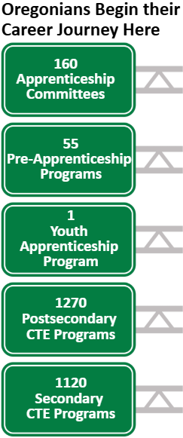
As outlined in ORS 344.125, the Partnering State Agencies continue to collaborate in support of high-quality CTE Programs of Study, registered apprenticeship and pre-apprenticeship programs, and equitable access to career connected learning. This shared work ensures that learners can engage in hands-on learning, earn recognized credentials, and pursue meaningful postsecondary and career opportunities. By aligning the strengths of ODE, HECC, and BOLI, the Partnering State Agencies are reaffirming their shared commitment to building an education-to-workforce system that responds to Oregon’s economic needs, prepares learners for high-wage, in-demand careers, and removes barriers that limit participation and success.

Progress on Goals Outlined in ORS 344.125

Goal #1
Ensure that career and technical education programs that are available at the public schools of this state and through youth job development organizations as defined in ORS 344.415 (Definitions for ORS 344.415 to 344.425) are founded on partnerships with business and industry and receive appropriate investments of time, money, and other resources.

Career and Technical Education (CTE) is opening doors for learners across Oregon, connecting students to relevant coursework, supportive pathways, and real-world opportunities aligned with in-demand careers. This section highlights progress across the state’s secondary, postsecondary, and registered apprenticeship systems to ensure access, and reinforces the need for sustained commitment to CTE infrastructure at every level.
Oregon’s secondary CTE offerings continue to grow, reflecting both statewide investment and renewed momentum following pandemic-era declines. From the 2023-24 to 2024-25 school years, the number of approved Programs of Study increased by 34 programs—a 3.13% gain, representing the largest year-over-year increase since 2019-20, when implementation of the High School Success Initiative began to positively impact CTE expansion. After the dip in 2021-22 due to COVID-related disruptions, Oregon has now surpassed pre-pandemic totals for two consecutive years. A breakdown of CTE Program of Study totals by career area is shown in Figure #2.
Figure #2 - 2024-25 Secondary CTE Programs of Study by Career Area
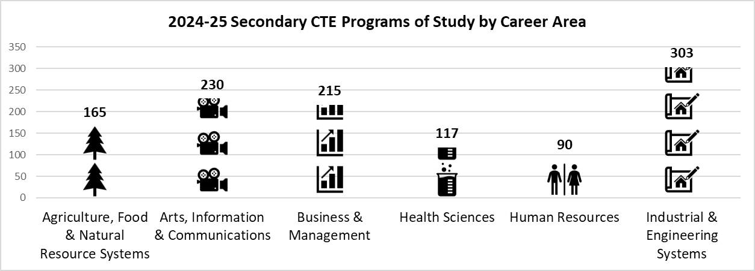
Secondary CTE concentrator totals have grown nearly 20% since 2021-22, indicating that more students are persisting in their chosen Program of Study and advancing through CTE pathways. However, overall participant numbers declined by more than 12% in the past year, despite continued growth in the number of approved programs. This pattern suggests that students may be becoming more intentional in selecting pathways, or that factors such as access barriers or staffing challenges are limiting entry into introductory CTE courses. Concentrator growth has begun to level off, with less than 1% growth between 2022-23 and 2023-24. These trends highlight the need to bolster recruitment, address early access challenges, and ensure students are supported from first exposure through program completion. (Please note: the 2024-2025 CTE data will be released in January 2026.)
Figure #3 shows the relative change in secondary CTE participation and concentration, indexed to a common baseline year (2021-22 = 100). This allows for clear comparison of growth or decline across categories with different starting values. An index above 100 indicates growth compared to the baseline year, while an index below 100 indicates a decline.
Figure #3 - Indexed Trend of Secondary CTE Participants and Concentrators
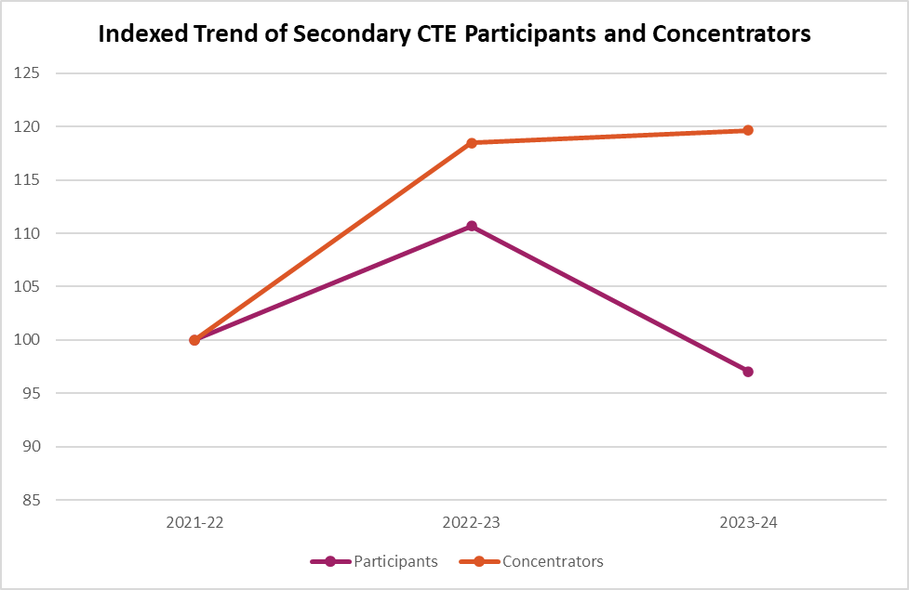
Data Insight:
+19.6% growth in concentrators since 2021-22
Students are persisting in CTE pathways at higher rates.
–12.3% drop in participants from 2022-23 to 2023-24
Fewer students are entering the CTE pipeline despite more programs.
Trend: Persistence among enrolled students is holding, but the entry pipeline is thinning.
CTE continues to provide relevant, real-world learning opportunities to thousands of Oregon high school students each year. In 2023-24, over 161,000 students participated in CTE Programs of Study statewide, with more than 45,000 students reaching concentrator status. This broad engagement reflects the strength and stability of Oregon’s CTE infrastructure, even as programs work to deepen industry alignment and expand access for historically underserved students.
Recent efforts have focused on increasing equity, expanding Work-Based Learning (WBL) access, and strengthening program quality and outcomes. These efforts are making a difference: CTE students consistently demonstrate higher levels of engagement and success, with a graduation rate exceeding 95% in 2023-24 and regular attender rates well above the state average. In 2023-24, the statewide regular attender rate for CTE concentrators was 68.0%, compared to 55.4% for non-CTE students—a gap of over 12 percentage points. This pattern of higher attendance for both CTE participants and concentrators holds across all racial and ethnic groups as shown in Figure #4.
Figure #4 - Regular Attender Percentages by Student Group and CTE Status
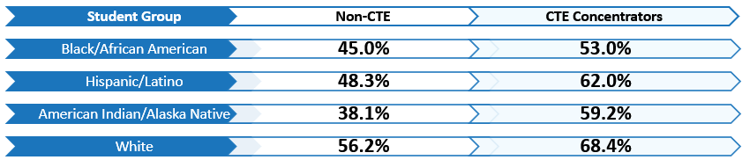
Additionally, CTE concentrators consistently outperform CTE participants as well as their non-CTE peers, further reinforcing that students who persist in their Program of Study experience stronger outcomes. Concentrators demonstrate higher attendance, higher rates of proficiency in English Language Arts and Mathematics on statewide assessments, higher graduation rates, and greater engagement in Work-Based Learning—reflecting deeper and more sustained engagement in learning and career pathways. This trend aligns with previous years and underscores CTE’s role as a powerful tool for improving attendance, closing equity gaps, and preparing students for lifelong success. These outcomes highlight the importance of access, persistence, and program quality as key levers for student success. Expanded investments in high-quality CTE are likely to sustain and deepen these gains, particularly for historically underserved students.
As students move beyond high school, the ability to continue skill development through aligned programs—including certificates, degrees, and registered apprenticeships—plays a crucial role in advancing economic mobility and addressing workforce needs. Oregon’s 17 community colleges continue to prioritize opportunities for students to experience education and training through CTE Programs of Study that lead to high-wage, in-demand careers. In the 2024-25 academic year, HECC approved 153 new community college CTE certificate and degree programs as shown in Figure #5.
Figure #5 - 2024-25 New Postsecondary Programs by Career Area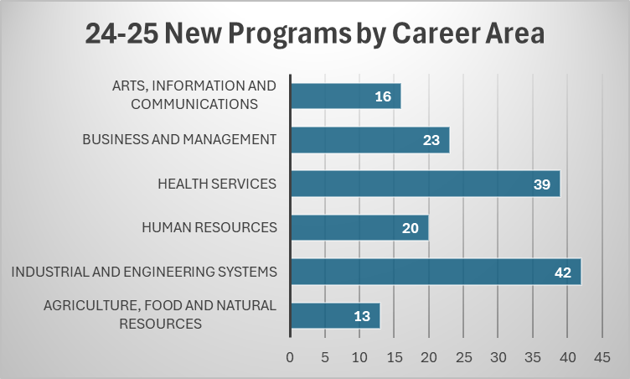
The total amount of 1,270 CTE certificate and degree offerings from Oregon’s community colleges in 2024-25 is represented by career area in Figure #6.
Figure #6 - 2024-25 Total Certificate and Degree Offerings by Career Area
Career Area | Total
Ag, Food and Natural Resources | 102
Arts, Information and Communications | 123
Business and Management | 154
Health Services | 222
Human Resources | 192
Industrial and Engineering Systems | 477
Grand Total | 1270
While postsecondary CTE participation increased by 5.1% from 2021-22 to 2023-24, concentrator totals dipped slightly—falling 1.2% from the previous year after a large jump in 2022-23. This may signal a leveling off following a recovery year, or it could reflect barriers to completion, changes in program pathways, or shifting student demand. Continued focus on retention, advising, and credential alignment will be essential to ensure students complete and benefit fully from CTE opportunities.
Figure #7 shows the relative change in postsecondary CTE participation and concentration, indexed to a common baseline year (2021-22 = 100). This allows for clear comparison of growth or decline across categories with different starting values. An index above 100 indicates growth compared to the baseline year, while an index below 100 indicates a decline.
Figure #7 - Indexed Trend of Postsecondary CTE Participants and Concentrators

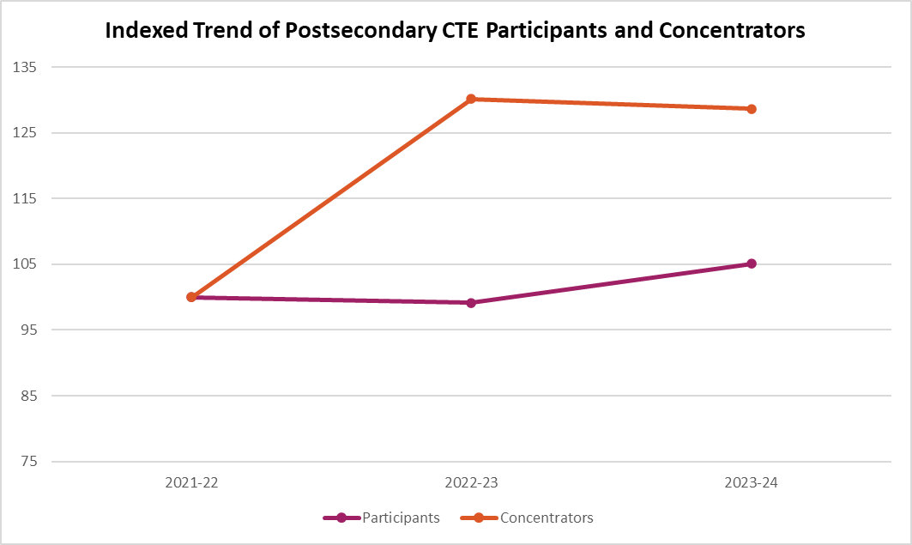

Data Insight:
+28.6% growth in concentrators since 2021-22
Students are persisting in CTE pathways at higher rates.
6% growth in participants from 2022-23 to 2023-24
Growth in participants may signal future increases in concentrators and completers.
Trend: Participation is growing modestly, warranting continued attention to retention, credential attainment, and alignment with evolving student needs.
Between 2019-20 and 2023-24, the number of CTE participants at the postsecondary level self-identifying solely as students of color increased by 14.3%, while the number of CTE concentrators self-identifying solely as students of color increased by 35.0%. When comparing CTE-engaged students of color with students of color in Oregon community colleges for program year 2023-24, there is a higher percentage of students of color engaged in CTE than in community colleges overall:
- 27.0% of all community college students were students of color
- 28.9% of all CTE participants were students of color
- 29.2% of all CTE concentrators were students of color
From 2022-23 to 2023-24, the number of postsecondary CTE concentrators self-identifying as students of color increased by 3.5%, while students self-identifying as Two or More Races increased by over 11%. Figure #8 further highlights the change in CTE concentrators who self-identify as students of color from 2019-20 through 2023-24.
Figure #8 - Growth in Postsecondary CTE Concentrators of Color
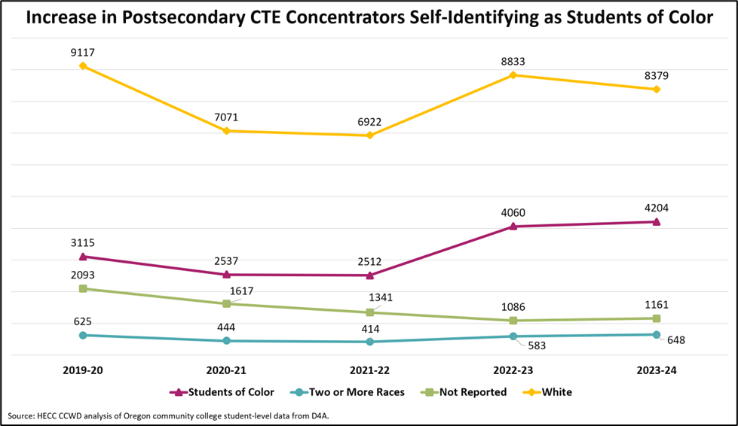
Strengthening the connections from classroom to career remains essential to achieving equitable, lifelong success for Oregon learners. Registered apprenticeship numbers remained relatively stable in 2024-25, with just over 10,000 Oregonians earning while they learn in a skilled profession. Expanding access to these opportunities must begin early. Oregon’s growing network of pre-apprenticeship programs is increasingly reaching high school students, reflecting strong local partnerships that connect education and industry to support students’ career aspirations. While most programs focus on the construction trades—where more than 80% of Oregon’s apprenticeship opportunities exist—new programs are emerging in manufacturing and healthcare. Many school districts have forged relationships with registered apprenticeship sponsors, creating additional pathways that extend learning from the classroom into the workforce.
The registered pre-apprenticeship providers listed in Figure #9 represent a range of program models. Several operate as extensions to approved CTE Programs of Study, while others serve all high school students or out-of-school youth within their service area. This variation reflects both the diversity of Oregon’s pre-apprenticeship landscape and the opportunity to strengthen alignment between CTE and registered apprenticeship pathways. Oregon now has 29 registered pre-apprenticeship program sponsors supporting articulated career preparation pathways in over 50 high schools and five community colleges statewide.

Figure #9 - K-14 Pre-Apprenticeship Providers
Provider Name | Industry | Age | Associated Schools/  Areas of Oregon
71Five Votech Pre-Apprenticeship | Construction | Youth 16-24 | Jackson & Josephine counties
Beaverton School District Construction Technology | Construction | High School Students | Merlo Station High School
Behavioral Health PATP | Behavioral Health | High School Students 16-18 | High Schools: Astoria, Dufur, Forest Grove’s CALC, Franklin, Oak Street, Riverside, Salem-Keizer CTEC, Sunset, Tualatin, Warrenton, West Linn, West Salem and Wilsonville
Benson High School | Carpentry | High School Students | Benson High School (Portland Public Schools)
Carpenter Trades Youth Pre-Apprenticeship | Carpentry | Juniors age 16+ | Portland metro-area high schools
Cascadia Technical Academy | Construction | High School Juniors and Seniors | open to students attending a high school in Clark County, Washington
Central OR Pact | Various Trades | K-14 Students | Central Oregon Community College and Columbia Gorge Community College. All area high schools (Bend, Bend Tech Academy at Marshall, Caldera, Crook County, Madras, Redmond)
Chemeketa Campus-Based PATP | Construction | High School Aged Youth & Adults | Chemeketa Community College
Clackamas Youth Trades Initiative PATP | Manufacturing & Construction | High School Students | Students in Clackamas County, including urban, suburban, and rural areas within the Oregon City School District
Construction Fast Program | Construction | High School Students | Gresham Barlow School District
Crater Lake Electrical PATP | Electrical | In School and Out of School Youth | Southern Oregon region including Lake, Harney, Jackson, Riddle School District and Days Creek Charter School, Josephine, Douglas, and Klamath counties
Edvocation Manufacturing PATP | Manufacturing | High School Students | Servicing the following school districts: Camas Valley, Days Creek, Glendale, Glide, Reedsport community, Oakland, Yoncalla, and South Umpqua
Klamath County School District PATP | Carpentry & Construction | High School Students | Open to students from Henley, Falcon Heights Alternative, Mazama, Bonanza, and Lost River High Schools
Lane Pact | Various Trades | High School Students | Serving all high schools in Lane County
Lane PAM (Pre-Apprenticeship Manufacturing) | Manufacturing | High School Students | Serving Creswell, Oakridge and Willamette High Schools’ Manufacturing CTE Programs of Study
Metals Manufacturing Fast Program | Manufacturing | High School Students | Gresham Barlow School District
MPACT (Medford Pre-App Const & Trades) | Construction | High School Students | Medford School District
NWCOC Construction Fundamentals PATP | Construction | 15 – 18 years | Parkrose High School
OCC PACT | Construction | High School aged Youth & Adults | Oregon Coast Community College
PCC Swan Island Trade Center | Construction | High School aged Youth & Adults | Portland Community College
Reynolds High School HVAC | HVAC | High School Students | Reynolds High School
Sherwood SD CTE PATP | Construction | High School Students | Sherwood 88J School District, including parts of Washington, Yamhill, and Clackamas Counties
Southern Oregon Apprenticeship Readiness | Construction | High School Students | Eagle Ridge High School
St Helens High School | Construction | High School Students | St. Helens High School
Tero Vocational Training Center | Construction | High School aged Youth & Adults | Nixyaawii Charter School, Umatilla Indian Reservation
Umpqua Pre-Apprenticeship Program | Various Trades | High School Students | Douglas County, Roseburg, Phoenix Charter School, Douglas and Elkton High Schools, Umpqua Community College
West Linn-Wilsonville SD Const PATP | Construction | High School Students 15-18 | West Linn – Wilsonville School District
West Linn-Wilsonville SD Healthcare PATP | Healthcare | High School Students 15-18 | Riverside High School
West Linn-Wilsonville SD Manuf PATP | Manufacturing | High School Students 15-18 | West Linn – Wilsonville School District
New partnerships and pre-apprenticeship models are expanding access for high school students, especially in construction, manufacturing, and behavioral health. The following examples illustrate how CTE-aligned pre-apprenticeship efforts are emerging across the state:
- Behavioral Health (United We Heal JATC): The Salem-Keizer Career & Technical Education Center (CTEC), Sunset High School, Tualatin High School, and other CTE Health Sciences Programs of Study aligned with United We Heal’s pre-apprenticeship model, creating a pathway into registered behavioral health apprenticeships. Program administrators noted that this opportunity provides a pipeline from high school into a variety of behavioral health careers to help address a critical workforce need across the state.
- Construction/Manufacturing (West Linn-Wilsonville SD): With support from Future Ready Oregon grant funding, the district launched a State Apprenticeship Council-approved pre-apprenticeship program serving students in Engineering Technology CTE Programs of Study at two high schools. The program integrates Computer Aided Design (CAD) and robotics design, paired with strong mentorship and a focus on priority populations.
- Construction/Manufacturing (Oregon City SD): Through its Clackamas Academy of Industrial Sciences, the district introduced a pre-apprenticeship program aligned to the United Association of Plumbers and Pipefitters Local 290, offering a direct entry pathway into registered apprenticeship.
While outcome data for these newly approved programs is not yet available, their development reflects promising momentum in building clear, aligned pathways from secondary CTE into Oregon’s registered apprenticeship system.
From secondary classrooms to community college campuses to registered apprenticeship programs, learners are gaining the knowledge, skills, and experience needed to thrive in an evolving economy. Strong program offerings, persistent concentrator growth, and encouraging outcomes among historically underserved learners demonstrate that CTE is working. However, ensuring that every student has access to high-quality, industry-aligned pathways requires continued investment and innovation. By expanding targeted funding, supporting systems navigation, and scaling successful models, Oregon can build a truly comprehensive CTE system that delivers on its promise of opportunity for all.

Goal #2
Develop regional centers that establish any appropriate partnerships between public schools, community colleges, public universities, businesses, unions, and other entities and that ensure that every student of this state has access to a regional center in person or online.

Progress toward regional CTE centers continues slowly across Oregon as local and regional leaders pursue partnerships to expand student access to high-quality, hands-on career learning. These efforts consistently reveal both the systemic challenges that limit progress and what it takes to overcome them.
Two examples highlight both the barriers and the conditions that make meaningful regional CTE expansion possible:
- In Sheridan, Hampton Lumber committed $1 million toward the development of the Barbara Roberts CTE Center, a regional facility that will serve multiple school districts with programs in Fire Science, Diesel Technology, Manufacturing, Agribusiness, and more. The project demonstrates how significant private-sector investment, combined with regional coordination and phased implementation, can help rural communities move forward even when public funding is limited. Work at this center was also advanced through a CTE Revitalization Grant (2023-25 cycle) crafted to support a start-up Firefighting/Emergency Medical Technician (EMT) Program of Study. Students participating in the Firefighting/EMT Program of Study will receive training in vehicle extrication, firefighting, and emergency services to prepare them for higher education and/or certification. Perrydale School District, Amity School District, Amity Fire District, Sheridan Fire District, Confederated Tribes of Grand Ronde, Chemeketa Community College, and Willamette Education Service District support the Firefighting Program of Study. Chemeketa Community College is also planning to contribute technical expertise by advising on the design of the fire training tower, offering opportunities for students to observe college-level fire suppression drills, and assisting in developing safety policies and procedures—strengthening alignment between secondary and postsecondary programs. This venture supports critical career development in the region and further demonstrates the value of public/private collaboration.
- At the Willamette Career Academy, the Willamette Education Service District launched a new Dental Assisting program in 2024. Thirty student slots filled immediately, and local dental offices began expressing interest in future graduates before the first class even began. The program was made possible through a combination of donations from dental equipment manufacturer DCI and the Spencer Family Foundation, state grant funding, and strong community will. Chemeketa Community College and Oregon Institute of Technology are supporting the program through advising materials, guest speaking, field trips, and early alignment conversations to support long-term transfer and credit opportunities. This example reflects both the strength of student and employer demand and the fragility of programs that depend on one-time funding or philanthropy to launch and sustain.

Together, these stories reinforce what has been echoed across the state:
- There is strong and growing demand for high-quality, regional CTE access.
- Local leadership and partnerships are essential, but are insufficient without consistent, sustainable support.
- Addressing geographic and resource barriers requires flexible, multi-partner strategies, and a stable funding structure.
- Regional CTE expansion is strongest when deeply connected to community colleges, which provide technical expertise, transfer alignment, and sustainable program support.
While these two regional models reflect momentum, broader progress will require coordinated policy and funding mechanisms that acknowledge the complexity of developing and sustaining regional CTE access across Oregon’s diverse landscape. In both examples, $500,000 CTE Revitalization Grants to each site served as essential early investments—one of the few CTE funding sources available for capital projects—helping regions turn vision into tangible facilities and programs. Continued collaboration among state agencies, education providers, community colleges, industry partners, and communities will be essential to building on this momentum.

Goal #3
Encourage the establishment of joint high school and community college advisory committees that may include representatives of public schools, community colleges, public universities, businesses, and unions.

Robust and collaborative advisory structures are essential to ensuring CTE Programs of Study remain aligned to industry needs and regional workforce goals. Over the past year, the Partnering State Agencies and CTE leaders have strengthened partnerships that bring together K-12 schools, community colleges, workforce development, business and industry, and labor representatives. These joint advisory efforts help shape statewide priorities, guide program design, and ensure learners are equipped with relevant skills and experiences.
CTE leaders have actively participated in the Future Ready Oregon Industry Consortia, ensuring that secondary and postsecondary career education perspectives are represented in statewide workforce conversations. Through this engagement, CTE partners have contributed to discussions on regional talent development, alignment between education and industry needs, and strategies for increasing equitable access to high-wage, in-demand careers.
- Healthcare Consortium: Exploring the needs of the behavioral health workforce and how to introduce youth into that pipeline through CTE, pre-apprenticeships, and other entry points. Offering feedback on healthcare occupational profiles/wage data and how to present the information in an accessible and helpful format.
- Technology Consortium: Developing strategies for targeted investments in Artificial Intelligence (AI) education, including leveraging state partnerships with Nvidia and Oregon’s Memorandum of Agreement to expand AI learning opportunities. Exploring potential connections between high school programs that align with newly launched postsecondary pathways in areas of database administration and unmanned aerial navigation.
- Manufacturing Consortium: Supporting the expansion of innovative education models in the sector, such as the Hillsboro Advanced Manufacturing Apprenticeship Program. Over the summer, the consortium completed critical updates to occupational profiles and wage data products that map to manufacturing industry opportunities. Through the efforts of consortium partners, approximately $12.6 million in Workforce Ready Grants went to support 19 manufacturing-specific projects across Oregon that increase earn-and-learn opportunities for priority populations, expand K-12 outreach for manufacturing career paths, and strengthen and sustain strong relationships with industry.
Participation in these cross-sector forums has reinforced the importance of coordinated advisory structures that bring together education, workforce, labor, and industry voices. Insights gained through these engagements are informing efforts to strengthen local and regional advisory models, helping to ensure that Oregon students are prepared to enter and thrive in evolving workforce sectors.

In parallel, efforts have continued to formalize and strengthen statewide advisory structures across CTE industry sectors, with a focus on aligning secondary and postsecondary instruction to industry expectations and workforce needs. In the Health Sciences sector, business and industry partners collaborated with secondary and postsecondary educators to revise the CTE Program of Study knowledge and skill statements, strengthening alignment between high school and college programs and ensuring the curriculum remains responsive to evolving workforce demands. The state is also advancing efforts to establish statewide advisory structures in additional sectors, including Education & Training and Personal Care Services. Oregon’s Team Ag Ed (Agricultural Education) continues to serve as the statewide advisory committee for Agriculture, offering a strong example of sustained, sector-specific collaboration. This group includes partners from community colleges, Oregon State University, and a range of industry organizations, and plays a key role in guiding the alignment and improvement of Agriculture CTE programs statewide. Additionally, the implementation of the statewide Natural Resource/Forestry advisory committee has been formalized, working in collaboration with various natural resource partners and assisting in the development of the statewide CTE Program of Study. Whether newly established or long-standing, these advisory structures are critical to ensuring that Oregon’s CTE Programs of Study remain current, connected to industry, and effective in preparing students for postsecondary success and meaningful careers.
At the local level, advisory committees play a vital role in informing local, regional, and statewide priorities. Advisory committee structures that center local voices and needs are more effective than top-down approaches from the state level. Oregon’s CTE Programs of Study rely on strong local advisory committees composed of educators, employers, labor, and industry professionals. These committees are essential for maintaining approved programs, ensuring alignment between secondary and postsecondary programs, and connecting coursework to current and emerging industry standards. They also serve as spaces for collaboration across education and workforce partners—helping identify gaps, inform program updates, and strengthen pathways for students.
In 2024-25, educators and partners across Oregon expressed growing interest in improving the alignment, efficiency, and impact of advisory committee operations. To better understand how local resources support these committees, ODE and HECC facilitated a series of design and listening sessions throughout spring and summer 2025.
During the spring sessions, Perkins grant managers and state staff engaged in a creative design activity to identify common challenges and generate innovative solutions. Participants surfaced opportunities to streamline implementation, clarify expectations, and enhance consistency in how advisory feedback informs program improvement. In the summer, ODE and HECC hosted three listening sessions to gather more detailed feedback from secondary and postsecondary institutions. These discussions explored both strengths and areas for growth across advisory structures statewide, highlighting promising practices, as well as barriers that limit effective engagement. Feedback from these conversations will inform next steps in aligning local advisory processes, identifying shared resources, and exploring potential state-level supports to improve coordination, consistency, and effectiveness.
These local insights, in turn, inform Oregon’s broader ecosystem. Alongside sector-specific and regional work, statewide advisory bodies help connect local perspectives to policy and planning. Now in its fourth year, the Statewide CTE Advisory Council continues to play a vital role in advancing Oregon’s vision for equitable, high-quality CTE. A committed group of students, educators, counselors, administrators, postsecondary leaders, workforce development experts, business and industry partners, and community-based organizations serve in collaboration with members of the Partnering State Agencies who serve as ex officio members.
In its 2024-25 quarterly meetings, the Council focused on topics such as:
- Monthly Communications – creating a consistent way to share updates and gather feedback between meetings.
- Dashboard – developing an internal resource where members can access meeting materials and exchange resources.
- Asset Mapping Project – connecting people and work across the state by leveraging members’ knowledge and expertise.
- Charter Review – co-creating a guiding document that reflects both state staff and partner input on the Council’s purpose and functions.
Details on meeting schedules, materials, and membership are available on the Statewide CTE Advisory Council webpage.
Equally important, student voices continue to play a critical role in shaping the future of CTE in Oregon. In its third year, the CTE Student Advisory Council (CSAC) continued to serve as a key advisory voice for the Partnering State Agencies in support of Oregon’s CTE State Plan. CSAC membership grew from six students in 2023-24 to 14 in 2024-25, with representation from secondary and postsecondary, as well as recent CTE graduates. CSAC accomplishments from 2024-25 included:
- Collaborated on the creation of the 2024 - 2027 CTE State Plan
- Created a student-facing CTE State Plan One-Pager (further outlined in Goal #7)
- Provided feedback on a variety of CTE as well as other ODE initiatives
- Led the #ThisIsCTE Social Media Campaign (further outlined in Goal #7)
- Published the inaugural edition of the CTE Students in Action Newsletter
Together, these advisory bodies—whether statewide, sector-specific, or student-led—help ensure Oregon’s CTE system is not only aligned, but responsive. By bringing together education, workforce, and industry partners to inform program design and policy decisions, these structures are building a more coherent and collaborative CTE ecosystem. Their continued evolution will be essential as Oregon works to meet the needs of learners, communities, and the economy.

Goal #4
Address academic requirements and regulatory barriers that inhibit successful movement of students in career and technical education from high schools to postsecondary school programs and the workforce.

Oregon continues to make progress in removing barriers that limit seamless transitions from high school to postsecondary education and the workforce. However, challenges related to credit transfer, program alignment, data reporting, and regulatory flexibility can still affect student mobility and pathway continuity. Through joint initiatives, innovative pilots, and strengthened cross-agency partnerships, the state is working to better align academic requirements, regulatory frameworks, and program design so that every learner can access, persist, and succeed in high-quality CTE pathways.

CTE Without Limits is a joint initiative led by ODE and the HECC, aimed at removing barriers to high-quality CTE access—particularly in online/virtual, youth corrections, small/rural/remote, tribal, and alternative education settings. The initiative focuses on building flexible systems, valuing learning wherever it occurs, closing equity gaps, and ensuring that all students have access to meaningful, portable, and high-quality CTE experiences. The work is patterned after Advance CTE’s, Without Limits: A Shared Vision for the Future of Career and Technical Education, particularly principles four and five that call for portable skills and a flexible career preparation ecosystem for learners.
In 2024-25, the initiative matured from foundational work into coordinated action across agencies and partners. Key developments included:
- Organizational structure work
  - Bringing areas of work together under the CTE Without Limits umbrella
  - Adding additional state agency staff to the workgroups
  - Establishing yearly planning and meeting cadence
  - Visioning work
- Launched the Innovation Zones competitive grant process for small/rural/remote schools
- Established the Alternative Education & CTE workgroup
- Launched a CTE Without Limits dashboard (for internal use across the various groups)
- Organized a CTE Without Limits conference track at the Oregon ACTE conference
- Began the process of creating a CTE Without Limits community of practice
  - Gathered feedback from teachers and administrators via a survey
  - Established a planning team
This developing infrastructure represents growing momentum and partnerships toward removing systemic barriers and aligning supports so that all students—regardless of geography or setting—can access high-quality CTE opportunities.
Oregon is also addressing academic barriers that limit student mobility between secondary and postsecondary education through revised Credit for Prior Learning (CPL) standards, which help reduce academic and financial barriers for learners pursuing postsecondary education and training. In 2024-25, Rogue Community College (RCC) implemented CPL opportunities into multiple CTE pathways including Applied Technology, Arts/Humanities/Communication, Business, Health Professions, Public Safety, STEM, Social and Behavioral Science, and Education. Additionally, RCC launched a CPL framework for students who reach certain scores on the GED test credential to receive college credit at no cost.
In addition to addressing academic and credit-transfer barriers, Oregon continues to focus on strengthening pathways into registered apprenticeship and employment. The Future Ready Oregon legislation, through the Future Ready Apprenticeship Program, was designed to strategically expand registered apprenticeship models into high-demand occupations such as healthcare and manufacturing, while also strengthening pre-apprenticeship pathways in the construction industry. A core objective was to increase overall program participation, particularly among Priority Populations, including women and individuals from communities of color. Many educational partners used these resources to extend or embed pre-apprenticeship opportunities within high schools; some aligned with existing CTE Programs of Study.
Early implementation data show that new or expanded K-14 pre-apprenticeship programs have broadened access to general knowledge of construction trades but have yet to demonstrate measurable movement into registered apprenticeship placements as summarized in Figure #10.
Figure #10 - Outcomes of High School/Youth Pre-Apprenticeship Programs Supported by Future Ready Oregon
Program Type | Registered | Graduated | Placed in Apprenticeship
Existing Programs Approved by OSATC before July 2022 | 515 | 378 | 67
New Programs Approved by OSATC after July 2022 | 418 | 171 | 6

Time and additional analysis are needed to identify the factors influencing transition and completion in registered apprenticeships, including program design, the early career stage of participating youth, or the need for deeper partnership with registered apprenticeship sponsors. High school-based pre-apprenticeship programs may also benefit from increased administrative and technical support to meet state reporting requirements and strengthen long-term connections to registered apprenticeship pathways. In contrast, established programs with longstanding experience serving out-of-school youth—such as Portland YouthBuilders and Portland Opportunities Industrial Center—show measurable success in supporting participants’ entry into registered apprenticeship and in maintaining robust reporting through the Oregon Pre-Apprenticeship Tracking Portal.
Together, these findings highlight the importance of continued cross-agency collaboration to enhance data systems, align expectations, and ensure that pre-apprenticeship initiatives across Oregon effectively prepare students for sustained success within registered apprenticeship programs.
While the Future Ready Oregon investments focused on expanding pathways into registered apprenticeship, employers across sectors have also emphasized the need for students to build foundational employability skills essential to success in any career. The Oregon Employability Skills (OES) curriculum is continuing to advance this initiative through cross-sector collaboration between education, workforce, and industry partners to ensure that students build these essential competencies early in their educational journey.
Industry partners across Oregon have consistently noted that students entering the workforce often lack essential employability skills crucial for success in any job. Employers frequently do not have the time or resources to teach these skills. Industry leaders believe integrating these skills into the K-12 education system ensures that students develop a common language and understanding of employability skills before entering the workforce. This challenge has a significant economic impact, affecting companies and Oregonians.
By addressing this barrier through the OES curriculum, students are equipped with the necessary skills to thrive in the workforce, ultimately benefiting the broader economy and community. These employability skills, which have been validated by five community colleges and aligned with work from the University of Oregon and Oregon State University, are not just about entering the workforce directly but are core competencies for navigating academic and personal challenges. By intentionally developing these skills, students are better equipped to connect their educational choices to their career goals, increasing their commitment to their studies and their chances of success.
2024-25 saw much progress in Oregon’s efforts to further bridge the classroom and the workforce using Oregon Employability Skills.
- Educational Institutions: Established collaborations with seven community college partners and four university partners, creating a robust pipeline for student and educator engagement.
- Workforce & Community Reach: Partnered with seven Local Workforce Areas and 11 community-based organizations (CBOs) (spanning nine counties), demonstrating a strong commitment to local workforce and community needs.
- Wider Engagement: Reached 500+ partners (including educators, CBOs, apprenticeship programs, and industry) through presentations at 10+ conferences, significantly expanding the network and influence.
- Educator Training: Successfully trained 100+ educators, directly impacting the quality of instruction and career-readiness programs across partner institutions.
- Validated Need: Gathered 400 survey responses that indicate a high degree of need for explicit teaching of OES from both industry and educators, confirming the critical relevance of the work.
- Diverse Industry Focus: Supported nine key economic sectors and their companies: construction, hospitality & tourism, manufacturing, childcare, cosmetology, transportation & logistics, healthcare, information technology, and Oregon clean energy.
These cross-sector partnerships ensure that academic programs develop the practical skills employers need while supporting student engagement and persistence.
To sustain this alignment between education and workforce, Oregon’s Career Connected Learning Systems Navigators (CCLSNs) coordinate regional efforts to address access barriers and support early, equitable exposure to CCL and CTE opportunities. Each of Oregon’s 17 community colleges hosts a CCLSN who builds partnerships with schools, employers, colleges, and workforce networks. These positions were previously funded by ODE and now are funded by HECC through the Community College Support Fund, a strong example of state agency partnership to scale promising practices. The CCLSNs help to:
- support aligned, equitable, and sustainable CCL systems,
- address barriers and equity gaps in regional CCL systems,
- work with partners to deliver CCL opportunities and activities for K-12 students that promote earlier career identity development and build pathways into college and career, and
- elevate postsecondary institutions as a hub of opportunity for education and training that supports regional economic prosperity.
One example of this work is illustrated by Jessica Griffin Conner, Columbia Gorge Community College’s CCLSN, whose regional collaboration demonstrates how targeted partnerships can address barriers to student CTE transitions:
“Maritime Career Day was designed to introduce all 8th grade students at The Dalles Middle School to high-wage, high-demand career pathways that exist within their own region. By connecting hands-on experiences to real-world careers, especially in maritime, construction, and advanced manufacturing, we aimed to spark early interest in CTE and help students see themselves in future career opportunities, regardless of background. The event intentionally included all 8th grade students, creating equitable access to career exploration activities in a region with diverse populations and economic disparities.
Our region is home to a diverse student population, with 21.7% of residents identifying as Hispanic/Latino and more than 10% living below the poverty line. By including all 8th grade students at The Dalles Middle School (161 students total) we ensured every student had access to high-quality, hands-on experiences tied to local career paths.
Feedback from educators, administration, and students was overwhelmingly positive. One strong indicator of success: students who attended the first day spoke about the event to students who were scheduled to attend on the second day, a rare level of enthusiasm for middle school career events. The school principal and teachers noted students were inspired and engaged, and the administration expressed interest in continuing the event in future years if funding allows.”
The Qualified Mental Health Associate (QMHA) Pilot Project, developed by the American Federation of State, County and Municipal Employees and their employer partners through the United We Heal registered apprenticeship, tackles longstanding academic and regulatory barriers that have limited student transitions into Oregon’s behavioral health workforce. Historically, QMHA certification required a four-year degree or a combination of three years of education, training, and work experience that unintentionally excluded or delayed entry for students completing rigorous two-year associate degree programs with embedded practicum experiences. This pilot introduces two new, accelerated pathways to QMHA Registered (QMHA-R) status: one for graduates of specialized associate degree programs and another for completers of a state-registered QMHA apprenticeships. These pathways are designed to recognize the value of applied learning and reduce the time and financial burden for students associated with traditional certification routes.
By aligning curriculum and practicum requirements in community college programs with the competencies outlined in Oregon Administrative Rule OAR 309-019-0125, the pilot ensures that students are workforce-ready upon graduation. This alignment not only validates the quality of associate level education but also removes the redundant requirement for additional work experience post-graduation. The pilot also includes a mechanism for high school CTE pre-apprenticeship programs to feed into the QMHA registered apprenticeship track, creating a more inclusive and continuous pipeline from secondary education to employment. This approach is particularly impactful for students from underserved communities who may face financial, geographic, or familial barriers to pursuing a four-year degree.
The pilot also addresses regulatory rigidity by proposing a data-informed revision to OAR 309-019-0125. Through collaboration with the Oregon Health Authority, the Mental Health and Addiction Certification Board of Oregon, and the Bureau of Labor and Industries, the pilot will collect and analyze data on student demographics, attrition, graduation, certification, and employment outcomes. These findings will inform a final report recommending whether a permanent third pathway to QMHA certification should be codified. This evidence-based approach ensures that regulatory changes are grounded in real-world outcomes and workforce needs.
Additionally, the pilot’s design acknowledges the systemic challenges faced by historically underserved students, including high dropout rates due to work, childcare, and financial pressures. To mitigate these barriers, the project plan includes provisions, pending funding, for tuition assistance, stipends, and fee waivers. These supports are critical to improving retention and completion rates, particularly among adult learners and students from historically marginalized communities. By reducing financial strain, the pilot intends to enhance equity in access to behavioral health careers.
The inclusion of registered apprenticeship as a parallel pathway further strengthens the bridge between education and employment. Apprenticeship programs offer structured, paid on-the-job training combined with classroom instruction, making them an attractive option for students who need to earn while they learn. The pilot’s registered apprenticeship model, which includes 3,400 hours of supervised work experience and 290 hours of related instruction, is designed to meet or exceed the competencies required for QMHA-R certification. This model also provides a scalable framework for future workforce development initiatives in other health and human services fields.
The pilot’s emphasis on collaboration with educational institutions, employers, and regulatory bodies ensures that the pathways developed are responsive to both student needs and industry standards. By evaluating the effectiveness of these new pathways across multiple institutions and geographic regions, the pilot will generate a comprehensive understanding of how academic and regulatory systems can better support student mobility and workforce readiness. This collaborative, data-driven approach exemplifies how policy innovation can dismantle structural barriers and create more equitable, efficient, and responsive career and technical education systems.
The QMHA Pilot Project is a strategic and timely initiative that addresses Goal #4 by reimagining how academic credentials and regulatory frameworks can work together to support student success and meet workforce demand. It not only expands access to behavioral health careers but also lays the groundwork for systemic change that could benefit a wide range of CTE pathways across Oregon.
By aligning systems, valuing applied learning, and strengthening collaboration between education and workforce partners, Oregon is paving a smoother, more equitable path from classroom to career for all learners.

Goal #5
Implement accelerated college credit programs that allow students to move seamlessly from public schools to postsecondary education or training to the workforce.

Oregon made significant progress in 2024-25 to expand access to accelerated college credit opportunities and ensure smoother transitions from high school to postsecondary education and the workforce. A cross-agency team consisting of representatives from the HECC, ODE, and research and community college partners launched a statewide dual credit policy project — one of only seven nationally selected through a competitive grant process to work with national experts.
This project focuses on four key deliverables highlighted in Figure #11 and centers on strengthening state policy to increase access for rural and multilingual students to intentional college credit in high school. The lessons learned will then be applied through a statewide lens to expand access to these opportunities for all of Oregon’s high school students.
Figure #11 - Dual Credit Policy Project Key Deliverables 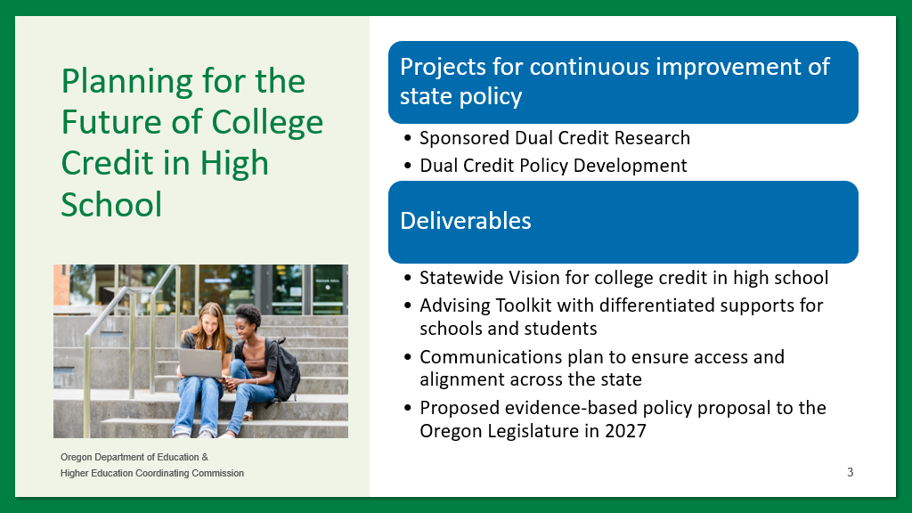
The decision to focus on rural and multilingual students was evidence-based. Rural students in Oregon participate in college credit in high school at comparable rates to their suburban and urban counterparts. However, they often face limited course options, less diverse credit offerings, and are less likely to enroll in postsecondary education after graduation. Figure #12 illustrates this gap in college enrollment outcomes between rural and nonrural graduates.
Figure #12 - College Outcomes for Rural and Nonrural High School Graduates
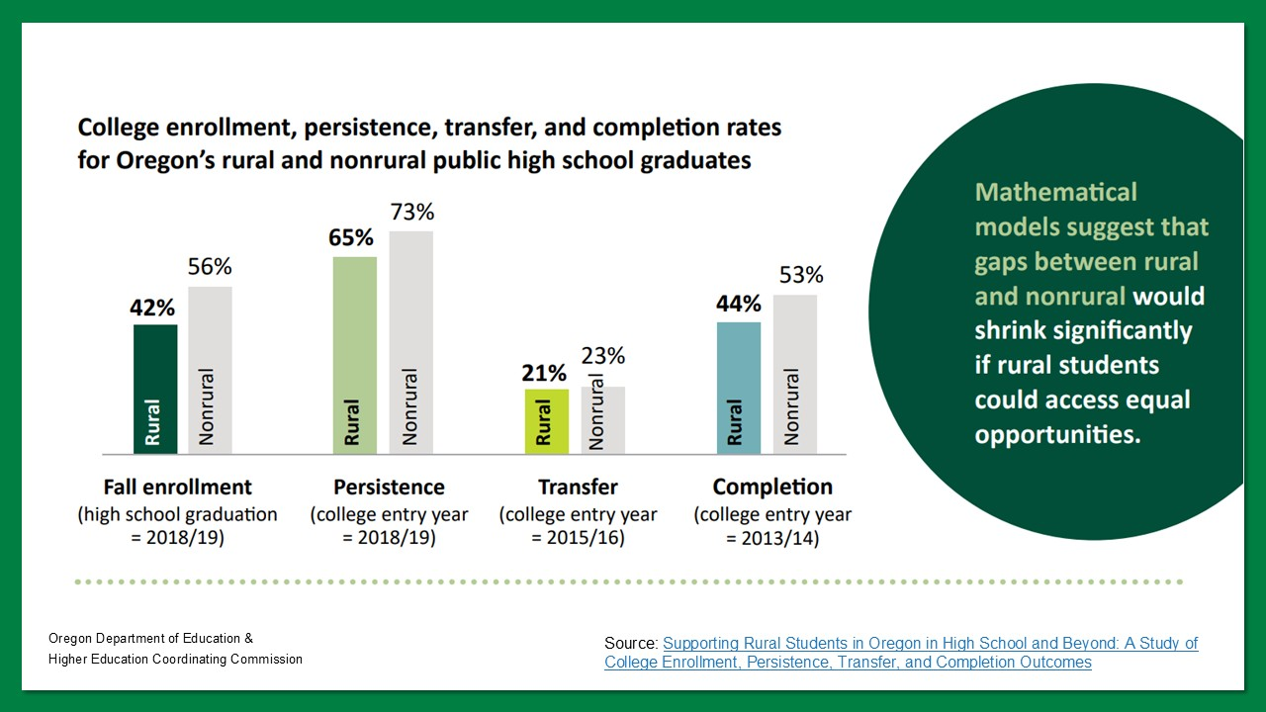
Participation gaps are even more pronounced for multilingual learners, particularly for students who were ever classified as English Language Learners (ELL) during high school. Data from the Oregon Accelerated Learning Dashboard from 2021-22 shows that only 14% of students classified as ELL in grades 9-12 earned college credit in high school that year, compared to 29% of all students. These disparities underscore the need for intentional policies that support access to accelerated credit for students who have been historically underrepresented in such programs.
Looking ahead to 2025-26, the Dual Credit Policy Project will launch a statewide survey and conduct student and parent/guardian focus groups. Findings will inform Oregon’s future vision and policy priorities and support the development of a statewide advising toolkit for educators. This toolkit will help schools guide students in choosing intentional, career-aligned college-credit opportunities that build momentum toward postsecondary success.

Goal #6
Increase professional development opportunities for teachers and learning opportunities for students through industry mentorships, internships, summer programs, after-school programs, and career-based student leadership opportunities.

Oregon continues to invest in expanding professional development for CTE educators and providing students with meaningful, career connected learning experiences. From statewide professional learning communities and educator externships to youth leadership programs and pre-apprenticeship collaborations, these efforts collectively strengthen the bridge between classroom learning and career readiness. In 2024-25, cross-agency and cross-sector efforts deepened partnerships, built educator capacity, and increased equitable access to high-quality learning opportunities.
Career Connected Learning Systems Navigators (CCLSNs) played a vital role in strengthening regional educator professional development throughout the state.
- Clackamas County Industry Connected Classroom Project
The Clackamas Community College CCLSN, South Metro-Salem STEM Partnership, regional industries and employers, Clackamas Education Service District, and Clackamas Workforce Partnership collaborated on the Industry Connected Classroom Project (ICCP). The ICCP is designed to strengthen the alignment between K-12 education and workforce needs by connecting educators with industry to co-develop project-based learning experiences. This hands-on, collaborative approach addresses regional workforce needs by preparing students with relevant, real-world skills. It also helps close equity gaps by ensuring more students, regardless of background, have access to meaningful CCL experiences, increasing engagement, motivation, and awareness of high-wage, in-demand career pathways.
In Clackamas County, middle school, high school, and college teachers were included in the project to help build a path from secondary to post-secondary to career. One of the participating teachers who benefitted from this professional development was a Business/Marketing Teacher in the Clean Energy ICCP. As a result of the ICCP experience, one of her students created a sales pitch for an energy-efficient Customer Relationship Management. The student presented his Portland General Electric Capstone Project at the DECA State Career Development Conference and placed top three in the state of Oregon. Other students participating in the Wildland Fire/GIS ICCP were able to participate in a live fire event at Hopkins Demonstration Forest and created prototype products to solve problems that firefighters reported to the students in interviews.
- Lane County Educator Externships
The Lane Community College CCLSN, Lane County schools, Lane CTE, Lane ESD, and a wide variety of business partners help to support Lane County Educator Externships. These externships place Lane County educators with local businesses to get in-depth, hands-on experience, work on mutually beneficial projects, and build workplace skills that they can bring back to the classroom. The project serves to build educator-industry relationships and results in current, updated information about career paths that reaches students and helps them make decisions about their futures. Stories from teachers and industry partners who have participated in the past, and the curriculum that has come out of the program, help to demonstrate the impact of Lane County Educator Externships. Teachers are able to create more applied, project-based curriculum and teach their students about current standards in the industries in which they're interested, and counselors are better able to advise their students on career path choices.
Sustained professional learning opportunities for educators remain a cornerstone of high-quality CTE. Now in their second full year, Oregon’s statewide CTE Professional Learning Communities (PLCs) have continued to grow as collaborative spaces for teachers to strengthen instruction, align programs, and support student transitions into postsecondary education and careers. PLCs across six career areas met throughout the 2024-25 school year, engaging CTE educators in meaningful learning driven by educator voice.
Each PLC identified specific priorities aligned with their program area goals. Highlights from across the career areas include:
- Agriculture, Food, and Natural Resources Systems: The Agriculture PLC held professional development gatherings in Lebanon, Redmond, and Astoria where high school and community college partners engaged in collegial professional learning embedded within the CTE skillsets. They also connected specifically about accelerated college credit opportunities between the high schools and community colleges. Educators also received support and guidance throughout the year related to Program of Study renewals. The community college partners for the Agriculture CTE Program of Study held their annual PLC at Chemeketa Community College, with eight partners present.
The Natural Resources/Forestry PLC similarly convened through a professional development series in Albany, Silverton, and Scio. The community college partners for the Natural Resource/Forestry CTE Program of Study held their annual PLC at Treasure Valley Community College, with seven community college partners present.
- Arts, Information and Communications: Educators from Fine & Performing Arts, Digital Media & Production, Computer Science, and Broadcasting & Journalism participated in a series of quarterly PLC gatherings with a shared focus on strengthening and expanding WBL. Computer Science educators explored how to build partnerships with school and district IT departments to support WBL experiences. Each of the other PLCs focused on navigating and developing external business partnerships to expand and improve business engagement in WBL. Across all groups, educators deepened their understanding of Oregon’s WBL criteria and types and accessed support to increase student participation in high-quality WBL.
The Arts, Information Technology, and Communications PLCs also engaged in meaningful discussions around expanding statewide professional development. The groups explored opportunities to partner with ODE and statewide career area organizations to develop annual professional learning experiences tailored to the specific needs of each career area. In addition, PLC members invited industry partners to share insights and opportunities related to local, student-focused leadership development events. These connections are helping to build stronger ties between CTE Programs of Study and relevant industries, enriching both classroom learning and real-world application.
The Computer Science PLC also heard from representatives at AP/College Board regarding a new AP Cybersecurity course. Notably, five Oregon teachers were selected to pilot this course during the upcoming school year—an exciting step forward in expanding advanced computer science offerings in the state.
- Health Sciences: The Health Sciences PLC (focused primarily on health care) engaged an average of 30 teachers per meeting throughout the school year. Educators used the space to problem-solve, exchange resources, and collaboratively address student needs within the career area. As many participants are the sole Health Sciences CTE teacher in their school district, the PLC has served as a valuable professional community and source of support. Educators also received support and guidance throughout the year related to Program of Study renewals.
The Biotechnology PLC represents three active Programs of Study that collaborate to share resources, align course outcomes, and explore industry opportunities. Portland Community College serves as a key partner, and the group meets quarterly to support continued alignment and professional growth.
WBL was featured in Health Sciences and Biotechnology PLCs, focusing on leveraging existing student opportunities and sharing examples.
- Industrial and Engineering Systems: PLCs in this career cluster focused on strengthening WBL connections and enhancing career awareness activities. Members also dedicated time to discussions around CTE lab and shop safety, resulting in significant progress toward a draft safety guide. This guide was informed by common themes and ideas raised within the PLC, with the goal of promoting a more consistent approach across programs.
The PLCs met in a hybrid format at Central Oregon Community College, where they explored shared challenges and toured learning spaces on the Redmond campus and at nearby Redmond High School. These site visits offered valuable insight into both secondary capacity and postsecondary opportunities, giving participants a broader perspective on teaching and learning within the career area.
- Business and Management: Educators in the Finance PLC focused on Program of Study renewal guidance and shared how the finance knowledge and skill sets align with their existing coursework. The group also reviewed Oregon’s new Personal Financial Education course standards, now required for high school graduation, and explored how these standards, and the course itself, could be integrated into a Finance Program of Study. Business educators explored strategies for transforming existing student opportunities into meaningful WBL experiences, with a focus on aligning activities to Oregon’s WBL criteria.
- Human Resources: Education & Training teachers explored ways to expand WBL opportunities beyond traditional cadet teaching and childcare placements, exploring new approaches to connect students with high-quality experiences. A subcommittee on teacher education piloted a project with Clackamas Community College, aligning their programs to the Elementary Education Major Transfer Map and the transfer degree program to more accurately reflect education and workforce needs in teacher preparation. The project has been approved for replication in other regions, and efforts to establish a statewide Program of Study for both Teacher Education and Early Childhood Education will begin in fall 2025.
The Personal Care Services PLC engaged in a deep dive into sustained professional interactions as part of high-quality WBL experiences. The Statewide PLC also reviewed and prepared for the upcoming Program of Study renewal and met throughout the year to establish those systems, including more alignment to Klamath Community College and the Health Licensing Office requirements. This program area is expanding, and three new school districts have submitted new program applications.
In Protective Services, educators reviewed Oregon’s WBL criteria and types, shared experiences and challenges from their programs, and began identifying areas for growth and improvement in providing meaningful WBL opportunities for students.
By supporting CTE teachers in structured, peer-led communities of practice, Oregon is building a stronger foundation for quality, equity, and innovation in CTE instruction statewide. These PLCs are not only enhancing professional relationships between secondary and postsecondary educators but also ensuring that students benefit from more cohesive, industry-aligned learning experiences.
Work-Based Learning (WBL) was a consistent focus across many of the PLCs, with educators exploring strategies to expand opportunities for students. The PLCs were complemented by additional statewide efforts to expand equitable access to high-quality WBL (as outlined in Figure #13).
Figure #13 - WBL Criteria and Types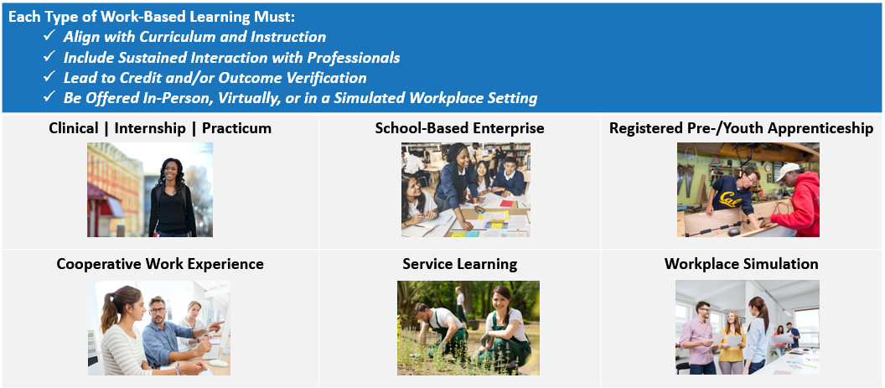
A monthly series of WBL Lunch & Learn sessions provided technical support and professional development to educators, administrators, and partners. Topics included employment law, service learning, student reflection practices, and strategies for sustaining engagement with industry and community partners. These sessions supported the implementation of WBL aligned with state criteria while promoting a shared understanding of what high-quality, student-centered WBL looks like across different settings.
To further equip schools and partners, ODE released an updated Work-Based Learning Handbook—a comprehensive resource designed to support equity, expand learning opportunities, and deepen partnerships with business and community leaders. The refreshed handbook includes practical tools, planning prompts, and guidance to connect all learners with real-world preparation and training experiences. It also links to Canvas-based WBL modules that offer additional learning on topics such as aligning WBL with Integrated Guidance applications and enhancing CTE Programs of Study by becoming registered pre-apprenticeship programs. The handbook is a key resource in advancing WBL as both a core benefit and required component of secondary CTE Programs of Study.
These statewide supports are making an impact. In 2023-24, 54.33% of secondary CTE concentrators participated in WBL. Figures #14-16 show the distribution of performance across career clusters—highlighting which exceed or fall below the statewide benchmark—as well as focal student groups whose participation exceeded the statewide rate. Strong participation is evident in Education & Training and Hospitality & Tourism, and among Hispanic learners, while Manufacturing and Arts, Audio Visual Technology & Communications currently reflect lower levels of WBL participation. These differences often reflect variation in program structure, WBL design, employer engagement, and staffing capacity. Together, these charts illuminate where progress is occurring and where additional support may be needed to close opportunity gaps.
Figure #14 - Career Clusters Below Statewide WBL Participation Rate
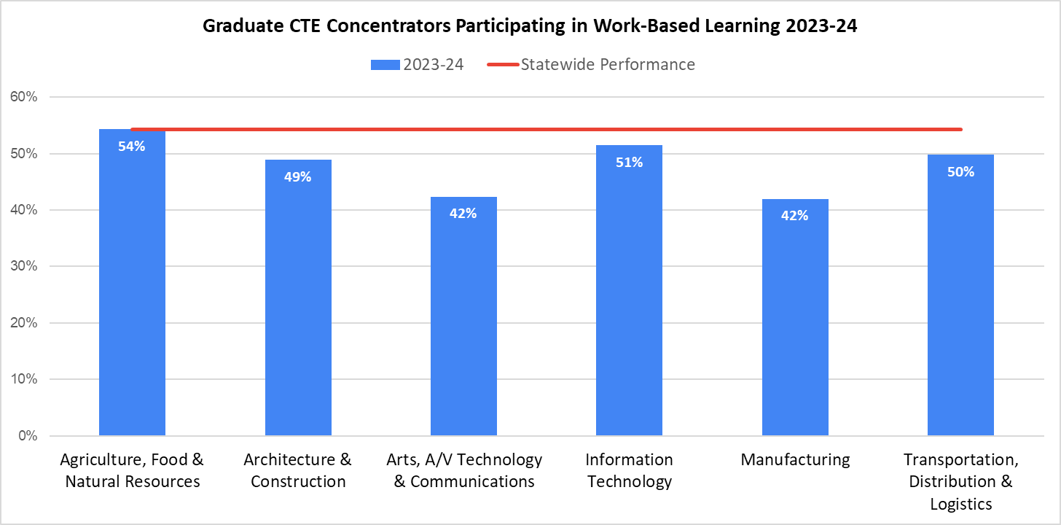

Figure #15 - Career Clusters Above Statewide WBL Participation Rate
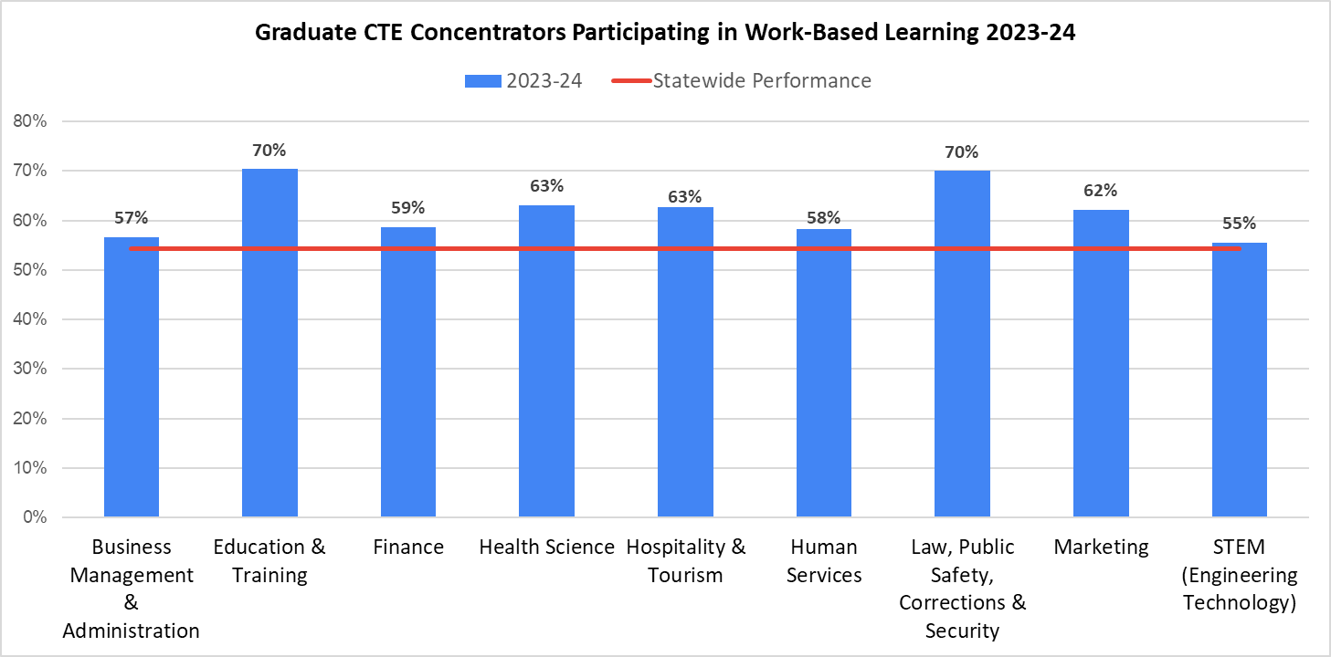
Figure #16 - Student Groups Above Statewide WBL Participation Rate
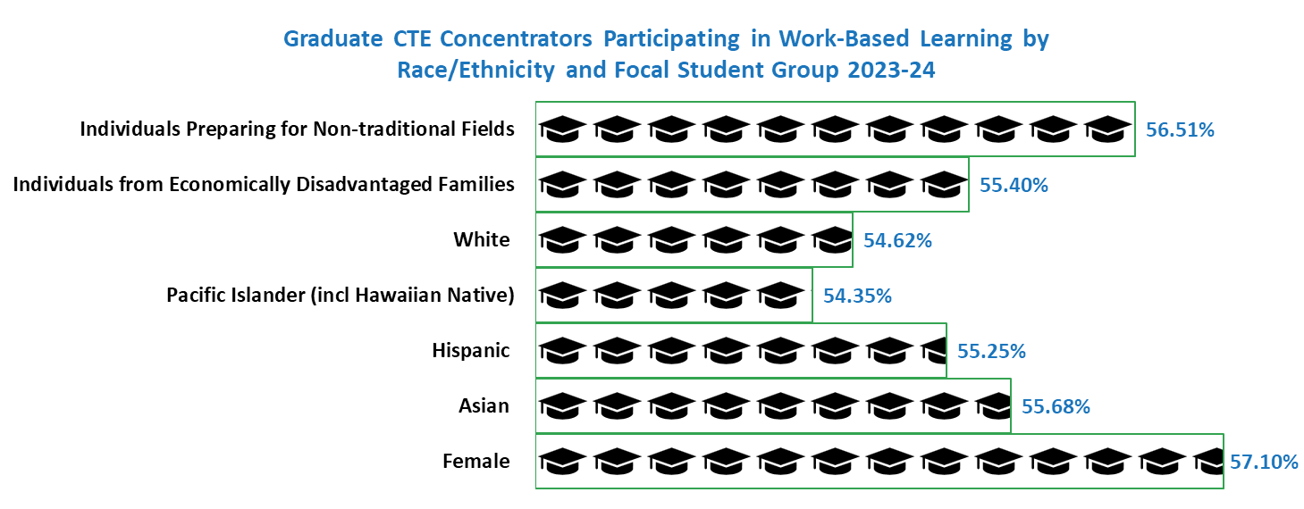
CTE teachers and partners are also connecting directly with Oregon’s pre-apprenticeship network to strengthen student pathways into skilled careers. Quarterly Pre-Apprenticeship Providers (PAP) meetings have traditionally been hosted by BOLI-ATD (Apprenticeship & Training Division) staff. Over this past year, the leadership shifted to the community of registered pre-apprenticeship program providers. Historically, these meetings are well attended by pre-apprenticeship program administrators, instructors, and their community partners. Community partners include employers, union representatives, registered apprenticeship program administrators, community colleges, alternative schools, high schools, school districts, nonprofit and for profit organizations, and ODE. PAP meetings are not mandatory, and they do not currently follow any governing structures. This is a convening where common space is provided to share success stories, receive BOLI updates, and explore available resources.
ATD staff will continue to support quarterly meetings by providing regular reports, ensuring regulatory compliance, and offering technical assistance as policy questions arise. Additionally, ATD will provide updated contact lists of registered providers as they typically change on a quarterly basis. BOLI-ATD is excited to announce that two very talented and experienced pre-apprenticeship coordinators have stepped up to assume the roles as hosts for future meetings—Construction Pathway for English Language Pre-Apprenticeship Program Coordinator, Nikki Gillis and Clackamas County Youth Initiatives Pre-Apprenticeship Program Coordinator, Angie Gilbert. This peer-led model is helping strengthen collaboration among schools, employers, and apprenticeship sponsors while cultivating leadership capacity among Oregon’s pre-apprenticeship coordinators.
Students also benefited from hands-on, leadership-focused opportunities supported through targeted legislative investment. Through the Future Farmers of America (FFA) Summer Duty/Summer Extended Contract Grant Program, 84 grants were awarded across the 2023-25 biennium, funding extended teacher contracts and hands-on leadership experiences for 3,848 students, including 2,105 historically underserved learners. Students engaged in FFA and Supervised Agricultural Experiences (SAE) activities for an average of 12 days per grant, participating in projects like county and state fair preparation, career exploration, and WBL aligned to agriculture pathways.
Additionally, the FFA Administration Grant Program supported leadership exposure and engagement for approximately 15,000 students enrolled in Agriculture Science and Technology Programs of Study. This funding ensured access to regional leadership conferences, competitive career development events, portfolio and SAE tracking through the Agriculture Experience Tracker, and local instruction aligned to national FFA standards. The program also covered FFA membership dues and supported professional development for agriculture teachers.
Together, these grant programs provide robust, equity-centered professional learning for educators and sustained, high-quality leadership development opportunities for students across Oregon’s agricultural CTE Programs of Study. These initiatives demonstrate the power of targeted state investment in both student learning and teacher support. To build on this success, the Partnering State Agencies encourage the legislature to consider expanding similar funding models to other CTE career areas—ensuring that all students have access to meaningful leadership development and extended learning aligned to their chosen pathways. Figure #17 illustrates statewide student participation in Career & Technical Student Organizations, demonstrating both the scale and reach of these leadership opportunities.
Figure #17 - 2024-25 Career & Technical Student Organization Membership
Career & Technical Student Organization | Oregon Membership
FFA prepares future generations to thrive, succeed, and be educated in the agriculture industry. | 15,780
FNRL develops learners’ potential for leadership, personal growth, and career success through Natural Resources Education. | 3,092
DECA prepares emerging leaders and entrepreneurs for careers in marketing, finance, hospitality and management. | 2,012
FBLA supports student leaders preparing for careers in business, management, entrepreneurship, and technology. | 1,546
HOSA provides learners with a program of leadership and skill development to help them become better health science leaders. | 1,271
SkillsUSA empowers learners to become skilled workers, leaders, and responsible citizens. | 923
TSA enhances the personal development, leadership, and career opportunities of STEM learners. | 460
FCCLA helps youth make a difference in their families, careers, and communities by addressing important personal, work, and societal issues through Family and Consumer Sciences education. | 242
Oregon’s coordinated efforts to expand educator professional development and student leadership opportunities are creating powerful ripple effects across the state. Teachers are better equipped to connect classroom learning with real-world applications, while students are gaining authentic experiences that prepare them for college, careers, and life. Continued investment in these initiatives will strengthen Oregon’s talent pipeline and ensure that every learner has access to high-quality, career connected education.

Goal #7
Establish partnerships between public and private entities for the purpose of educating students, parents, teachers, school advisors, policymakers, and the general public about the benefits and opportunities related to career and technical education.

Oregon continues to expand outreach and communication efforts that elevate understanding of CTE and its essential role in preparing students for college and career success. These statewide efforts emphasize consistent messaging, accessible storytelling, and authentic student voice, showcasing how CTE connects classroom learning to real-world opportunity.
Student leadership continues to play a central role in shaping how CTE is represented and understood statewide. In 2024-25, the CTE Student Advisory Council partnered with ODE and HECC to create a one-page visual to communicate the key components and value of CTE, ways to get involved in CTE, as well as the purpose of Oregon’s CTE State Plan to other students. This one-pager, as seen in Figure #18, was shared broadly through secondary and postsecondary CTE networks and with the Statewide CTE Advisory Council.

Figure #18 – Student-Created CTE Promotional Pieces
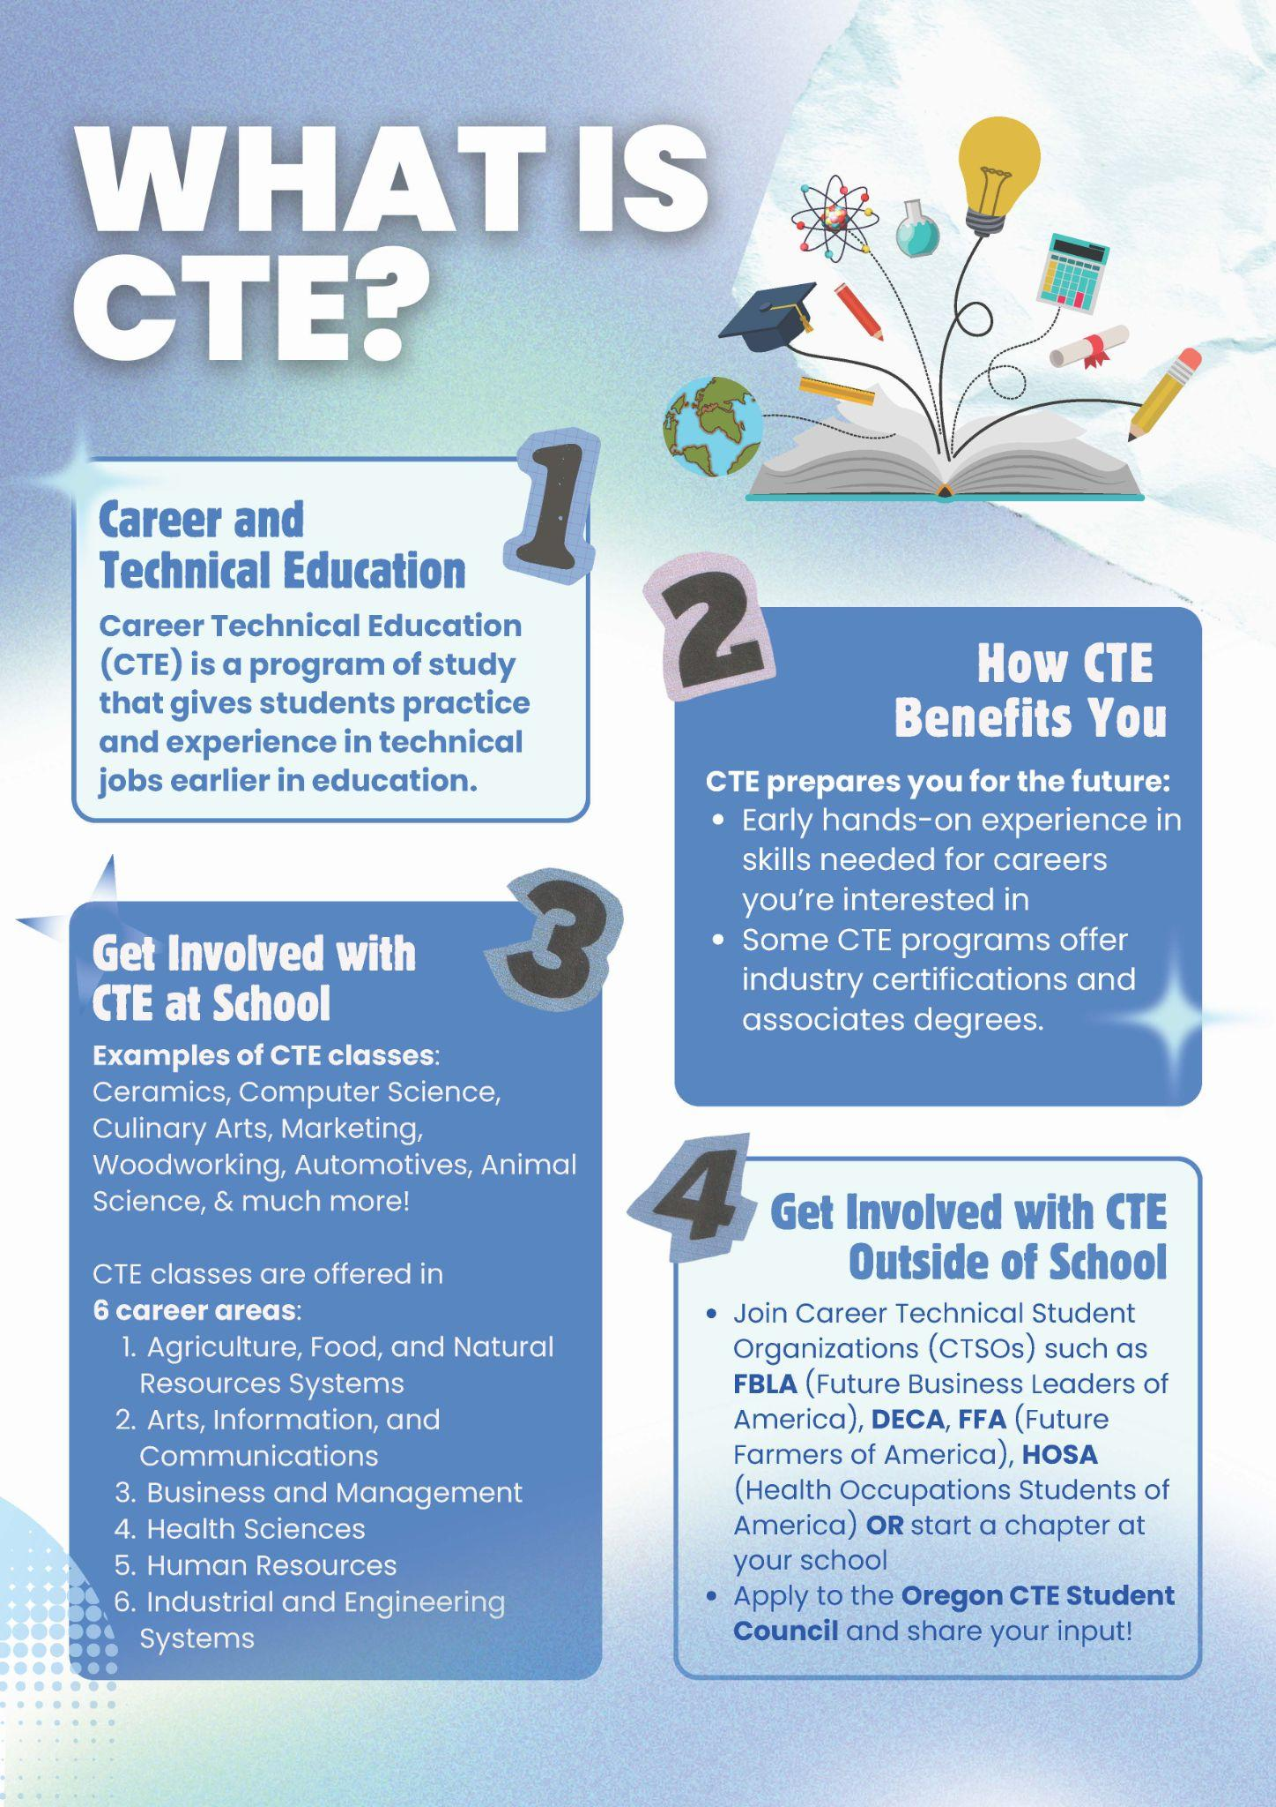
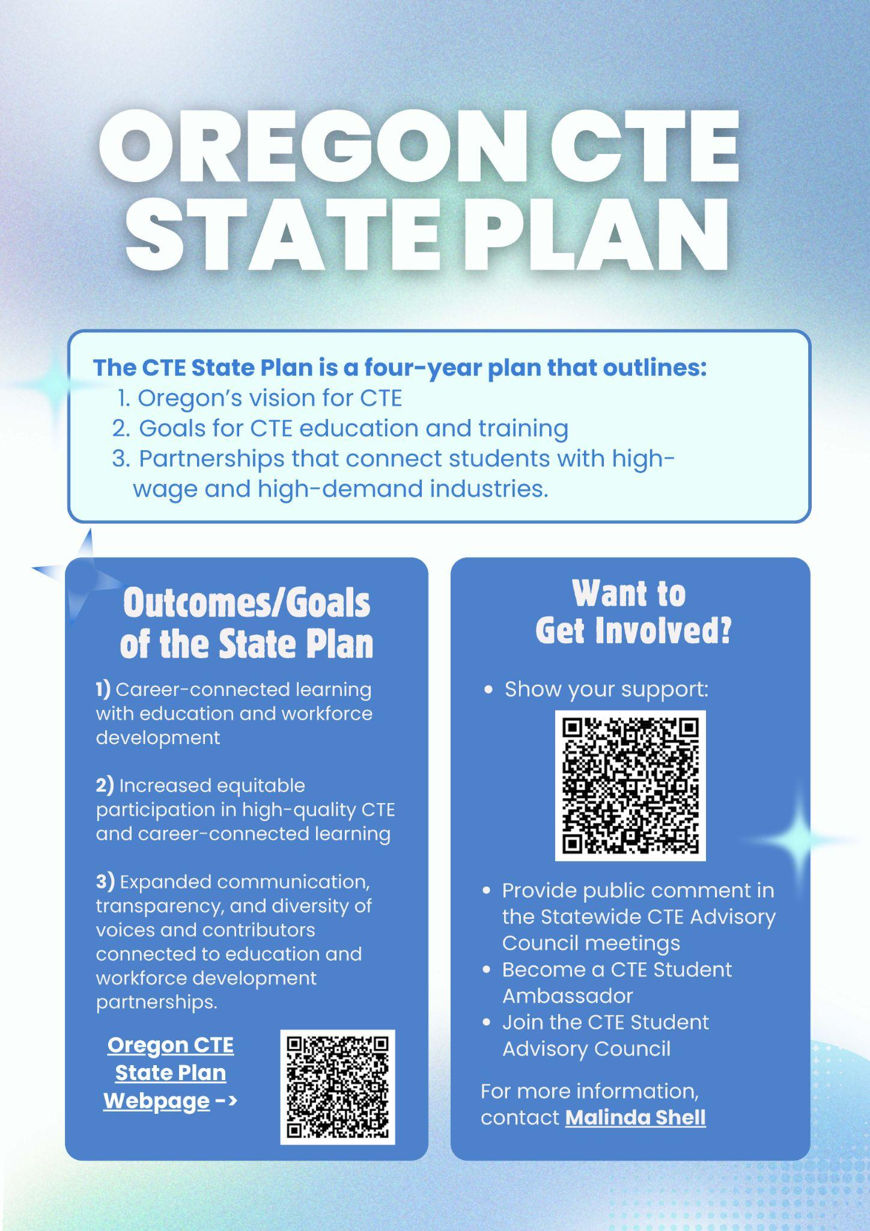
In 2024-25, the CTE Student Advisory Council also partnered with ODE and HECC to lead the #ThisIsCTE social media campaign, which brought 17 featured submissions of statewide secondary and postsecondary CTE activities representing Clackamas, Columbia, Coos, Deschutes, Jefferson, Malheur, Morrow, Multnomah, and Yamhill counties.
Featured #ThisIsCTE Social Media Campaign Posts
#1: Madras High School Health Sciences
“During the 1st semester of CTE Health Science at Madras High School there were over 40 students who received CPR and first aid training. Out of those 40 students, 20 students got BLS certified. Included in the training was Anaphylaxis first aid, Opioid overdose, and blood borne pathogens.”
#2: Central Oregon Community College Criminal Justice
“CTE keeps us safe—and the Criminal Justice program at Central Oregon Community College is on the front lines of that mission! These students are learning how to examine blood patterns, a key skill in crime scene investigation. Every day, they’re gaining hands-on experience to help keep our communities safe.”

#3: Ione Community Charter School Agriculture
"The Ione Agriculture Education Program is facilitated within the Ione Community Charter School 35 minutes south of Boardman, OR. All students within the agriculture courses during the Fall of 2024 assisted in converting half of a garden shed into a chicken coop with a run built on the side. All supplies and materials were from on-hand resources. Chickens were donated by D-L Ranches out of Prosser, WA.
Monitored daily by the Ione 7th Grade Exploratory Agriculture Class; poultry handling, health, showmanship, and judging are all studies the Ione Agriculture Chicken Coop has allowed active participation in building poultry production industry skills & knowledge. The Coop has been used year-round across multiple disciplines of agriculture curriculum for the Ione Community Charter School's Students.
Recently, students are studying American Poultry Association Breed Standards to develop proficient skills in identifying exterior parts of a chicken. The program is looking to turn this chicken coop into their School Based Enterprise by selling eggs and possibly even pullets later on to members of the community. Several middle school students are in charge of one individual chicken and use the care of that chicken for their individual foundational SAE project. Many students in the program are members of the Ione FFA Chapter. The chapter hopes to have its members compete in the Blue Mountain District Poultry CDE competition this spring.
Students record their experience with the chickens and time in the coop on their individual AET account. The AET, Agriculture Experience Tracker, is an essential tool for every Agriculture Education Career Technical Program. Follow the Ione Oregon FFA Chapter on Facebook and Instagram to find out what they do next with their chicken coop in the future!”
These student-driven efforts to promote and personalize CTE messaging mirror broader statewide strategies to deepen understanding of WBL. Even with strong WBL participation in some career areas, WBL access and understanding remain uneven among educators, students, families, and partners. To address these disparities and support coordinated messaging, a WBL communication plan was launched to elevate understanding of WBL as both a key benefit and required component of CTE Programs of Study. The plan aims to build a shared understanding of WBL in Oregon and support expanded, equitable access to high-quality WBL experiences, especially for learners who have historically experienced disparities in our schools.
This strategy leverages partnerships between public and private entities to deliver targeted, action-oriented messaging to key audiences. In 2024-25, outreach efforts focused on classroom, school, family, regional, and industry partners.

To engage these audiences, a range of communication tools were used:
34 WBL presentations
to educators, administrators, workforce and regional partners
In a Power Hour session with youth workforce development leaders, we shared tools, exchanged stories, and explored how WBL partnerships help build a future-ready workforce that benefits everyone. (See Figure #19)
50+ direct email communications
to workforce development organizations, trade associations, CCL Systems Navigators
2 video posts on social media
for learners and families
Hear from students in this social media video post as they share how hands-on Work-Based Learning helped them build skills and gain confidence. (See Figure #20)

11 WBL articles
via trade association newsletters, the ODE administrator listserv, CTE Network announcements
Partnerships with industry associations are helping us highlight the value of WBL - check out our contributed article in the spring 2025 Oregon Restaurant & Lodging Association magazine - From Classroom to Kitchen. (See Figure #21)
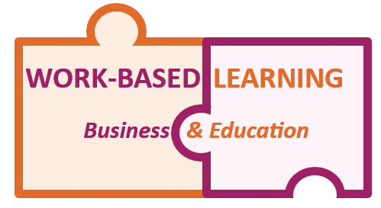
Figure #19 - WBL Power Hour Flyer
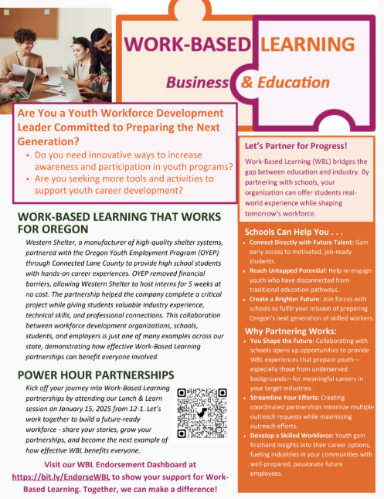
Figure #20 - #ThisIsCTE WBL Post
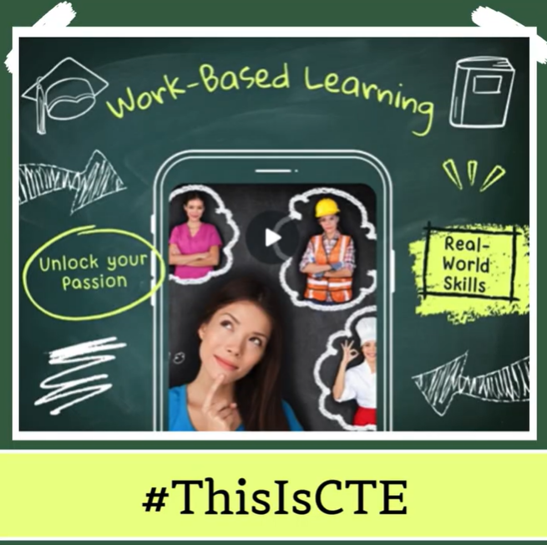
Figure #21 - Article in Oregon Restaurant & Lodging Association Magazine

This multi-channel, partnership-driven strategy is building awareness, strengthening alignment, deepening collaboration, and increasing student access to meaningful WBL experiences.
These statewide communication efforts are complemented by additional cross-agency partnerships that strengthen visibility and access to career connected opportunities for learners across the lifespan. One example is Oregon’s work to expand Integrated Education and Training (IET) programs for adult learners. IET is another key partnership strategy that strengthens alignment between Oregon’s education and workforce systems. It brings together Adult Basic Skills, postsecondary CTE, and employers to support Oregon’s Adult Attainment Goal of enabling at least 300,000 adults (25 and older) to earn a new postsecondary degree, certificate, or credential of value by 2030. IET effectively combines academic instruction with occupational skills training and wrap-around support services.
To further develop and improve IET programs, the 2024 CTE and Workforce Innovation and Opportunity Act state plans include alignment recommendations and strategies for Adult Basic Skills, Community College Career Pathways, and CTE through IET. These plans encourage colleges to participate in offering IET programs to support adults transitioning from Adult Basic Skills to credit-bearing CTE.
During 2024-25, Oregon made notable progress in growing and strengthening IET statewide. Employment outcomes and median earnings for IET participants exceeded those of other adult learner groups, underscoring the model’s effectiveness in supporting economic mobility. The CCWD IET team conducted a statewide landscape study across all 17 community colleges, identifying common themes, challenges, and technical assistance needs to guide future development. To support continuous improvement, CCWD developed a new professional development series for CTE and Adult Basic Skills partners (launched in fall 2025) and began updating policy and guidance to strengthen IET implementation.
Oregon’s CTE communication and engagement initiatives reflect a growing commitment to collaboration and sustainability. By uniting student voices with statewide messaging and WBL outreach, the Partnering State Agencies are cultivating long-term understanding and support for CTE. These collective efforts will continue to inspire participation, strengthen partnerships, and expand access to high-quality CTE for all learners.

Recommendations
As Oregon continues to advance CTE, the Partnering State Agencies present these 2025 recommendations to guide the next phase of growth and investment. Findings from 2024-25 underscore the importance of sustaining high-quality CTE Programs of Study while addressing persistent challenges related to funding stability, regional capacity, and cross-system alignment. Building on prior progress, these recommendations focus on ensuring that CTE Programs of Study are well-resourced, equitable, and fully aligned with student needs and workforce demands. By strategically investing in program stability, leadership, and cross-system collaboration, Oregon can strengthen career pathways that prepare learners for high-wage, in-demand jobs and support a thriving statewide economy.

Recommendation #1
Allocate targeted funding to support and expand CTE Programs of Study across the state.

Students and industries thrive when CTE Programs of Study are stable, well-resourced, and equitably available. Sustainable, dedicated funding would ensure all students have access to modern equipment, hands-on learning, and meaningful career experiences that lead to high-wage, in-demand jobs. Today, Oregon relies on federal Perkins grants, local budget decisions, and limited state-level foundational funding. Moving toward categorical CTE funding, like many other states have adopted, would give schools and colleges the stability they need to plan, grow, and innovate.
The Partnering State Agencies recognize Oregon’s challenging budget environment. Sustaining and scaling what works will require thoughtful, strategic investment in CTE efforts that deliver clear value for students, communities, and employers. These investments reflect staffing and programmatic support intended to stabilize instruction, expand equitable access, and improve student transitions. To address these gaps, Oregon should:
- Fully fund CTE administration and leadership at both the state and regional levels, including CTE Regional Coordinators, to ensure consistent support, coordination, and alignment between secondary and postsecondary.
- Provide sustainable funding for CTE Programs of Study in high schools and community colleges, covering high-cost consumables, up-to-date equipment, and instructional materials for industry-aligned learning.
- Support Career Connected Learning systems navigation to expand equitable access to career exploration, work-based learning opportunities, and pre-apprenticeships especially for historically underserved students.
Investing in these priorities will strengthen coordination across systems and stabilize CTE Programs of Study, thereby expanding equitable access to career pathways, supporting the educator pipeline, and preparing students to meet Oregon’s evolving economic needs. Stable CTE funding is not just an education investment, it is workforce infrastructure that Oregon’s economy depends on.

Recommendation #2
Reaffirm and strengthen commitments to the intentional alignment of education and workforce development priorities, projects, and processes.

Oregon’s students and industries succeed when education and workforce systems function as a connected ecosystem. Strengthening links between CTE Programs of Study, registered apprenticeships, Career Connected Learning initiatives, workforce centers, and industry partners ensures learners acquire skills that meet both current and emerging labor market needs. These efforts should be guided by statewide workforce priorities and be informed by advisory bodies such as the Future Ready Oregon Industry Consortia, Joint Apprenticeship and Training Committees (JATCs), and the Workforce and Talent Development Board. Their role is critical in keeping programs relevant, responsive, and industry driven.
To advance alignment, Oregon should strengthen structures that:
- Deepen collaboration across agencies, K-12 schools, community colleges, workforce development programs, and industry to connect education, workforce, and economic development efforts to prioritize equitable outcomes for Oregon’s learners.
- Leverage youth workforce development funds in coordination with CTE to expand career pathways with strong outcomes.
- Strengthen and align advisory structures across education and workforce development to ensure resources are used effectively and programs remain responsive to labor market needs.
By building a truly connected ecosystem, Oregon can foster equitable and practical pathways, address gaps in coordination, and use resources more effectively to prepare students for careers that address industry demands. When education and workforce systems align, students succeed and industries thrive.

Recommendation #3
Strengthen Oregon’s registered apprenticeship system as a talent development solution by addressing statutory and regulatory alignment in non-traditional, high demand industries and incentivizing new pathways that expand capacity for both youth and adult learners.

Expanding meaningful career pathways for Oregonians requires a larger, more flexible registered apprenticeship system. A robust, well-aligned apprenticeship system ensures that employers, labor organizations, adults, youth, and pre-apprentices are integrated in ways that provide real, sustainable career opportunities, as well as lowers the average age of entry into registered apprenticeships.
To expand capacity, Oregon should:
- Address statutory and regulatory alignment across partnering entities where they limit growth and flexibility in new occupational areas for registered apprenticeship pathways, while preserving apprentice safety and program quality.
- Incentivize new program development that meets industry needs, including nontraditional pathways.
- Integrate youth and pre-apprenticeships with K-12 and postsecondary CTE partnerships and CTE systems, aligning with learning outcomes, industry needs, and broader workforce strategies to expand access and strengthen results.
By drawing on lessons from other states and the Qualified Mental Health Associate pilot, exploring incentives (such as approaches similar to apprentice labor hour requirements on public works) to encourage employer engagement, and evaluating promising models, Oregon can expand registered apprenticeship opportunities in ways that benefit all learners and employers. Expanding apprenticeships is not only about creating opportunities for learners, it is about building Oregon’s workforce from within.

Conclusion
As Oregon continues to navigate shifting budgets and competing priorities, the Partnering State Agencies—ODE, HECC, and BOLI—remain deeply committed to advancing CTE as a proven driver of student success and economic vitality. The progress reflected throughout this report was made possible through the dedication of CTE educators, administrators, employers, and community partners who work tirelessly to expand opportunities for learners across the state.
Even in times of financial constraint and a shifting federal landscape, Oregon’s CTE system continues to demonstrate measurable impact—improving student engagement, increasing graduation rates, connecting learners to high-wage, in-demand careers, and strengthening alignment between education and industry. These outcomes make CTE not only an investment in workforce readiness, but also a cornerstone of school improvement.
Moving forward, the Partnering State Agencies urge continued commitment to sustaining and expanding high-quality CTE and apprenticeship opportunities. With strategic investment, cross-agency collaboration, and shared vision, Oregon can ensure that every learner—regardless of background or geography—has access to meaningful, career connected education that strengthens both our communities and our economy.

In the Perkins V Act, the term CTE “Program of Study” means a coordinated, non-duplicative sequence of academic and technical content at the secondary and postsecondary level.
A secondary CTE concentrator is a student who earns at least two credits in a single CTE Program of Study. One of those credits must be earned through a course or courses identified as intermediate or advanced.
A secondary CTE participant in Oregon is defined as a student who has earned at least 0.5 credits (earned in grade level 9 or higher) in a single CTE start-up or Program of Study.
A postsecondary CTE participant in Oregon is defined as a student with fewer than 12.0 credits completed and/or fewer than 9.0 program credits that are CTE-specific in a program offering at least 12.0 credits, OR who has not completed a CTE program that offers fewer than 12.0 credits.
A postsecondary CTE concentrator is a student who has earned at least 12 credits, of which nine program credits are CTE specific, within a CTE program or Program of Study; or completed the program if it is fewer than 12 credits.
Senate Bill (SB) 1545 (2022) created the Future Ready Oregon framework that uses the term Priority Populations to mean communities of color, women, low-income communities, rural and frontier communities, veterans, persons with disabilities, incarcerated and formerly incarcerated individuals, members of Oregon’s nine federally recognized Indian tribes, individuals who disproportionately experience discrimination in employment on the basis of age, and individuals who identify as members of the LGBTQ+ community.

