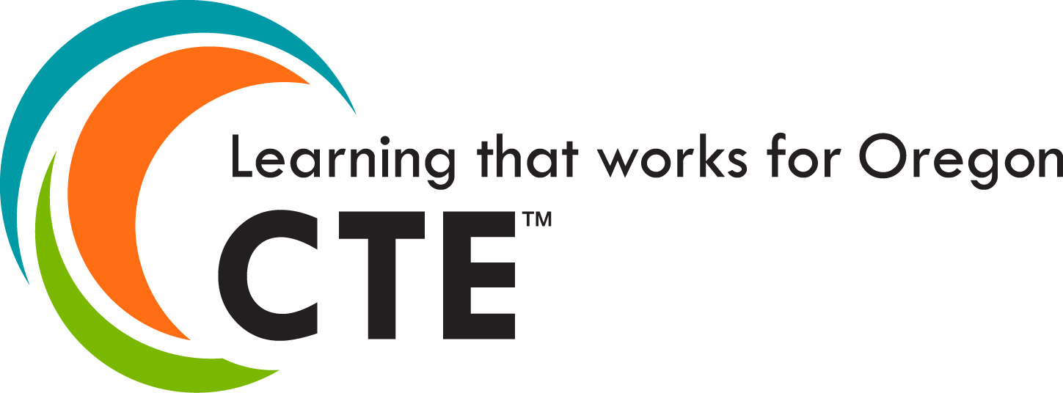

Dual Credit Coordinators @ A Glance

2019-2020

Postsecondary Inst.: Community Colleges | Coordinator(s) | Contact Information
Blue Mountain CC | Molly Turner | 541-278-5936  mturner@bluecc.edu
Central Oregon CC | Jennie Newby | 541-383-7562  jlnewby@cocc.edu
Chemeketa CC | Sara Hastings | 503-399-3696  sara.hastings@chemeketa.edu
Clackamas CC | Cheryl Tallman | 503-594-3208  cherylt@clackamas.edu
Clatsop CC | Margaret Frimoth | 503-338-2506  mfrimoth@clatsopcc.edu
Columbia Gorge CC | Mary Kramer | 541-506-6033  mkramer@cgcc.edu
Klamath CC | Kelly Kline | 541-880-2337  KCCDualCredit@Klamathcc.edu
Lane CC | Deron Fort | 541-463-5535  fortd@lanecc.edu
Linn Benton CC | Virginia Mallory | 541-917-4208  mallory@linnbenton.edu
Mt. Hood CC | Kealani Balfour | 503-491-6980  kealani.balfour@mhcc.edu
Oregon Coast CC | Dan Lara | 541-867-8506  dan.lara@oregoncoastcc.org
Portland CC | Kate Depaolis | 971-722-7736  kate.depaolis@pcc.edu
 | Beth Molenkamp | 971-722-7735  Elizabeth.molenkamp@pcc.edu
 | Frank Smith | 971-722-7732  frank.smith@pcc.edu
Rogue CC | Daye Stone | 541-245-7991  dstone@roguecc.edu
Rogue CC | Laura Garrett | 541-245-7865  lgarrett@roguecc.edu
Southwestern Oregon CC | Teri Grier | 541-888-7271  teri.grier@socc.edu
Tillamook Bay CC | Daniella Bivens | 503-842-8222 x 1020  daniellabivens@tillamookbaycc.edu
 | Tami Schild (ESD) | 503-842-8222 x 1840  tschild@nwresd.k12.or.us
Treasure Valley CC | Stephanie Oester | 541-881-8822 X339  soester@tvcc.cc
 | Calvin Hiatt | 541-581-5593  chiatt@tvcc.cc
Umpqua CC | Missy Olson | 541-440-7865  missy.olson@umpqua.edu
 | Destiny Hunt | 541-440-7709  destiny.hunt@umpqua.edu

Postsecondary Inst.:  Universities | Coordinator(s) | Contact Information
Eastern Oregon University | Matt Seimears | 541-962-3091  mseimears@eou.edu
 | Laurie Powell | 541-962-3941  lpowell@eou.edu
Oregon Tech | Carleen Drago | 503-821-1297  Carleen.drago@oit.edu
 | Grace Rusth | 541-885-1844  Grace.rusth@oit.edu
 | Josh Jones | 503-821-1306  josh.jones@oit.edu
Portland State University | Joy Beckett | 503-725-5995  jbeckett@pdx.edu
Southern Oregon University | Stephanie Butler | 541-552-6916  butlers@sou.edu
 | Rachel Jones | 541-552-6326  jonesr4@sou.edu
Western Oregon University | Sue Monahan – Willamette Promise | 503-838-9216  smonahan@wou.edu

Secondary Partners | Coordinator/s | Contact Information
Northwest Promise | Tara Cooper  Deanna DSouza  Raya Nichols | 503-614-3189  tcooper@nwresd.k12.or.us  503-614-1263  ddsouza@nwresd.k12.or.us  503-516-9931  nicholsr@hsd.k12.or.us
Willamette Promise | Gretchen Brunner  Adam Whalen | 503-540-4426  gretchen.brunner@wesd.org  503-540-4420  adam.whalen@wesd.org

State Agency | Liaisons | Contact Information
HECC Office of Community Colleges and Workforce Development | Eric Juenemann | 503-947-2431  eric.juenemann@hecc.oregon.gov
HECC Office of Academic Policy and Authorization | Erin Weeks-Earp | 503-947-5659  erin.weeks-earp@hecc.oregon.gov
Oregon Department of Education | Lillian White  (High School Success and Accelerated Learning) | 503-934-0742  lillian.white@state.or.us
Oregon Department of Education | Pandie Anderson (Personalized and Accelerated Learning Specialist) | 503-947-0500  pandie.anderson@state.or.us

