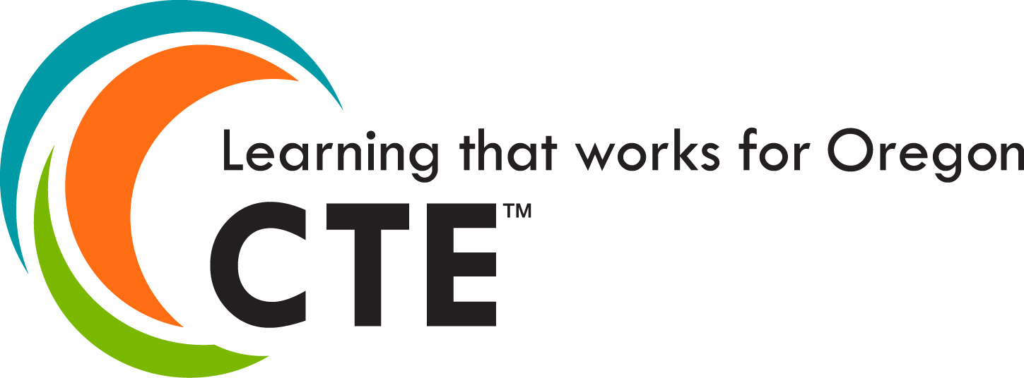

2020–2021 Community College
Career & Technical Education Leaders

Community College | Leaders/Members | Contact Information
Blue Mountain CC | Wade Muller | wmuller@bluecc.edu  541-278-5971
Central Oregon CC | Jenni Newby | jlnewby@cocc.edu  541-383-7530
 | Michael Fisher | mfisher@cocc.edu  541-383-7755
 | Julie Downing | jdowning@cocc.edu  541-383-7238
Chemeketa CC | Larry Cheyne | larry.cheyne@chemeketa.edu  503-316-3279
 | Johnny Mack | johnny.mack@chemeketa.edu 503-399-6243
 | Megan Cogswell | megan.cogswell@chemeketa.edu  503-399-6266
 | Marshall Roache | mroache@chemeketa.edu  503-399-2339
 | Robin Taylor | rtaylor@chemeketa.edu  503-399-6566
Clackamas CC | Shalee Hodgson | shaleeh@clackamas.edu  503-594-3323
 | Jaime Clarke | jaimec@clackamas.edu  503-594-3220
 | Cynthia Risan | cynthiar@clackamas.edu  503-594-3440
Clatsop CC | Kristen Wilkin | kwilkin@clatsopcc.edu  503-338-7696
Columbia Gorge CC | Mary Kramer | mkramer@cgcc.edu  541-506-6033
Klamath CC | Chris Stickles | stickles@klamathcc.edu  541-880-2240
Lane CC | Paul Ruscher | ruscherp@lanecc.edu  541-463-5447
 | Dawn Dewolf | dewolfd@lanecc.edu  541-463-5302
 | Jeff Gregor | gregorj@lancecc.edu  541-463-5618
Linn-Benton CC | Steve Schilling | schills@linnbenton.edu  541-917-4754
 | Linda Carroll | carroll@linnbenton.edu  541-917-4263
 | Dale Moon | moond@linnbenton.edu  541-917-4219
Mt. Hood CC | Kay Lopez | kay.lopez@mhcc.edu  503-491-6991
 | Alfred McQuarters | al.mcquarters@mhcc.edu  503-491-7279
 | Douglas Scribner | douglas.scribner@mhcc.edu  503-491-6057
Oregon Coast CC | Linda Mollino | lmollino@oregoncoastcc.org  541-867-8513
 | Dan Lara | dan.lara@oregoncoastcc.org  541-867-8606
Portland CC | Jan Volinski | jwetzel@pcc.edu  503-437-0202
 | Kendra Cawley | kcawley@pcc.edu  971-722-4481
 | Marc Goldberg | marc.goldberg1@pcc.edu  971-722-2899
 | Janeen Hull | jan.hull@pcc.edu  971-722-5383
Rogue CC | Kim Freeze PsyD | KFreeze@roguecc.edu  541.245.7915 | 541.956.7117
Southwestern Oregon CC | Ali Mageehon | ali.mageehon@socc.edu  541-888-2525, ext. 7417
Tillamook Bay CC | Amy Alday-Murray | amyaldaymurray@tillamookbaycc.edu  503-842-8222, ext. 1070
 | Daniella Bivens | daniellabivens@tillamookbayCC.edu  503-842-8222, ext. 1050
 | Darryl Spitzer | darrylspitzer@tillamookbaycc.edu  503-842-8222, ext. 1310
 | Teresa Rivenes | teresarivenes@tillamookbaycc.edu  503-842-8222, ext. 1030
Treasure Valley CC | David Koehler | dkoehler@tvcc.cc  541-881-5583
 | Edward Alves | ealves@tvcc.cc  541-881-5590
Umpqua CC | Missy Olson | missy.olson@umpqua.edu  541-440-4713
Community Colleges Career & Technical Education State Team
HIGHER EDUCATION COORDINATING COMMISSION | Donna Lewelling | donna.lewelling@HECC.OREGON.GOV  503-947-2428
 | Luis Juárez | luis.juarez@state.or.us  503-947-2430
 | KC Andrew | kc.andrew@state.or.us  503-947-5742
 | Eric Juenemann | Eric.juenemann@state.or.us  503-947-2431
OREGON DEPT. OF EDUCATION | Jennell Ives | jennell.ives@state.or.us  503-947-5777

