
Application Guide for Secondary CTE Programs
2025-2026

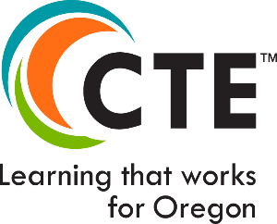
It is a policy of the State Board of Education and a priority of the Oregon Department of Education and the Higher Education Coordinating Commission that there will be no discrimination or harassment on the grounds of race, color, sex, marital status, religion, national origin, age, sexual orientation, or disability in any educational programs, activities, or employment.
(The CTE brand logo, brand positioning, theme, and brand extensions are the property of ADVANCE CTE www.careertech.org).

Table of Contents

Table of Contents 1
Introduction 3
CTE Program Overview 3
CTE Program Design 3
CTE Program Development 3
Program of Study Models 5
CTE Program Renewals 6
Elements of a High-Quality Program of Study 6
Access and Equity 6
Standards and Content 7
Assessment and Continuous Improvement 8
Instructional Quality and Educator Qualifications 8
Alignment and Articulation 9
Accountability and Evaluation 11
Student Support Services 12
Professional Development 13
CTE Application Types and Requirements 14
Renewal Application 14
Start-up Application 15
Full POS Application 16
Completing the CTE Program Application 16
Initiating a CTE Program Application 18
Application Types: Start-Up or Full 18
Secondary CTE Site Selection 19
Program Area, CIP And Framework Section 19
Application Types: Renewal 20
Viewing In-Progress Applications 21
CTE Program Application Sections 23
Program Details (Start-up Application Only) 23
Teacher Grid 23
Updating Contact Details 24
Community College Grid 25
Additional Components of a High-Quality Program of Study 26
Components of a High-Quality Program of Study 28
Student Support Services 28
Accountability & Evaluation 28
Professional Development 28
Continuous Program Improvement (Renewal Application Only) 29
Attachments 29
Initial Approval Assurances 30
The Matrix Form 31
Completing the Matrix 32
Application Submission 35
Application Submission Follow-up 37
Decision Comments 38
CTE Course Descriptions 40
NCES/SCED Codes in CTE Courses 43
CTE Program Certificatio of Assurance 44

Introduction
This guide is a resource for secondary schools and Regional Coordinators completing Oregon’s Career and Technical Education (CTE) Program Application. The application is the final step in a broader program design process that supports Oregon high schools and community colleges in preparing students with the industry-based technical and academic knowledge and skills needed for success in secondary and postsecondary education, and high-wage, in-demand careers.
CTE Program Applications initiated by a Regional Coordinator on or after July 1 and submitted to the Oregon Department of Education (ODE) by June 30 of the same school year will be reviewed and approved by August 15 for implementation in the following school year.

CTE Program Overview

CTE Program Design
In Oregon, the CTE Program of Study is the cornerstone of CTE programming. In the Perkins V Act, the term “program of study” (POS) means a coordinated, non-duplicative sequence of academic and technical content spanning the secondary and postsecondary level that
- incorporates challenging state academic standards;
- addresses both academic and technical knowledge and skill statements, including employability skills within the Oregon Skill Sets;
- is aligned with the needs of industries in the economy of the state, region, Tribal Community or local area Labor Market Information (LMI);
- progresses in specificity from a broad overview at the Career Cluster level, to occupation-specific instruction at the Focus Area level;
- has multiple entry and exit points; and
- culminates in the attainment of a recognized postsecondary credential and/or degree.
Oregon achieves the federal definition of High-Quality Programs of Study (HQPOS) by requiring six (6) core elements in all state approved POS. The elements of a High-Quality Program of Study include:
- Access and Equity
- Standards and Content
- Alignment and Articulation
- Accountability and Evaluation
- Student Support Services
- Professional Development

CTE Program Development
There is a continuum of CTE programming in Oregon, representing a progression in commitment and intensity. The development of a CTE program starts with community needs. Educators, employers, and other community partners come together to design a program to meet that community's needs. CTE High-Quality Programs of Study are designed and built over time and usually evolve as industry evolves. Typically, the progression looks like the following:
- Exploring Interests and Careers - In Oregon, this is known as career connected learning. It encompasses a variety of activities to support learners in developing an awareness and opportunities for exploration into the world of careers. It may include a collection of interest- and aptitude-based activities and/or courses offered during class time or outside of class hours. It could also align with industry tours and interviews with professionals working in a field of interest. Additionally, the Career Journeys video series is a great way for learners to learn more about a wide variety of careers, and it comes with lesson supports for teachers to help deepen learners’ learning. This type of programming provides interesting and engaging content for learners while exploring information about career options and interests based on their aptitude and/or school, family, and life experiences. These opportunities may integrate or be supported by academic content as well as business and industry engagement activities. Some examples might include Career and Technical Student Organizations (CTSOs), robotics programs, community-based clubs, maker space, introduction to careers, CTE/career exploration wheels, coding club, summer programs, etc. Depending on the progress of a learner in discovering and selecting a potential career pathway, every effort should be made for learners to be able to access these types of activities and programming at any point in their secondary experience (Grades 5-12). For additional information, please see ODE’s Career Connected Learning webpage.
- Start-Up CTE Program - an intentional sequence of secondary CTE courses designed toward meeting Oregon’s requirements for size, scope, and quality within a three-year period. A course qualifies as CTE if it aligns with the Knowledge and Skill Sets, is taught by a CTE-endorsed teacher, and is included in the sequence of a state-approved CTE program. Start-up programs are not required to meet all full POS elements until applying for full status. An example of a Start-Up CTE program is a new course in entrepreneurship in year one that builds into a full Marketing CTE Program of Study offering three secondary credits two years later.
- Once a CTE Start-Up program meets the core elements, it’s ready to evolve into a CTE Program of Study - a comprehensive, state approved sequence of courses that bridges secondary and post-secondary education and leads students toward high-skill, high-wage, or in-demand careers. Grounded in the federal Perkins Act, a CTE POS is co-developed by secondary and post-secondary partners, aligning rigorous academic instruction with hands-on technical and employability skills validated by industry. These programs include at least three high school credits, offer work-based learning experiences, and are taught by appropriately licensed CTE educators. Many programs also offer opportunities for students to earn dual credit or industry-recognized credentials. A full POS must meet Oregon’s requirements for size, scope, and quality; align with labor market needs; and incorporate continuous improvement using the CTE POS Quality Rubric. Students in a CTE POS benefit from clear career pathways, career guidance, and equitable access to supports that ensure success in both education and the workforce.
Whether secondary schools are pursuing a new CTE startup or Program of Study, all CTE programs undergo essentially the same process for development and implementation:
- Partners identify labor market needs (LMI) based on advisory group recommendations and local needs assessments.
- Partners determine whether adopting Oregon’s CTE Statewide Framework works for their community or if a locally developed Program of Study would be a better fit.
- The secondary CTE teacher and community college (CC) instructor work together with their partners to help outline how the program will meet CTE Program Size, Scope, and Quality and outline the foundational information in the six required POS elements. This work includes determining how CTE Programs of Study will provide students with the full range of knowledge and skill statements over the course of the high school and community college program and provide Work-Based Learning opportunities.
- Once a program has been designed and developed and is ready to go through ODE’s program approval process, the Regional Coordinator initiates the application.
- Secondary CTE teachers and Regional Coordinators will work together to complete and submit the program application to ODE.
- ODE Content Specialists review and approve every CTE program application submitted to ODE that meets the Program of Study requirements. The applications are approved for one to four years, based on the statewide career cluster renewal schedule.
- This process should involve secondary teachers and CC instructors working collaboratively with the guidance and support of industry partners and advisors, regional coordinators, CTE deans, administrators, parents, students, and colleagues to implement the CTE POS with fidelity.
The information listed in the Program Overview section of the Application Guide for Secondary CTE Programs is also available in Section 5 of the CTE Policy Guidebook.

Program of Study Models
The Statewide CTE Program of Study Frameworks provide updated Knowledge and Skill Statements to inform CTE program development in each career cluster. The updated Knowledge and Skill Statements include 1) employability knowledge and skills, 2) career cluster knowledge and skills, and 3) focus area knowledge and skills. Within each career cluster, CTE Program of Study may be offered at the cluster or focus area level. Cluster-level programs offer high school learners a broad overview of careers in the field, along with skills valued by all industry partners. Focus area programs offer learners more occupationally specific training that may lead to industry recognized certificates and degrees.
Locally Developed and Statewide Framework applications will be evaluated using the same criteria. For additional details, contact your Content Specialist with questions.

CTE Program Renewals
All state-approved CTE Programs of Study undergo regular assessment through a renewal process based on the CTE Career Cluster Renewal Schedule. Career Clusters follow a four-year cycle for this renewal process. The intent of Programs of Study renewal is to review and evaluate how programs align with labor market needs (LMI); meet the state-defined criteria for size, scope, and quality; address the six (6) required elements of a HQPOS; and continuously improve CTE offerings. Regional Coordinators, in collaboration with District Administrators, CTE teachers, Community College (CC) instructors, and Advisory Committees, lead the POS evaluation and planning process, focusing on program improvements. These artifacts are submitted to ODE through the program renewal process in the CTE Information System.
Oregon’s High-Quality Program of Study Rubric is built around the six core elements and aligned to the national Association for Career and Technical Education’s (ACTE) HQPOS framework, Oregon Equity Lens, CTE Program Size, Scope, and Quality, and the Work-Based Learning Handbook. During program renewal, the HQPOS Rubric is a tool to guide program development and improvement. It is best practice to focus on at least one core element for each cycle. Conducted as part of the renewal process, the local review provides an opportunity to update and assess existing CTE POS to create continuous program improvement goals that heighten the learner’s experience. In collaboration with the local CTE Regional Coordinator, POS are expected to self-evaluate and continuously improve over the four-year period of the (program) approval.

Elements of a High-Quality Program of Study

Access and Equity
This element focuses on ensuring that all students—regardless of gender, race, ethnicity, ability, language, or socioeconomic status—have equitable access to, and success within, CTE programs of study. Programs must intentionally address barriers to participation and provide targeted supports for historically underserved and marginalized student populations. Access and equity will be embedded within all core elements of the CTE Program of Study.
Schools and teachers should consider the following as they design their activities, courses, course descriptions, and prerequisites. Please refer to the Equitable Participation in CTE Programs and Activities document to support Civil Rights compliance when designing courses and developing forecasting and marketing materials.
Key considerations include:
- Recruitment and Promotion: Use inclusive strategies and materials to promote programs to diverse student groups. Review marketing, course descriptions, and prerequisites regularly to ensure they are accessible and free of bias.
- Data-Informed Improvement: As part of the continuous improvement process, analyze program-level data (e.g., local needs assessments, CTE performance indicators, and disaggregated data) to identify gaps in student participation and outcomes. Focus areas may include graduation rates, CTE concentrator status, industry-recognized credential (IRC) attainment, work-based learning, and leadership opportunities.
- Targeted Strategies: Identify and implement specific strategies that support the success of underserved students within the CTE POS. Ensure students are prepared to participate fully in all program components and successfully transition to postsecondary education or the workforce.
- Representation and Outcomes: Strive for CTE enrollment to reflect overall school demographics and contribute to greater diversity in local industry. CTE student outcomes should help close opportunity gaps and address systemic inequities.
- Family and Community Engagement: Provide students and their families with clear, accessible information to make informed education and career decisions. Engage caregivers and community members in program development and review.
CTE programs should have a clear equity plan, monitor progress regularly, and adjust strategies as needed to ensure that all learners can thrive.

Standards and Content
This element ensures CTE students have access to rigorous academic instruction integrated with technical and professional skill development. Learners have repeated opportunities to apply academic and technical knowledge in both CTE and academic courses, through student-centered instruction that builds upon their interests, strengths, and areas for growth.
High-quality CTE instruction emphasizes applied learning within the context of the relevant Career Cluster. Students use the technical skills identified in the Oregon Skill Sets in authentic, career-connected settings, while also applying the academic skills required for success in the field. Instruction includes hands-on, workplace-style learning experiences and is strengthened through collaboration with experienced educators, industry partners, and community members.
Programs of Study must include a coherent, non-duplicative sequence of courses aligned to Oregon’s industry-identified knowledge and skill sets. Course sequences should progress from introductory to advanced levels and support increasing levels of skill development and application.
Course Level Definitions
- Introductory Course – A course that focuses on raising career awareness and learning basic professional and technical skills associated with the CTE Program of Study. The course helps develop students’ interest rather than technical proficiency in a CTE Program of Study.
- Intermediate Course – A course that focuses on exploring careers and learning specific technical and professional skills. The course builds on basic skills and moves toward technical proficiency in preparation for a career.
- Advanced Course – A course that focuses on preparing for a career and refining specific technical and professional skills. The course integrates multiple skills through project-based instruction and/or work-based learning. These courses focus on preparing students for entry-level work or post-secondary programs.
Curriculum, Credentials, and Alignment
Curriculum must follow a defined scope and sequence aligned to Oregon’s industry-identified standards. A CTE Program of Study must offer a minimum of three year-long credits or equivalent at the high school level.
Secondary schools and community colleges are expected to collaborate to support smooth transitions between secondary, postsecondary, and industry opportunities.
All CTE Programs of Study must provide students with Oregon’s complete Knowledge and Skill Set over the span of the high school and community college program. Each Knowledge and Skill Set includes:
- 10 employability skills that crosscut across Career Learning Areas
- Cross-cutting Career Cluster knowledge and skills
- If applicable, Focus Area knowledge and skills.
Learning experiences should be meaningful, project-based, and connected to real-world applications, supported by partnerships among schools, colleges, employers, and the broader community.

Assessment and Continuous Improvement
Assessment strategies must align to industry standards and provide timely, actionable feedback to both learners and instructors. When possible, assessments should lead to the attainment of industry recognized credentials. Ongoing evaluation of curriculum, instruction, and assessment practices is expected to inform continuous program improvement.

Instructional Quality and Educator Qualifications
This element also requires qualified, licensed CTE teachers and postsecondary instructors who participate in ongoing professional development. Instructional strategies must foster inclusive, learner-centered environments that promote academic, technical, and employability skill attainment. Instruction should be relevant, authentic, and responsive to all learners while preparing students for both post-secondary education and careers.
Secondary teachers must hold the appropriate CTE endorsement(s), and postsecondary instructors must meet institutional requirements.

Please use the box below to plan your required submission components for this core element in the CTE Information System (CTE IS):
CTE Information System Secondary Application: Standards & Content
Required:
- Submit the program’s sequence of courses on the Matrix Form, progressing from introductory to advanced content (see CTE Course Descriptions on page 40 of the guide).
- Provide three non-duplicative credits (at minimum)
- Submit unique, clear, and concise course descriptions that accurately describe the essential academic, technical, and employability skills learners will gain in each of the CTE courses
- Course information and description should reflect public-facing materials such as curriculum guides, syllabi and counseling / guidance resources (see CTE Course Descriptions on page 40 of the guide).
- Use NCES course codes that align to the appropriate CTE endorsement and program area
- In the Teacher Grid, provide the required, appropriately CTE-endorsed Lead Teacher information
Optional:
- Note college credit/dual credit, articulated CC courses as applicable
- Share or attach any additional information to demonstrate Standards and Content
- Provide information on additional CTE Teachers

Alignment and Articulation
The emphasis of Alignment and Articulation is that students have a seamless career path connection between secondary and post-secondary. This results in a trajectory that is intentional and results-oriented from both learners and industry perspectives.
Expectations of Alignment in a Perkins Program of Study
The Oregon CTE State Plan, with help from state, regional, and local partners, supports Oregon CTE programs, schools, and colleges to ensure that historically and currently marginalized learners and families are welcome, safe, and included in our institutions and programs. The goal is that all Oregonians will receive appropriate and equitable access to and benefits from CTE. The priority is to create quality relationships, experiences, and interactions among learners, educators, business partners, and community members.
Aligning through High-Quality CTE Programs of Study can help achieve this goal and support activities including building a scope and sequence for career exploration and development, supporting local and regional implementation of the scope and sequence, mapping resources and assets, and integrating the scope and sequence with comprehensive school counseling programs and community college guided pathways.
Joint Expectations
- Reciprocity/shared learning between K-12 teachers and community college faculty
- Supports for equity strategies and the reduction of barriers for underserved populations
- Collaboration in the development of rigorous core academic coursework that is applicable to career interests
- Engagement/collaboration between postsecondary and secondary partners around annual collegial professional development and learning (PD) for educators, including creation of joint Professional Learning Communities (PLC)
- Scope and sequence of the CTE POS that includes what will be taught in secondary and postsecondary institutions in a seamless, non-duplicative manner
- Creating opportunities for teachers and instructors to build awareness of the curriculum and course outcomes at both secondary and postsecondary levels
- CTE POS Advisory Committees (local or regional)—Annual collegial alignment to industry standards meetings (minimum of two times per year) involving teachers/instructors AND industry partners with the intent to keep the POS aligned and up to date with current best practices in the industry
- When possible, creating on-campus live or virtual visits to the community college partner campus and visits from college faculty to the secondary programs to share opportunities for further education and training in the POS
- Making recruitment and pathway materials available to learners and families (in multiple languages) for their local high school and community college POS partners and statewide options for career paths
- Support the alignment of instructional facilities, equipment and industry expectations for workplace readiness
Please use the box below to plan your required submission components for this core element in the CTE Information System (CTE IS):
CTE Information System Secondary Application: Alignment & Articulation
Required:
- Using the Community College grid, list the aligned Community College program(s)
- Initial Approval Assurances: Community College Administrator Name, Acknowledgement, Acknowledgement Date - The specific community college is the partner that has been involved in the design and development of this CTE POS.
Optional:
- Share or attach any other information to demonstrate Alignment and Articulation

Accountability and Evaluation
Accountability and Evaluation are core elements of Perkins eligibility. Student data are collected yearly and are analyzed by the design team for program success and program planning. Data are shared with students, staff, parents, and the public to gain awareness and support of the CTE POS.
Continuous Program Improvement (Renewal Application Only):
Ongoing continuous program improvement goals are an important component of a High-Quality Program of Study. Using the HQPOS rubric as context, select one of the High-Quality Program of Study elements the program has decided to focus their improvement efforts on (excluding Professional Development, which is addressed in a separate section of the application). Continuous Improvement efforts should focus on enhancing the Program of Study based on student experience/performance, labor market demand, and employer requirements through the equity lens.
- As of July 1, 2026, the Continuous Program Improvement field is required.
Please use the box below to plan your required submission components for this core element in the CTE Information System (CTE IS):
CTE Information System Secondary Application: Accountability & Evaluation
Required:
Using the Accountability & Evaluation comment box, provide an explanation describing how each of the following elements are addressed:
- Describe how you used Perkins data, your local needs assessment, labor market data, or other data to inform program design or improvement
- Describe how you are working to achieve equity and serve historically and currently marginalized students based on your review of data to close opportunity gaps and address systemic inequities.
- Describe how your Advisory Committee/Industry Partners contribute to continuous program improvement
Optional:
- Share or attach any other information to demonstrate Accountability and Evaluation
- Using the Continuous Improvement comment box, select one of the six HQPOS elements the program has decided to focus their improvement efforts on. In the comment box:
  - Provide at least one long-term continuous improvement goal that is directly connected to the success and growth of the POS.
  - Explain how this goal was identified, referencing data from your local needs assessment, input from advisory committees, and/or collaboration with regional partners in meeting the expected annual collegial professional development secondary and post-secondary partners.
  - Describe the activities that will support progress toward the goal.
  - Through an equity lens, identify how goal outcomes will enhance the program.

Student Support Services
Student Support Services are integral to the success of any Program of Study, ensuring that all students receive comprehensive assistance throughout their academic journey. Students should receive personalized advising to help them plan their career pathways, ensuring they make informed decisions about their academic and professional futures. Additionally, students should have access to programs that foster leadership by providing opportunities to take on leadership roles, participate in governance, and engage in community service within a Career and Technical Student Organization (CTSO) or a leadership equivalent locally-developed student leadership opportunity. Career Connected Learning (CCL) and Work-Based Learning (WBL) are emphasized, integrating real-world experiences and industry partnerships into the curriculum to prepare students for the workforce. The program also offers clear pathways to postsecondary education, guiding students through the process and helping them identify the best options for their personal and professional goals.
WBL is a critical bridge that connects the classroom to the world of work and helps learners make informed decisions about their educational and career goals. Each state-approved Program of Study must incorporate WBL as a component of its program. Each school and district must determine the best way to track and verify CTE WBL that meets the approved WBL types and criteria. Detailed guidance can be found in the WBL Handbook.
In February 2020, the Oregon State Board of Education approved the following WBL definition:
Structured learning in the workplace or simulated environment that provides opportunities for sustained interactions with industry or community professionals that foster in-depth, firsthand experience of the expectations and application of knowledge and skills required in a given career field.
Oregon has identified six types of measurable WBL experiences:
- Service Learning
- Clinical | Internship | Practicum
- Cooperative Work Experience
- Registered Pre-/Youth Apprenticeship
- School-Based Enterprise
- Workplace Simulation
Each type of WBL experience must meet the following criteria:
- Align with Curriculum and Instruction
- Include Sustained Interaction with Industry, Business or Community Professionals
- Lead to Earning of Credit and/or Outcome Verification
- Be Offered In-Person, Virtually, or in a Simulated Workplace Setting
Please use the box below to plan your required submission components for this core element in the CTE Information System (CTE IS):
CTE Information System Secondary Application: Student Support Services
Required:
Using the Student Support Services comment box, provide an explanation describing how each of the following elements are addressed:
- Describe two strategies you undertake to recruit and support focal group or nontraditional students to your program outside of the course planning guide.
- Using the dropdown box, identify the Work-Based Learning opportunities provided in the program. In the comment box, describe how you are working to ensure your WBL experiences meet all of the WBL criteria.
- Describe how students in your program are provided with structured opportunities for career advising and planning throughout their CTE experience, particularly in ways that align with their individual goals and future pathways.
- Using the dropdown box, identify your student leadership opportunities.
  - If “Locally Developed Student Leadership” is selected, use the comment box to describe how the three main elements of Student Leadership Expectations are implemented in your program.
Optional:
- Share or attach any other information to demonstrate Student Support Services.

Professional Development
This element promotes ongoing instructor growth that aligns with the long-term goals of the CTE Program of Study. Professional development is an essential component of sustaining a High-Quality Program of Study, fostering innovation, and supporting continuous improvement.
Each CTE instructor should have a Professional Development Plan (PDP) that reflects the needs of the program and the instructor’s own professional growth. The PDP should:
- Be informed by the local or regional needs assessment and aligned with program goals.
- Maintain an explicit equity focus, ensuring all students have access to high-quality instruction and opportunities.
- Be developed with input from advisory committees and industry partners to ensure relevance and alignment with workforce needs.
- Include strategies for staying current with technical advances in the relevant industry, including exposure to and use of emerging technologies, updated curriculum, and innovative instructional methods.
Professional development plans should be dynamic documents that evolve with the program. Any adjustments made should reflect the continuous improvement design of the CTE POS and demonstrate a commitment to instructional excellence and responsiveness to industry and student needs.
If the CTE teacher(s) is/are on a CTE Licensure Professional Development Plan, you may use those plans to fulfill these required comments.
Please use the box below to plan your required submission components for this core element in the CTE Information System (CTE IS):
CTE Information System Secondary Application: Professional Development
Required:
Using the Professional Development comment box, describe your plan for ongoing instructor professional development that supports the growth and advancement of this POS.
- Provide at least one long-term professional development goal for CTE instructors that is directly connected to the success and growth of the POS.
- Explain how this goal was identified, referencing data from your local needs assessment, input from advisory committees, and/or collaboration with regional partners in meeting the expected annual collegial professional development secondary and post-secondary partners.
- Describe the professional development activities that will support this goal (e.g., industry externships, instructional strategy training, technology updates, curriculum development workshops).
- Through an equity lens, identify how goal outcomes will be used to improve instruction, student outcomes, and student experiences.
Optional:
- Share or attach any supports that would be helpful for you to complete these goals

CTE Application Types and Requirements

Renewal Application
The following sections of Renewal Applications are required to be filled out prior to submitting the application to ODE for review:
- School and District
- Career Learning Area, Career Cluster, and Focus Area
- Statewide Framework or Locally Developed Program
- Course Matrix (three credits and a sequence of intro, intermediate and advanced courses)
- Additional Components of a High-Quality Program of Study (Work-based Learning and Student Leadership Opportunities)
- Teacher Grid (Lead Teacher)
- Community College Grid
- Components of a High-Quality Program of Study Comments (Student Support Services, Continuous Improvement Goal, Accountability and Evaluation, and Professional Development)
- Initial Approval Assurances

CTE Statewide Career Cluster Renewal Schedule
Career Clusters | Expiration Date | Application Due By
Architecture & Construction  Business Management & Administration  Information & Communications  Manufacturing | June 2026* | June 2026
Automotive & Heavy Equipment  Education & Training  Law, Public Safety & Security  Natural Resource Systems | June 2027* | June 2027
Hospitality, Tourism & Culinary  Arts, A/V & Communications  Marketing  Engineering Technology | June 2028* | June 2028
Human Services  Government & Public Administration  Finance  Health Sciences  Agriculture & Food Systems | June 2029* | June 2029
*All Statewide and Locally Developed CTE POS must renew according to the statewide renewal cycle for their associated Career Cluster, regardless of the expiration date listed at initial approval.

Start-up Application
The following sections of Start-up Applications are required to be filled out prior to submitting the application to ODE for review:
- School and District
- Career Learning Area, Career Cluster, and Focus Area
- Course Matrix (minimum of one course)
- Cost to Start up Program
- Expected Use of Allowed Perkins Start up Dollars
- Initial Approval Assurances
The following information is not required to be filled out for a CTE Start-up Application, but ODE encourages inclusion of the information if the program components are already established:
- Additional Components of a High-Quality Program of Study (Work-based Learning and Student Leadership Opportunities, Industry Recognized Credentials)
- Teacher Grid (Lead Teacher)
- Community College Grid
- Initial Approval Assurances for Advisory Committee Member and Community College Administrator.

Full POS Application
The following sections of New Applications are required to be filled out prior to submitting the application to ODE for review:
- School and District
- Career Learning Area, Career Cluster, and Focus Area
- Statewide Framework or Locally Developed Program
- Course Matrix (three credits and a sequence of intro, intermediate and advanced courses)
- Additional Components of a High-Quality Program of Study (Work-based Learning and Student Leadership Opportunities)
- Teacher Grid (Lead Teacher)
- Community College Grid
- Components of a High-Quality Program of Study Comments (Student Support Services, Accountability and Evaluation, and Professional Development)
- Initial Approval Assurances

Completing the CTE Program Application
All applications must be initiated by a CTE Regional Coordinator. Districts and secondary schools must work in partnership with their Regional Coordinator when beginning the application process. Regional Coordinator’s provide expertise and support throughout program development and technical assistance during the application process. They are required participants in application submission.
All CTE program applications – Start-Up, Full, and Renewal – use the same application form. While the core application is the same, some fields vary based on the selected Application Type (Full, Start-Up, or Renewal). Follow the steps below to initiate and complete a CTE program application for submission to ODE.
The CTE program application is housed in ODE’s CTE Information System application. Users must have the appropriate CTE Information System role to access and complete the program application.
To support completion of the application, the screenshots included in this guide are color-coded to indicate responsibility for each field:
- Yellow: Fields completed by the Regional Coordinator
- Green: Fields completed by the Lead Teacher and/or Local Admin
- Login to your account through Central Login – available on ODE’s District Data Site
- If you do not have a Password or cannot log in, please contact your District Security Administrator.
- If you do not know who the District Security Administrator is, please contact the district office, or click “Locate your District Security Administrator” on the Central Login page to find the correct contact information.
Figure 1 Central Login Webpage
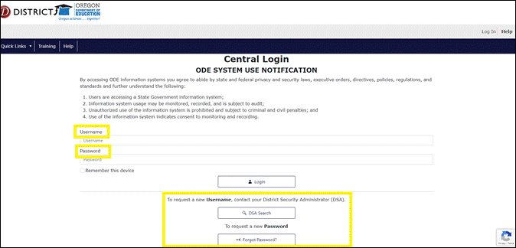
- Select the “CTE Information System – [your institution name]” on your Central Login Applications list.
- School Level Users must select the “CTE Information System – [High School]” option. If the only option is “CTE Information System – [School District]”, contact your District Security Administrator and ask them to correct the permissions that were set up.
- Regional Coordinators should select the “CTE Information System – [ESD/CC]” option.
Figure 2 Central Login Applications List
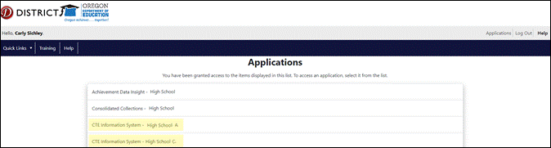
Verify that you are logged into the correct institution in the black header bar of the CTE IS Home Page. Text reads: [Your Name [Selected Institution] (Institution ID [X]).”
Every time you log into the CTE IS application, you’ll be directed to the Home Page.
Figure 3 CTE Information System (IS) Home Page
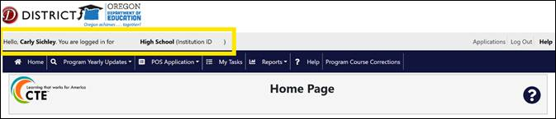

Initiating a CTE Program Application

Application Types: Start-Up or Full
- To initiate a new CTE Program Application, either:
- Click POS Application > Start New Application from the vertical black menu on the top of the page, or
- Click the green Start POS Application box on the CTE IS home screen.
Figure 4 CTE IS Home Page – Start a New Application
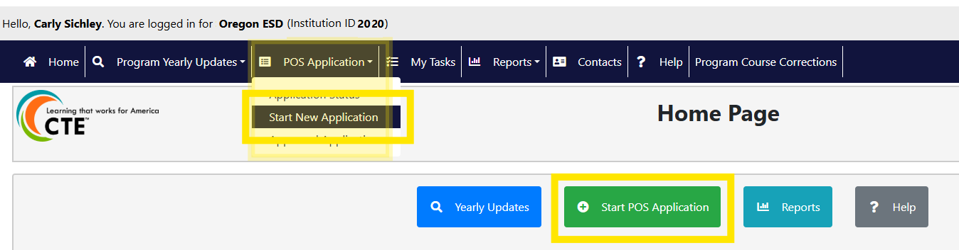
- Using the Application Type field, select the appropriate option from the drop-down menu.
- If the application type is Full or Start-Up, continue to step 5.
- If the application type is Renewal, skip to the Application Types: Renewal section on page 20.
Figure 5 CTE IS - Application Type Field
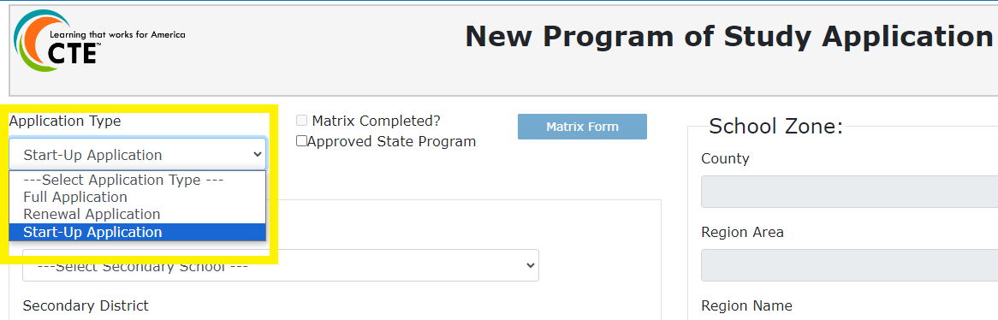

Secondary CTE Site Selection
- Select the school title from the Secondary School field drop down list.
- The list includes only CTE sites associated with the institution the Regional Coordinator is logged within the CTE IS.
  - For example, if School 12 in District 12A is part of Region AB, it will appear when the RC logs in under Region AB. It will not appear if the RC logs in under District 85.
If the application is for a school that is new to CTE and does not appear in the drop-down list, please contact ODE.CTEISHelp@ode.oregon.gov to request that the institution be updated as a CTE site in ODE’s Institution Management System.
Note: All institution details in the CTE IS are sourced from the Institutions Directory Database.
Figure 6 Application's Secondary School Field
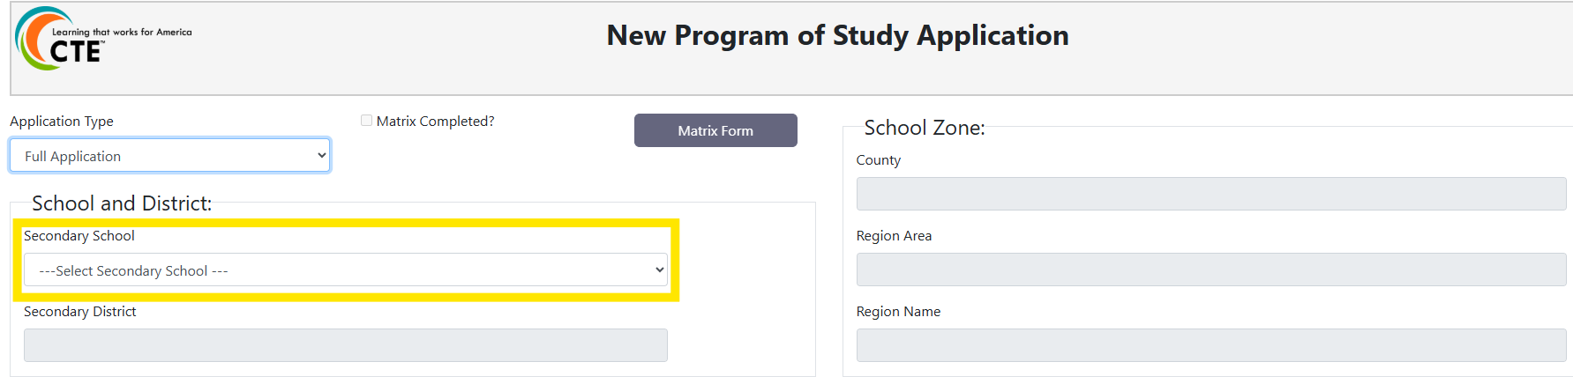
Once a Secondary School is selected, the District, County, Region Area and Region Name fields will automatically populate based on ODE’s Directory Database records.

Program Area, CIP And Framework Section
The Program Area, CIP, and Framework fields must be completed in sequence.
While the Focus Area is optional when designing a CTE Program, the CTE IS currently requires a selection in the Focus Area field.
Figure 7 CTE IS - Application Program Area Fields
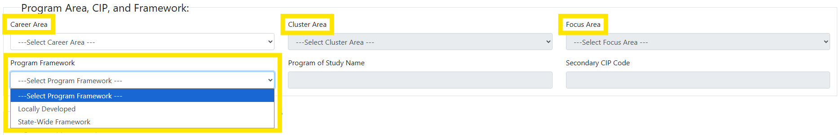
Complete the fields as follows:
- Select a Career Learning Area from the Career Area drop down list.
- Select a Career Cluster from the Cluster Area drop down list.
- Select a Focus Area from the Focus Area drop down list.
- For programs designed at the Cluster Level (except Arts, A/V Technology and Communications), please select the general option.
Once a Focus Area is selected:
- The Program of Study Name and Secondary CIP Code will auto-populate.
- These fields cannot be changed after the application is approved.
- Select whether the program is Locally Developed or part of the Statewide POS model using the Program Framework drop-down.
- Choose State-Wide Framework if the program is adopting the statewide model.
- The Program Framework selection is informational and does not change application requirements. As Statewide POS development continues, ODE will enhance the application process to better support programs that are part of the statewide model.
- Click Save Progress at the bottom of the page to save the newly initiated application.

Application Types: Renewal
When “Renewal Application” is selected, Regional Coordinators can import select information from the currently approved program.
- Note: Not all sections are imported, and imported fields remain editable within standard application parameters.
Contacts from the Teacher Grid are not copied to renewal applications. Lead Teachers, Additional Teachers and Local Admin must be re-added to the Teacher Grid when the application is ready for school-level input. When contacts are added to the Teacher Grid, the system automatically sends an email letting the recipients know a renewal application is in progress.
Changing a program’s Focus Area at renewal also changes the associated CIP code and interrupts data accumulation. CTE programs that change Focus Area/CIP Codes at renewal will be treated as new programs, and data accumulation will restart.
Upon selecting Renewal Application, a pop-up window titled Programs Due for Renewal will appear.
- This list includes all approved programs with expiration dates of June 30 of the current school year, specific to the institution the RC is logged into the CTE IS under.
To initiate the renewal:
- Select the appropriate program from the list.
- Click Select Program or double click the program line.
Figure 8 CTE IS New Program Application - Programs Due for Renewal Application Window
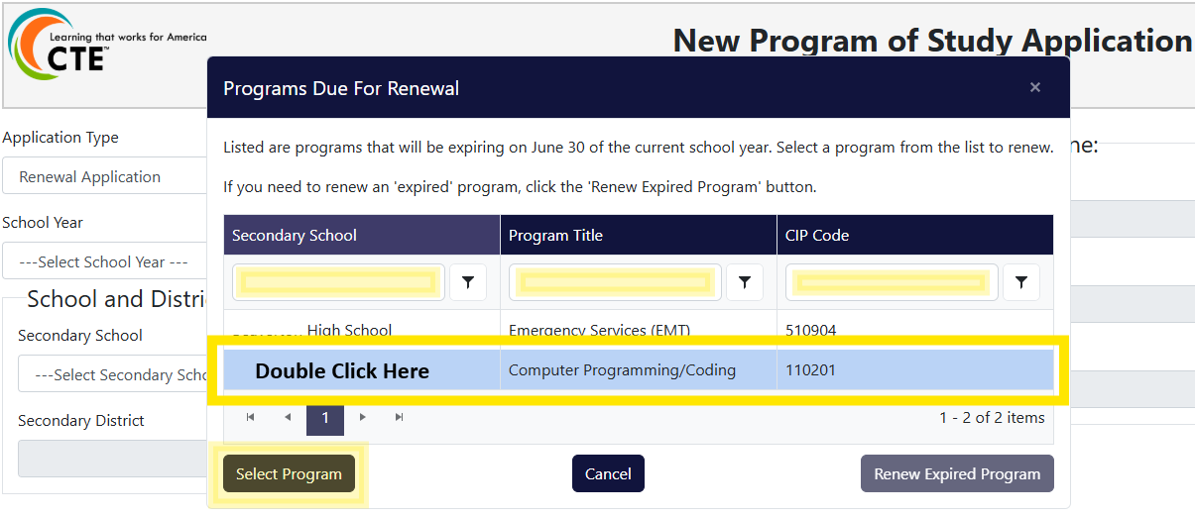
A green confirmation message will appear once the program data has been successfully imported.
Figure 9 Application Successfully Initiated Message
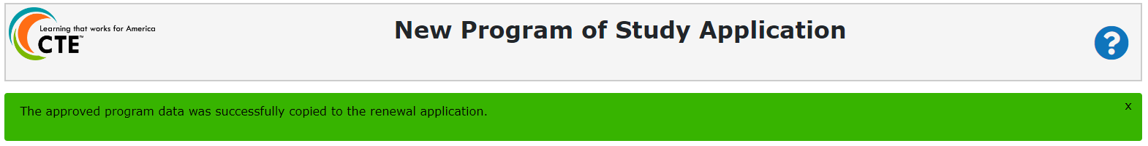
After importing, continue with the standard application process and click “Save Progress” at the bottom of the page.
If a renewal application is needed for a program that has already expired, select Renew Expired Program at the bottom of the pop-up window.
- No previous program information will be copied in this case.

Viewing In-Progress Applications
Once an application has been saved, it appears in the CTE Information System with a status of “In Progress”.
User Access and Visibility
Access to In-Progress applications is based on user role and institution a user is logged into within the CTE Information System:
- Regional Coordinators and Local Administrators can view all In-Progress applications associated with the institution they are logged into.
- Lead Teachers and Additional Teachers can view In-Progress applications associated with the institution they are logged into after they have been added to the application’s Teacher Grid by the Regional Coordinator.
When a school-level user (Lead Teacher, Additional Teacher or Local Admin) is added to the Teacher Grid:
- A system generated email notification is sent directing the user to log into ODE’s District website to access the CTE Information System.
- If the user is new to the CTE Information System, they must contact their District Security Administrator to be granted access to the CTE Information System for the specific school listed in the email notification.
- Accurate role designation is critical. If permissions are not set up correctly, users will be unable to view or edit application information.
For additional guidance on user roles and access, refer to the CTE Information System Roles and Access document.
Opening an In-Progress Application
In-Progress applications can be accessed in either of the following ways:
- Select POS Application > Application Status from the Main Menu and click Edit on the desired application.
- Select My Tasks from the Main Menu and click Edit on the desired application.
In-Progress applications remain visible and editable in My Tasks for both Regional Coordinators and school-level users until the application is submitted to the Regional Coordinator.
Figure 10 CTE IS - Application Status
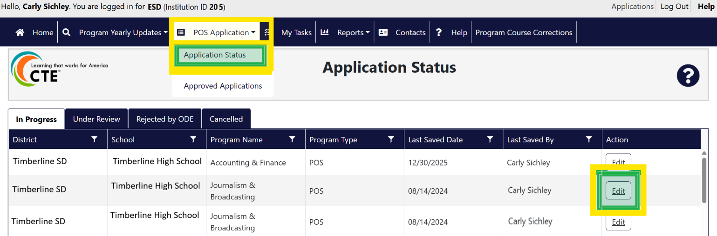

CTE Program Application Sections

Program Details (Start-up Application Only)
The Program Details section of the Startup Application captures high-level financial estimates associated with launching a new CTE program.
This section is intended to support program planning and fiscal awareness during the start-up phase. While districts must internally identify resources that will be utilized to establish a CTE program’s startup costs, the source of funds (community, CTE revitalization, High School Success, general fund and/or Perkins), timelines, and implementation steps as part of program development, only summary cost estimates are entered into the application.
Local educational agencies are responsible for funding the base level program. Perkins resources are used to enhance the POS and take the program to the next level.
Who Completes This Section
- Regional Coordinators only
Required Information
- Cost to Start-up Program - Enter the estimated total dollar amount the district expects to spend to launch the CTE program.
- Expected Use of Allowed Perkins Start-up Dollars - Enter the estimated dollar amount of Perkins funds the district anticipates using for allowable start-up activities, if applicable.
Figure 11 Startup Application Detail Fields
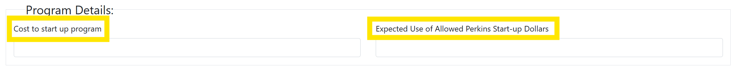

Teacher Grid
CTE program contacts are added to the application using the Teacher Grid. Only Regional Coordinators can add contacts to the Teacher Grid.
The following contact types may be added:
- Lead Teacher (required)
- Additional Teacher(s) (optional but encouraged)
- Local Administrator(s) (optional)
Until a Lead Teacher or Additional Teacher is added to the Teacher Grid, these school-level users will not be able to access the newly initiated application in the CTE Information System.

System Notifications
Once a program contact is added to the Teacher Grid and the application has been saved:
- A system-generated email from the ODE Helpdesk to the added contact.
- The email subject line will read: “School Title, Program Title – Lead Teacher Assignment”.
- The email notifies the recipient that they have been assigned to a CTE program application in the CTE Information System.
Adding Contacts to the Teacher Grid
- Click Add new record.
Figure 12 CTE IS New Program Application - Teacher Grid
- Enter the contact’s Email address first.
  - If the email already exists in the CTE Information System, the TSPC Account, First Name and Last Name fields will auto-populate.
  - If the email does not exist in the system, all remaining fields must be entered manually.
Figure 13 CTE IS - Teacher Grid Editing
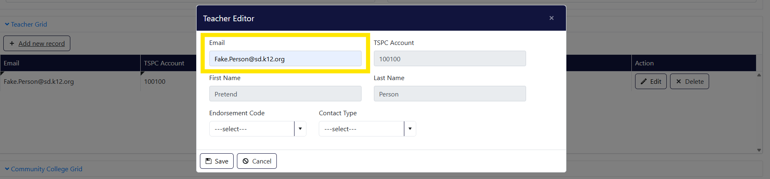
- Enter the TSPC Account number for Lead Teacher and Additional Teacher contacts. Local Admin contacts do not require a TSPC Account number.
- Enter the contact’s First Name and Last Name.
- Select the Endorsement Type for Lead Teacher and any Additional Teacher contacts. Local Admin contacts do not require an Endorsement Type.
- Select the appropriate Contact Type:
  - Lead Teacher
  - Additional Teacher
  - Local Admin
- Click Save to add the contacts to the Teacher Grid.

Updating Contact Details
When existing contact information is no longer accurate, Regional Coordinators must update the existing contact record rather than create a new one.
Editing contact information in the Contacts section of the Main Menu ensures updates are applied across all CTE programs associated with that individual and helps prevent duplicate contact records in the CTE Information System.
- Select Contacts from the Main Menu in the CTE Information System.
- Click Last Name to sort contacts alphabetically and locate the appropriate contact record.
Figure 14 CTE IS - Contacts
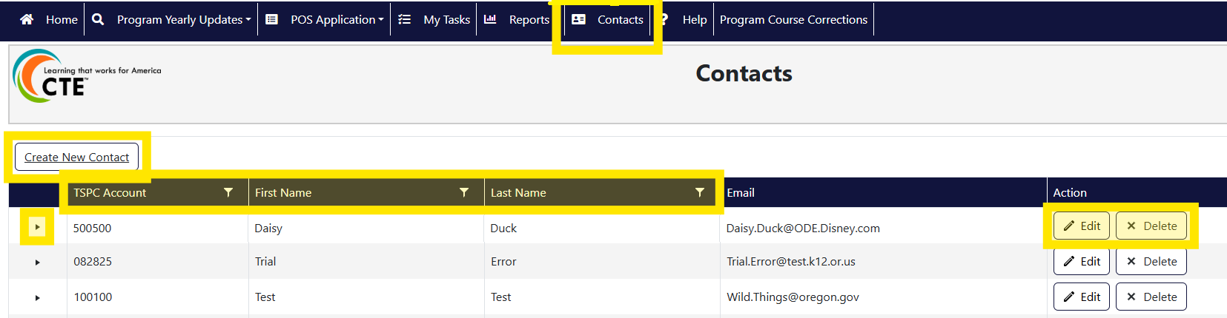
- Click Edit on the contact’s record to enable editing.
- Update the contact’s email address, TSPC Account, and/or name, as needed.
- Click Update to save the changes.
Figure 15 CTE IS - Editing Contact Records
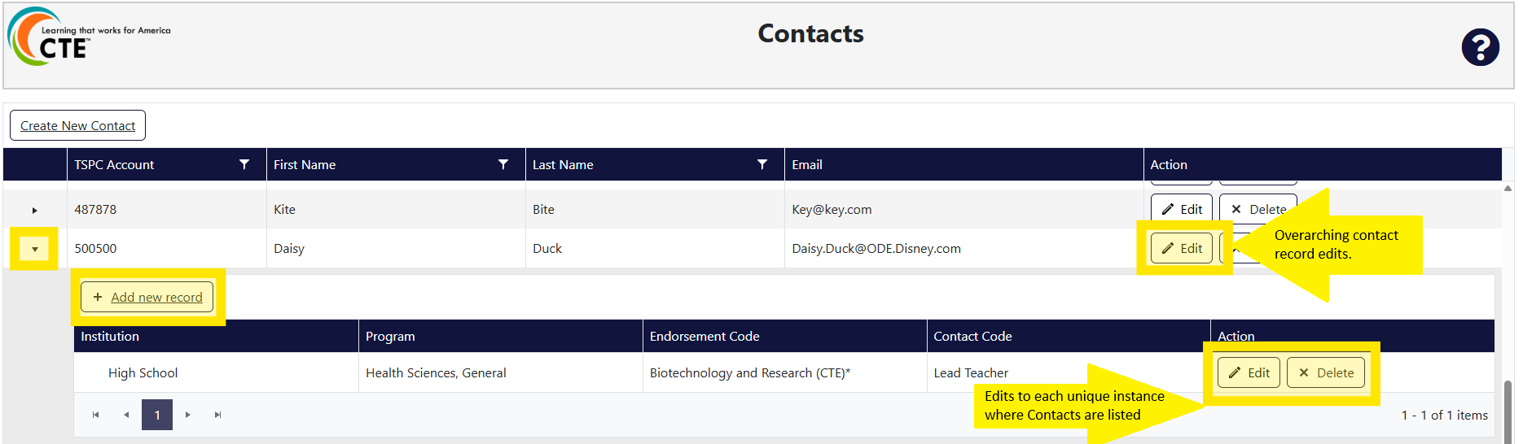
Once saved, the updated contact information will automatically be reflected in the application’s Teacher Grid.

Community College Grid
The Community College Grid is used by Regional Coordinators to document alignment between a secondary POS and an associated community college program. For additional information about POS alignment expectations and requirements, refer to the Alignment & Articulation section on pg. 9 of this guide.
Adding Community College Alignment
- Click Community College Grid to expand the section.
- Click Add New Record to display the Primary Name and Program Title selection fields.
- Select the aligning community college name from the Primary Name drop-down list.
  - Once the community college name is selected, the Program Title field will become available.
- Select the aligning community college program from the Program Title drop-down list.
  - The Contact, Award and CIP Code fields will auto-populate based on the selected program.
- Click Add to save the community college alignment information.
Figure 16 CTE IS - Community College Grid
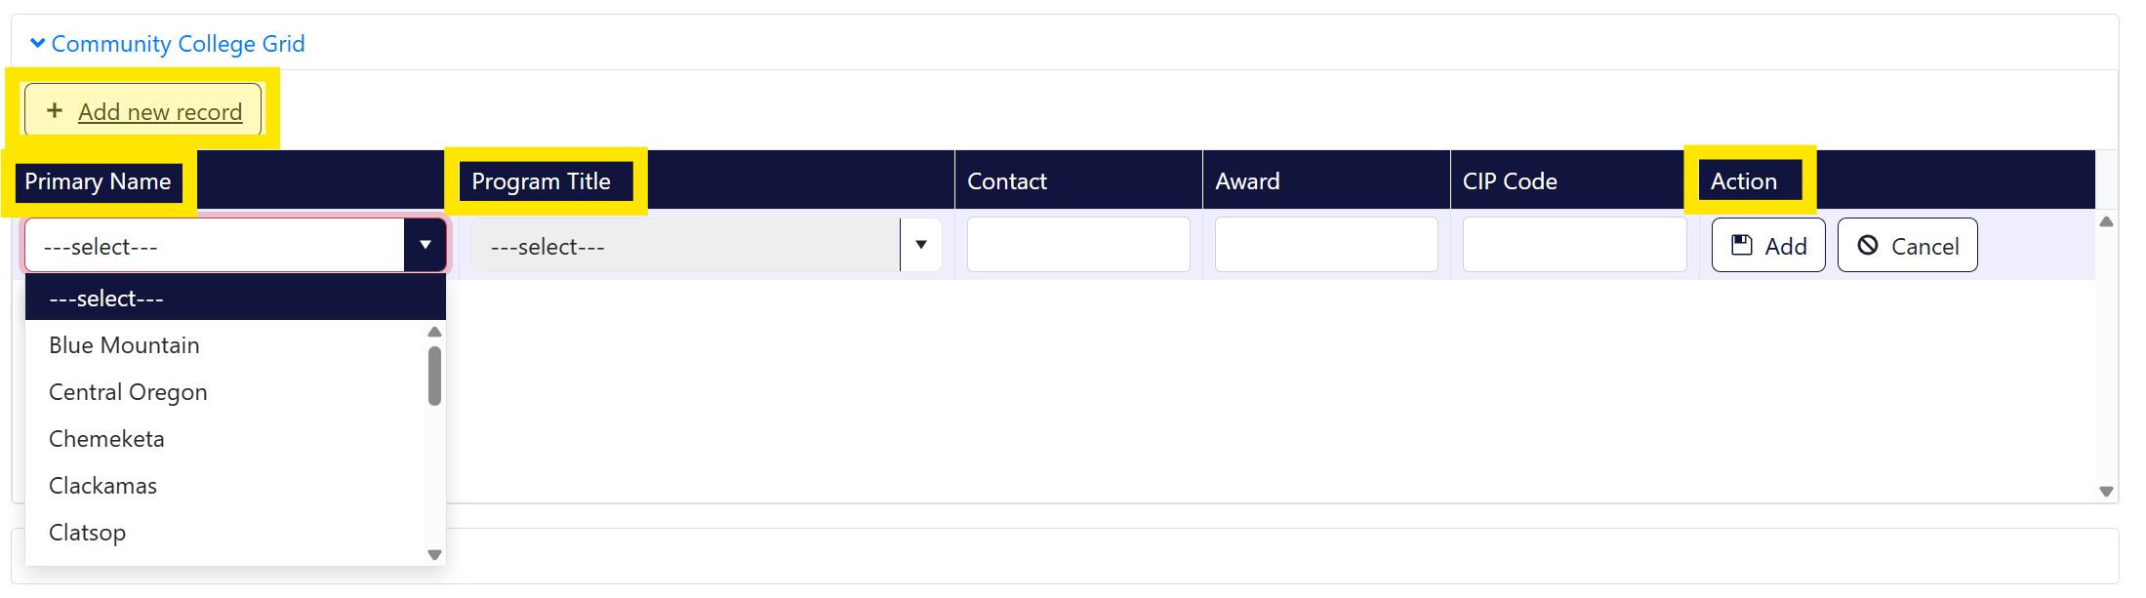
Community College programs available in the Program Title drop-down list are provided to ODE through a report from the Higher Education Coordinating Commission (HECC) Office of Community College and Workforce Development (CCWD).
- If a specific community college program is missing or appears incorrect, please contact Kasena Dailey, Program Coordinator in CCWD at Kasena.Dailey@hecc.oregon.gov.

Additional Components of a High-Quality Program of Study
This section is used to document program offerings related to Work-Based Learning, Student Leadership Opportunities, and Industry Recognized Credentials associated with the CTE Program.
The following four multi-select fields are included in this section:
- Work-Based Learning
- Student Leadership Opportunity
- Secondary Industry Recognized Credentials
- CC Industry Recognized Credentials
These fields may be completed by either school-level users (Lead Teacher, Additional Teacher, Local Admin) or the Regional Coordinator.
- School-level users may edit this section until the application is in “Submitted to RC” status.
- Regional Coordinators may edit this section until the application is in “Submitted to ODE” status.
- Click inside any of the four multi-select fields to view available options.
  - A drop-down list will expand for each of the fields.
- Select all options that apply to the CTE program applying.
Figure 18 CTE IS - Additional Components of a HQPOS
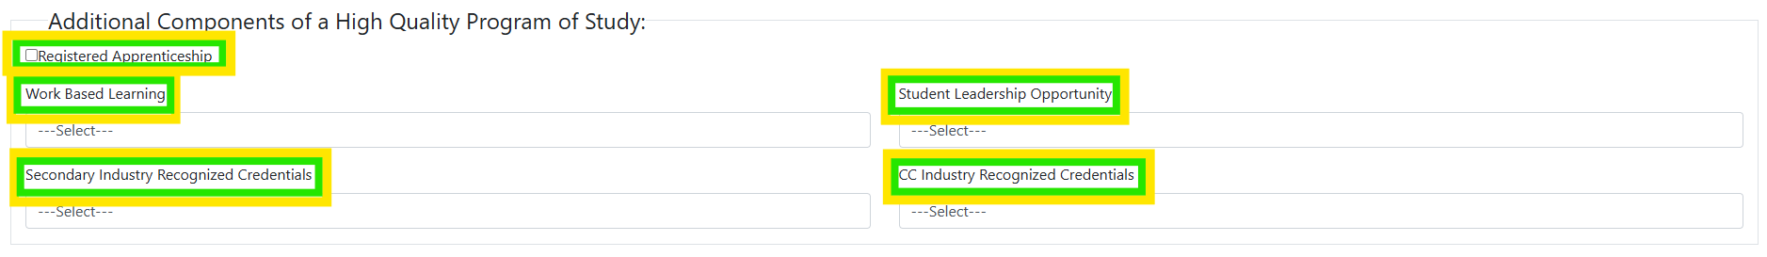

Work-based Learning
Oregon has identified six types of measurable WBL experiences:
- Service Learning
- Clinical | Internship | Practicum
- Cooperative Work Experience
- Registered Pre-/Youth Apprenticeship
- School-Based Enterprise
- Workplace Simulation
Select all the work-based learning opportunities to students participating in the CTE program.

Student Leadership Opportunities
Select the associated Career and Technical Student Organizations or “Locally Developed Student Leadership” option from the drop-down list.
- If “Locally Developed Student Leadership” is selected, refer to the Student Support Services section of this guide for required verification.
  - Applications that do not provide sufficient verification of the leadership equivalent, as outlined in the Locally Developed Student Leadership guidance, will be returned for further information.

CTE Industry Recognized Credentials
Select all CTE Industry Recognized Credentials (IRCs) that will be offered to students participating in the CTE program.
The current list of approved IRCs is available on the CTE Industry Recognized Credentials webpage (IRC Look-Up Table). This list or the IRC Guide should be used to verify whether an IRC has been approved or if a request for approval is required.
If an Industry Recognized Credential (IRC) or Career and Technical Student Organization (CTSO) that is utilized by the school is missing from the drop-down list, please check the ODE website for the lists of CTSOs of the IRC Look-Up Table.

Components of a High-Quality Program of Study
The Components of a High-Quality Program of Study section is used to provide narrative responses for required program elements within the application.
The following comment box fields are included in this section:
- Student Support Services
- Accountability and Evaluation
- Professional Development
- Continuous Program Improvement Goal (Renewal Application only)
These fields may be completed by either school-level users (Lead Teacher, Additional Teacher, Local Admin) or the Regional Coordinator.
- School-level users may edit this section until the application is in “Submitted to RC” status.
- Regional Coordinators may edit this section until the application is in “Submitted to ODE” status.
Each comment box has a 4,000-character limit. If additional details are needed, supporting documentation may be uploaded in the Attachments section of the application.
Figure 19 CTE IS - Components of a HQPOS
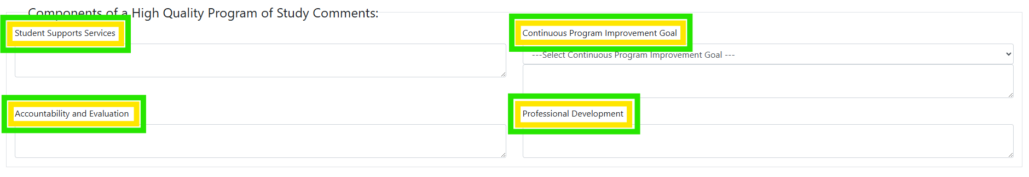

Student Support Services
Refer to the orange box titled “CTE Information System Secondary Application: Student Support Services” in the Student Support Services component of the Elements of a HQPOS section for detailed guidance on the information to include in this comment box.

Accountability & Evaluation
Refer to the orange box titled “CTE Information System Secondary Application: Accountability & Evaluation” in the Accountability and Evaluation component of the Elements of a HQPOS section for detailed guidance on the information to include in this comment box.

Professional Development
Refer to the orange box titled “CTE Information System Secondary Application: Professional Development” in the Professional Development component of the Elements of a HQPOS section for detailed guidance on the information to include in this comment box.

Continuous Program Improvement (Renewal Application Only)
Refer to the orange box titled “CTE Information System Secondary Application: Accountability & Evaluation” in the Accountability and Evaluation component of the Elements of a HQPOS section for detailed guidance on the information to include in this comment box.

Attachments
The Attachments section allows users to upload supplemental files to support a CTE application. Documents uploaded to this section may be viewed and downloaded by school-level users, Regional Coordinators, and ODE Content Specialists.
Supporting documentation uploaded during the application process remains associated with the program for the duration of it’s approved period, unless the document is removed.
- Click Attachments to add or view documents.
- Click Add new document.
Figure 20 CTE IS - Attachments Section
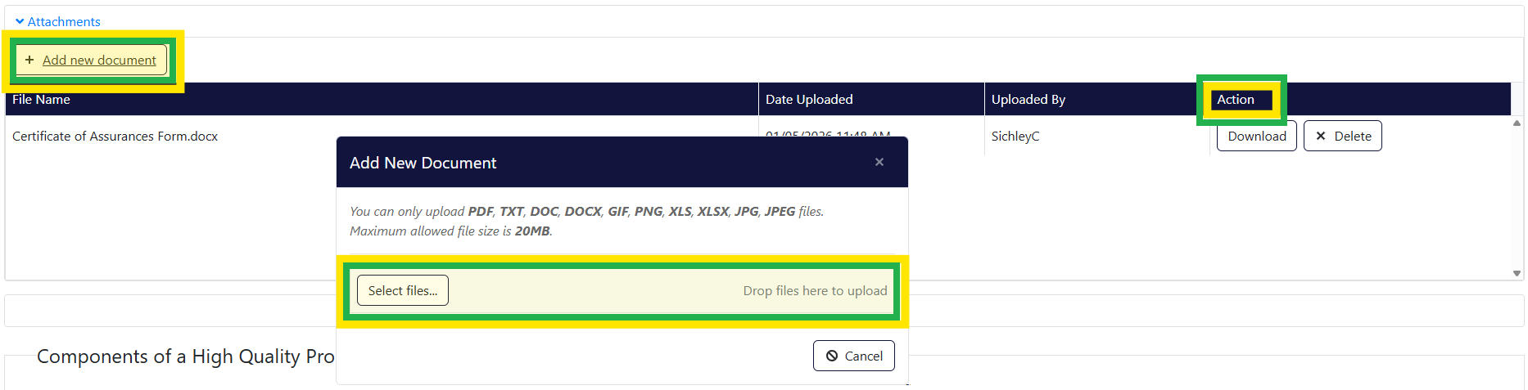
- Click Select Files to browse for a file on your computer, or drag and drop the file into the upload area.
  - Repeat this process until all desired documents are selected.
- Click Upload.
Figure 21 CTE IS - Upload Documents to Attachments
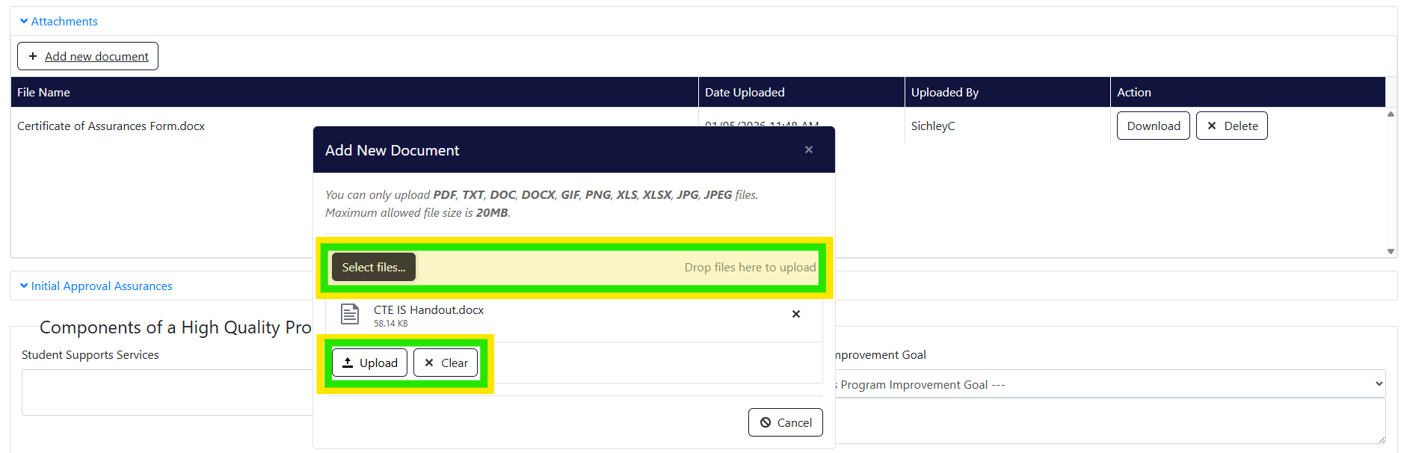
- Uploaded documents will display in the Attachments section with the file name, upload date and uploaded by information.
  - Any user with access to the application may download uploaded documents.

Initial Approval Assurances
The Initial Approval Assurances section must be completed before any CTE application can be submitted to ODE. This section serves as the certification of assurances for the CTE program application.
ODE does not require physical copies of signed assurance documents to be submitted as part of the application. A Certification of Assurances template is provided at the end of this guide (page 44) for optional use if Regional Coordinators choose to collect signatures. If signatures are collected, the completed document may be uploaded to the Attachments section of the application for recordkeeping purposes.
Only Regional Coordinators can complete the Initial Approval Assurances section. By entering assurance information, the Regional Coordinator is verifying that program partners have acknowledged and agreed to the following assurances:
- Regional Coordinator – Confirms the program is recommend for state approval and is Perkins-eligible.
- Secondary School Administrator – Confirms review of the program application document for clarity, completeness and adherence to program quality standards and support its approval. The secondary school administrator agrees that the CTE program area requirements for secondary CTE programs, including appropriate CTE certification for teachers, the rules and regulations for Public Law 109-270, and the requirements contained in the Oregon State Plan for Career and Technical Education will be complied with in the operation of the CTE programs and services offered by the district or through contract between the district and other agencies, institutions, or individuals. The secondary school administrator agrees to furnish CTE program data as requested by the Oregon Department of Education.
- Advisory Committee Member, Organization Name (committee chair is preferred), Local/Regional Advisory Committee – Confirms that the advisory committee was involved in the design and development of the CTE program.
- Community College Administrator Name – Confirms the specific community college(s) involvement in the design and development of the POS and agreement to continue collaboration (collegial professional development), especially alignment and articulation.
Figure 22 CTE IS - Initial Approval Assurances Section
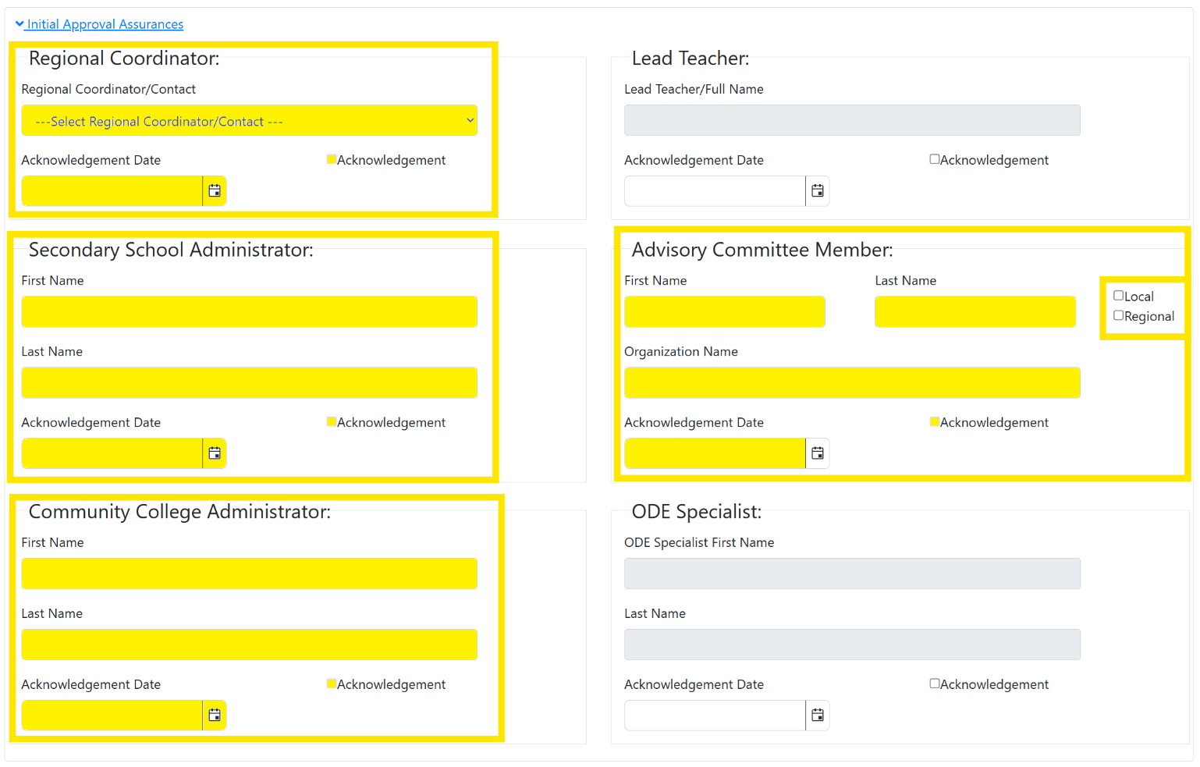
Some assurance fields are system-controlled and cannot be manually edited:
- Lead Teacher assurance fields automatically populate when the application matrix is marked Complete and submitted to the Regional Coordinator.
- ODE Content Specialist acknowledgement fields are completed upon final state approval of the application.
Once an application is approved, the names listed for Secondary School Administrator, Community College Administrator, and Advisory Committee Member can’t be edited. These individuals represent the partners involved in the program’s design and development at the time of approval and will remain with the approved program until the program completes a new application cycle.

The Matrix Form
Every CTE program application must include a completed Matrix Form. The Matrix Form documents the depth and sequence of non-duplicative CTE courses that progress from introductory to advanced content within a POS.
Lead Teachers should utilize the Matrix Form to demonstrate how the program’s course sequence supports student progression and aligns to the approved POS.
Figure 23 CTE IS Program Application - Matrix Form Button
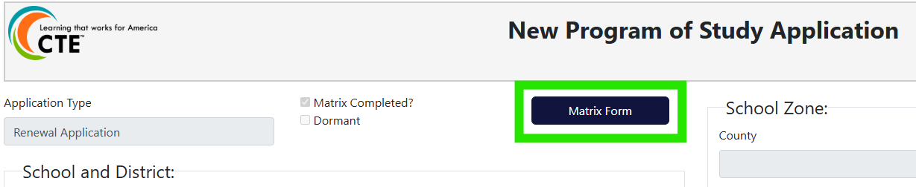
All Programs of Study must provide students with the full range of required Knowledge and Skill Statements over the course of the high school and community college program. These include:
- Cross-cutting employability knowledge and skills
- Cross-cutting Career cluster knowledge and skills
- Focus Area-specific knowledge and skills (where applicable)
All programs (statewide and locally developed) going through the renewal cycle are expected to have transitioned to the new Oregon Knowledge and Skill Statements.

Completing the Matrix
All users with access to the application can view the Matrix Form; however, the Matrix must be completed by a School Level User (Lead Teacher, Additional Teacher or Local Admin).
Every application must have a completed Matrix Form prior to submission:
- Start-up applications: Minimum of one (1) CTE course
- Full and Renewal applications: Minimum of three (3) non-duplicative credits worth of CTE courses
Adding Courses to the Matrix
Having course information readily available from the Student Information System will make completing the Matrix Form more efficient.
- Click Matrix Form at the top of the application to open the Matrix.
  - Start-up and Full applications will display a blank Matrix Form.
Figure 24 CTE IS - Blank Matrix
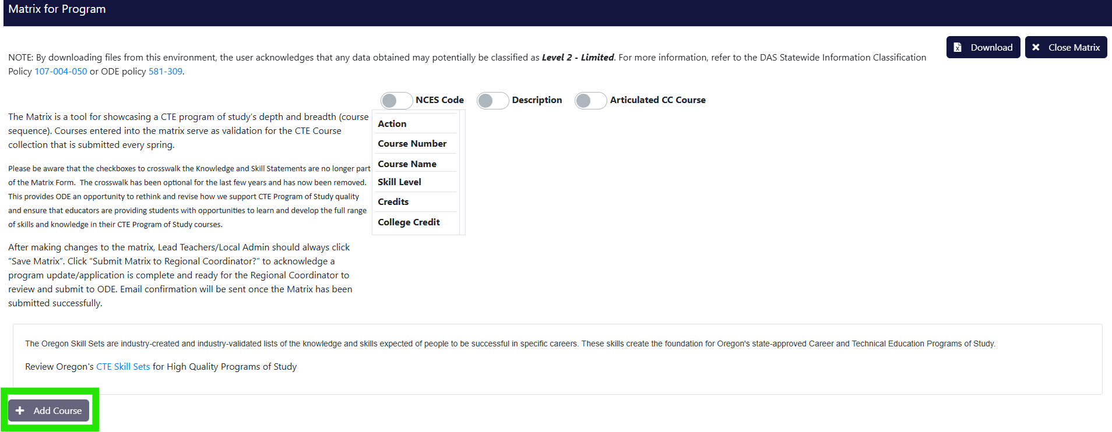
  - For Renewal applications with imported information, previously approved CTE courses will populate automatically and must be reviewed for accuracy.
- Click Add Course. Course entry fields will appear at the bottom of the Matrix Form.
Figure 25 Figure 23 CTE IS – Adding a Course to the Matrix Form
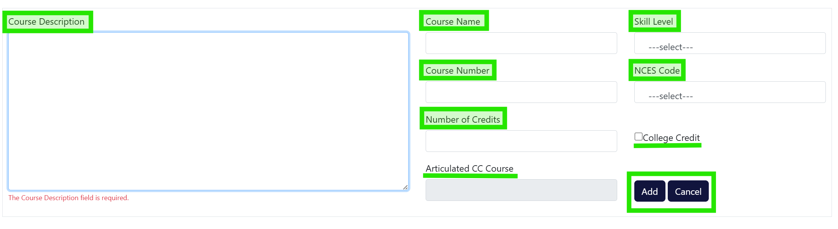
Each course added to the Matrix Form must include the following information:
- Course Number (required):
Must match the course number used in the Student Information System.
  - CTE sites have full autonomy over course numbering.
- Skill Level (required):
Select Introductory, Intermediate, or Advanced (See the Standards and Content section for definitions).
  - Course sequencing should demonstrate progression from Introductory to Advanced
- Credits (required):
The number of credits students earn upon successful completion of the course.
  - CTE data are calculated and compiled for state and federal reporting based on the Oregon Diploma and Modified Diploma requirement of 24 credits to graduate (ORS 329.451). When divided, the 24 credits equate to learners earning an average of 0.5 credits a semester or 0.34 credits a trimester awarded at successful completion of a course.
- Course Name (required):
Must match the name listed in the student course handbook.
- NCES Code (required):
Select the NCES code that best aligns with the course content and matches the Student Information System.
  - Refer to the Course to Endorsement Catalog for the current listing of NCES codes.
- Course Description (required):
Should match what is published for students and the community in public-facing materials like curriculum guides, syllabi and websites. Descriptions should be clear and concise and accurately describe the essential learning students will experience in the CTE course.
- Descriptions may include capstone projects, work-based learning experiences and student leadership opportunities.
- If the course awards graduation credit (science, math, language arts, etc) and/or accelerated college credit, indicate how CTE content aligns with the respective academic standards.
- For year-long courses, specify semester or trimester distinctions if different course codes are used.
- College Credits (optional):
Check this box if students may earn both high school and postsecondary credit through an articulation or dual credit agreement with a postsecondary institution.
- Articulated Community College Course (optional):
Enter the post-secondary course information.
  - This field is enabled when the College Credits box is selected.
- Complete all required fields for the course.
- Click Add to save the course.
  - Select Cancel to exit without saving.
Repeat this process until all applicable courses are added to the Matrix Form.
Editing or Removing Courses
After a course is added, it may be edited or removed as needed. School Level Users should carefully review imported courses on Renewal applications to ensure accuracy.
- Click Edit or Delete in the Action row for the course. The course fields will reopen at the bottom of the Matrix Form.
  - Delete courses that are no longer offered and will not be part of the POS during the upcoming approval cycle.
- Update the necessary field(s).
- Click Update to save changes.
Figure 26 CTE IS - Editing the Matrix Form
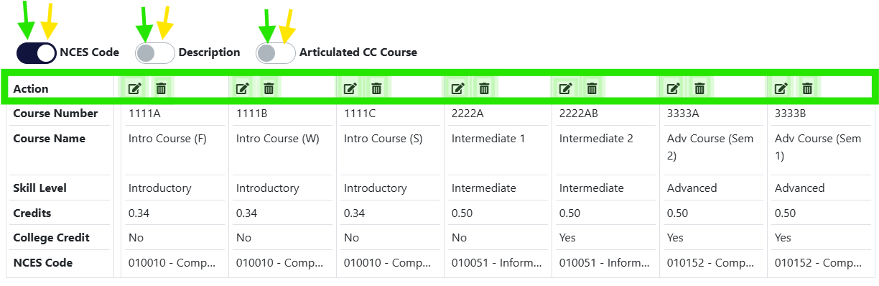
- Repeat steps 43 - 48 until the Matrix Form is complete.

Application Submission
Once a School Level User has completed all required sections of the application, it must be submitted to the Regional Coordinator for review.
Before submitting the matrix, School Level Users should confirm that all required information for Full and Renewal applications has been entered, including:
- Work-Based Learning opportunities
- Student Leadership Opportunities
- Student Support Services
- Accountability and Evaluation
- Professional Development
- To submit the application to the RC, click the Submit Matrix to Regional Coordinator checkbox.
Figure 27 CTE IS Program Application – Submit to Regional Coordinator
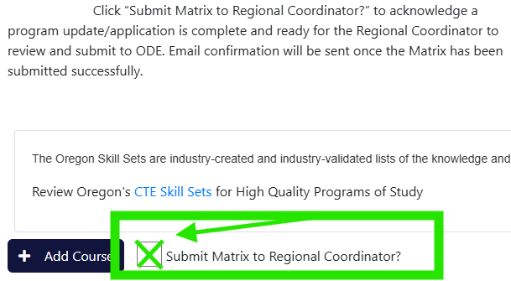
After the application is successfully submitted, the system will display a green confirmation message next to the Submit Matrix to Regional Coordinator checkbox, verifying that the submission is complete.
Figure 28 CTE Program Application Submission Complete
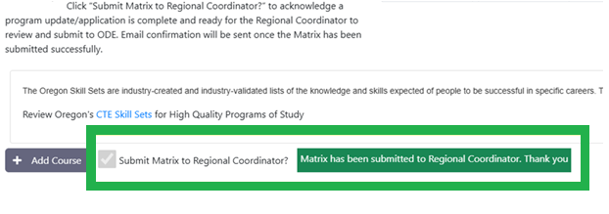
When the application is submitted, a system-generated email from ODE Helpdesk with subject line, “School Title, Program Title – Matrix Complete” is sent to the contacts listed in the application’s Teacher Grid and the Regional Coordinator. The email informs the Regional Coordinator that an application is ready for review and provides School Level Users with confirmation that they have completed their portion of the application process unless further edits are requested.
After submission to the Regional Coordinator:
- The application will no longer appear in the School Level User’s My Tasks.
- School Level Users will no longer have editing access to the application.
- All system users can view submitted applications under POS Application > Application Status.

Recalling a Submitted Application
School Level Users may recall a submitted application if additional edits are needed.
To Recall an application:
- Navigate to POS Application > Application Status.
- Locate the application under the In Progress or Under Review tabs.
- Click View on the appropriate application row.
- Open the application’s Matrix Form.
- Click the Edit Matrix button to return the application to editable status.
- Make the necessary updates and repeat the submission steps outlined above.
Figure 29 CTE Program Application Recall Submission
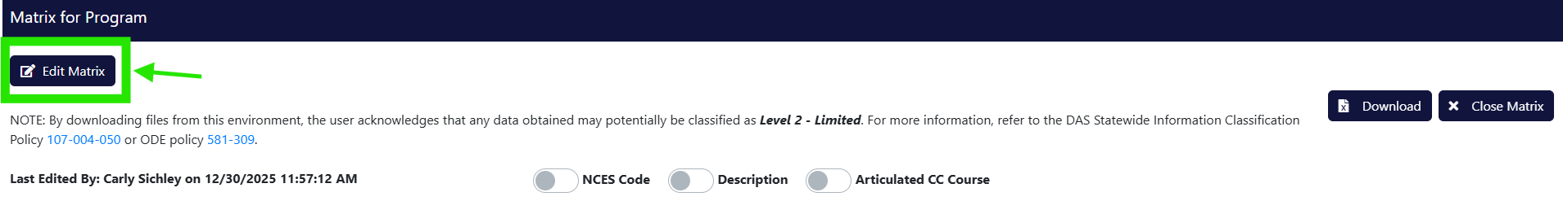

Application Submission Follow-up
Once a School Level User submits an application to the Regional Coordinator, its status changes from “In Progress > In Progress” to “In Progress > Submitted to RC”. At this point:
- The application is removed from the School Level User’s My Tasks.
- Editing access for School Level Users is removed unless the application is returned for revisions.
Regional Coordinators will see submitted application in their My Tasks and will have sole editing access to some fields. The Regional Coordinator reviews the application and either:
- Submits the application to ODE for review, or
- Returns the application to the school for additional edits.
When the Regional Coordinator submits the application to ODE, its status changes from “In Progress > Submitted to RC” to “Under Review > Submitted”.
- The application is removed from the Regional Coordinator’s My Tasks.
- A system-generated email from the ODE Helpdesk is sent to all contacts listed in the Teacher Grid, the Regional Coordinator, and the ODE Content Specialist with the subject line “School Title, Program Title – Submitted to ODE”
Submitted applications remain viewable to School Level Users and Regional Coordinators under POS Application > Application Status. Users can browse the four (4) status tabs in Application Status to find an application.
Figure 30 CTE IS – Application Status View
ODE Review Statuses
Applications listed in the Under Review tab will display one of the following statuses:
- Submitted - The application has been submitted to ODE but has not yet been reviewed by the ODE Content Specialist.
- Under Review - An ODE Content Specialist has begun the initial review.
When an application is approved by the ODE Content Specialist:
- A system-generated email from the ODE Helpdesk will go out to all contacts listed in the Teacher Grid, the Regional Coordinator, and the ODE Content Specialist with the subject line “School Title, Program Title – CTE Application Approved”.
- The approved application will remain permanently available for viewing under POS Applications > Approved Applications in the main CTE Information System menu.
All CTE program applications submitted by June 30th will be approved by August 15th.
New, Start-up and Renewal applications approved by the August 15th deadline will first appear as approved program on the last Thursday of August in both the CTE Information System and Approved CTE Programs report.

Decision Comments
The Decision Comments box is used to document communication throughout the application review process. Comments may be entered when an application is:
- submitted to ODE
- Returned for revision by a Regional Coordinator or ODE Content Specialist
- Approved
Decision comments should be used to explain required revisions, clarify application details, or document immediate or long-term program changes identified during the review process.
Comments entered in the Decision Comments box are public record and remain associated with the program until a new application is submitted during a future approval cycle (typically one to four years).
Type comments into the Decision Comments box immediately prior to submitting, returning, or approving an application. When an application is submitted or returned, the comment is saved automatically and included in the system-generated email notification.
The most recent comment appears at the top of the Decision Comments box. Previous comments entered by Regional Coordinators and ODE Content Specialists are listed below. To view a prior comment in full, click View in the corresponding comment row.
Figure 31 CTE IS - Application Decision Comments Box
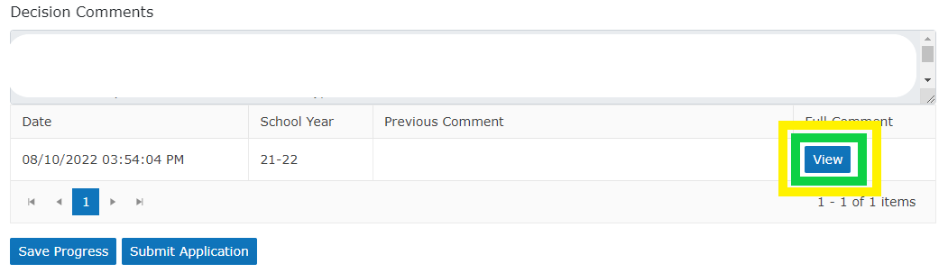

For Technical Assistance of the Application: Please contact ODE.CTEISHelp@ode.oregon.gov

Resources
High-Quality Programs of Study
CTE Oregon Skill Sets
ODE's CTE Teacher Resources webpage
Post-Secondary Career and Technical Education Administration webpage
CTE Policy Guidebook 2025-26
Equitable Participation in CTE Programs and Activities
NCES Course to Endorsement Catalogue
SB3: Personal Finance Courses
Equitable Participation in CTE Programs and Activities
Work-Based Learning Handbook

CTE Course Descriptions
A well-written course description has the double benefit of providing an effective summary of the course for Career Area Specialists review and approval to be part of a CTE POS while simultaneously recruiting students by presenting the features and benefits offered to the learner. It should be specific enough that it truly matches what’s offered and the value it provides.
Course descriptions on a CTE program’s Matrix Form in the CTE Information System (IS) should reflect what is published for students and the community in public-facing materials like curriculum guides, syllabi and websites. Descriptions should be clear and concise and accurately describe the essential learning students will experience in the CTE course. Content may include such elements as capstone projects, work-based learning experiences and student leadership opportunities. If courses are part of a sequence, differences between introductory, intermediate and advanced levels should be communicated. If the course is college credit bearing, that may also be stated. Approved CTE course information, including the course description, is public information and offers partners insight to what students are learning in CTE programs across Oregon.
Please note that language directly “copied and pasted” from NCES course code descriptions does not provide information tailored to a specific course in a specific program.
These course descriptions are provided as examples only:
Course Title - Level | Description
Web Design - Intermediate  (Digital Arts, General) | An introduction to design and communication principles as they apply to web design. Students will investigate the unique challenges involved in website design. Web-design uses HTML format for students to design internet web pages. Students will learn basic tags and design techniques in developing pages that would include text, color, sound, images, video and special effects. Students will also learn design terms that are used in technological design settings. Students will use the knowledge gained to build their own web pages. They will use design terminology to reflect and analyze their design. Students in this class may receive “College Now” credit through Lane Community College.
Medical Terminology - Intermediate  (Health Sciences, General) | Discover the language of healthcare in our Medical Terminology course. Dive into the essential terms and concepts used by medical professionals. Through interactive digital lessons and real-world job shadowing experiences with medical assistants and scribes, students will gain practical insights and hands-on knowledge. Whether students are considering a future in healthcare or just curious about the medical field, this course will equip students with the vocabulary and understanding needed to succeed. This course will provide valuable knowledge and skills that will set students on the path to success in the dynamic world of healthcare!
Introduction to Agriculture - Intro  (Agriculture, General) | An introductory course in Agricultural Science. Specific areas of study include: basic animal husbandry, horticulture/greenhouse production, basic agriculture mechanics/welding, agriculture leadership, and basic agriculture business record keeping. The FFA will be an integral part of the class and students will have the opportunity to participate. Exploration of the various careers within the world of Agriculture is the focus of the class. Students will receive their Tractor Certification/Farm Machinery Licensure. The Agriculture Experience Tracker (AET), a student portfolio system, will be utilized to identify personal goals, reflect on personal learning and track student experiences within their career path.
Introduction to Horticulture - Intro  (Agriculture, General) | The student will learn various aspects of the horticulture field, including plant propagation, garden starts, turf grass management, and landscaping. The growth of bedding and house plants will be covered in laboratory/greenhouse demonstrations and laboratory projects. This course will also deal with insect and plant disease treatments and prevention. Students will produce plants for personal use and the FFA annual plant sale. The FFA will be an integral part of the class and students will have the opportunity to participate within plant science / horticulture specific career development events. The Agriculture Experience Tracker (AET) will be utilized to identify personal goals, reflect on personal learning and track student experiences within the horticulture career path. Students may earn HORT 100 college credits through Chemeketa Community College. Introduction to Horticulture in conjunction with Advanced Horticulture may qualify for 1 science credit at ABC High School and would be recognized as a graduation credit.
Auto Technology III – Intermediate  (Automotive Service Technology) | This course is for the student who is serious about a job in the auto industry. The subjects studied alternate every other year with Auto IV and cover the systems of the automobile. The skills learned in Auto 1 and Auto 2 are put to use in as close to a live shop setting as possible. Students are earning their grade just as Auto Technicians earn their pay. There is a lot of time for live, hands-on experience. Students must schedule and plan their work. Auto 3 and Auto 4 students are working together in the same class.
Family and Schools - Intermediate  (Education & Training, General) | The study of influences on children and families which impact child and family behaviors, values, attitudes, beliefs, and morals. Topics include parenting patterns, cultural, religious, and socioeconomic influences, peer, school, media impacts, community ecology, and public policy. Dual Credit Course.
Criminology – Intermediate  (Law, Public Safety & Security, General) | This course covers the development and conceptualization of crime, including historical perspectives, social and legal definitions, and classifications. It includes an overview of criminology, research, data gathering, and analysis. It introduces major theoretical perspectives on the nature of crime, criminals, and victimization, along with current trends and patterns of crime typologies and responses to them.
Foundations of Cosmetology - Intro  (Personal Care Services) | Foundations of Cosmetology presents beginner skills and knowledge related to cosmetology. It prepares students with skills and knowledge necessary to meet the Oregon State Board of Cosmetology statutes and deliver quality services. Foundations of Cosmetology A & B will emphasize safety and sanitation, state rules, regulations and anatomy and physiology. The structure and growth of hair, skin, and nails and their diseases and disorders.
Introduction to Marketing - Intro  (Marketing, General) | Students will learn the foundations of marketing, including the ‘Four P’s of Marketing,’ the elements of the marketing mix, consumer behavior, influences of external factors on marketing, the role of marketing research and elements, the design and purposes of marketing plans, pricing and promotion strategies. Students will have the opportunity to work in teams on community Marketing projects, and to participate in Oregon DECA. Students can earn Credit Now with Chemeketa Community College.

NCES/SCED Codes in CTE Courses
It is expected that all courses connected to a CTE Program of Study be tied to the NCES course codes listed within the respective CTE content area and/or instructional focus and be taught by a teacher with the appropriate CTE endorsement. There may be instances that a “non-CTE NCES codes” could be utilized within a CTE Program of Study. The “non-CTE NCES codes” are the exception and not the rule within CTE programming.
As a teacher, administrator, Regional Coordinator, or Advisory Committee is considering the inclusion or addition of a “non-CTE courses” it is important to communicate the intent, logic model and sequencing of courses that supports the rationale to include the course(s) in a CTE Program of Study. Some CTE Programs of Study have a natural connection to the student learning outcomes of a non-CTE course. A technical approach to environmental science for the Natural Resources Program of Study and anatomy and physiology within the Health Occupations Program of Study are examples of where a non-CTE course could be appropriate for a CTE Program of Study. Yet, a biology course that is a school district requirement, cannot be included within an Agriculture Science and Technology CTE Program of Study. As a rule of thumb, any course that is required to be taken by all students cannot be included within a CTE Program of Study. In cases where non-CTE NCES courses are being included within a CTE Program of Study, explicit examples must be provided to show how the student learning outcomes are connected to the CTE Skillset that the Program of Study is built upon.
OAR 584-230-0020 authorizes a teacher for instructional assignments within the scope of the approved CTE endorsement, as determined by NCES course codes. OAR (584-210-01700) provides guidance for educator mis-assignment allowing teachers on unrestricted licenses to teach in an out-of-field subject-matter endorsement not to exceed 10 hours per week. Per OAR (584-210-0160) this provision does not apply to teaching assignments in ODE approved CTE Programs. EXAMPLE: An advanced math teacher without a CTE endorsement teaching mechanical engineering in an state-approved CTE program would require a LCA for the CTE endorsement. As with considering the inclusion or addition of a “non-CTE course” it is important to communicate the intent and rationale for including a non-CTE licensed teacher in an approved POS.
School systems are encouraged to reach out to Carly Sichley carly.sichley@state.or.us and the respective CTE Content Education Specialist with specific questions related to the non-CTE course and content area. There may be a delay / time lag in getting a non-CTE course approved in the POS due to the updates required within the data system.
The following links provide the context for awarding “academic credit” / graduation credit for CTE courses. The Oregon State Board of Education has acknowledged and approved the awarding of “Applied Academic Credit for CTE courses”.
Applied Academics
- Oregon Applied Academic Project Final Report
- Applied Academic Case Study Summary Report
- Applied Academics Brief
- Applied Academic Guidelines
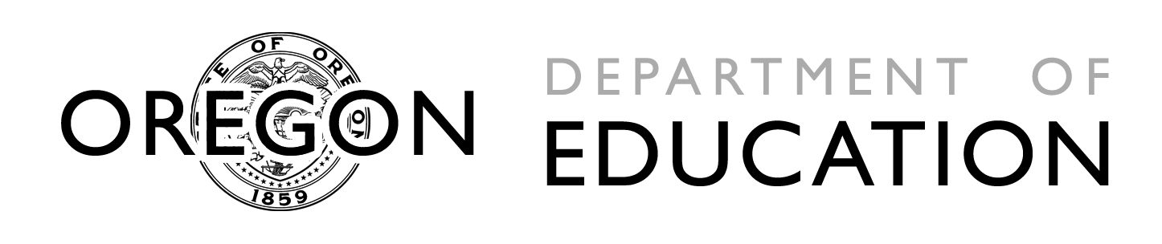  Office of Educational  Improvement and Innovation  Public Service Building  255 Capitol Street NE  Salem, OR 97310 | 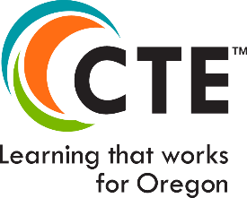 | Office of Community College and Workforce Development
CTE Program Certification of Assurance
Regional Coordinators must provide the Initial Approval Assurance details to any CTE program application in the CTE Information System. By providing this information, Regional Coordinators are verifying that the program partners have agreed to the items below. After filling in all the appropriate fields of this form, Regional Coordinators can collect signatures either electronically or on a printed copy. Gathered signatures can be uploaded to the CTE application for tracking purposes and should match all names provided in the Initial Approval Assurances section of CTE programs.
CTE Program Title:
Secondary School Name:
Name of Community College:
SECONDARY LOCAL SUPPORT and CERTIFICATE OF ASSURANCE
Have reviewed this program application document for clarity, completeness and adherence to program quality standards and support its approval. The secondary school administrator agrees that the CTE program area requirements for secondary CTE programs, including appropriate CTE certification for teachers, the rules and regulations for Public Law 109-270, and the requirements contained in the Oregon State Plan for Career and Technical Education will be complied with in the operation of the CTE programs and services offered by the district or through contract between the district and other agencies, institutions or individuals. The secondary school administrator agrees to furnish CTE program data as requested by the Oregon Department of Education.
Secondary School District Administrator Signature:

Date:
Lead Teacher Signature:

Date:

ADVISORY COMMITTEE SUPPORT and CERTIFICATE OF ASSURANCE
The Advisory Committee has been involved in the design and development of this program.
Advisory Committee Signature:

Date:

POST-SECONDARY LOCAL SUPPORT AND CERTIFICATE OF ASSURANCE
The specific community college(s) has been involved in the design and development of this CTE program of study and agrees to continue collaboration (collegial professional development), meeting all six (6) core elements, especially alignment and articulation.
Community College Administrator’s Signature:

Date:

CTE REGIONAL COORDINATOR
Recommend program for state approval (Perkins Eligible)
CTE Regional Coordinator Signature:

Date:

Non-Duplicative - Courses within a POS should build logically on prior coursework and not repeat the same content unless necessary for reinforcement or depth. Each course should add clear new knowledge or skills that align to industry standards and progression.

