CTE Program Update

User Guide

Fall 2018

Table of Contents

Introduction - 3 -
CTE Program Update Roles - 3 -
Program Administrator (School/District/ESD) - 3 -
Regional Coordinator - 3 -
ODE Education Specialist - 3 -
Important Information - 4 -
Dates - 4 -
NCES Codes - 4 -
Changes Allowed - 4 -
Course Codes & Credits - 4 -
Logging Into Program Update - 5 -
The Web Based Application - 6 -
Status: Waiting For Updates - 7 -
Status: Working - 8 -
Status: Submitted to Regional Coordinator for Review - 9 -
Status: Submitted to ODE for Approval - 10 -
Editing Program Records - 11 -
Search Icon - 12 -
Add/Edit Secondary Course - 13 -
Add/Edit College Course - 14 -
Add/Edit Contact - 16 -
View Program History - 17 -
Validation Errors - 18 -
NCES Course Code Error - 18 -
CIP Code Error - 21 -
Expiration Date Error - 21 -
Program Completion Credits Error - 22 -
Post Secondary Course Error - 23 -

CTE Program Update

Introduction

This manual has been created to assist you in completing the annual CTE Program Update. Please make sure to review all programs and their courses for accuracy even if no changes are to be made. All CTE Programs of Study must be submitted through this process for annual review and approval. Submission of inaccurate program and course information during the Fall Program Update may lead to data submission inaccuracies and errors during the Spring CTE Student and Course Collections which in turn may effect funding.

CTE Program Update Roles:
Who Submits?
School, District or ESD submit program updates to their Regional Coordinator.
Regional Coordinators review and submit program updates to ODE.
ODE Education Specialists review and either approve or reject program update.

Program Administrator (School/District/ESD submitter):
The Program Administrators have the ability to edit programs, submit to Regional Coordinators, and unsubmit records.

Regional Coordinator:
Regional Coordinators can act as Program Administrators and they have the additional ability to submit and unsubmit program records to ODE
Important Information
Dates:
Dates for the 2018-19 Annual Fall Program Update can be found here.

NCES Codes:
New NCES SCED Codes for Courses
NCES Codes by Endorsement Area

Review & Update:
The following is a list of what can and cannot be updated during the Fall Program Update.

Changes Allowed:
Contact information
School course name
Changes Not Allowed
Course credit
Changes Not Allowed
Name of program
CIP code
Add or delete courses
Course required/optional

School Course Codes & Credits:

Year-long/sequential semester/term courses should be differentiated with different course numbers for each grading period.
Ex: Introduction to Agriculture (a continuous year-long course worth 1 credit total)
Would be split into two semester courses worth 0.5 credits, or three term courses worth 0.33, 0.33, & 0.34 each with a different school course code to differentiate the semester/term.
Course # Course Title Credit
945F Introduction to Ag (Fall) 0.5
945S Introduction to Ag (Spring) 0.5

The CTE Program Update Application is located at the ODE District Website.

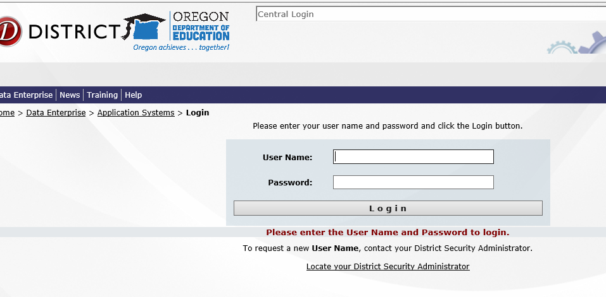

Under Applications, click on CTE Program Update. If you do not see this option, ask your School/District Security Administrator for access.

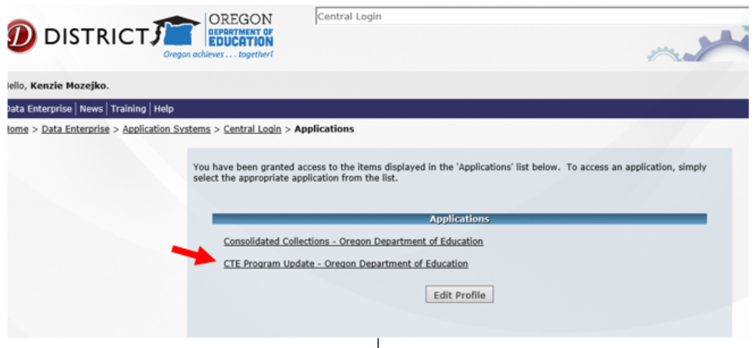

The Web Based Application:

The application will open with the following screen:

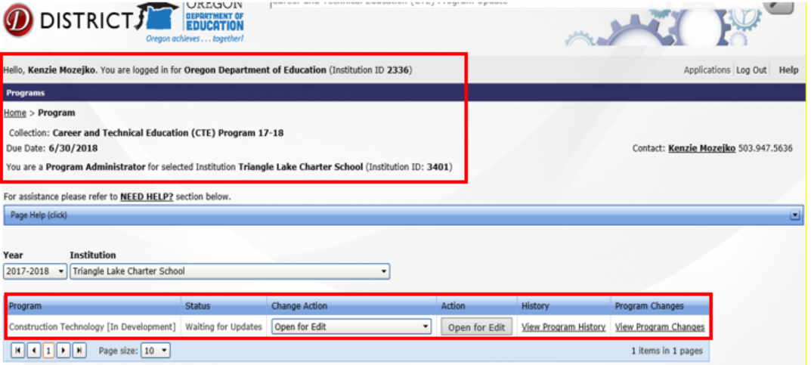

The top of the web page is informational and shows you the institution that you are logged in under, the application that you have opened (CTE…) and the level of permissions that you have.

You can change the School Year and the Institution to any you have permissions to.

In the working section of the page, you are shown each Program, the Status of the program and the available Actions, which change, depending on the Status.

The View Program History link will display all recorded actions with user and ODE comments that have happened to the program for the selected year.

The View Program Changes displays approved program changes for that year.

Status: Waiting for Updates

Status of all programs will be set to Waiting for Updates initially. Click on Open for Edit under Action.

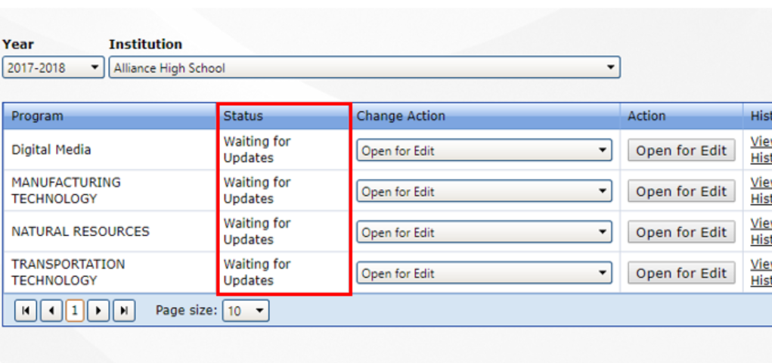

Click on the Change Action dropdown to see the available actions:

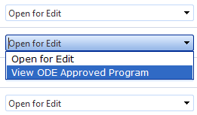

You can set the action to Open for Edit to edit it, or you can set the action to View the ODE Approved Program. When the Status is “Waiting for Updates”, the Existing record is the same as the ODE Approved program because no edits have taken place.

Select Open for Edit from Change Action dropdown, then click on the Open for Edit action button. Scroll to the bottom of the page to see the record and begin editing.

Status: Working

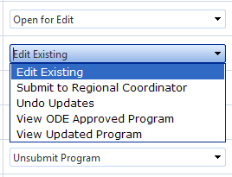

When the Status is working, this means that the record has been edited. Click on the Action Dropdown to see the available options:

Edit Existing will open the record (at the bottom of the page) allowing you to continue editing.

Submit to Regional Coordinator submits the record to the Regional Coordinator who can approve the edits and submit the record to ODE.

Undo Updates will drop all the edits on the record, and change the status back to Approved (if it was previously approved by ODE) or Waiting for Updates

View ODE Approved Program will open the ODE approved program in Read-Only mode

View Updated Program will open the existing record in Read-Only mode.

Status: Submitted to Regional Coordinator for Review

Click on the Change Action Dropdown to see the available actions:

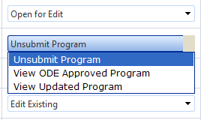

Unsubmit Program will change the Status back to Working and allow you to edit the record.

View ODE Approved Program will open the ODE approved program in Read-Only mode.

View Updated Program will open the existing record in Read-Only mode.

Regional Coordinators will have the following options:

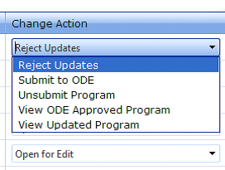

Status: Submitted to ODE for Approval

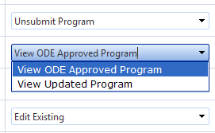

View ODE Approved Program will open the ODE approved program in Read-Only mode

View Updated Program will open the existing record in Read-Only mode.

Regional Coordinators will see the additional action choice Unsubmit Program

Editing Program Records

When the action is set to Open for Edits or Edit Existing, you can edit the Program record.

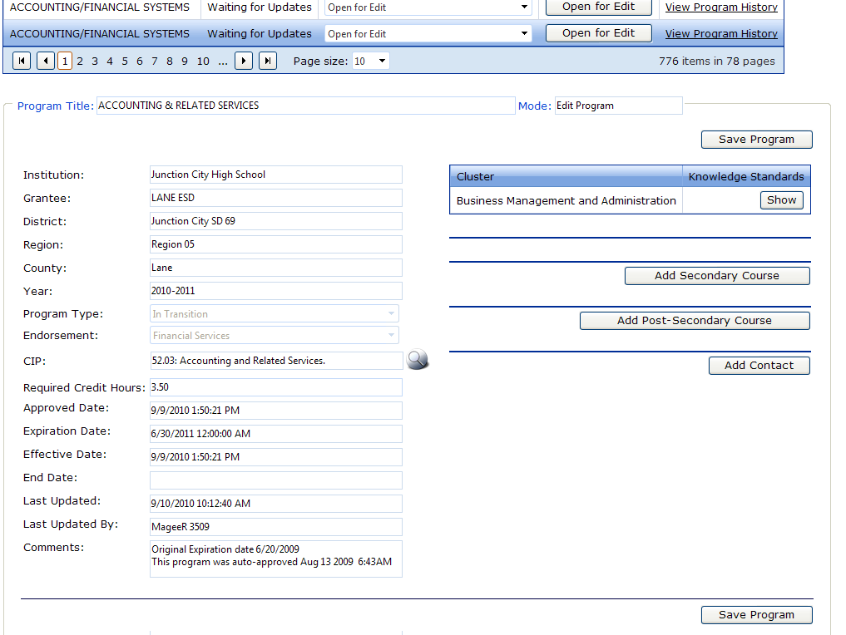Click the button to open the record at the bottom of the page, then scroll down to see it.

Click in the fields you want to edit. Remember to click Save Program after making changes.

The editable fields are:
Program Title
CIP (Classification of Instructional Programs)
Required Credit Hours.
Secondary Courses
Post-Secondary Courses

Search Icon:
You cannot directly edit a field with the Search icon….. next to it. You must click on the Search icon and select the appropriate item from the items returned by the Search.

Change the search in the Code and/or Description boxes and click the Search button to refresh the list and find the item that you need.

Click the Select button to fill the program field with the Search item.

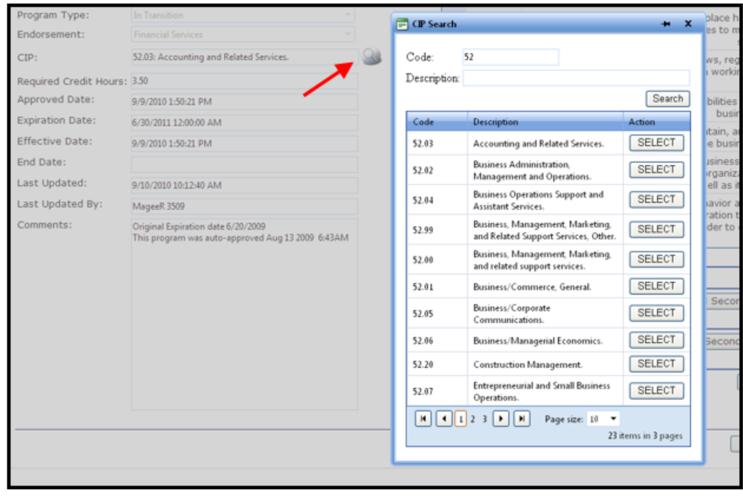

Add/Edit Secondary Course:

Click the Add Secondary Course button at the bottom of the Secondary course area or click the Edit Course button next to the course you wish to edit. A new window will open. Make edits as needed. Don’t forget to press Save at the bottom when finished making course edits.

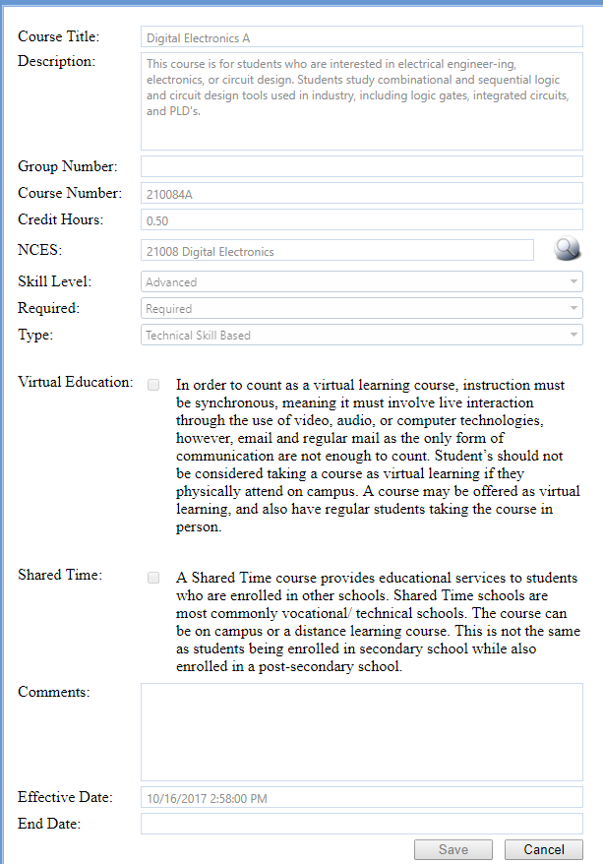

Add/Edit College Course:

Click the Add Post-Secondary Course button at the bottom of the Post-Secondary course area, or click Edit Course to make changes to an existing course. A new window will open.
Click the Search Icon. A new window will open.

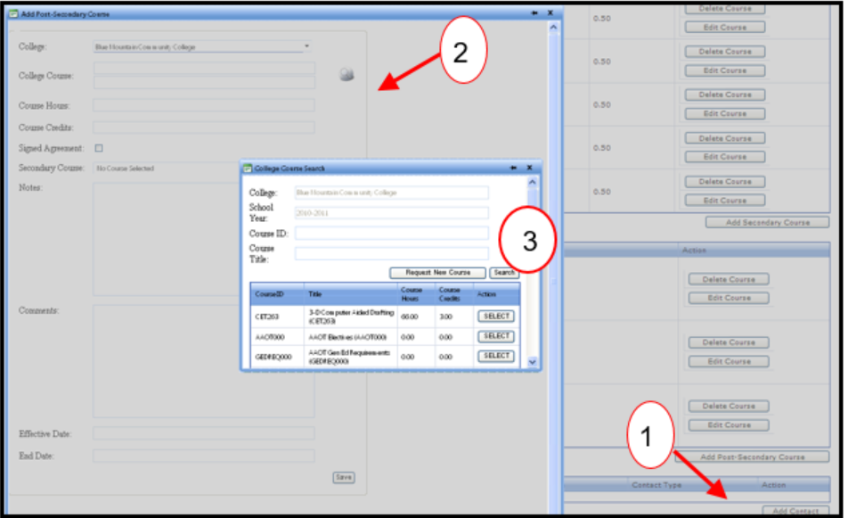
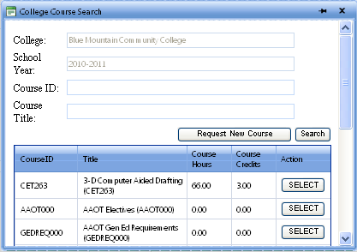

Fill in a partial Course Title or ID and click the Search button. A list of courses based on your search criteria will be displayed. Click the Select button to select that course and return to the previous window. Remember to press Save when done adding or editing courses.

If you cannot find the course that you want, you may click the Request New Course button. The following page will open.

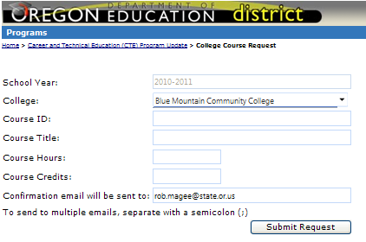

Enter the Course information and click Submit Request. The request will be sent to the ODE Data Owner for approval.

Add/Edit Contact:

Click the Add Contact button to request a new contact for the program.
Click the Search icon to find an existing contact or to Request a New Contact.

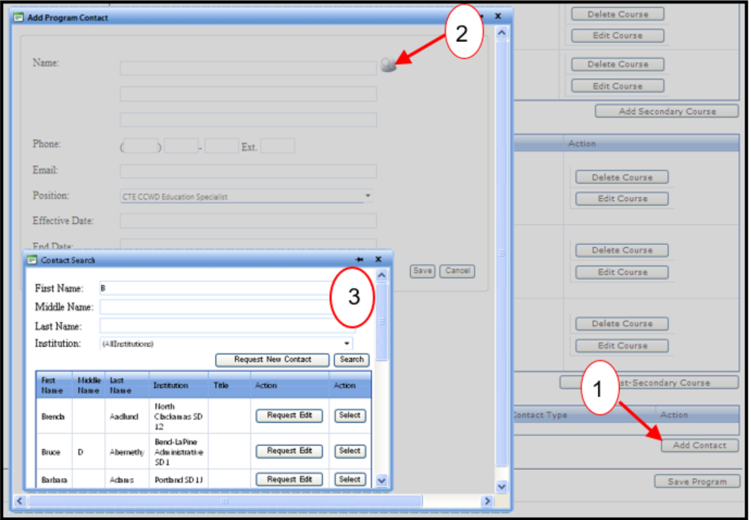

Fill in a partial First Name and/or Last name to find and Select the correct Program Contact.
If you cannot find the contact you need, you can Request a New Contact, or an Edit to an existing contact. The change must be approved by ODE.

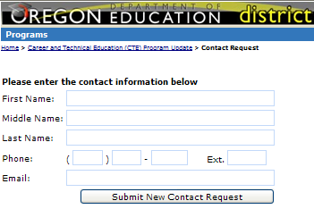

View Program History

Click the View Program History link to see the actions related to that program record.

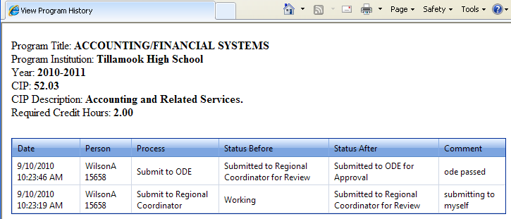

Validation Error Messages
Please ensure pop-ups are enabled. Switching to a different browser may be required to see error pop-ups.
NCES Code Error
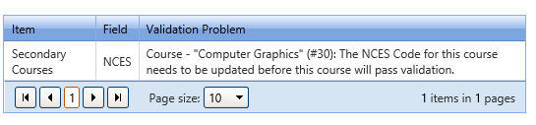
Click on Edit Course. The Edit Secondary Course window will open. If the NCES code says Inactive, click on the magnifying glass and search for the NCES course by name or code. Press enter on keyboard to display search results.

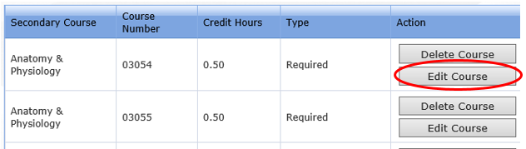

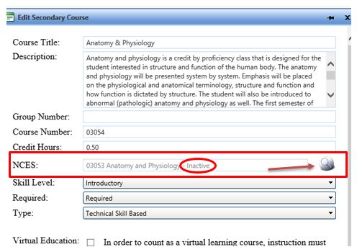

Click Select next to correct course.
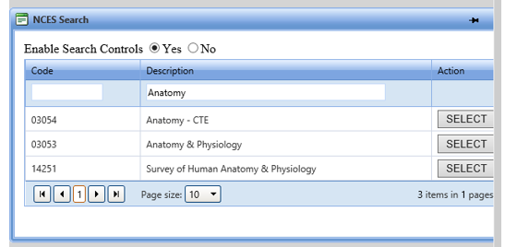
The NCES window will close and Inactive should no longer display. Scroll down to bottom of window and Click on Save.

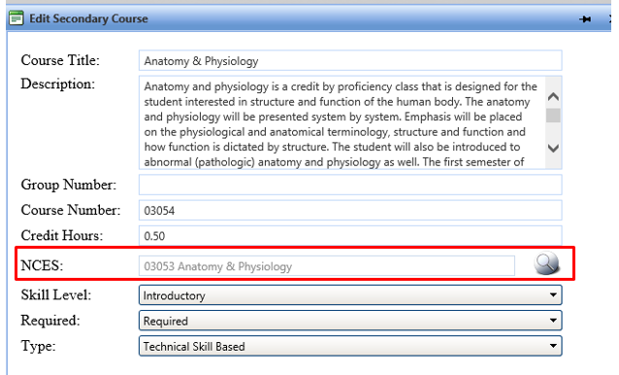

CIP Code Error
Ignore the CIP code error. It is outdated and no longer applies to the program update process. It displays along with other validation errors, but does not actually hinder the program from passing validation. The program will pass validation upon fixing all other validation errors listed.

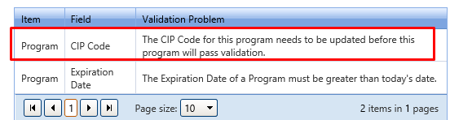

Expiration Date Error

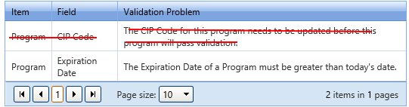

Solution:
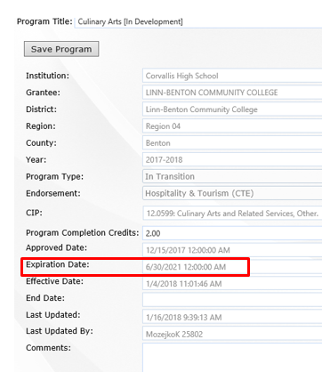

Program Completion Credits Error

Less than
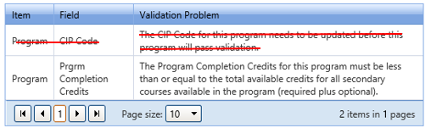
Solution: Change the number of program completion credits to be equal to or less than the number of credits shown under all credits. Click save at top

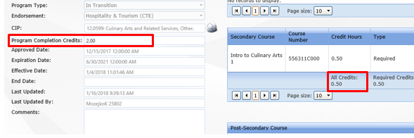
Greater than
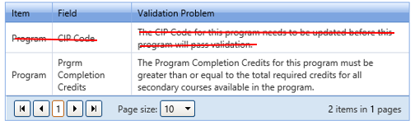

Solution: Change the Program Completion Credits to be equal to or greater than the number listed below required credits at the bottom of the Secondary Course section. Click Save at top.
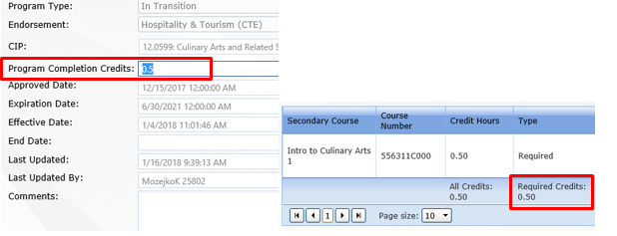

Post Secondary Course Error
A minimum of one post secondary course is required for all full programs of study.
