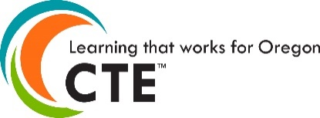

CTE/STEM Regional Network/Carl D. Perkins Contact Update
Please email updates to Barbara.ONeill@state.or.us

First Name
Last Name
Title
Address
Institution
Region #
City, ST Zip
Email
Phone
Comments

CTE Educational Assignment | Other
Regional Coordinator | New assignment
Dual Credit/College Now Coordinator | Replacing?
CTE Specialist | Remove from the contact list:
CTE Dean
The CTE brand logo, brand-positioning, theme, and brand extensions are the property of NASDCTEc

